Gardening after Late Blight
James F. Dill PhD, Pest Management Specialist, UMaine Cooperative Extension

The gardening season has come to an end and you are already thinking ahead to next year. The garden was a big success except for LATE BLIGHT that wiped out the tomatoes and potatoes. A few tomatoes managed to ripen and the potatoes, if there are any, are still in the ground. Of course, the potato plants have been dead for 2-3 weeks now and the tomato plants certainly need to be given last rites. So, now what?!

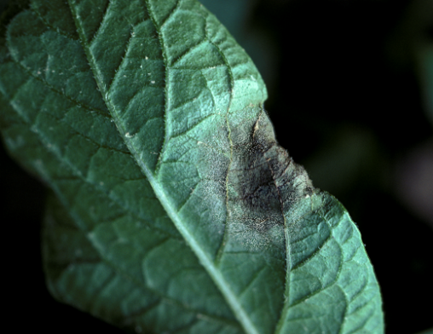
Let’s first look at late blight and what happened in 2009. Late blight (which helped to create the Irish Potato Famine and the “hungry forties” in England and throughout Europe in the 1840s) is caused by Phytophthora infestans, a fungus that overwinters on living tomato or potato tissue. The disease first appears as irregular, pale to dark green, water-soaked spots. These spots usually appear on the tips or edges of the leaves. In cool, moist weather or under humid conditions, the spots enlarge rapidly and form brown to purplish-black necrotic areas with wavy, indefinite borders, surrounded by a yellowish-green halo. Also under these conditions, a ring or a surface of white fungal growth may appear at the edge of the lesion on the underside of the leaf, which produces spores that move to other plants and continue the infection.

In 2009, we had perfect late blight weather for the months of June and July. Unfortunately, there was also plenty of spore inoculum around from store purchased tomato plants to cause very early late blight infections in home and commercial gardens.
These spores continued to spread and caused severe outbreaks of late blight in both tomatoes and potatoes in southern and central Maine. Luckily, the weather in August was hot and dry and eventually slowed the outbreak down and brought it to a standstill.

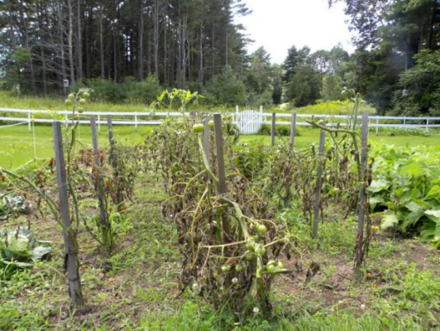
However, that doesn’t mean that the disease is gone. It is just lying dormant in those remaining leaf, stem, fruit, and tuber lesions waiting for the cool, wet weather so it can become active again and start sending out new spores for new infections.

So now the big questions come up. What do I do with my dying plants and disgusting fruit and, oh yeah, what about those potato tubers that I still haven’t dug yet? What about next year do I have to worry about late blight in my garden again, especially since I had it this year? Are there any resistant varieties?

Any healthy tomatoes you can salvage can be eaten. However, the USDA doesn’t recommend canning tomatoes from late blight infected plants. There is a concern that the fungus may change the acidity of the tomatoes and therefore affect canning quality. Late Blight is an obligate parasite and thus needs living tissue to survive. Once the infected plant material is dead the fungus will die and will not carry over to the next year. The removal of living tissue is the key to preventing carry over. The remaining infected and dead plants (both potato and tomato) and infected fruit should be destroyed by burying or sealing in garbage bags and taken to a landfill. Do NOT compost diseased plants or fruit. Composting is not recommended because many compost piles are not tended properly and are therefore not “cooked” to the proper temperature to kill the pathogens. Next year, if there are any surviving pathogens in the compost or on partially decomposed plants, they may be spread to living plants if the compost is used in the garden. ALL potato tubers should be dug and carefully washed and graded. If you leave any tubers behind in the ground and if they have a late blight lesion on them, it is possible they could survive the winter in the ground and give rise to a new infection next year. After you have examined your potatoes, discard any damaged ones as was done with the diseased plants.

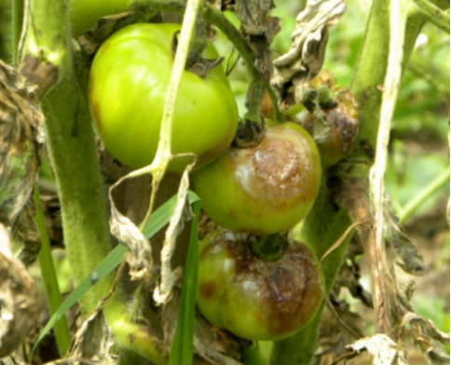
If you are storing your potatoes for the winter be sure to examine them every couple of weeks. It could be possible that a small lesion or two may have been missed during washing and grading and could give rise to an infection in storage destroying much of your winter supply, just like in the 1840’s!

You are now ready for next year’s garden. Don’t plant any of the saved tubers from your late blight potatoes from this year. You certainly don’t want to infect your plants before you get started. Buy and plant certified seed to reduce your risk of planting infected tubers. You can plant your tomatoes and potatoes in the same spot you did last year and you shouldn’t have any late blight problems as long as you cleaned up plant debris well. However, it is certainly good practice to rotate the crops in your garden as much as possible. Don’t plant the potatoes in the same spot in your garden year after year. Also, do not rotate with related crops. For example, tomatoes should not be planted where your potatoes were last year.


Planting late blight resistant varieties is also an option. The thing to remember about resistance is that it does not mean immunity. Resistance means that the plant can resist to a point, in this case, the late blight fungus. However, if there is a great spore load from many infected plants, then even resistant plants can get the disease although not as badly as the susceptible ones. The other point to remember is that the fungus can mutate and the mutation may be able to overcome the resistance. There are some resistant potato varieties available to the backyard gardener such as Kennebec, Sebago, Allegany and Chieftain (a red-skinned variety). There are also some resistant tomato varieties, including Ferline, Fantasio, and Legend that are available. Good gardening!

Published and distributed in furtherance of Acts of Congress of May 8 and June 30, 1914, by the University of Maine Cooperative Extension, the Land Grant University of the state of Maine and the U.S. Department of Agriculture cooperating. Cooperative Extension and other agencies of the U.S.D.A. provide equal opportunities in programs and employment. 9/09

