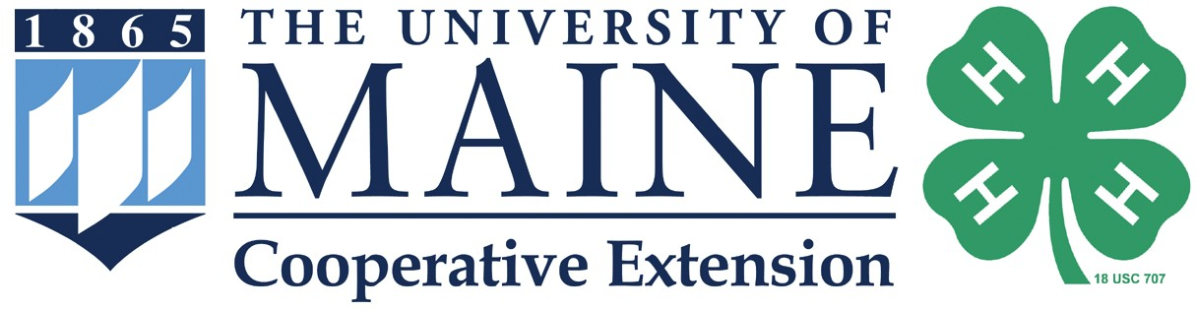

Maine 4-H Science

Where are 4-H Science programs happening in Maine?
Right here!

Maine 4-H makes hands-on STEM (Science, Technology, Engineering, and Math) education available for schools, after-school and community programs.

Insert image here
We offer:
4-H Science Project Kits for Teachers STEM Ambassadors
Follow a Researcher
Citizen Science Opportunities
4-H Science and Enrichment Programs

Want to learn more about 4-H STEM programs in the area?

Insert image here
Contact us:
extension.umaine.edu/county office University of Maine Cooperative Extension XXXXXXXX County Address
Town, ME XXXXX
207.XXX.XXXX 800.XXX.XXXX (in Maine)
TDD 800.XXX.XXXX
email address

extension.umaine.edu/4h
The University of Maine is an EEO/AA employer, and does not discriminate on the grounds of race, color, religion, sex, sexual orientation, transgender status, gender expression, national origin, citizenship status, age, disability, genetic information or veteran’s status in employment, education, and all other programs and activities. The following person has been designated to handle inquiries regarding non-discrimination policies: Sarah E. Harebo, Director of Equal Opportunity, 101 North Stevens Hall, University of Maine, Orono, ME 04469-5754, 207.581.1226, TTY 711 (Maine Relay System).

