Learning Targets:
- Identify the different types of teeth mammals have (incisors, canines, premolars, and molars) and what they are used for.
- Understand the different types of feeding diets: herbivore, omnivore, and carnivore.
- Compare human teeth and diets to other animals.

Length: 30 minutes

Essential Questions:
- Can you tell what a mammal’s diet is based on their teeth?
- Why are teeth shaped the way they are?
- What are the different types of teeth that mammals have?

Enduring Understandings:
- Most mammals have premolars and molars, but they come in different shapes depending on what the animal eats.
- Plants are hard to digest, so animals that eat them (herbivores) have a lot of flat teeth with many folds that help grind the material down.
- Meat is easier to digest, so sharp teeth are helpful at cutting the food into pieces that can be swallowed.
- Animals that eat both plants and animals have a mixture of flat and sharp teeth (i.e. humans).

Background for Facilitator:
Teeth are essential for animals because they are needed to eat, to groom, and used for protection. For humans, teeth also help us form words to talk to one another! Teeth come in a variety of shapes and sizes, and are dependent on an animal's trophic level and diet. Some teeth are used to grind things down and build (i.e. Beaver), while others are used to slice food into smaller pieces (i.e. Crocodile). Some animals have single rows of teeth (i.e. Red Fox), while others have multiple rows (i.e. Great White Shark). You can learn a lot about an animal by just looking at their teeth! Teeth can tell us what an animal is eating, how old they might be, and also how they behave.

Common teeth found in mammals include: incisors, canines, premolars, and molars. Incisors are found in the front of the mouth and are usually small and chisel-shaped. Their purpose is to bite and to cut food into chunks. Canines are sharp and pointed and are found on either side of the incisors. Their purpose is to grip and tear food. Premolars and molars are sometimes referred to as the “cheek teeth.” They are typically wide and flat. Their purpose is to crush, chew, and grind food to make it easier for an animal to swallow. Animals that are herbivores often lack canines, while animals that are carnivores have premolars and molars that are pointier and sharper due to the need to tear their food instead of grind it. Omnivores typically have all the different types of teeth because they are consuming a variety of food types that have different textures.

Vocabulary List:
Canines: teeth found on either side of the incisors. They are sharp and pointed. Their purpose is to grip and tear food.
Carnivore: an animal that primarily eats meat (example: Bobcat).
Diet: types of food an animal eats (example: insects, plants, meat, etc.).
Herbivore: an animal that primarily eats plants and algae (example: Moose).
Incisors: teeth found in the front of the mouth. They are usually small and chisel-shaped. Their purpose is to bite and cut food into smaller chunks.
Molars: teeth found in the back of the mouth that are wide and flat. Their purpose is to crush, chew, and grind food to make it easier for an animal to swallow.
Omnivore: an animal that has a mixed diet of plants, algae, and meat (example: Black Bear).
Premolar: teeth found in the back of the mouth that are wide and flat. Their purpose is to crush, chew, and grind food to make it easier for an animal to swallow.
Producer: a species that makes its own food (plants or algae). This is typically done through photosynthesis (example: Red Maple or Sugar Kelp).
Scavenger: an animal that feeds on dead animals and plants (example: Coyote).
Trophic level: the level a species occupies in the food web (i.e. or trophic web).

Materials:
- What’s My Diet? worksheets (9 different animals)
- 8 Skulls (Beaver, White-tailed Deer, Black Bear, Red Fox, Coyote, Mink, Bobcat, Raccoon) *there is no moose skull
- What am I? laminated cards (1 for each skull)
- Mirrors (12)
- Human Teeth Diagram Cards (4)
- Critters of Maine Pocket Guide (6)
- Not included: Coloring utensils (crayons, markers, or color pencils)

Methods:

Engage
- Start a discussion with your group on why teeth are important and come up with a list of ideas on what they are used for.
- Pass a mirror around to everyone and have them examine their own teeth. Note: some students might not feel comfortable looking at their teeth, if that is the case have them feel around in their mouth with a finger or their tongue and make observations.
  - Do they all look (or feel) the same?
  - Can someone describe the shapes they see (or feel)?
  - Do you think different teeth are important for different things?
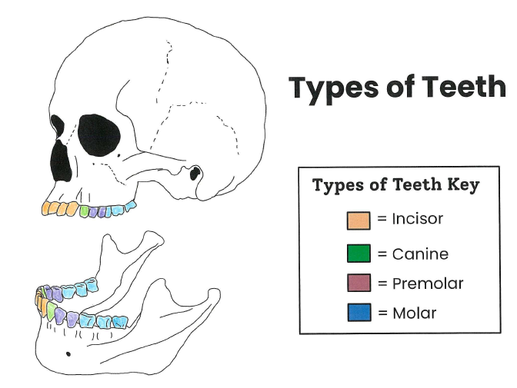
  - Does anyone know the names of the different teeth?
- Place students in groups of 3 to 4 and give each group a Human Teeth Diagram Card. Based on what they see in the diagram, can they identify the different types of teeth in their own mouth?

Explore
- Give everyone an herbivore tooth worksheet (#1 - 3) and see if they can identify the different types of teeth just discussed. Have them use a different color for each type, and make sure they identify the color on their “Types of Teeth Key.”
  - Pull out the Beaver or Deer skulls from the toolkit to let students investigate in more detail. The only skull not contained in the toolkit is the moose.
- Next, students can look at a carnivore tooth worksheet (#9 or 10), followed by an omnivore tooth worksheet (# 4 - 8).
  - Have the other skulls from the toolkit out for students to examine, as well. Each skull is labeled with the number on the worksheet. An answer key is also provided in the toolkit.

Evaluate
- After everyone has had a chance to look at the 3 different trophic levels, discuss the answers with the group.
  - Were they able to identify diets based on the teeth they saw?
  - Were there teeth that were easy to identify?
  - Were there teeth that were difficult to identify?

In complying with the letter and spirit of applicable laws and pursuing its own goals of diversity, the University of Maine System does not discriminate on the grounds of race, color, religion, sex, sexual orientation, transgender status, gender, gender identity or expression, ethnicity, national origin, citizenship status, familial status, ancestry, age, disability physical or mental, genetic information, or veterans or military status in employment, education, and all other programs and activities. The University provides reasonable accommodations to qualified individuals with disabilities upon request. The following person has been designated to handle inquiries regarding non-discrimination policies: Director of Equal Opportunity and Title IX Services, 5713 Chadbourne Hall, Room 412, University of Maine, Orono, ME 04469-5713, 207.581.1226, TTY 711 (Maine Relay System).

