

Learning Targets:
- Know and identify the different foot types: plantigrade, digitigrade, and unguligrade.
- Gain perspective on the actual size of Maine mammals.
- Create a track using a mold.

Length: 20 - 30 minutes

Essential Questions:
- Why are animal tracks different?
- What mammals are found in Maine?

Enduring Understandings:
- Further scaffolding of information learned in Activity 1: What’s that Track?!

Background for Facilitator:
The background information on animal tracks is contained in Activity 1: What’s that Track?! In this activity, students get a chance to make their own temporary or permanent tracks using molds included with the toolkit. The species in the “Materials” list have two tracks: front foot and hind foot. The materials to make the tracks are not included in the toolkit, but there is a table listing a variety of ingredients you could use!

Vocabulary List:
Digitigrade: animals that walk using their toes (i.e. digits). This includes coyotes, bobcats, and birds.
Plantigrade: animals that walk using their entire foot. This includes bears, raccoons, and humans.
Tracks: footprints left on the surface of something. This could include snow, mud, sand, etc.
Unguligrade: animals that walk on the tips of their toes (i.e. toenails or hooves). This includes moose, deer, and cows.

Materials:
- Track molds (Beaver, White-tailed Deer, Moose, Black Bear, Red Fox, Coyote, Mink, Bobcat, Raccoon, Skunk, Cottontail, Gray Squirrel)
- Books: Critters of Maine Pocket Guide (6); Peterson Field Guide to Animal Tracks (3); Big Tracks, Little Tracks; Tracks, Scat, and Signs (book choice is dependent on the age of your group)
- Not included: materials to make tracks (refer to the table below for options)

The type of materials you use in this activity is entirely up to you. Some options are one-time use, while others are repeated use.
Material/ Product | Durability | How to Make
Plaster of Paris | One-time use; hard, but will break if dropped | Follow instructions on the container.
Model Magic | One-time use; air-dry, light and squishy. | Pre-made.
Playdough | Not permanent; can use the material to make multiple tracks. | Pre-made.
Salt Dough | One-time use; air dry or in the oven, hard. | Two parts flour, one part salt, one part water.
Baking Soda Dough | One-time use; air dry or in the oven, hard. | 1 cup baking soda, ½ cup corn starch, ¾ cup water.

Methods:

Engage
- Prior to the activity, decide which media you want your students to use to create their own track cast and have the materials ready.
- Start a conversation with your group about what they learned from Activity 1: What’s the Track?! and the things to look for when identifying a track.
  - What are the 3 foot types and what do they mean? plantigrade, digitigrade, and unguligrade.
- Discuss the different mammals that live in Maine and then display the selection of tracks to choose from. The molds in the kit are the average adult size of the species. Even with humans, our feet are unique shapes and sizes, and nature is the same way! When you see tracks in the wilderness, they often look different from track drawings. What you step in (mud, sand, leaves, etc.) also affects the way a track looks!

Explore
- Have your students create their track cast and allow time for drying if the material is one-time use only.

Evaluate
- Students remove their track from the mold and see how well it came out!

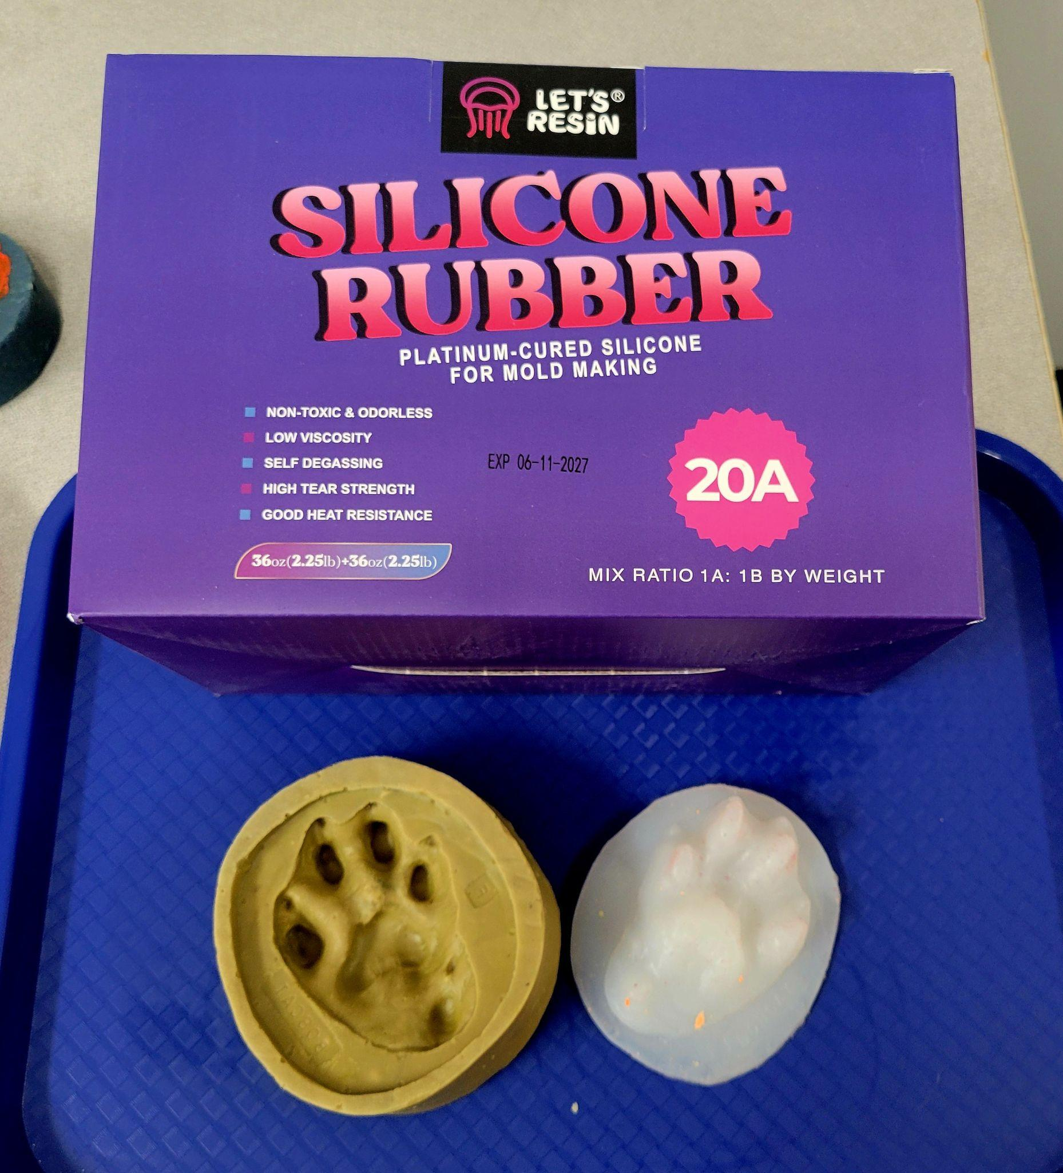
Extension Ideas:
- You can make your own rubber molds that students can use to make prints using “Let’s Resin: Silicone Rubber”.

- There are many demonstration videos and lessons on how to cast tracks you find out in the environment. After students gain experience doing it in the classroom, they can try it out in the field!

In complying with the letter and spirit of applicable laws and pursuing its own goals of diversity, the University of Maine System does not discriminate on the grounds of race, color, religion, sex, sexual orientation, transgender status, gender, gender identity or expression, ethnicity, national origin, citizenship status, familial status, ancestry, age, disability physical or mental, genetic information, or veterans or military status in employment, education, and all other programs and activities. The University provides reasonable accommodations to qualified individuals with disabilities upon request. The following person has been designated to handle inquiries regarding non-discrimination policies: Director of Equal Opportunity and Title IX Services, 5713 Chadbourne Hall, Room 412, University of Maine, Orono, ME 04469-5713, 207.581.1226, TTY 711 (Maine Relay System).

