# 4-H and University of Maine Cooperative Extension logo Activity 2: Go Fish for Seaweed

# Learning Targets:

* Recognize the differences between seaweeds and land plants
* Identify the parts of a seaweed (blade, stipe, holdfast, and sometimes float)
* Identify common species of seaweed in Maine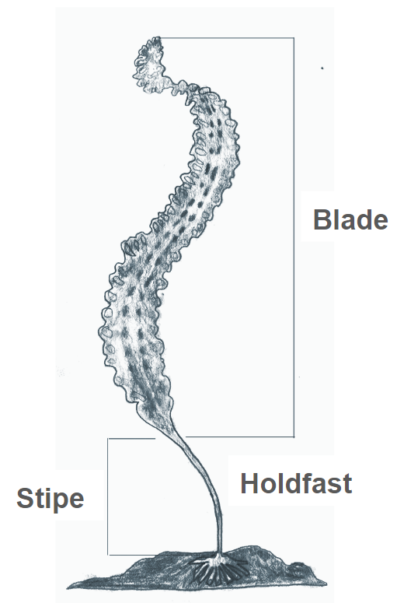

# Length: 45-60 minutes

# Key Concepts:

* Seaweeds do not have roots, stems, or leaves, or flowers. They have holdfasts, stipes, and blades, and sometimes floats.
* Seaweeds have different structures than land plants because they live in the water rather than on land.

# Essential Questions:

* Concepts in the Venn diagram described in the *Evaluate* section.

# Background for Facilitator:

"Seaweed" is the common name for countless species of marine algae that grow in the sea. They produce oxygen by photosynthesizing energy from the sun, just like plants do on land. But, seaweeds differ from land plants in many important ways:

* Seaweeds can photosynthesize in all of their tissues. Most land plants photosynthesize only in their leaves.
* Seaweeds absorb water and nutrients in all of their tissues. Land plants have complex systems of roots, specialized tissues, and leaves that help them move water and nutrients around their body.
* Seaweeds are typically supported by the water they live in. Land plants need structures to help hold them up against gravity.
* Seaweeds can reproduce by simply breaking apart, releasing eggs and sperm, or releasing spores. Land plants typically reproduce by spreading their seeds.
* Seaweeds do not have flowers. Land plants can have flowers.
* Seaweeds can have **holdfasts** that help them cling to rocks. (Holdfasts do not transport nutrients or water, they just hold the base of the seaweed in one place). Land plants have roots that anchor the plant in the ground and uptake nutrients and water that then gets transported around their body.
* Seaweeds have **blades**. Land plants have leaves.
* Seaweeds have **stipes**. Land plants have stems.

# Vocabulary List:

**Blade:** Flattened part of a seaweed that resembles a leaf.

**Holdfast:** Base of a seaweed that attaches it to a rock; this resembles roots.

**Stipe:** Stalk of a seaweed between holdfast and blade; this resembles a stem.

**Float:** Air bladder that allows seaweeds to float closer to sunlight.

**Species:** the largest group of organisms from which two individuals are capable of reproducing fertile offspring (ex. dogs, humans, chickadees).

# Materials:

* 4 species of “Seaweed vs. Plant” Clue Cards
* “Seaweed vs. Plant” answer key
* 4 sets of “Go Fish for Seaweed” Cards

# Methods:

## Engage

1. Ask youth to recall some of the information they learned in Activity 1:
2. **How is seaweed different from a plant?**
3. **What clues do you need to tell them apart from each other? On chart paper, begin with the word “Seaweed”. Have youth list as many terms, facts, ideas, and definitions that they can remember from the previous activity. Alternative -- have small groups come up with focused lists. The entire group can then look for similarities between lists. What is readily remembered? Is any concept missing which is critical to understanding?1**

## Explore

1. Divide the groups into 3-4 cooperative learning groups and begin by playing a game of “Seaweed vs. Plant” to refresh their memory of seaweed:
   1. **The object of the game is to determine whether your species is a plant or a seaweed based on the clues given on the card.**
   2. **There will be five rounds, and each group will receive one clue card per round.**
   3. **Read the clue card aloud to your group, and decide whether you think the species described is a SEAWEED, PLANT, or NOT SURE based on the information given on the card.**
   4. **Each round, you will receive another clue card with more information about your species.**
   5. **The next round doesn’t begin until each group has chosen: SEAWEED, PLANT, or NOT SURE. Raise your hand when your group is ready. We won’t move on until all groups have their hands raised.**
2. Distribute “Round 1” of the “Seaweed vs. Plant” clue cards. Each group should have a different species.
3. Proceed with rounds 2-5 until all groups have come to a decision.
4. At the end of round 5, prompt the youth to share their ideas, one group at a time:
   1. **Read through all of the clues, in order, and tell us what you decided; is your species a SEAWEED or PLANT?**
   2. **What clues led you to believe that?**
5. Following each presentation, address the rest of the youth:
   1. **Do you agree with this group’s decision? Why or why not?**
6. After the discussion, reference the answer key and tell the youth the name of the species and if it is a plant or a seaweed.
7. Be sure to point out the clues that help the youth understand the differences between plants and seaweeds.
   1. **For example: Species 1, Clue 4 says that this species never has any flowers. Seaweeds do not have flowers; only land plants have flowers. Similarly, Species 2, Clue 5 references “my flowers.”**
   2. **Another example: Species 4, Clue 5 says “my holdfasts are used to hold on tight to rocks, not take up water or nutrients, like roots do,” indicating that this species is a seaweed.**
   3. **Another example: Species 1, clue 1 says “Love the sun”, which applies to both.**
   4. **Another example: Species 4, Clue 4 says “surrounding water supports me.”**

Add new understandings to the posted Focused List.

## Explain

1. Now that the youth have refreshed their memory of the differences between seaweeds and plants, it’s time to play “Go Fish for Seaweed!”
2. Review the vocabulary words: holdfast, blade, stipe. Draw a diagram if necessary.
   1. **Does anyone remember these 3 important parts of seaweed?**
3. Tell youth they will be assembling these structures of seaweeds in a game similar to the card game “Go Fish.”
4. Read the following rules aloud:

### Game Rules

This variation of the popular card game, “Go Fish”, is designed to help you compare the different structures of seaweed and plants. If you already know how to play “Go Fish,” this variation may not be the same as you are used to, so listen carefully to the rules:

**Objective:** The object of the game isto collect as many complete species as possible. A complete species is a set of three cards with different structures that make up one species. For example, “Kelp Blade,” “Kelp Stipe,” and “Kelp Holdfast” is one complete species *(***\*show an example from the deck\****)*.

**Dealing and Setup:** The game can be played by 2-5 players. If there are 2-3 players, they are each dealt 7 cards. If there are 4-5 players, they are each dealt 5 cards. Once the dealing is done, the rest of the deck is placed in a random pile on the table in the center of the players, face down. If the players have any complete species in their hand at this time, they can put them on the table in front of them, face up, to reveal the “catch.” This counts as one point.

**Fishing:** You can decide who goes first through a game of rock, paper, scissors. The first player starts by asking one of the other players for a particular species and structure that they need to build a seaweed. For example, if you have a kelp blade in your hand, you might ask another player: “Do you have a kelp stipe?”. You may **only** ask for a species that you already have at least one card of. For example, if you are not holding any kelp cards in your hand, you can’t ask for kelp from another player. If the player being asked for a kelp stipe has that card, then they **must** give them to you, and you get another turn. If they don't have any kelp stipes then they will tell you to "Go Fish", which means that you will draw one card from the pile on the table. If you get a kelp stipe, then you show it to the other players to reveal your “catch” and get another turn. If you get something else besides a kelp stipe from the pile, you are finished with your turn and the player to your left plays next.

**Adaptation Note:** There can be an alternate version of this activity, where they just have to match the species and not the 'kelp, blade, and holdfast' of those species.

**Scoring:** If you have a complete species (3 cards of the same species), put them on the table in front of you, face up, to reveal the “catch”. This counts as one point.

**Drawing new cards:** You can finish all the cards in your hand, either because someone else asked you for the last cards that you had, or you used up all your cards by making a complete species. If you have no cards left in your hand, you may draw new cards from the pile on the table. You may take the same number of cards as you were dealt at the start of the game. If you have no cards left in your hand and there are no more cards left in the pile to draw from, you are “out” and will wait until the other players finish the game. You will still keep all of the points you gathered during the game.

## Evaluate

1. Engage the youth in a discussion of their experience:
2. **Why do seaweeds have different structures than plants? Construct a Venn diagram: in the shared portion - produce oxygen through photosynthesis; need sunlight. In the Plants portion - found on land; need structure to hold them up; parts are root, stem, leaf, flower: photosynthesis in leaves. In the Seaweed portion - found in the ocean; supported by water; parts are holdfast, stipe, blade, bladder; photosynthesis throughout the entire plant.**
3. **What is the function of each seaweed part? What purpose does a holdfast, blade, stipe, or float serve? What purpose does a leaf, stem, roots, or flower serve in a plant?**

Annotated Student Drawing:2 Draw a seaweed and land plant side by side. Label parts and purpose of each.

1 Focused Listing – review technique from Science Formative Assessment by Page Keeley, NSTA Press 2008, page 95.

2 MTV: Making Your Thinking Visual from Page Keeley, Page 53 (see source 1).

# Seaweed vs. Plant Answer Key

Species 1: Sea Lettuce (SEAWEED)

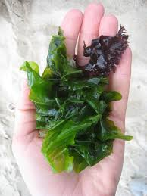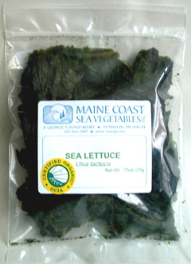

Species 2: Dandelion (PLANT)

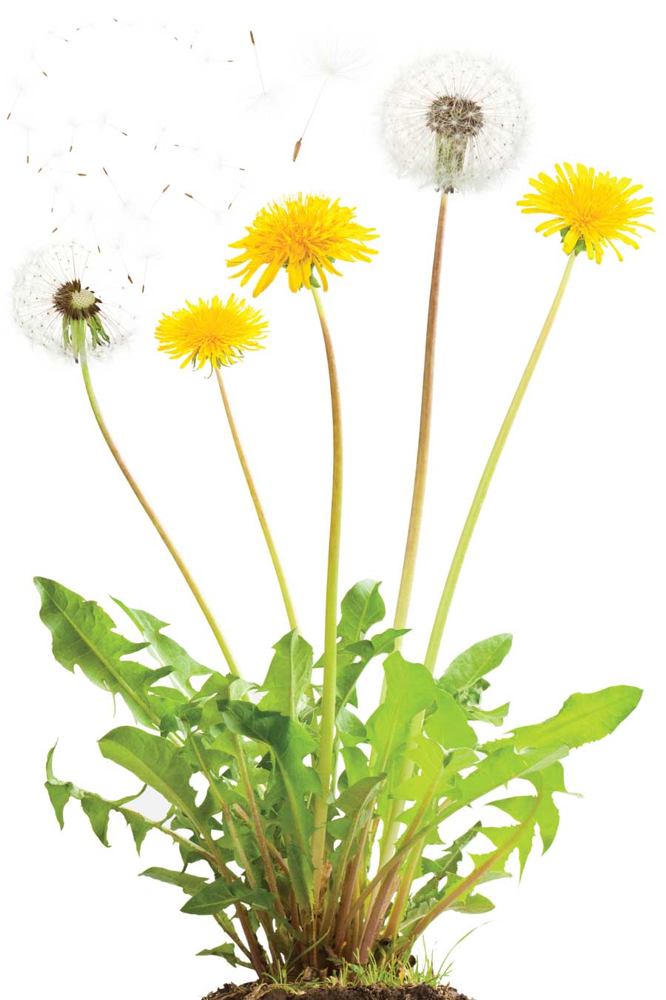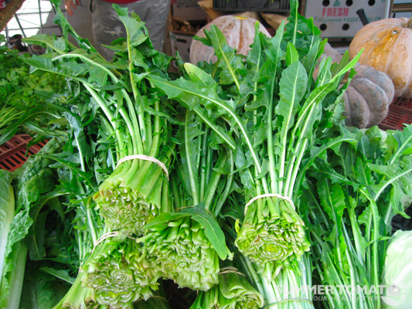

Species 3: Blueberry (PLANT)

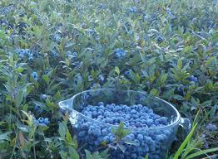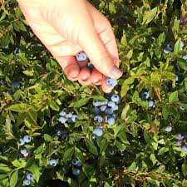

Species 4: Kelp (SEAWEED)

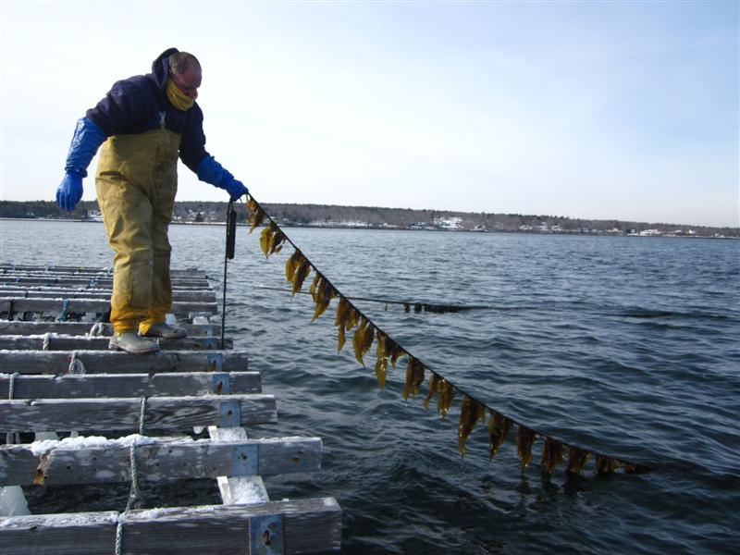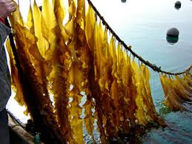

In complying with the letter and spirit of applicable laws and pursuing its own goals of diversity, the University of Maine System does not discriminate on the grounds of race, color, religion, sex, sexual orientation, transgender status, gender, gender identity or expression, ethnicity, national origin, citizenship status, familial status, ancestry, age, disability physical or mental, genetic information, or veterans or military status in employment, education, and all other programs and activities. The University provides reasonable accommodations to qualified individuals with disabilities upon request. The following person has been designated to handle inquiries regarding non-discrimination policies: Director of Equal Opportunity, 5713 Chadbourne Hall, Room 412, University of Maine, Orono, ME 04469-5713, 207.581.1226, TTY 711 (Maine Relay System).

