Researching Species and Water Bodies

All Species
Note: All links are provided purely for educational purposes. No responsibility is assumed for any content on the linked site(s).

Encyclopedia of Life from Smithsonian National Museum of Natural History:
- http://eol.org/
- Search for your species
- Knowing the scientific name helps (google the scientific name, then put that in the EOL search bar)
- Click on the “Details” tab along the top, then click on “Habitat” in the table of contents box
  - If needed, look through other areas on the page. For example, temperature may be mentioned in the sections on reproduction and growth since.
- Check out the “Names” tab along the top, then click on “Common Names” on the side to see other common names for this species … check that the common name you use is there.

Fish Watch from NOAA Fisheries
- https://www.fishwatch.gov/
- Search for your species
- Scroll down and look at the information under “The Science”
- Includes aquaculture information (if the species is farmed)

Freshwater Species

Maine Department of Inland Fisheries and Wildlife
- http://www.maine.gov/ifw/fish-wildlife/fisheries/species-information/index.html
- Lists the freshwater fish species monitored by the state

Marine Species

Maine Department of Marine Resources
- http://www.maine.gov/dmr/science-research/species/index.html
- Lists the saltwater (and anadromous) species monitored by the state
- Has links to other sources
- You will likely have to read in order to find the information you are looking for
- http://www.maine.gov/dmr/recreational-fishing/anglers-guide/doyouknowyourcatch/index.html

Atlantic States Marine Fisheries Commission (ASMFC)
- http://www.asmfc.org/fisheries-management/program-overview
- Group of states along the eastern coast of the US - some of the species listed may not be native to Maine
- Click on the name of your species on the left
- Look for a “Habitat Factsheet” for a summary

NOAA Fisheries
- https://www.fisheries.noaa.gov/welcome
- Click on “Find a Species”
- Click “View all species”
- Search for species, or filter for region

All Water Bodies

Maine Department of Environmental Protection
- http://www.maine.gov/dep/water/monitoring/index.html

United States Geological Survey (USGS)
- https://waterdata.usgs.gov/nwis
- https://waterdata.usgs.gov/nwis/qw
- https://maps.waterdata.usgs.gov/mapper/index.html

Freshwater

Lakes of Maine
- https://www.lakesofmaine.org/search-results.html?DoWhat=&l=phillips&t=&z=&m=
- Search for your lake
- Click on “Water Quality” along the top ribbons. Suggestions to explore are:
  - “Transparency”
  - “Dissolved Oxygen & Temperature”
  - “Chemistry” (has pH data)

Marine

Maine EPSCoR / SEANet
- https://umaine.edu/epscor/seanet/
- http://maine.loboviz.com/ (for raw data) …
- https://tuvalabs.com/renzibeth/datasets/f15ad0f86ac24b1f9b90c9c8ac02c869/ (for some data on Tuva - note: these are daily averages, not raw data)
- Data collected from buoys

Ocean Buoys vs. River Buoys

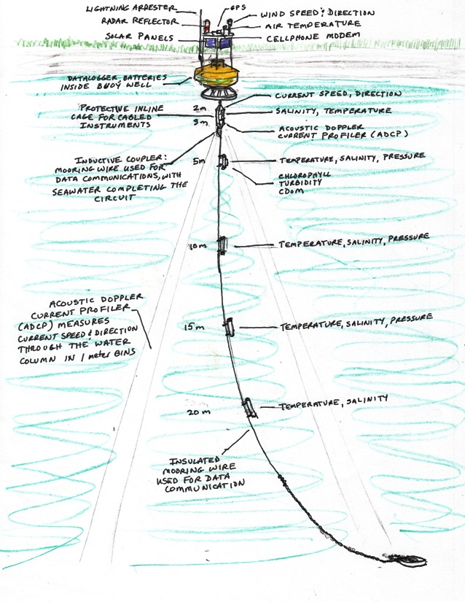 | “Ocean” Buoys  - Sensors at multiple depths: -3, 2, 5, 10, 15, and 20 meters  - Measurements taken every 20 minutes: temperature (water), salinity, pressure (at some depths)  - Measurements taken every 10 minutes: temperature (air)  Picture Source: http://gyre.umeoce.maine.edu/data/gomoos/buoy/html/E05.html
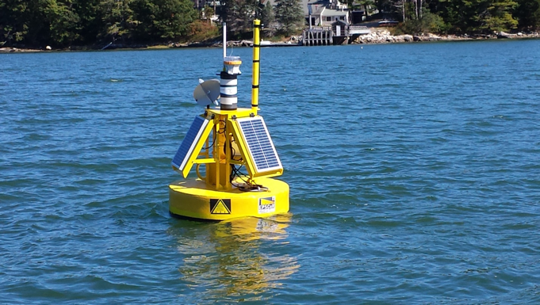 | “River” Buoys  - Sensors at only one depth: 1 meter  - Measurements taken every 1 hour: turbidity, salinity, temperature (water), pH, dissolved oxygen  Pictures Source: http://maine.loboviz.com/

TUVA LABS:
Tuva website: https://tuvalabs.com

(All data points are daily averages, as the raw data makes the website lag)
- Damariscotta Bay (2 river buoys, 1 ocean buoy): https://tuvalabs.com/renzibeth/datasets/10ecf99b43e54609a4797e6490559a34/
- Saco Bay (1 river buoy, 1 ocean buoy): https://tuvalabs.com/renzibeth/datasets/521994ddcab94910b8d66cf3bfda005b/
- Bagaduce River, Casco Bay, and Wood Island Harbor (4 river buoys): https://tuvalabs.com/renzibeth/datasets/79f265e4817d4f269827e5d1790eae27/

Units
A brief summary of the units you may find is included below.

Transparency and Turbidity Units
- Transparency: m = meters = depth of Secchi disc. Can also be in feet (ft).
- Turbidity: NTU = Nephelometric Turbidity Units = light reflected back to sensor by particles floating in the sample. Higher value = more turbid.

Salinity Units
- ppt = (the funky % sign) = parts per thousand = particles of salt per every 1000 particles
- psu = practical salinity units = grams salt per kilograms liquid
  - Note: Tuva uses “PSU”, which is the same thing
- 1 ppt = 1 psu

Temperature
- ℃ = degrees Celsius = the metric unit
- ℉ = degrees Fahrenheit = the English unit
- K = Kelvin (not in degrees) = same degree size as Celsius, but there are no negative values

pH
- (pH is unitless!)

Dissolved Oxygen
- mg/L = mg of oxygen per liter of solution
- mL/L = mL of oxygen per liter of solution
- ppm = parts per million = particles of oxygen per 1 million particles of solution
- 1 mg/L = 1 ppm
- 1 mL/L = 1.33 mg/L = 1.33 ppm (at 20℃ and 1 atm)

