

Learning Targets:
- Understand that the proportions of trophic levels (producer, primary consumer, secondary consumer) in an ecosystem are different.
- Understand what type of species are found in each trophic level.
- Understand that each level interconnects with all trophic levels, and if a species is removed there is an effect.

Length: 50 minutes

Essential Questions:
- What are the basic levels of the trophic web?
- What Maine species are found in each level?
- Can species be removed from an ecosystem without detrimental effects?

Enduring Understandings:
- Trophic levels are levels of a food web, which is sometimes referred to as a trophic web. If you make your own food, your trophic level is producer.

Background for Facilitator:
Ecosystems are a complex system that includes all the living (biotic) and non-living (abiotic) parameters within a specific area. If we are looking at a Maine forest the living things might include: Gray Squirrels, Fishers, Great Horned Owls, Red Maples, and Carpenter Ants. The non-living parameters could include the type of sediment in the area, the water source (i.e. lake, river, stream), and the type of weather the area experiences.

Within every ecosystem there are trophic levels, and this refers to how living organisms get their food. Plants and algae are on the first trophic level because they make their own food (i.e. photosynthesis). They are called producers. The next level, primary consumers, includes species that eat producers (i.e. herbivore). The third level are secondary consumers, and the species found here eat primary consumers and sometimes producers (i.e. carnivore or omnivore).

Vocabulary List:
Community: all the populations of different species that live and interact in a specific area.
Ecosystem: the interaction between the living (biotic) and nonliving (abiotic) things in a specific area. Examples of biotic factors include birds, insects, and mammals. Examples of abiotic factors include weather, sediment, and water.
Population: includes all the individuals of the same species living in a specific area.
Primary consumer: a species that eats primary producers (plants or algae). They are typically herbivores.
Producer: a species that makes its own food (plants or algae). This is typically done through photosynthesis.
Secondary consumer: a species that eats primary consumers and/or producers. They can be carnivores or omnivores.
Trophic level: the level a species occupies in the food web (i.e. or trophic web).

Materials:
- Trophic Tumble Jenga game
- Game Spinner
- Trophic Tumble Cards (12 cards per game)
- Trophic Tumble Data Sheet (Round 1 & Round 2 per group)
- Trophic Tumble Bar Graph (Round 1 & Round 2 per group)
- Photos of different organisms (6 producers, 6 primary consumers, 6 secondary consumers)

Methods:
Engage
- Discuss with students what an ecosystem is: a complex system that includes all the living (biotic) and non-living (abiotic) parameters within a specific area. Maine has a number of different types of ecosystems: forests, estuaries, open upland, peatlands, tidal, aquatic, and more. Have the students brainstorm what would be considered a living and non-living parameter. Make a class ecosystem drawing based on what you discussed and see if they can figure out where the laminated photos would go in the ecosystem. You can tape them onto the drawing, or place them on the drawing if it’s on a table.
  - As you discuss where organisms are placed, this is a good time to discuss the difference between the different trophic levels: producer, primary consumer, and secondary consumer.
- In today’s game, students will get a chance to see what happens when organisms are displaced in an ecosystem. The stacking game will consist of producers (dark brown), primary consumers (white), and secondary consumers (tan). The proportion of each trophic level varies to show that in a healthy system, the number and variety of species found at each level is not balanced.
  - There are 33 producers, 16 primary consumers, and 5 secondary consumers.
- Students should be placed in groups of 6 or less. Each team gets a Trophic Tumble game box, spinner, a set of Trophic Tumble cards (12), 2 data sheets (for 2 rounds), 2 bar graph worksheets.
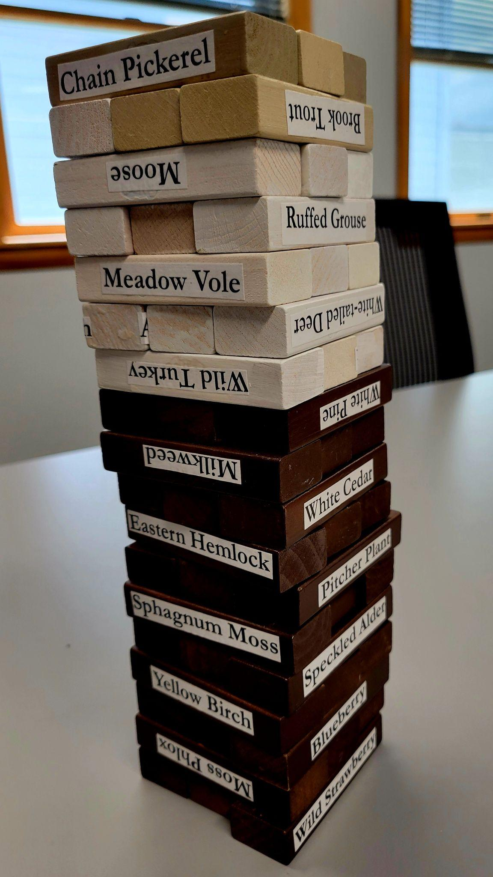
- Round 1: To set up the game, have the students stack their blocks in a 3 x 3 matrix with producers on the bottom, primary consumers in the middle, and secondary consumers on the top. When the game starts, a student will spin the spinner and follow the instructions on where the arrow lands. If the spinner lands on a solid color, they will remove a block of the same color from the tower. If the spinner lands on blue (Trophic Card), they will pick a card and follow the instructions.
  - Students are only allowed to use one hand when adding or removing blocks from the tower.
- As students play the game, their group should record what species is added (+) or subtracted (-) on their data sheet.

Explore
- When their ecosystem collapses, this is a good time to discuss what they think happened:
  - What factors in the game contributed to the trophic levels falling over?
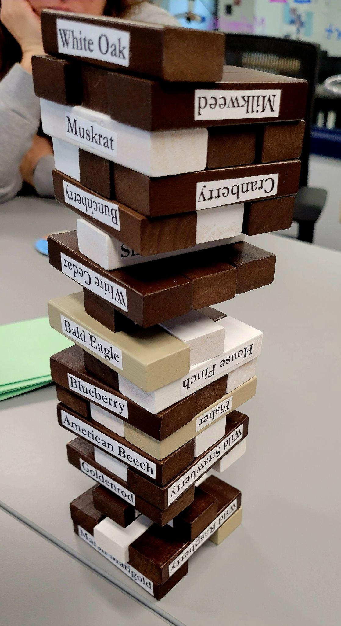
  - When too many species are pulled from an ecosystem, the trophic levels become unbalanced and the system experiences a crash (i.e. collapse).
- Round 2: Have the students mix the different trophic level colors and build their 3x3 matrix. They will then play the game as they did Round 1 and see if they have different results.

Evaluate
- After the data has been collected from each round, the group (or every student) will put their data on the bar graph handout. *Example data sheets and graphs are provided at the end of the lesson.
- Discuss with the group what they found. This might be a good time to discuss what the different Trophic Cards mean.
  - Why are resources removed versus replaced?
  - Why is the amount significant?

In complying with the letter and spirit of applicable laws and pursuing its own goals of diversity, the University of Maine System does not discriminate on the grounds of race, color, religion, sex, sexual orientation, transgender status, gender, gender identity or expression, ethnicity, national origin, citizenship status, familial status, ancestry, age, disability physical or mental, genetic information, or veterans or military status in employment, education, and all other programs and activities. The University provides reasonable accommodations to qualified individuals with disabilities upon request. The following person has been designated to handle inquiries regarding non-discrimination policies: Director of Equal Opportunity and Title IX Services, 5713 Chadbourne Hall, Room 412, University of Maine, Orono, ME 04469-5713, 207.581.1226, TTY 711 (Maine Relay System).

