

Activity 1:

Build a Vernal Pool

Target Grade: Kindergarten - 8th (Extension Ideas for high

school at the bottom of the lesson)

Learning Targets:
- Where do vernal pools form?
- Name 2 things you would find in a vernal pool to make it successful for amphibians to breed in.
- Identify environmental stressors that affect vernal pools.
- Practice collecting data for a vernal pool.

Length: 30-40 minutes

Essential Questions:
- What is a vernal pool, and where do they form?
- Why are vernal pools important to amphibians?
- Does it matter where you deposit your eggs in a vernal pool?

Enduring Understandings:
- Vernal pools are temporary habitats that form in the spring and dry up in the middle of the summer.
- To have a successful vernal pool, it needs to be in a forested area that shades the majority of the water (to prevent fast evaporation) and has a lot of leaf litter and wood debris.
- Species that breed in vernal pools need to have offspring that develop quickly before the pool dries up.
- Physical stressors that affect the survival of amphibian eggs and larvae in a vernal pool include drought, heavy rain, terrestrial predation, and human impacts (development and interaction).

Background for Facilitator:
Vernal pools are important breeding grounds for amphibians, insects, spiders, and crustaceans. They are unique because, unlike other bodies of water that are present year-round, they lack fish and predaceous frogs. This lack of aquatic predators increases the chance that eggs deposited in a vernal pool will successfully develop into adults. While aquatic predators are low, there are terrestrial (land-based) predators that visit vernal pools. This ecosystem is a great feeding spot for species like turtles, snakes, raccoons, and birds.

Vernal pools are created in small, shallow depressions in the earth. The depressions could have been created by glaciers long ago, sinkholes, or natural depressions that groundwater carved out in hard clay or bedrock. Pools of water found in man-made structures (i.e., road ditches or agricultural fields) are not true vernal pools. Successful vernal pools are typically found in forested areas that shade over 60% of the water. The shade is critical because it helps decrease the rate at which water evaporates from the pool. Forested vernal pools also have large amounts of leaf litter and woody debris, which create important shelter and food sources for the organisms living there.

Vocabulary List:
Vernal pools - seasonal bodies of water that appear in the spring and summer due to melting snow and rainfall; serve as breeding grounds for several species of amphibians and invertebrates.
Terrestrial - referring to species that live on land (not water).
Ecosystem - a community of living organisms (plants, organisms, and microbes) that interact with each other and the non-living environment.
Brumation - a state of inactivity for reptiles and amphibians during winter or extended periods of low temperatures; metabolism and respiratory rates slow.
Hibernation - a state of inactivity for mammals during winter or extended periods of low temperatures; metabolism and respiratory rates slow.

Materials:
The Secret Pool by Kimberley Ridley (a story to visually introduce the topic to younger grades)
Frisbees (10)
Aluminum foil
Plastic jumping frogs (25)
Chia seeds
Pop-up sponges (10)
Pitcher of water
Laminated Vernal Pool Survival Game rules and data sheets (10)
Dice
Washable markers

Items not in the toolkit that you will need:
Rocks of varying sizes (if you are not able to find any you can use items you find indoors that can get wet: marbles, dice, small balls, etc.)
Nature: sticks, leaves, etc. (to build their ecosystem)

Methods:

Engage
- Depending on students’ prior knowledge, you can have the group draw a vernal pool and include all the pieces they think are relevant to it being a success, OR you can have a discussion/brainstorm on what a vernal pool is.
  - You could read The Secret Pool to your group first before starting the lesson to introduce the topic if working with younger grades (i.e. K - 3rd grade).
- Explain that a vernal pool is a temporary body of water that many different creatures utilize for their survival and growth. Explain that they are going to create a model of a vernal pool to explore how they are created and which types of animals utilize them.

Explore
- Split your students into groups of 2 or 3 and provide them with a Frisbee.
  - This is going to be their forest ecosystem.
- Explain that a vernal pool develops in a depression in the landscape. In order to make a depression in their forest landscape, youth will need to collect some rocks.
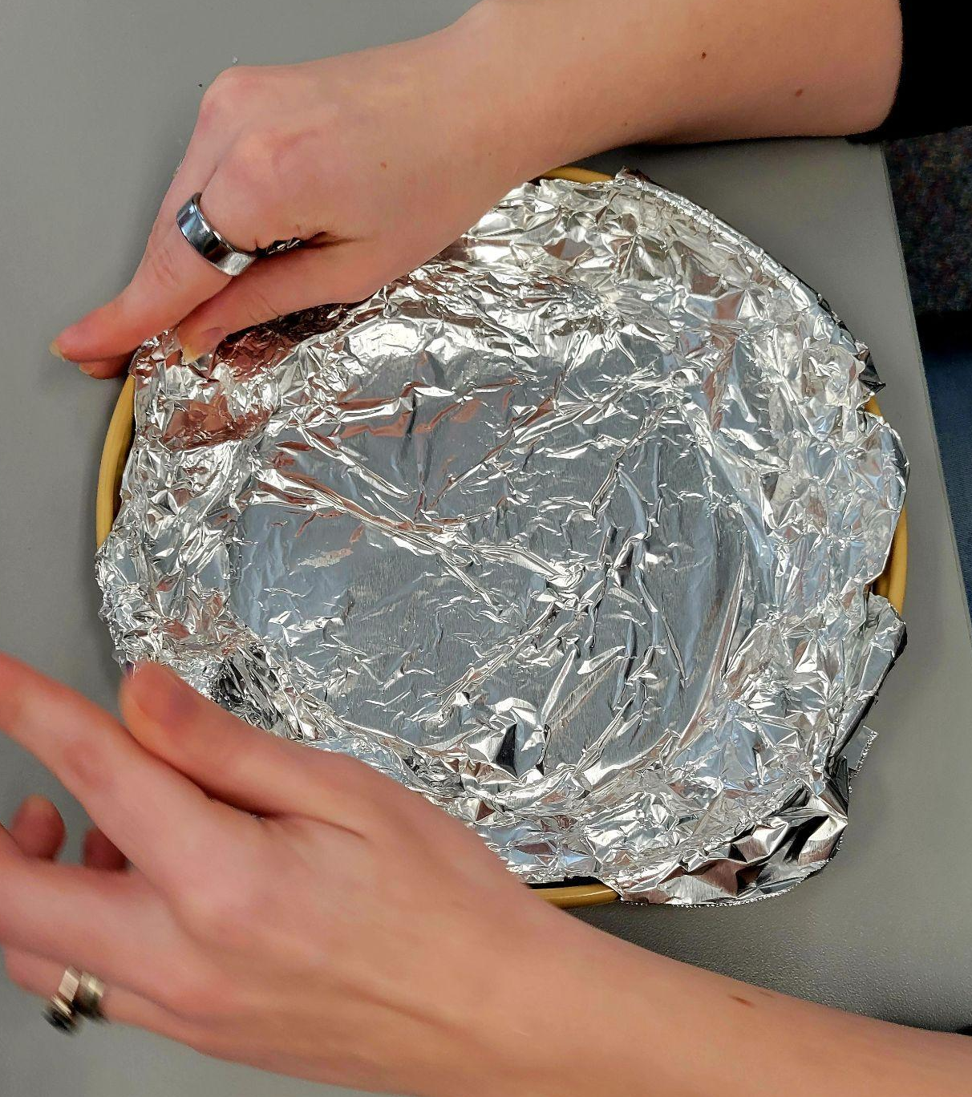
  - If students are collecting their own rocks, make sure to specify the size they need (nothing bigger than a golf ball size) and set the boundaries for their search.
  - Have youth organize their rocks in a circle inside their Frisbee in whatever design they like.
- Give each group a piece of aluminum foil to put over their rocks.
  - This creates the depression in the landscape.
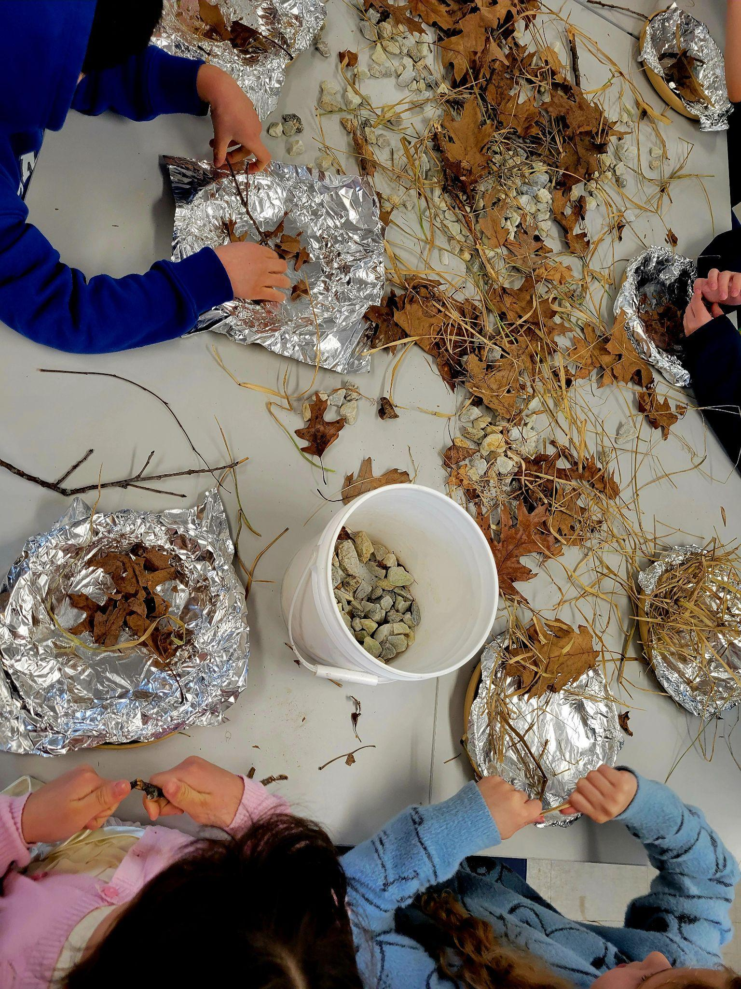
- Now, students can brainstorm about natural items that would be found in a vernal pool in the forest: sticks, mud, leaves, grass, etc. Using items that were collected outside, they can add the nature items they think are important to their tin foil depression.
- Explain that in the winter months, when it snows, these depressions in the landscape fill with snow.
  - If you have ice, you can allow youth to grab a handful and put it in their vernal pool, but it will take awhile to melt!
  - What do you think frogs and salamanders are doing at this time of year?
    - In the winter, frogs and salamanders go into their winter brumation. Brumation is a state of inactivity for reptiles and amphibians during winter or extended periods of low temperatures. It is the equivalent of hibernation (which mammals do). They dig a burrow and find a safe place for the cold months, allowing their metabolism and respiratory rates to slow. They store urine and sugars in their blood, which act as antifreeze, preventing their body from fully freezing!
- What happens in March and April when the average temperature starts to get warmer?
  - Snow and ice start to melt.
  - Have your students pour water into their vernal pool to simulate ice melt. If your group cannot handle pouring the water, do it yourself.
  - What do you think happens to these brumating animals when the temperatures start to warm?
    - They come out of their brumation and start to make their way to vernal pools to breed.
- At this point, hand out a plastic jumping frog to each student. Explain that these represent the frogs and salamanders that are making their way to vernal pools after brumation.
  - Youth can “jump or walk” their creatures to the vernal pools or simply drop them in!
  - You can also set the challenge of having students start a distance away from their vernal pool and hop their frog the whole way into the pool. This starts the discussion of barriers amphibians face when trying to make it to a pool. It’s not as easy as it looks!
- When frogs are in their vernal pool, ask students to predict what happens next.
  - They reproduce or breed!
- Provide each group with a pinch of chia seeds. Can youth explain what these represent?
  - Eggs!
- Students can decide how to “disperse” their eggs in their vernal pool. You can discuss the advantages of clumping them versus spreading them out. Within a few minutes, the chia seeds will change. Ask students what they notice.
  - The chia seeds will soak up water, allowing them to grow. This is a great representation of how the eggs grow and stick to items.
  - Tell the students to touch their “eggs,” what happens? Why is being sticky an important adaptation?
- Once the vernal pool models are complete, the Vernal Pool Chance Game starts. Everyone gets a laminated data sheet and records the starting phase of their vernal pool. The instructor rolls the dice, and each group follows the instructions according to the number rolled. The data sheet should be filled out by the group after each round.
  - Warning: make sure to thoroughly clean the sponge after the game because plants will start sprouting on it!

Evaluate
- Have a discussion with all the groups on how successful their vernal pool was after the different stressors from the survival game.
  - Did they have any eggs that survived the last round? If so, what helped the eggs survive? Eggs that are hidden really well under debris stand a great chance of surviving. Exposed eggs, not so much!
- This is a good time for groups to look at the other vernal pool designs.
  - How do size, shape, and depth affect the survival rates of amphibians breeding in the various designs?
  - Which model was the most successful?

Extension Ideas:
- Middle/ high school extension: Turn the model vernal pool into an experiment to help students prepare for going out into the field to collect data. Students can:
  - Practice mapping their pool and measuring depth at different intervals.
  - Research threats to vernal pools and simulate those threats with their model: heat/drought (heat lamp), extreme rain (flood of water), land-use (shrinking the size of their model), pollution runoff (colored water), invasive species, loss of habitat, etc. They can observe what happens to amphibian eggs during these stressors.
- Youth can have a jumping contest with their plastic frogs to see who can go the furthest. Set out the measuring tape, and students can then plot distances.
- Frogsicles: Frozen But Still Alive video by Smithsonian Channel
- Expand everyone’s knowledge by learning about Maine Big Night.
- Of Pools and People: this website contains vernal pool information and research for the Northeast and Midwest regions of the U.S.
- Gulf of Maine Research Institute: this link is the learning resource hub for vernal pool related information in the state of Maine.

