

Activity 2:

Maine Amphibian

Target Grade: 5th-12th (Extension Ideas for younger grades at

the bottom of the lesson)

Learning Targets:
- Know the names of a frog and a salamander found in Maine.
- Practice looking at physical features to identify amphibians they might find in the field.
- Identify a frog based on its call.

Length: 15-30 minutes

Essential Questions:
- What is an amphibian, and what species are found in Maine?
- Can we find all Maine amphibians in the same habitats?
- Do frogs all sound the same?

Enduring Understandings:
- Amphibians are cold-blooded vertebrates (animals with a backbone) that do not have scales. They spend part of their life cycle in the water and part of their life cycle on land.
- Frogs can be identified by their call. Typically, it’s the male call we hear at night, which is used to attract a mate.
- We find Maine amphibians in a variety of habitats, including forests, fields, freshwater habitats (lakes, ponds, streams, rivers, vernal pools), etc.
- Some amphibians spend the majority of their life in water, while others only go to water to breed.
- In the winter, amphibians brumate in burrows. They fill their blood with urine and glucose, which acts as an antifreeze, so their bodies do not freeze solid when it gets cold.

Background for Facilitator:
Amphibians are unique animals that are cold-blooded, have a backbone, do not have scales, and usually produce a wet, slimy coating on their skin. The name comes from a Greek word, amphíbios, meaning “double-life.” Amphibians typically need water to reproduce because their permeable eggs require it for embryo development. When amphibian eggs hatch, the larvae have gills, which later develop into lungs, or the gills disappear when they become land-based.

Frogs are well known for the sounds they make. This can range from a croak, a ribbit, a chirp, or a hoot. In most frog species, the male makes the loudest call, which is the one we usually hear all night long (most frogs are nocturnal)! The call is an important method of attracting females to mate. Females usually respond with low grunts or croaks.

In Maine, we have 18 different species of amphibians, ranging from frogs, toads, and salamanders. There is a non-native species, the mudpuppy, found in a few locations in central Maine (this lesson does not cover the mudpuppy).

Vocabulary List:
Brumate - a state of inactivity for reptiles and amphibians during winter or extended periods of low temperatures; metabolism and respiratory rates slow. This is the amphibian version of hibernation.
Amphibian - cold-blooded vertebrates (animals with a backbone) that do not have scales. Part of their life cycle is spent in the water, and part of their life cycle is on land.
Larvae - immature, “fish-like” stage of amphibians after hatching from an egg.
Nocturnal - active at night.

Materials:
Amphibian matching cards (4 sets of 36 cards)

Items not in the toolkit that you will need:
Computer with internet access

Methods:

Engage
- Ask your group if they’ve heard the word amphibian before and see if they can define it. See if anyone can give examples of animals that are considered amphibians.
  - If you have time, you could look at pictures of different amphibians from around the world on your computer.
- Students often get confused about the difference between reptiles and amphibians. You could also discuss those differences:
  - Reptiles are cold-blooded like amphibians, and rely on the environment to keep them warm (ectothermic). Their skin is dry, tough, and has scales or plates, which help them keep water in their body. They have lungs to breathe air, and they lay their eggs on land (or have live-births).
  - Examples of reptiles include: crocodiles, alligators, lizards, turtles, and snakes.

Explore
- For this activity, students will learn about amphibians found in Maine through a matching game. Divide the youth into 4 groups and hand them a set of cards.
- Their challenge is to match the appropriate facts to the correct amphibian image.
- When the groups finish, before going over the answers, play the frog sound clips (located at the bottom with the answers) and have students hold up the picture of the frog that they think made the sound.
  - If using a printed copy of this lesson, you can access the electronic document via the link provided: docs.google.com/document/d/1fuzGr5ql7L3RHZomM2DFgECc4XSSfGS-/edit?usp=sharing&ouid=117133253366660647036&rtpof=true&sd=true

Evaluate
- Go over the answers as a class to see how everyone did. The answers and sound clips are provided below.
- Of the species they matched, which ones rely solely on vernal pools to breed? Wood Frog, Blue-spotted Salamander, and Spotted Salamander.
- Which amphibians seem to be top predators? American Bullfrog and Green Frog.

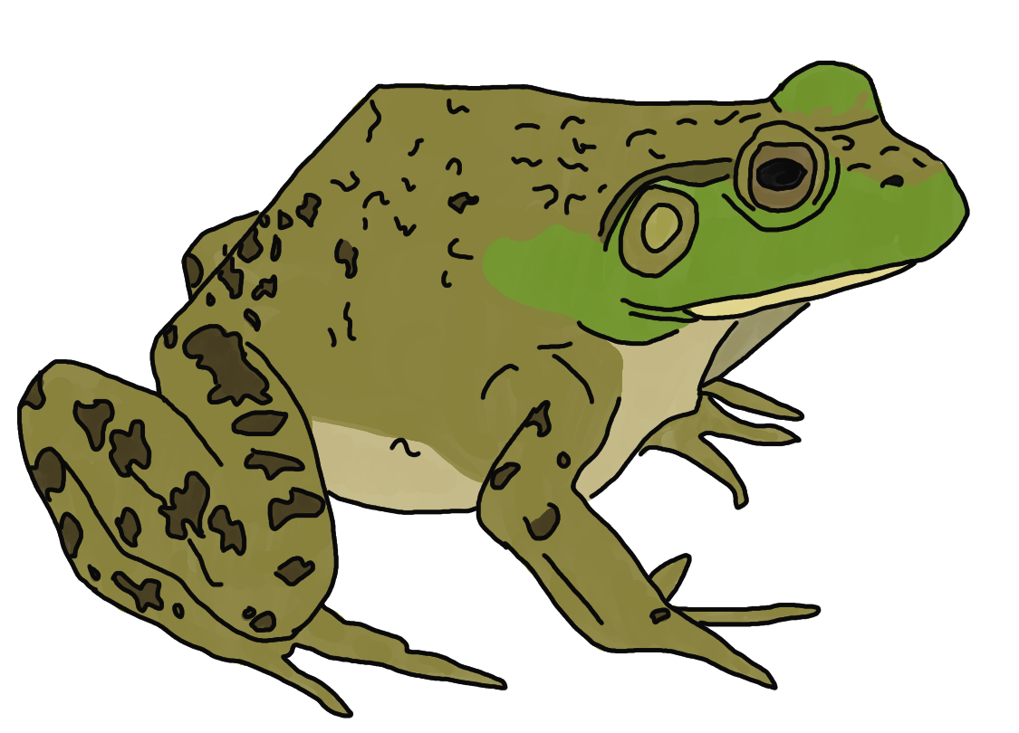
- American Bullfrog:
  - I am the largest frog in North America.
  - I will try to eat anything smaller than myself: frogs, fish, mice, turtles, ducklings.
  - I brumate in mud, underwater.
  - I have olive-green coloring with little to no ridges along my side.
  - YouTube: American Bullfrog call soundbite

- Northern Leopard Frog:
  - I am often confused with the Pickerel Frog.
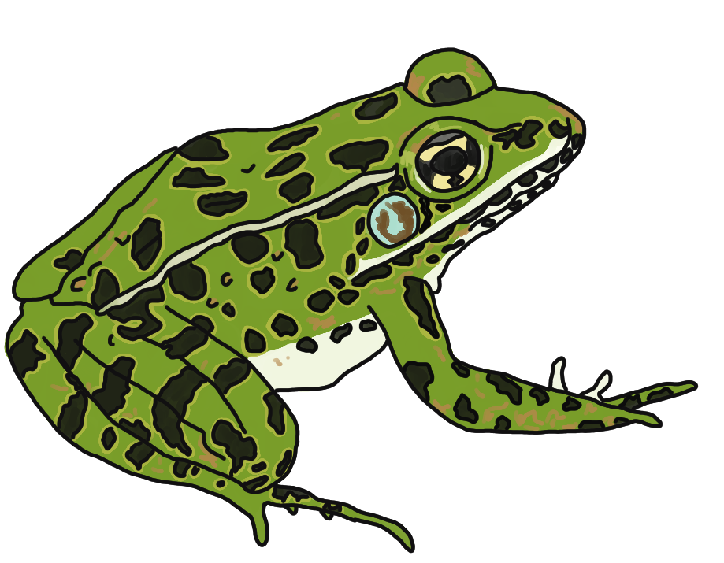
  - I have weird-shaped spots that are light around the outside.
  - I have a cream-colored ridge that runs from my eye down to my legs.
  - I brumate in the mud, underwater.
  - YouTube: Northern Leopard Frog call soundbite

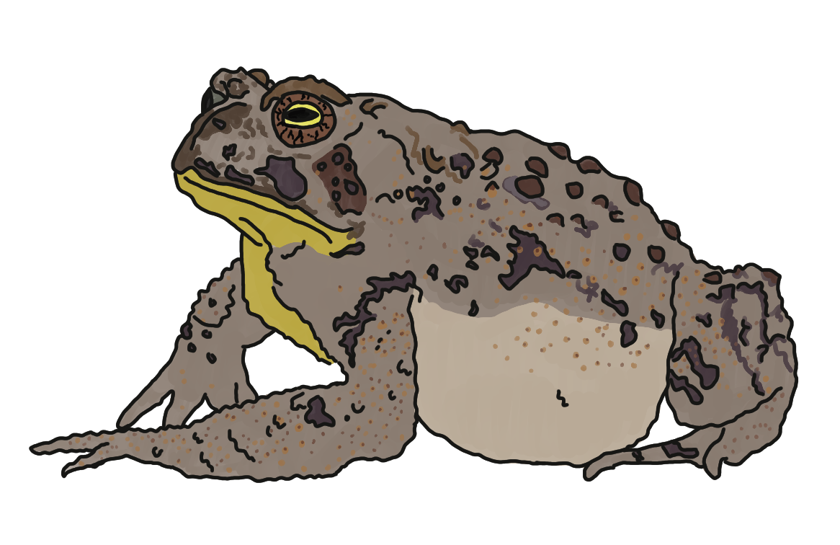
- Eastern American Toad:
  - My skin secretes a toxic liquid to keep predators from eating me.
  - I am not a frog, a salamander, or a newt.
  - My skin is rough and covered in warts.
  - I burrow in dirt when it’s hot or cold.
  - I love to eat insects.
  - YouTube: Eastern American Toad call soundbite

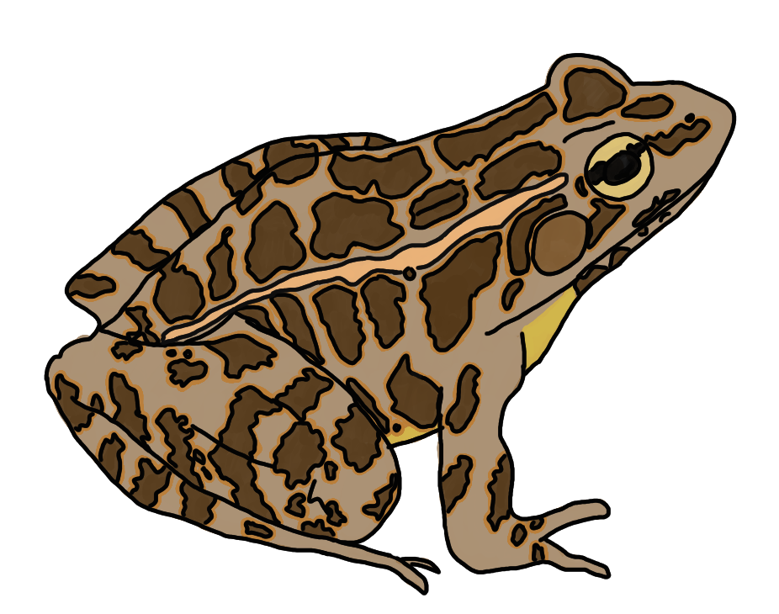
- Pickerel Frog:
  - I am a frog in your yard, eating insects I find there.
  - My belly is yellow-orange, I have brown spots, and a ridge along my side.
  - I secrete a mildly toxic liquid so I am not eaten.
  - I brumate in the mud, underwater.
  - YouTube: Pickerel Frog call soundbite
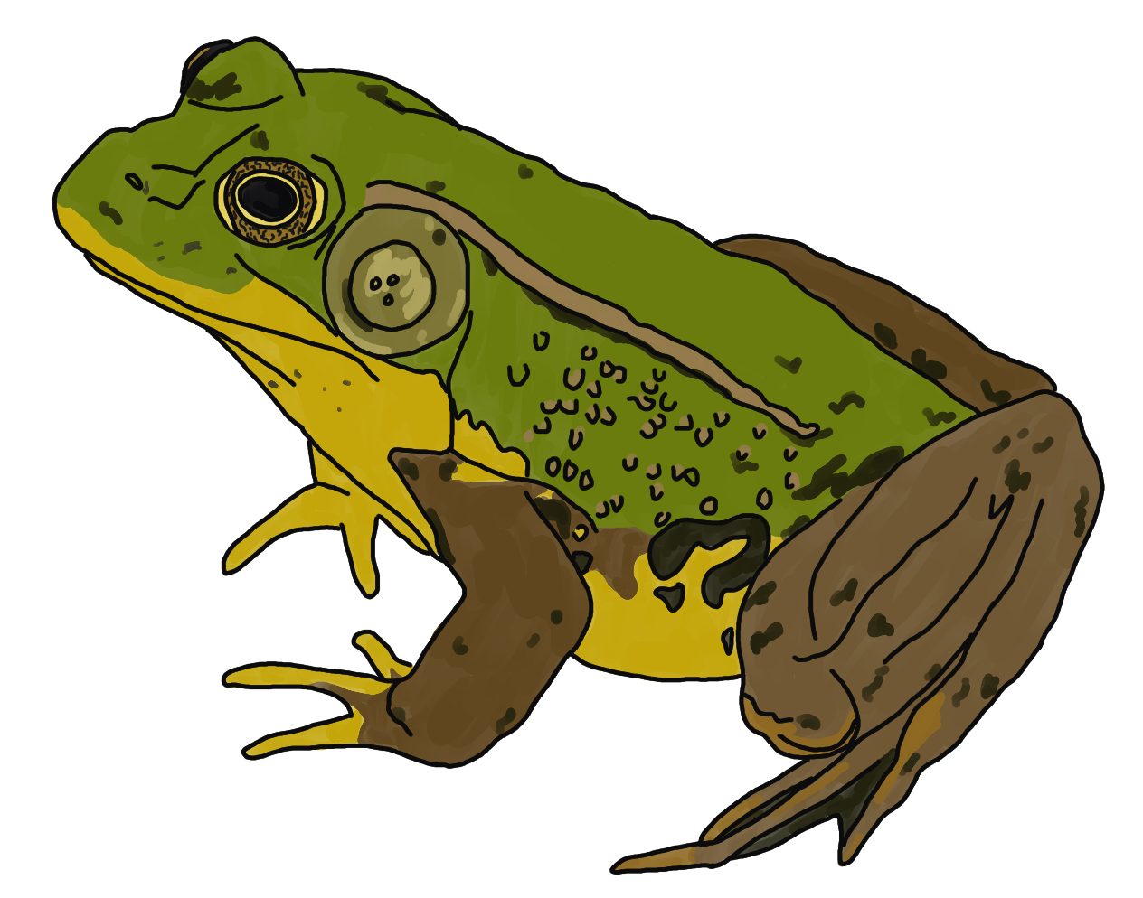
- Green Frog:
  - I have olive-green coloring with a ridge along my side.
  - I am an aggressive predator and love to eat fish, snakes, and frogs.
  - I brumate in the mud, underwater.
  - I am often confused with the American Bullfrog.
  - YouTube: Green Frog call soundbite

- Mink Frog:
  - I smell like rotten eggs, which contributes to my name.
  - I am rarely found on land.
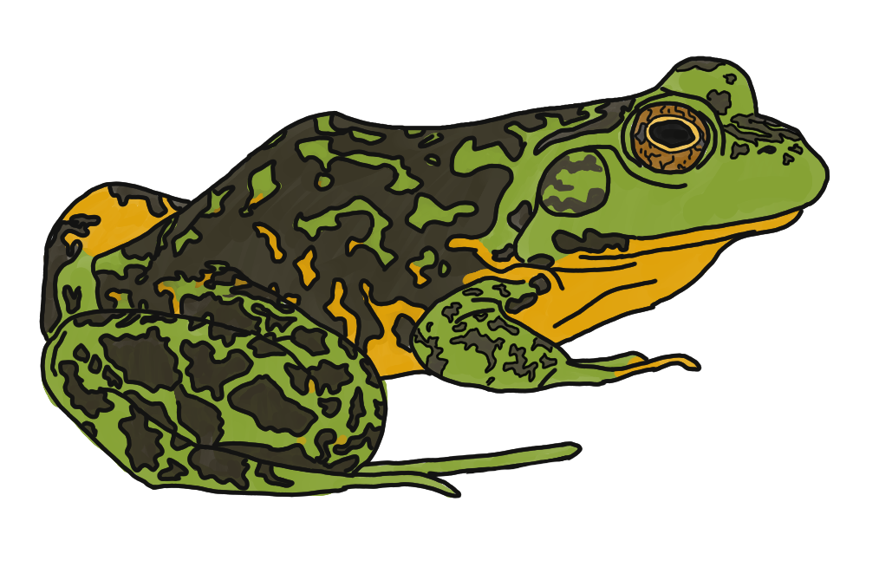
  - I am a frog with large, weirdly shaped spots all over.
  - I brumate in the mud, underwater.
  - I prefer to live in cold water.
  - YouTube: Mink Frog call soundbite

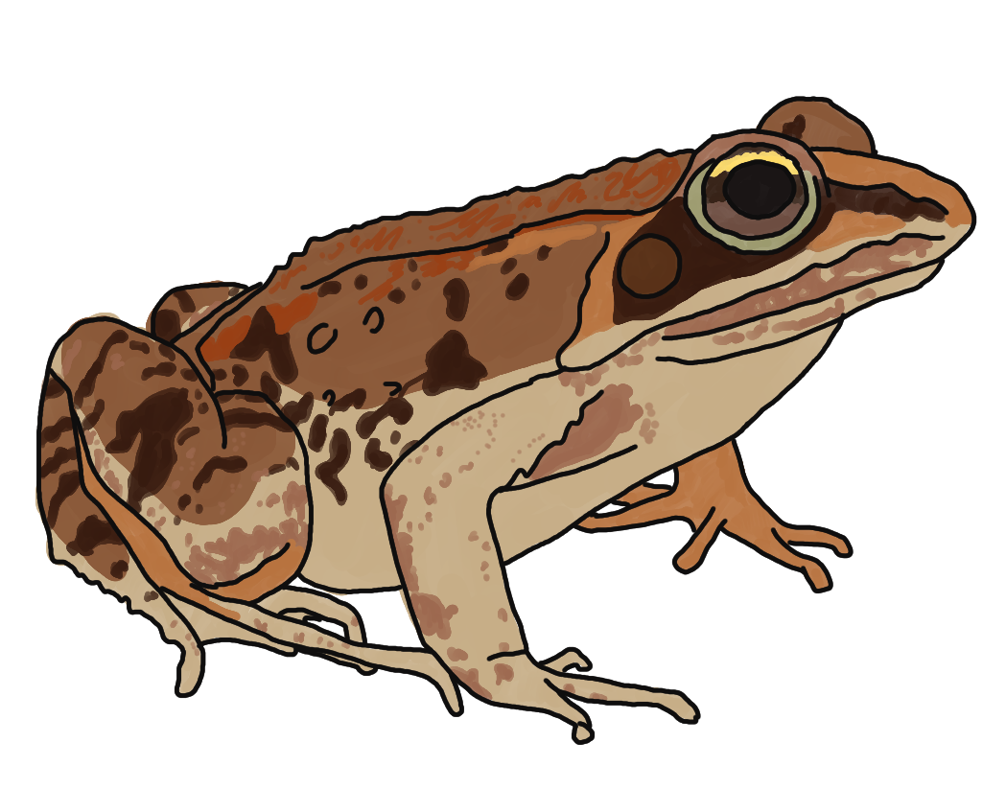
- Wood Frog:
  - The only time I am near water is when I am breeding in vernal pools.
  - I brumate on land.
  - I am the only frog found north of the Arctic Circle.
  - I have dark colors around my eyes that look like a “mask.”
  - YouTube: call soundbite

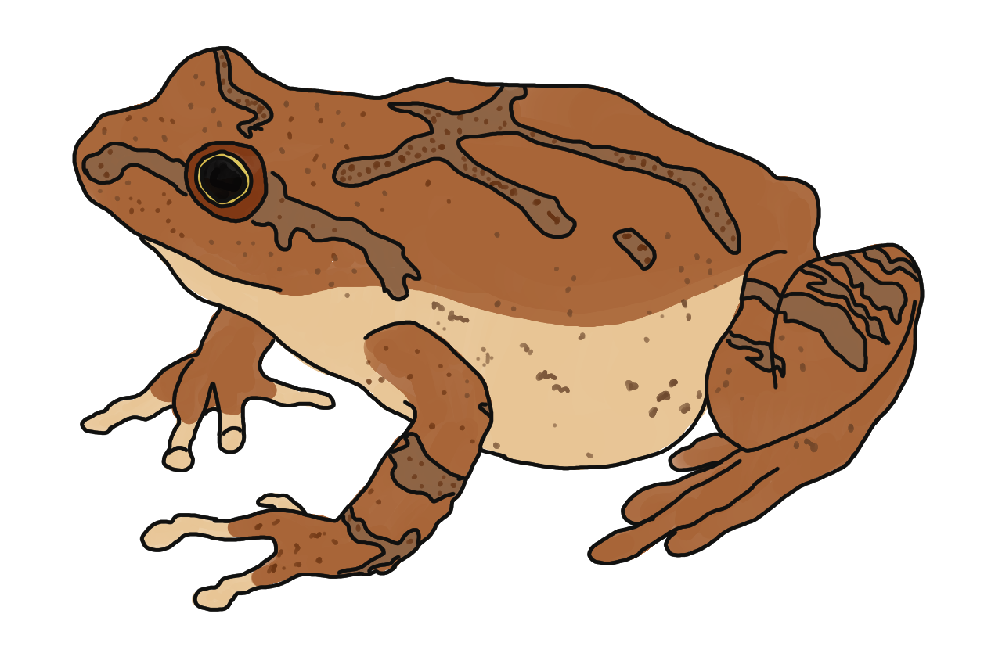
- Spring Peeper:
  - I am the smallest frog in Maine.
  - I am often found on trees and shrubs.
  - My skin is smooth and brown with lines.
  - I can change colors to match my surroundings.
  - I brumate on land.
  - I am known for my sound!
  - YouTube: call soundbite

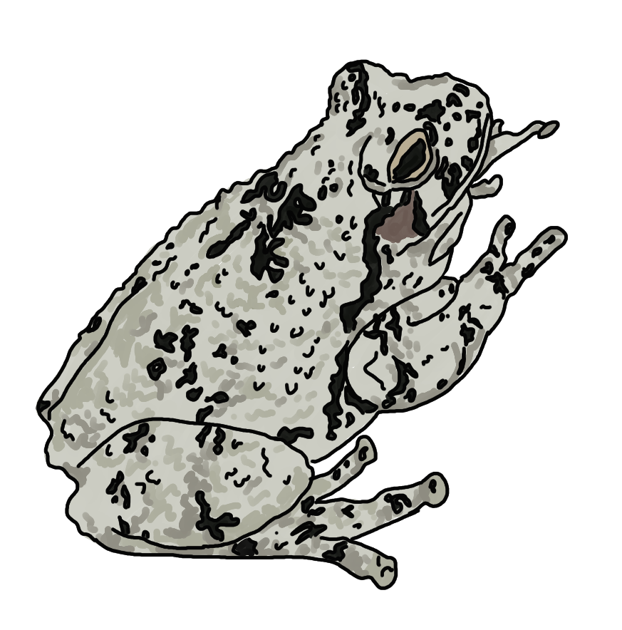
- Gray Treefrog:
  - I am often found on trees and shrubs.
  - I am a frog with rough, warty skin with yellow patches under my legs.
  - I am usually gray-ish, but turn green when I breed.
  - I am great at camouflage!
  - I brumate on land.
  - YouTube: call soundbite

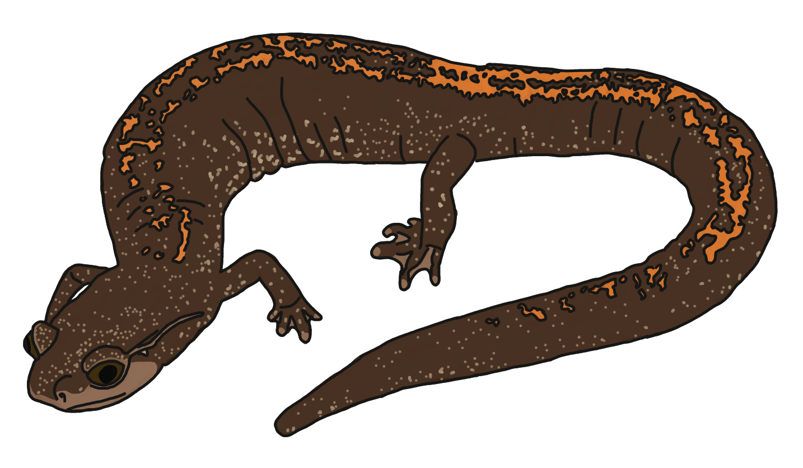
- Eastern Red-backed Salamander:
  - I am the most abundant amphibian in Maine.
  - I like to eat ticks, worms, and other insects.
  - I lay my eggs in decaying wood.
  - I have distinctive red markings on my back.
  - I do not have lungs! I breathe through my skin.

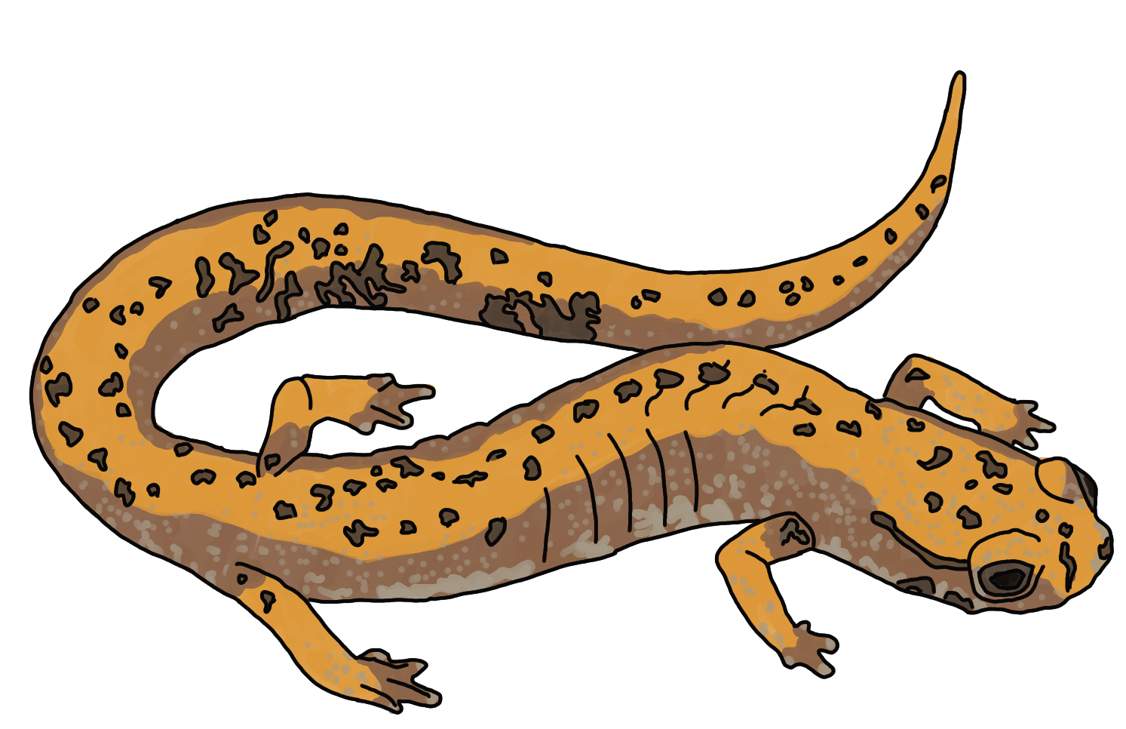
- Four-toed Salamander:
  - My back feet have fewer toes than other salamanders.
  - I am the smallest land-based vertebrate in Maine.
  - I do not have lungs! I breathe through my skin.
  - You can find me under moss or rotting logs.
  - I brumate on land in burrows.
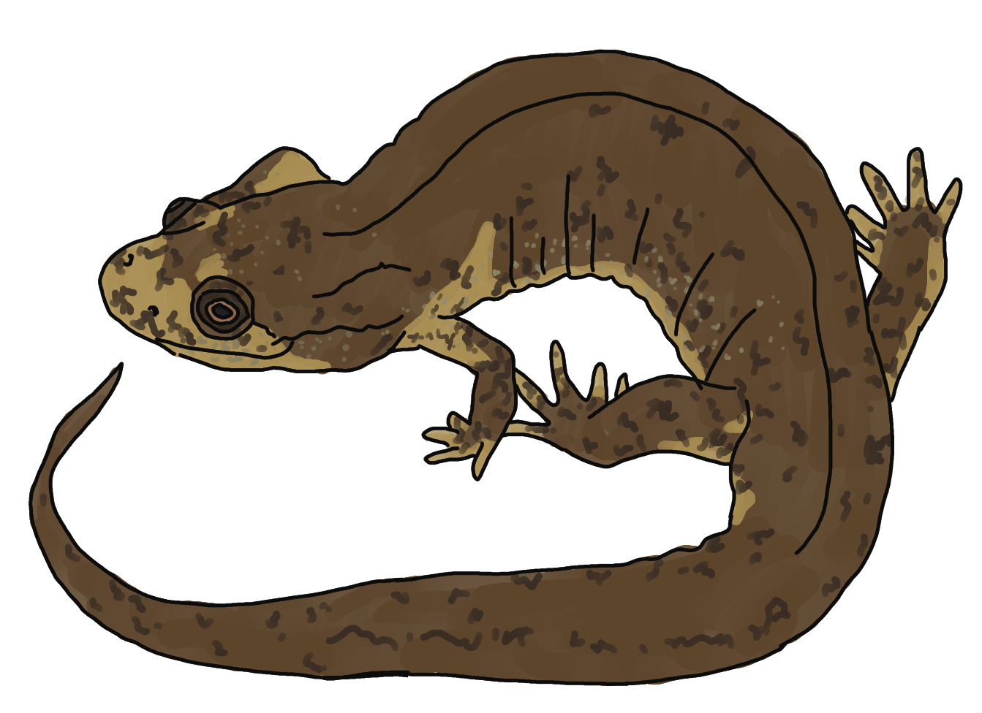
- Northern Dusky Salamander:
  - My back legs are thicker than my front.
  - My skin is usually brown with white spots along the sides.
  - I do not have lungs! I breathe through my skin.
  - You often find me near or in the water.

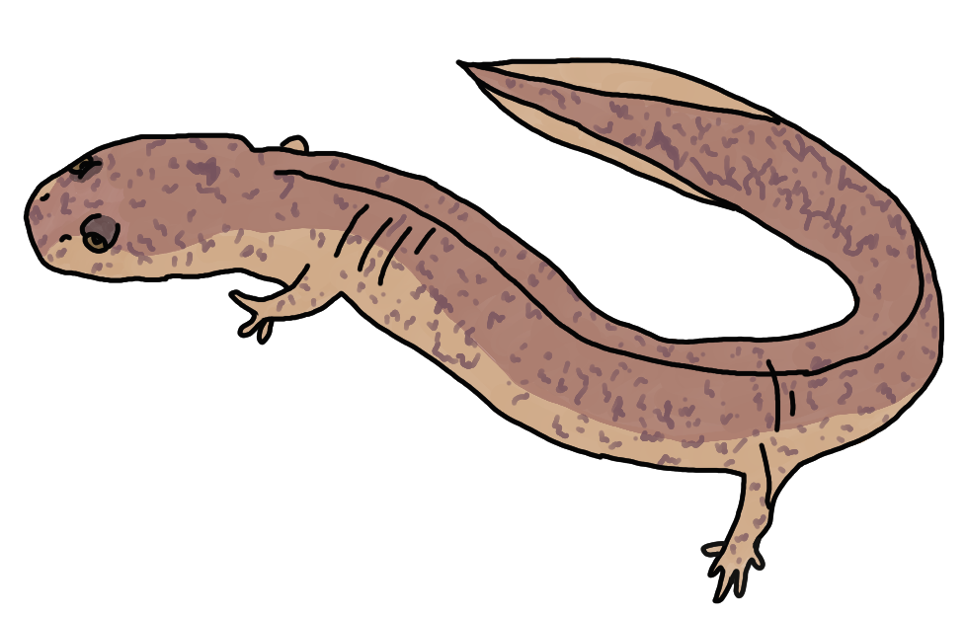
- Spring Salamander:
  - My tail is more flat than other salamanders because I swim a lot.
  - I like cold, clear moving water with gravel bottoms.
  - I do not have lungs! I breathe through my skin.
  - I am rarely found on land.
  - I brumate on land near the water.

- Northern Two-lined Salamander:
  - I have a dark stripe on both sides of my body.
  - I am rarely found on land.
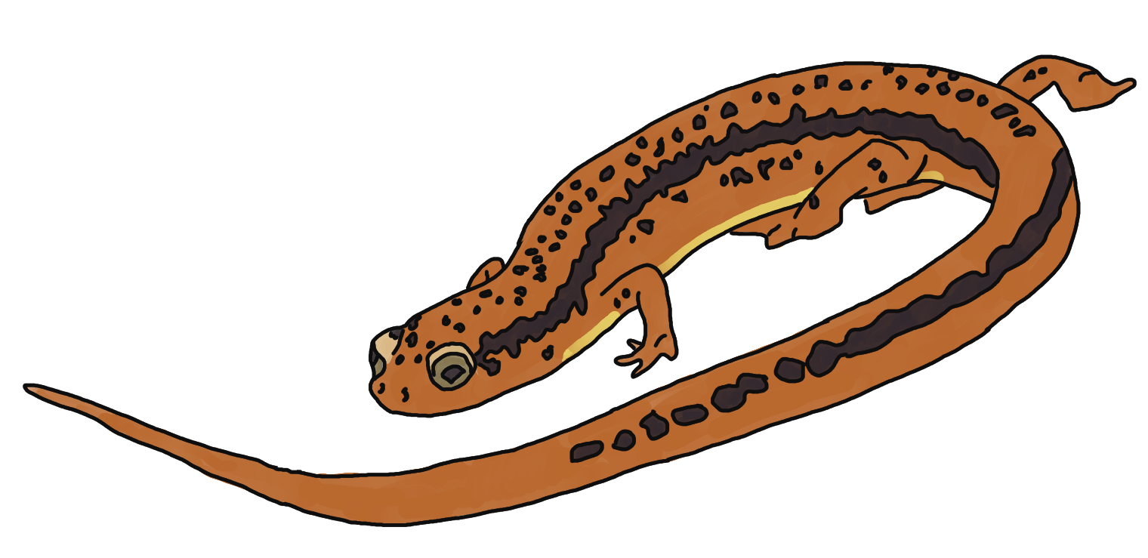
  - I prefer rocky streams and brooks.
  - I do not have lungs! I breathe through my skin.
  - I can tolerate a wide range of water temperatures and oxygen levels.

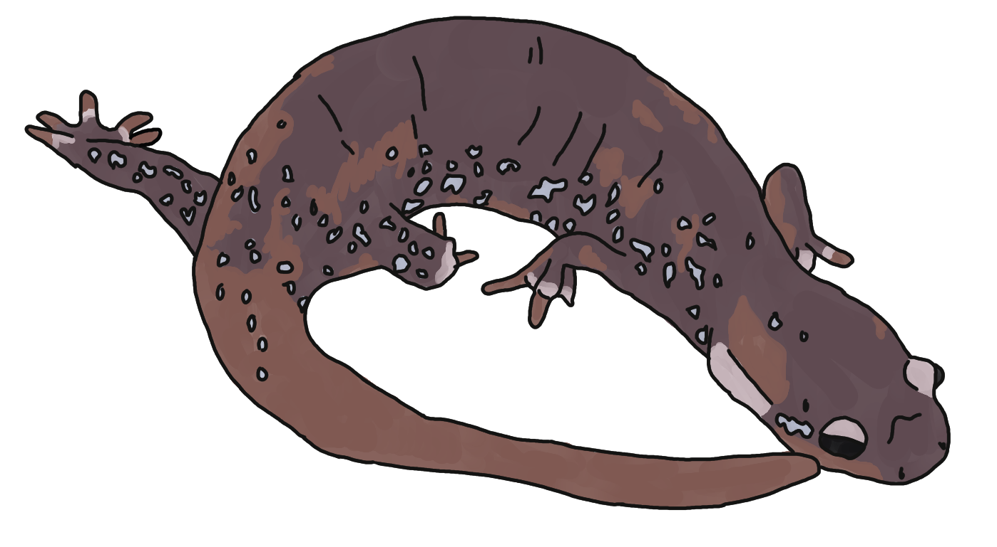
- Hybrid Blue-spotted Salamander:
  - I have gills when I am young, but develop lungs when I am an adult.
  - I brumate on land.
  - My name is misleading, because I am not a mix of two species but a unique type of clone called a “unisexual.”

- Eastern Newt:
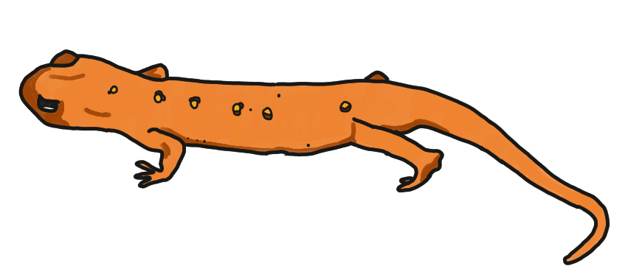
  - When I am young, I live in the forest, and when I become an adult, I live in the water.
  - I change colors depending on how old I am: when I’m young, I am red-orange with black spots, when I’m an adult, I am yellow-brown.
  - When I am an adult, I develop lungs.

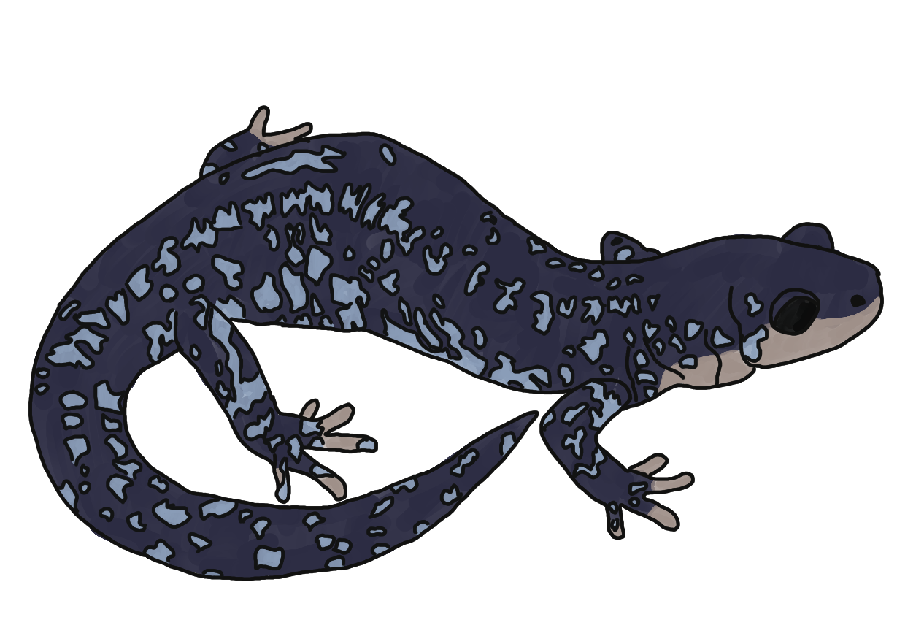
- Blue-spotted Salamander:
  - I have small, light blue spots all over my body.
  - There are many conservation efforts to save me.
  - I breed in vernal pools right after snowmelt.
  - I have gills when I am young, but develop lungs when I am an adult.
  - I brumate on land.

- Spotted Salamander:
  - My skin secretes a toxic liquid to keep predators from eating me.
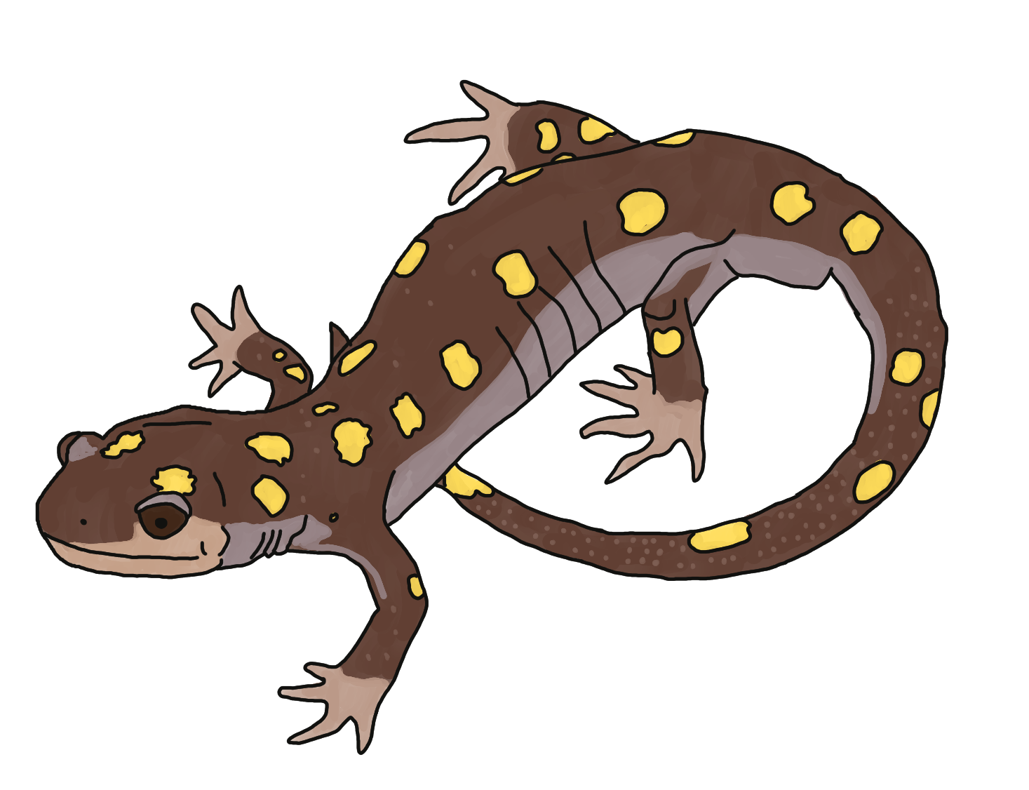
  - I have gills when I am young, but develop lungs when I am an adult.
  - I have bright yellow spots all over my body.
  - I breed in vernal pools.

Extension Ideas:
- Kindergarten - 4th Grade: 1) If your students struggle with reading, you can place them in small groups with the picture cards and read the facts out loud. Youth can discuss with their group and hold up the picture of the amphibian that they think matches the clues. 2) Have each group examine the amphibian photos and come up with their own identifying features that distinguish one species from the next.
  - Listen to the song “Frogs in the Road” by Rick Charette, who is a children’s musician/songwriter from Maine!
- Take students out into the field and record amphibian sounds, and then listen to the recording in the classroom and see if you can identify what was recorded!

