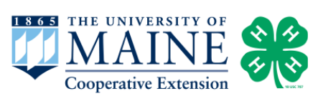

Activity 3:

Amphibian Life Cycle

Target Grade: Kindergarten - 6th (Extension Ideas for older

grades at the bottom of the lesson)

Learning Targets:
- What are the different stages an amphibian goes through during its life?
- What are important habitats that an amphibian needs to survive?

Length: 15-30 minutes

Essential Questions:
- What is a life cycle and why is it important to know for a species?
- Do salamanders and frogs have the same life stages?
- What do larval frogs and salamanders breathe with when they are in the water?
- Do all amphibians have lungs to breathe air?

Enduring Understandings:
- Amphibians are cold-blooded vertebrates (animals with a backbone) that do not have scales. They spend part of their life cycle in the water and part of their life cycle on land.
- An organism's diet changes over the course of its life cycle and this often relates to their size, the environment they live in, and their anatomy.

Background for Facilitator:
Amphibians are a unique group of animals that are ectothermic (cold-blooded). Unlike reptiles, who are also ectothermic, they do not have scales. They have special skin that needs to stay moist because it often is the organ that is used to breathe oxygen. Having access to water helps maintain their moist skin and is required for certain life stages in their life cycle.

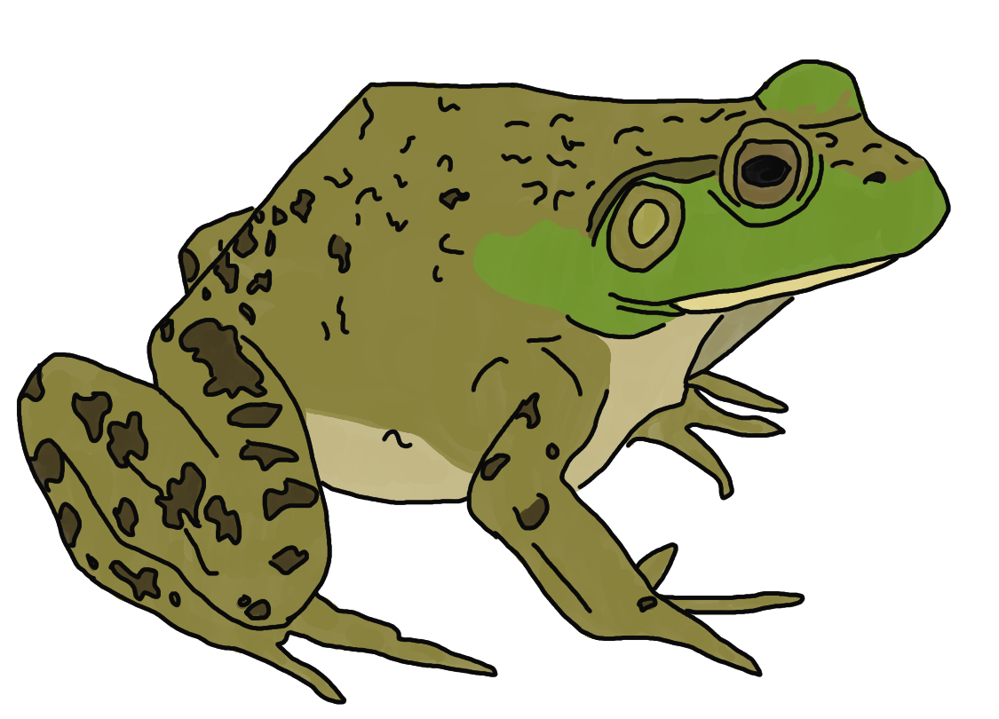
Amphibian eggs do not have shells. When the egg hatches the larval form has gills and needs to stay in the water until it reaches its adult form. In the case of the American Bullfrog, a female adult lays 12,000-20,000 eggs. When the egg hatches (in 3 to 5 days), it becomes a tadpole (larval form) and stays in that life stage for 2 winters. As the tadpole develops, limbs (i.e. arms and legs) will start to form and create a froglet. When the tail disappears the froglet is officially an adult frog and it can then leave the water. Some species of frog stick to water their whole adult life, while some stay on land and only return to water to reproduce. American Bullfrogs can live up to 8 years.

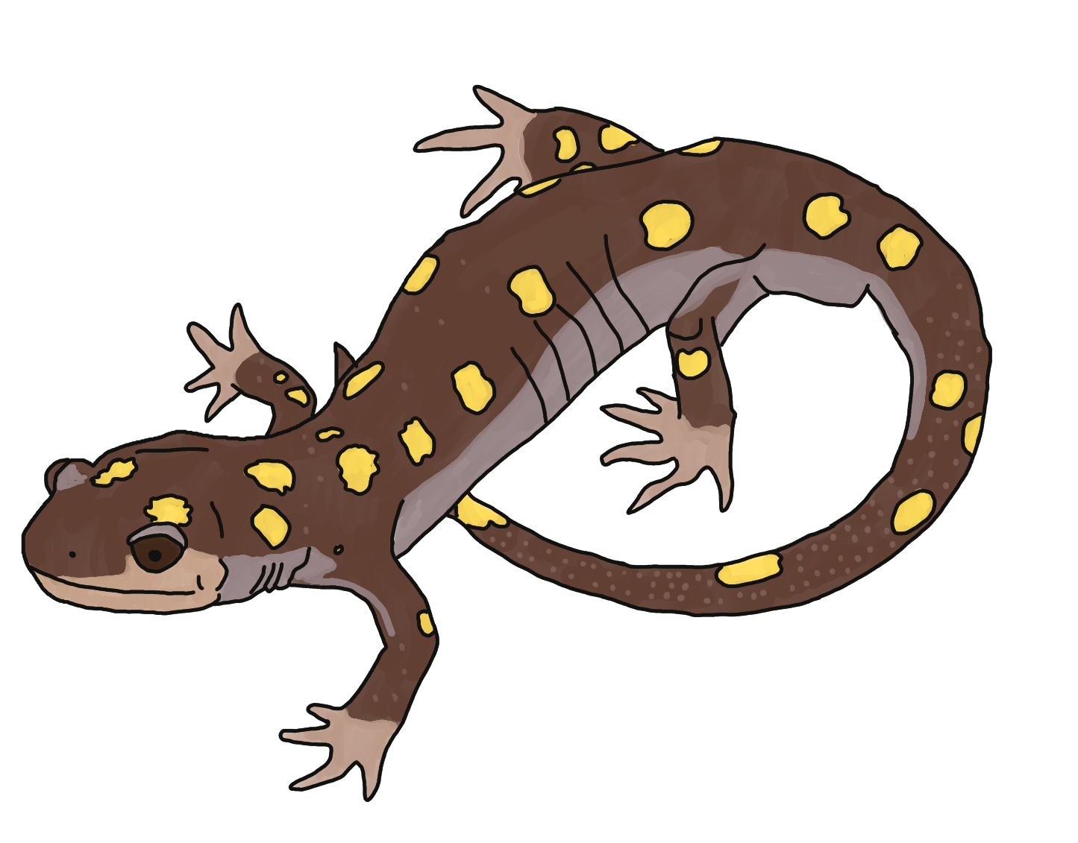
In the case of the Spotted Salamander, a female adult lays 400-600 eggs. When the eggs hatch (in 20-60 days), it has several larval stages before it becomes an adult (this can last 60 to 90 days). When the Spotted Salamander moves from water to land it develops lungs. Not all salamander species develop lungs. Those that do not rely on their skin for breathing. Spotted Salamanders can live 20-30 years.

Vocabulary List:
Anatomy - an organism’s physical structures.
Ectothermic - animals that are cold-blooded. The animal relies on the environment to keep it warm because it cannot make its own heat.
Environment - all the living and non-living things that make up a space. Examples include freshwater lakes and deciduous forests.
Froglet - a stage in a frog’s life cycle where its larval form has front legs and back legs. This stage still has a long swimming tail.
Life cycle - the developmental stages an organism goes through during the course of its life. This includes birth, important physiological developments, maturity, reproduction, etc.
Life stage - a particular phase an organism is in during their life cycle. Example life stages: egg, larvae, juvenile, adult.
Tadpole - the larval form of a frog or a toad.

Materials:
Laminated Life Cycle diagrams
Amphibian Life Cycle Coloring Sheet

Items not in the toolkit that you will need:
Coloring utensils (i.e. crayons, colored pencils, etc.)

Methods:

Engage
- What is a life cycle? Can anyone come up with an example? Humans are a good example to explain how each phase is different. Our movements and diets are very different at each stage, and the same applies to amphibians!
  - For the older grades, put your students in small groups of 2-3 and brainstorm what the different life stages are for humans and write/draw them.
- Reveal the laminated diagram of a Human Life Cycle and go over the different stages. Discuss what the diet may look like for each stage and how movement is different:
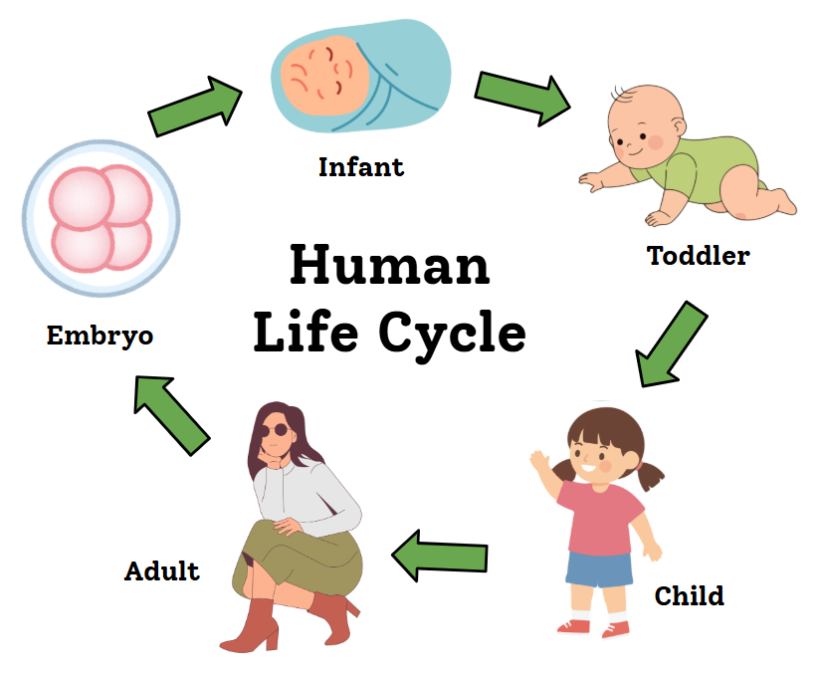
  - Does an infant eat the same thing that a child does? Why?
  - Can a toddler move like an adult? Why?
- Amphibians (specifically the frog) do not have the same life stages as humans because they live in a different environment than we do! Before revealing the Frog Life Cycle, see if your students already know the different life stages:
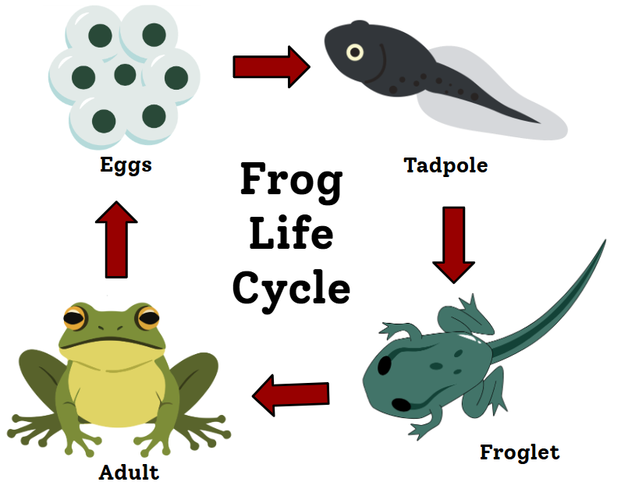
  - Which life stage of a frog is in water and which is land-based? It depends on the frog! Typically, all the stages except the adult are in the water.

Explore
- For this activity, students will be playing a Frog Life Cycle game where they will be metamorphing into the different frog life stages through a “rock, paper, scissors” challenge. With each life stage there is a certain body movement:
  - Egg: wrap your arms around your body and crouch down.
  - Tadpole: arms stay warped around your body, stand up and slowly wiggle
  - Froglet: move around with “swimming” strokes
  - Adult: Hop like a frog
- In the game of “Rock, Paper, Scissors,” when you challenge an opponent there are various ways to win: Rock beats Scissors, Paper beats Rock, and Scissors beats Paper. Everyone will start off as an egg in a vernal pool and then compete their way up to an adult frog! In order to compete you have to find someone else in the same life stage as you. If you win the “Rock, Paper, Scissors” battle, you move up a life stage. If there is a tie, you stay in the same life stage. If you lose, you go down a life stage.
  - If your students are not able to do “Rock, Paper, Scissors” you can turn the motions into a “Simon Says” game where you call out a life stage and they make the body movement.

Evaluate
- When the activity is finished, ask your students how they did? Did anyone struggle? Was it easy for some? Did anyone get frustrated? When frogs are moving through their life stages it can often be difficult as well.
- Brainstorm what stressors amphibians might face as they go through the course of their life: predators, lack of food, lack of water, competition with other amphibians, natural disturbances, etc.

Extension Ideas:
- 7th - 12th Grade: Have students choose an amphibian found in Maine and research its life cycle to create their own diagram/poster. Have them include images/drawings and details of how long the species spends in each life stage. They can include information about physiological changes that make each life stage unique. They can then report to the rest of the class about their findings.
- Hop into Action: The Amphibian Curriculum Guide for Grades K-4 by David Alexander has a lot of fun activities if you are looking for more ideas! This book is available as a pdf if you do an internet search.

