

Activity 4:

Amphibian Camouflage

Target Grade: Kindergarten - 12th grade

Learning Targets:
- Understand the purpose of camouflage and countershading.
- Identify an amphibian in Maine that produces a toxin to prevent predators from eating it.
- Understand that camouflaging correctly takes work!

Length: 20-30 minutes

Essential Questions:
- Why is camouflage important?
- Do amphibians in Maine have other means to protect themselves from predation besides camouflage?

Enduring Understandings:
- Camouflage is used by both prey and predators.
- Some amphibians in Maine can produce a toxin on their skin to avoid predation: the Eastern American Toad, Pickerel Frog, and the Spotted Salamander.

Background for Facilitator:
Camouflage (blending into your surroundings) is an important animal adaptation for a variety of reasons: it helps prey animals avoid detection by predators, and it helps a predator sneak up on its prey! Some amphibians avoid being eaten by being brightly colored, which acts as a warning sign. Bright colors, in the animal kingdom, are usually associated with poison, and some amphibians produce a toxic chemical on their skin that can kill a predator if they are ingested (i.e., the Spotted Salamander and Eastern Newt).
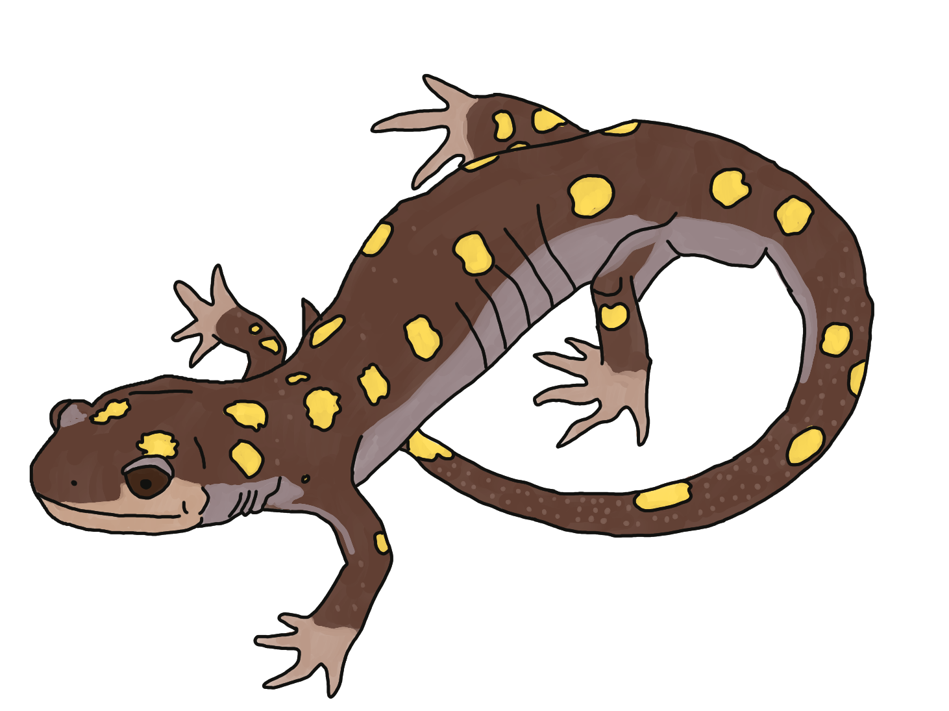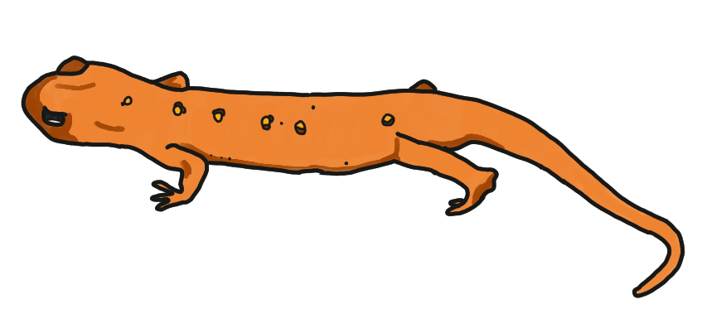
Image from left to right: Spotted Salamander and Eastern Newt.

The Eastern American Toad and the Pickerel Frog are an exception to the rule! They camouflage into their surroundings and produce a toxic chemical that will hurt a predator if they are eaten. The Mink Frog, when threatened, will produce an odor from its skin that smells like rotten onions to deter predators!
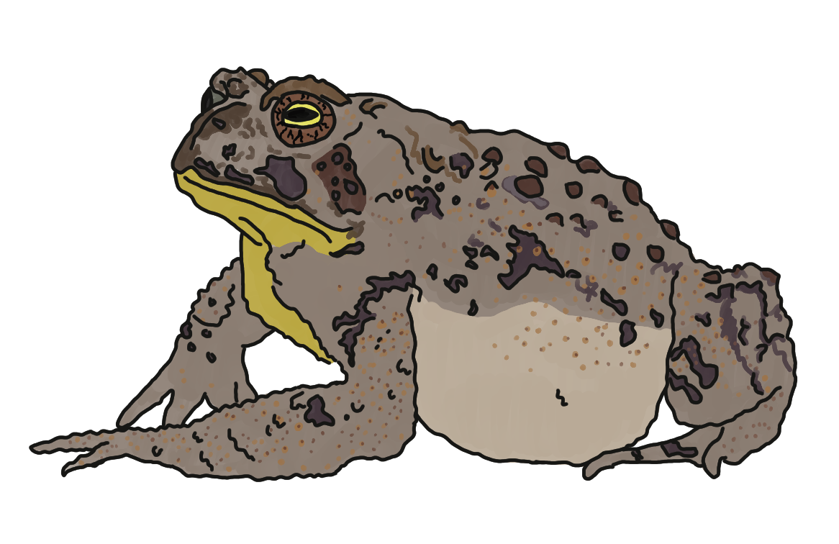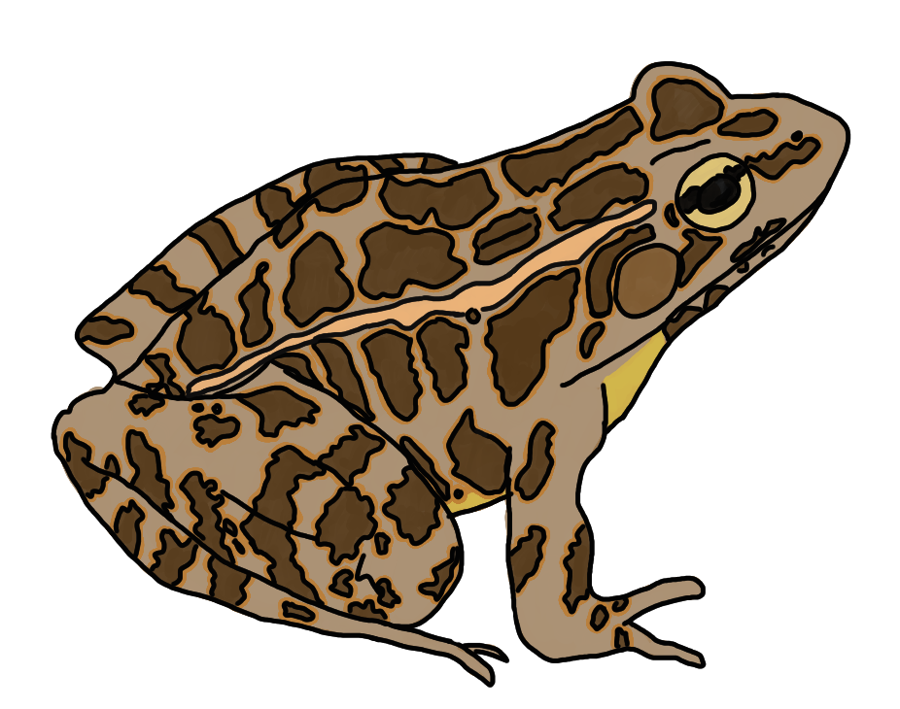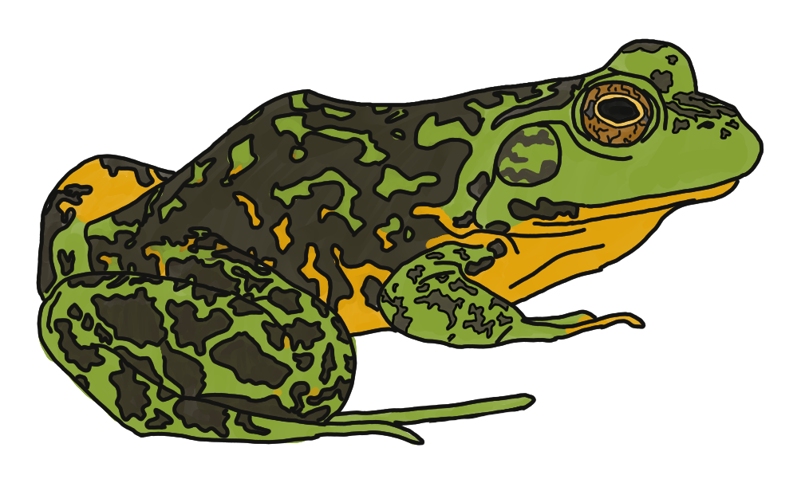
Image from left to right: Eastern American Toad, Pickerel Frog, and Mink Frog.

Amphibians have many types of predators to worry about. Some are aerial, aquatic, and land-based! Many amphibians have a type of camouflage called countershading. This means their back is a dark color while their belly is a lighter color. This type of camouflage works well when a predator is hunting from above, because the dark colors on their back blend with the dark ground. If the predator is below them, looking up, a light-colored belly helps blend into the light color of the sky.

Vocabulary List:
Adaptation - a physical or behavioral change an organism goes through in order to better survive in its environment. Examples include white fur in a snowy environment (physical) or pretending to be dead when a predator is around (behavioral).
Camouflage - a defensive technique of blending into your surroundings so predators cannot find you.
Countershading - a type of camouflage where an animal has dark coloring on its back (to blend in with the ground if a predator is hunting from above) and light coloring on its belly (to blend in with the sky if a predator is hunting from below).

Materials:
Amphibian matching cards from Activity 2: Maine Amphibians
Camouflage animal outline
Tape

Items not in the toolkit that you will need:
Coloring utensils (i.e. markers, crayons, color pencils)
Scissors

Methods:

Engage
- Most ages understand the concept of camouflage and why it is important. Using the Amphibian deck of cards from Activity 2: Maine Amphibians, separate your students into 4 groups and have them start brainstorming on how Maine amphibians camouflage:
  - Some amphibians are not camouflaged. How do they think those animals survive?
- Have a group discussion about what they discovered. Many may notice that the bellies of the amphibians are different colors from their back. This is a good segue into how countershading works!
- They may notice that some of the salamanders and newts have bright colors. This is a good time to discuss toxins and smelly deterrents!
  - Poisonous: Spotted Salamander, Eastern Newt, Eastern American Toad, Pickerel Frog.
  - Secret unpleasant odor/taste: Mink Frog and the rest of the salamanders found in Maine.

Explore
- For this activity, students will camouflage their own amphibian to see how well they can hide it in the room! Your students can decide which amphibian template they want to use (i.e., frog or salamander) and pass out the coloring supplies.
- Students are allowed to wander the room for a few minutes to decide on the spot where they want their amphibian to “hide” and get an idea of what colors they want to use.
  - It is important that students not tell anyone where their spot is because there will be a guessing game at the end to see if anyone can find their hiding spot!
- Have students return to their seats and start coloring their amphibian based on where it will hide.
- After coloring, if there is time, they should cut out their amphibian.

Evaluate
- When everyone is done, have students present their camouflaged amphibian to the group and see if people can figure out where it was hiding.
  - There is tape in the kit if students are allowed to hang them up!
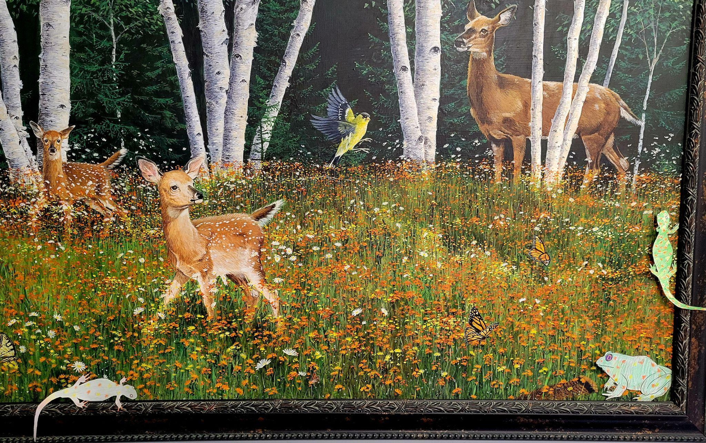
Examples of camouflaged amphibians.

Extension Ideas:
- Hop into Action: The Amphibian Curriculum Guide for Grades K-4 by David Alexander has a lot of fun activities if you are looking for more ideas! This book is available as a pdf if you do an internet search.

