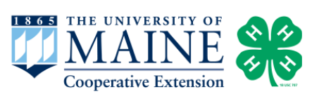

Activity 6:

In the Field

Target Grade: Kindergarten - 7th (Refer to Activity 10: Data Collection Site Visit for older grades)

Learning Targets:
- Use prior knowledge from Activities 1-5 to make observations and identify species while in the field.
- Identify amphibian and invertebrate species using ID guides.
- Collect field data about vernal pools and/or amphibian habitats using information learned from previous activities.
- Practice being a good steward of aquatic and terrestrial habitats.

Length: 90-120 minutes

Essential Questions:
- What important resources are needed for a successful amphibian habitat?
- What information is important to record when observing a vernal pool or amphibian habitat?
- What key organisms are found only in vernal pools?

Enduring Understandings:
- Youth have worked through Activities 1-5 and are familiar with the biotic and abiotic factors that make a vernal pool.
- Vernal pools are temporary habitats that form in the spring and dry up in the middle of the summer.
- Wood Frogs, Blue-spotted Salamanders, and Spotted Salamanders breed in vernal pools.
- Fairy Shrimp are only found in vernal pools and are more common in Southern Maine. Only 5% of Maine pools surveyed have Fairy Shrimp, so if you find a pool that has Fairy Shrimp, it is worth a mention!
- Vernal pools and wetland habitats should be treated with respect when collecting field data. You need to be very careful around egg masses and make sure you are not disturbing them too much.

Background for Facilitator:
There is no better way to reinforce information learned in the classroom than being out in the field, to see science happening in real time! This process often takes more time for the facilitator to prepare beforehand, and it requires flexibility due to environmental conditions (i.e., weather). Before you take your students to a site, it is good practice to check the site first to ensure it is safe for your students and, in this case, make sure amphibians are present!
Anything can happen when you are out in the field, so prepare for as many situations as you can! You should know student allergies (i.e., if they are allergic to bee stings, bug spray, etc.) so you are prepared if an accident were to happen (i.e., should a student have an EpiPen, etc). Creating a field pack to take with you whenever you are outside with students will save you a lot of headaches. Your field pack should have sunscreen, bug spray, a first aid kit, a few water bottles, snacks, extra writing utensils, and a list of your students with known allergies.

When you take your students outside, always do a head count to make sure everyone is accounted for. An easy way to keep track of students is by utilizing the “buddy system.” Everyone helps with the responsibility of keeping track of another person, so when someone is missing, you can figure it out faster. Students should always be able to see you when you are out in the field. A common phrase outdoor educators use is “if you cannot see me, I cannot see you!” Students should always be able to see you whenever they are exploring as a safety precaution. Make sure you set boundaries and consequences for if someone doesn’t follow the safety instructions.

Vocabulary List:
Abiotic - non-living components of an ecosystem. Examples include temperature, water, sediment type, and sun exposure.
Amphibian - cold-blooded vertebrates (animals with backbones) that do not have scales. Part of their life cycle is spent in the water, and part on land.
Biotic - the living components of an ecosystem. Examples include animals, insects, plants, bacteria, etc.
Guide - a document that helps the user make a decision about something. In this lesson, it is helping you identify an amphibian!
Field pack - a bag for use when you are out in the field, filled with important materials you might need: first aid kit, extra water and snacks, etc.
In the field - going outside into the natural environment to collect/learn information.
Invertebrate - a cold-blooded organism that lacks a backbone. In the case of vernal pools and wetland habitats, this could include Caddisfly larva, Fairy Shrimp, Blackfly larva, Dragonfly nymphs, etc.
Organism - a living thing. This includes plants, animals, insects, fungus, algae, etc.
Vernal pools - seasonal bodies of water that appear in the spring and summer due to melting snow and rainfall; serve as breeding grounds for several species of amphibians and invertebrates.

Materials:
Maine Vernal Pool Indicator Species cards (4 sets)
Vernal Pool Data Sheets (decide if you want every individual to fill one out or every group)
Dip nets (2)
Magnifying glasses (10)
10 Frisbee trays (to collect and observe samples)
Maine Gazetteer
Vernal Pool Maine Amphibian ID guides (10)
Vernal Pool Maine Invertebrate ID guides (10)
Measuring wheel/tape (to measure size of the vernal pool)

Items not in the toolkit that you will need:
Field Kit (as explained in the Background section above)
Muck boots, waders, or shoes that can get wet
Sunscreen and bug spray (make sure you do not have them on your hands if you plan to handle amphibians!)

Methods:

Engage
- Mentally prepare your students before they go out into the field. Everyone should bring water and wear appropriate clothes. Depending on the age group you are working with, you can either explore as a group and fill out one data sheet, or create teams to fill out their own.
  - Some teams could have an assigned role (i.e., one team is in charge of recording weather conditions while another team is measuring the pool) or each team could be in charge of everything on their data sheet.
  - Depending on how much time you have to explore, you might need to review the data sheet and the tools they will be using in the classroom to make sure you have plenty of time to explore.
  - Assign a buddy to each student to help keep track of everyone when out in the field.
- Review with your group the major concepts covered in Activities 1-5:
  - What is an amphibian?
  - What is a vernal pool?
  - What species reproduce in vernal pools?
  - Who can name an amphibian that lives in Maine?
  - If you can’t see an amphibian, what else can you “look” for? Hear their calls, egg masses, tadpoles.
- Students can use the “Maine Vernal Pool Indicator Species” cards, Maine Amphibian ID, and Invertebrate guides to help them identify organisms they see in the field. As the educator, some key details to look for when identifying what you find in the field are explained below:
  - Wood Frog:
    - Raccoon mask on face with white lip line.
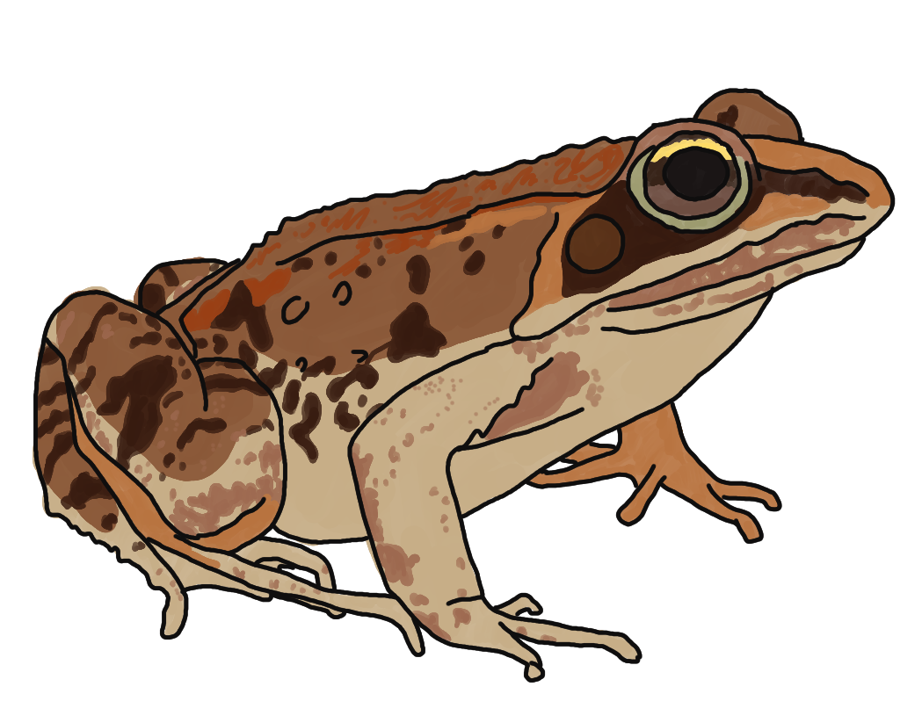
    - Small in size (less than 2.5 inches long).
  - Wood Frog Eggs:
    - Newly laid egg masses are small and compact (about the size of a golf ball). They will quickly expand to reach a maximum size of approximately 5 inches (about softball size).
    - Black or dark brown in color from above; underside is contrasting white or cream-colored.
    - Attached to grasses, cattails, sticks, and branches in the pool.
    - Can be deposited on the pool bottom in deeper water.
    - Looks like bubbles, tapioca pudding, or marbles.
  - Wood Frog Tadpoles:
    - Often seen in shallow pools.
    - Small, dark, and numerous.
    - No additional tadpoles are in pools in early spring when Wood Frogs hatch.
  - Spotted Salamander:
    - Dark colored body with bright yellow spots.
  - Spotted Salamander Spermatophores:
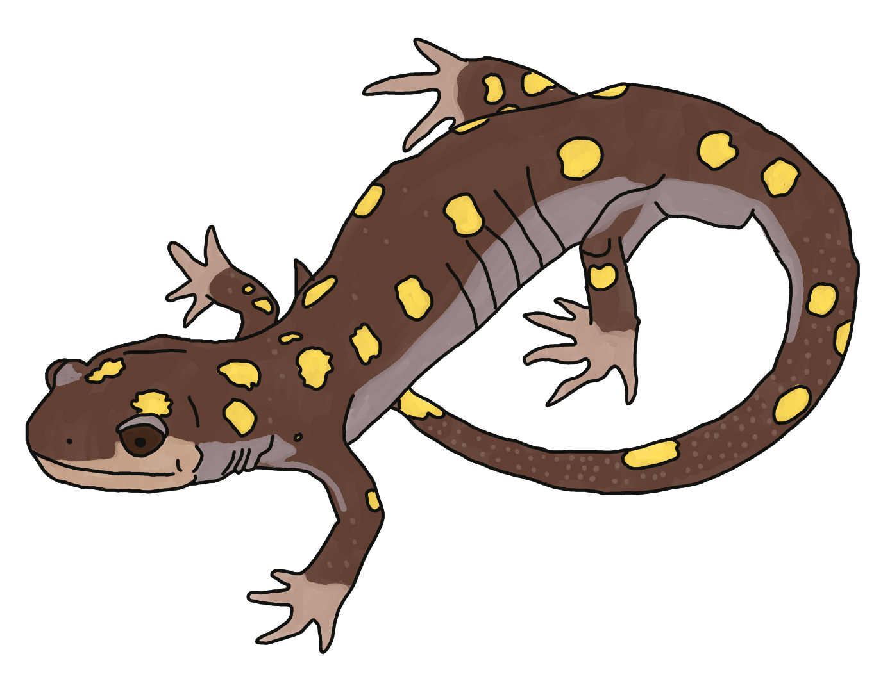
    - Male salamanders deposit spermatophores on leaf litter and submerged sticks.
  - Spotted Salamander Eggs:
    - 10-100 eggs in each mass with a jelly-like coating around the entire mass.
    - Attached to submerged vegetation.
    - 1-3 egg masses in a group.
  - Blue-spotted Salamander:
    - Dark slender body with blue spots.
  - Blue-spotted Salamander Eggs:
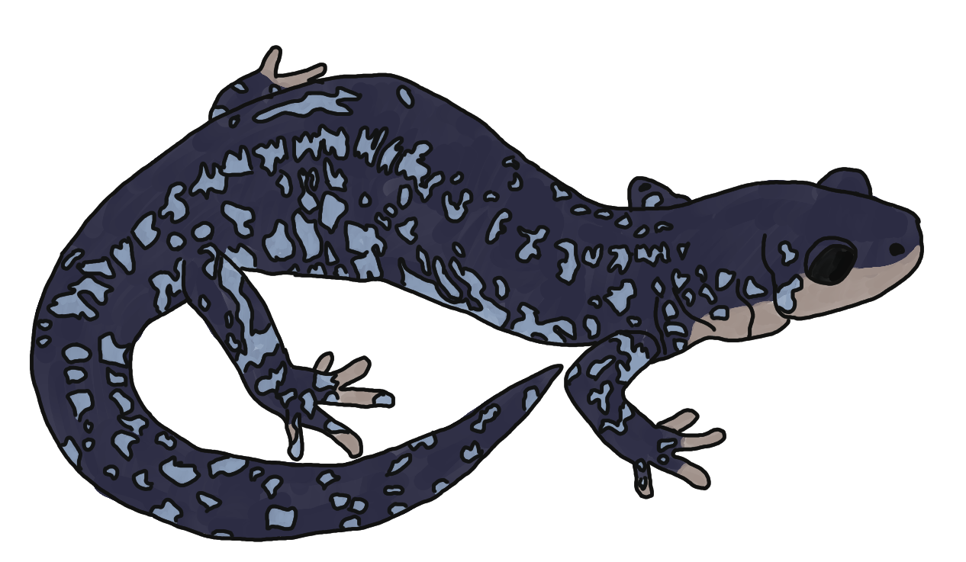
    - Egg masses are difficult to see below the water surface and may not be visible without gently lifting them from the water.
    - Attached to submerged vegetation.
    - Drippy, transparent jelly surrounds each mass.
    - May be deposited individually along the bottom of the pool or in small clusters along submerged sticks.
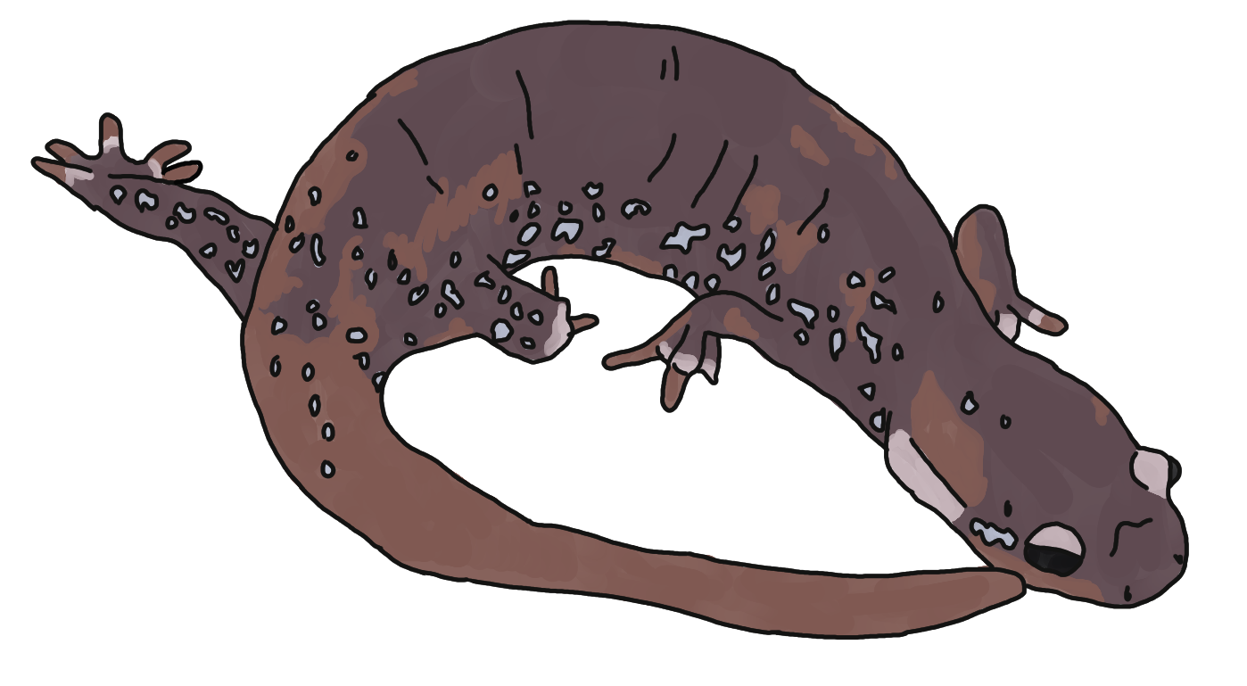
  - Hybrid Blue-spotted Salamander:
    - Often brownish-grey and larger bodied than the Blue-spotted Salamander. Hybrids have varying amounts of light blue flecking.
  - Hybrid Blue-spotted Salamander Eggs:
    - Often containing white infertile embryos, hybrid egg masses may be deposited in long strings of “pearls” along submerged vegetation.
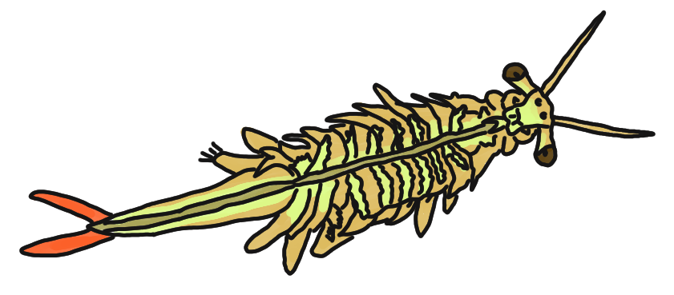
  - Fairy Shrimp:
    - Grow up to an inch in length.
    - Often seen swimming upside down in sunny pool shallows.
    - Much more common in southern New England. Only 5% of Maine pools surveyed have shrimp.
    - Eggs: deposited in the spring, need to dry and freeze before they hatch when pools refill the next spring.

Explore
- When you get your students to the field site, before they disperse, discuss the importance of being respectful to the environment:
  - The objective is to not destroy the habitat but to observe and collect data. No one should be throwing rocks or other pieces of nature: 1) someone might get hit and 2) you are going to scare away the organisms you are trying to observe.
  - You are not there to kill “bugs” (except mosquitoes!), pull leaves off the plants, or dig holes. This place you are visiting is the home of other organisms, and we wouldn’t like it if someone came to our home and destroyed where we live.
- Explain the boundaries of where students are allowed to go and pick a rally point for everyone to return to when the time for exploration is over.
  - Safety precaution: as students disperse, they should always be able to see you (and you them) during their exploration. They should never be out of sight. Remind them that if they can’t see you, then they need to find a new location.

Evaluate
- Once the group is back together, have a group conversation about what they observed and the data they collected. If any organisms were collected, this is a good time to identify what was found. Discussion questions could include:
  - Did anyone see or hear amphibians? Were they able to identify what it was?
  - Do you think this vernal pool (or wetland habitat) is healthy? Why or why not?
  - Can anyone give an example of biotic things found in this environment?
  - Can anyone give an example of abiotic things found in this environment?
  - What did you learn about collecting data in the field?
  - What did everyone think of this exploration?

Extension Ideas:
- Kindergarten - 6th Grade: Have your students go on a scavenger hunt while they are out in the field to help them practice observing the environment. Use the equipment in this activity to collect and learn as a group:
  - Color Scavenger Hunt sheet
  - Black and White Scavenger Hunt sheet
  - Vernal Pool Observation sheet can be used with students who are comfortable with writing.
- Maine Vernal Pool Summary Dashboard: The map on this site uses Google Earth and will display known vernal pool sites.
- Of Pools and People: This website provides information and research on vernal pools in the Northeast and Midwest regions of the U.S.
- Expand everyone’s knowledge by learning about Maine Big Night.
- Gulf of Maine Research Institute: This link is the learning resource hub for vernal pool information in Maine.

University of Maine Cooperative Extension is an equal opportunity institution and provider committed to fostering a nondiscriminatory environment and complying with all applicable nondiscrimination laws. Consistent with State and Federal law, UMaine Extension does not discriminate on the basis of race, color, religion, sex, sexual orientation, transgender status, gender, gender identity or expression, ethnicity, national origin, citizenship status, familial status, ancestry, age, disability physical or mental, genetic information, veterans or military status, income derived from a public assistance program, political beliefs, reprisal or retaliation for prior civil rights activity, in employment, education, and all other programs and activities.

The University of Maine System provides reasonable accommodations to qualified individuals with disabilities upon request. Persons with disabilities who require alternative means of communication for program information (e.g., Braille, large print, audiotape, American Sign Language, etc.) should contact the UMaine ADA Coordinator or contact USDA through the Telecommunications Relay Service at 711 (voice and TTY). Additionally, program information may be made available in languages other than English.

If you believe you have experienced discrimination or harassment, you are encouraged to contact the System Office of Equal Opportunity and Title IX Services at 5713 Chadbourne Hall, Room 412, Orono, ME 04469-5713, by calling 207.581.1226, or via TTY at 711 (Maine Relay System). For more information about Title IX or to file a complaint, please contact the UMS Title IX Coordinator at www.maine.edu/title-ix/. To file a program discrimination complaint, complete the USDA Program Discrimination Complaint Form, AD-3027, found online at https://www.usda.gov/oascr/how-to-file-a-program-discrimination-complaint and at any USDA office or write a letter addressed to USDA and provide in the letter all of the information requested in the form. To request a copy of the complaint form, call (866) 632-9992. Submit your completed form or letter to USDA by: (1) mail: U.S. Department of Agriculture, Office of the Assistant Secretary for Civil Rights, 1400 Independence Avenue, SW, Mail Stop 9410, Washington, D.C. 20250-9410; (2) fax: (202) 690-7442; or (3) email: program.intake@usda.gov.



