

Learning Targets:
- Understand why identifying tracks is important.
- Know the difference between foot types: plantigrade, digitigrade, and unguligrade.
- Identify different Maine mammal tracks using a guide and ruler.

Length: 20-30 minutes

Essential Questions:
- What can you learn about an animal if you just have their track?
- Why do animals have different footprints?
- Why do you need a guide and ruler to identify a track?

Enduring Understandings:
- Tracks are footprints, and they can tell you a lot about an animal's behavior and habitat use.
- There are three main foot types: plantigrade, digitigrade, and unguligrade.
- The stride, straddle, and gait can tell us how the animal was behaving and how they might use the habitat the track was found in.

Background for Facilitator:
Animal tracks (i.e. footprints) are an easy way to identify what species live in an area. Most mammals in Maine tend to avoid humans, so when you can’t find them in person, a track is the next best thing! Tracks can provide a lot of information about the behavior of an individual. The placement of feet can tell us if an animal was moving fast (i.e. hunting or being hunted) or taking a nice stroll (i.e. looking for food). How often we find those tracks in an area can also tell us what habitats are important throughout the day for that species.

The first thing to know about identifying tracks is the foot type: plantigrade, digitigrade, or unguligrade. Animals that are plantigrade walk using their entire foot. An example of plantigrade species includes bears, raccoons, and humans. Animals that are digitigrade walk on their toes (i.e. digits). An example of these types of walkers includes coyotes, bobcats, and birds. Unguligrade walkers are those that walk on the tip of their toes (i.e. toenails or hooves). A moose, deer, and cow are examples of unguligrade walkers.
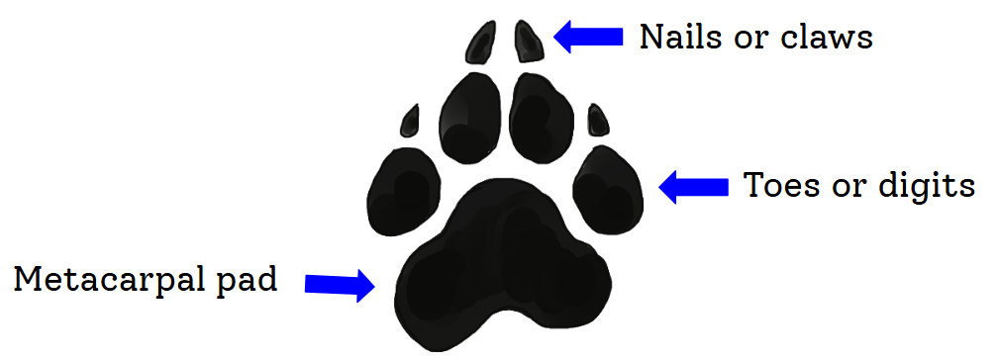
The next thing to identify when you find a track is determining what the animal was doing at the time it left the track. The stride is the distance between the heel of the front foot and the heel of the back foot. The straddle is how far apart the left and right feet are, and the gait is how fast the animal was moving. Was the animal moving slowly, was it running, was it jumping?
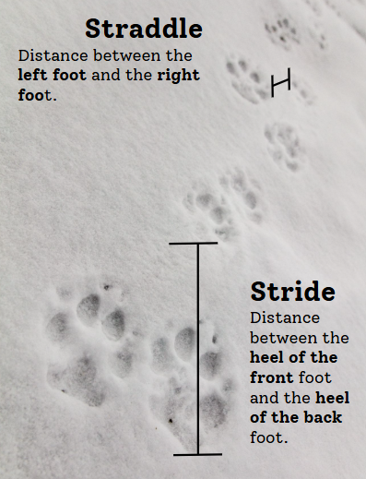
Photo courtesy: "Wolf tracks on Fountain Freight road" by YellowstoneNPS is marked with Public Domain Mark 1.0.

Vocabulary List:
Digitigrade: animals that walk using their toes (i.e. digits). This includes coyotes, bobcats, and birds.
Gait: the speed at which an animal is moving (i.e. walking, trotting, galloping, etc.)
Plantigrade: animals that walk using their entire foot. This includes bears, raccoons, and humans.
Straddle: distance between the right and left tracks.
Stride: distance of the heel from the front paw to the heel of the back paw.
Tracks: footprints left on the surface of something. This could include snow, mud, sand, etc.
Unguligrade: animals that walk on the tips of their toes (i.e. toenails or hooves). This includes moose, deer, and cows.

Materials:
- Animal Track Example cards (4)
- Match Track cards (4 sets of 24 cards)
- MDIFW Tracks of Maine
- Books: Critters of Maine Pocket Guide (6); Peterson Field Guide to Animal Tracks (3); Big Tracks, Little Tracks; Tracks, Scat, and Signs (book choice is dependent on the age of your group)
- Rulers (12)

Methods:

Engage
- Start a discussion with your group on what tracks are and where/what you find them in (mud, sand, snow, etc.).
  - Do all tracks look the same? Why or why not?
  - Do all animals move the same? Why or why not?
- Show them the different laminated examples of the three types of feet: plantigrade, digitigrade, and unguligrade.
- Fun addition: have your students attempt to use their feet in the same ways explained in the examples.
- Discuss why it’s important to be able to identify tracks and how most animals are hard to find because they avoid people.

Explore
- Place students in groups of 3 to 4 and give them a deck of Track Matching cards. The challenge is to match the track to the animal to the best of their ability using a ruler, guides, etc.

Evaluate
- Once everyone has had a chance to make their guesses, go over the answers with the group as a whole.

Animal | Track | Additional Information
New England Cottontail | A | Digitigrade when moving. Animals that jump or bound will push off with their back feet and land on their front feet. As they move, the back feet land in front of the front feet.
White-tailed Deer | B | Unguligrade. Tracks tend to follow in a relatively straight line because they are more delicate and cautious as they walk. Their hooves allow them to walk quietly to avoid predators.
Moose | C | Unguligrade. Moose tend to trudge through areas at a steady, unhurried pace. You often see dew claw prints because moose are heavy animals. Their wide feet act like snowshoes and help them cover soft ground.
Porcupine | D | Plantigrade. Front feet have 4 toes, and the back feet have 5. The bottoms of their feet are rough to help them climb.
Chipmunk | E | Plantigrade. Animals that jump or bound will push off with their back feet and land on their front feet. As they move, the back feet land in front of the front feet. Front feet have 4 toes, and the back feet have 5. They can climb, but are more specialized at digging.
Gray Squirrel | F | Plantigrade. Animals that jump or bound will push off with their back feet and land on their front feet. As they move, the back feet land in front of the front feet. Front feet have 4 toes and the back have 5. Their strong, sharp claws help them climb, dig, fight, and hunt.
American Mink | G | Digitigrade when moving. Minks are very furry (i.e. light gray in the track print) and hop when they run. Their movement is very similar to ferrets. They also have slightly webbed feet.
Striped Skunk | H | Plantigrade. Skunks have 5 toes on each foot. They have strong front feet for digging, and when threatened, will stomp them or do a handstand to intimidate the aggressor.
Raccoon | I | Plantigrade. They have 5 finger-like toes on their front and back feet to help them manipulate food and objects. Raccoon front paws are very sensitive to help them identify things in their environment, and they are more sensitive when they are wet.
Gray Fox | J | Digitigrade. They have very strong, semi-retractable claws that help them climb trees. Their feet resemble a dog's because they are canines.
River Otter | K | Plantigrade. They have webbed feet with non-retractable claws. River Otters use their hind feet to push through the water.
Black Bear | L | Plantigrade. They have 5 toes on each foot. The front paws are shaped differently from the back to help with climbing and grabbing things.

  - Some animals can retract their claws (i.e. bobcat) and that is an easy identifier for some species. Coyotes and dogs cannot.
  - The sizes on the chart might be different from what students actually measured. It is important to note that the sizes provided on the MDIFW Maine Tracks sheet are a measurement of the “average” animal track. Some animals they encountered might be juveniles, some might be really big adults!
  - Identifying tracks is not easy and takes a lot of practice!

Extension Ideas:
- Have students compare their own tracks to the class so they can see how tracks differ within the same species! Using a bare foot, have the student step in water and then step on a piece of colored construction paper. They can then outline it with a permanent marker to preserve the track before it dries. Students can make different prints by putting pressure on different parts of their foot (i.e. the side, their toes, the ball) to see how tracks can change depending on what an animal is doing: the animal might be injured, moving fast, stepping on something soft, jumping, etc.

If you have a long roll of paper, or a dark colored sheet, have students walk with wet feet using different strides to compare placement and distance between steps.
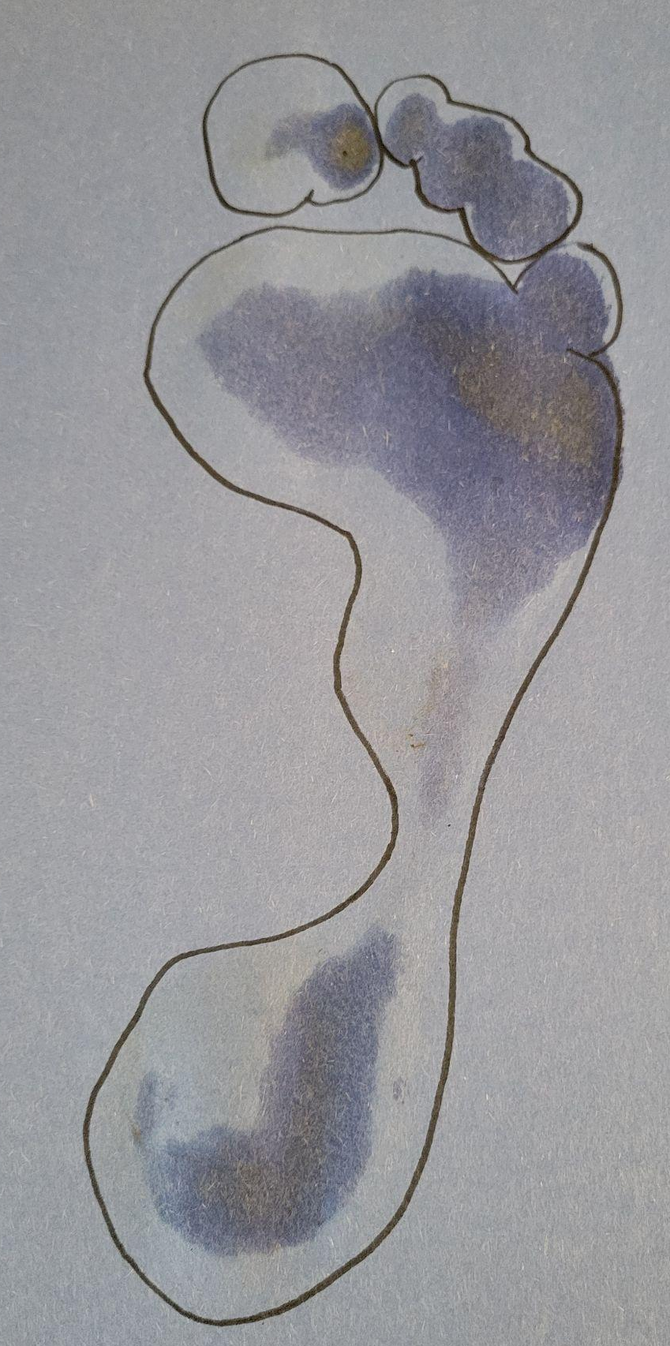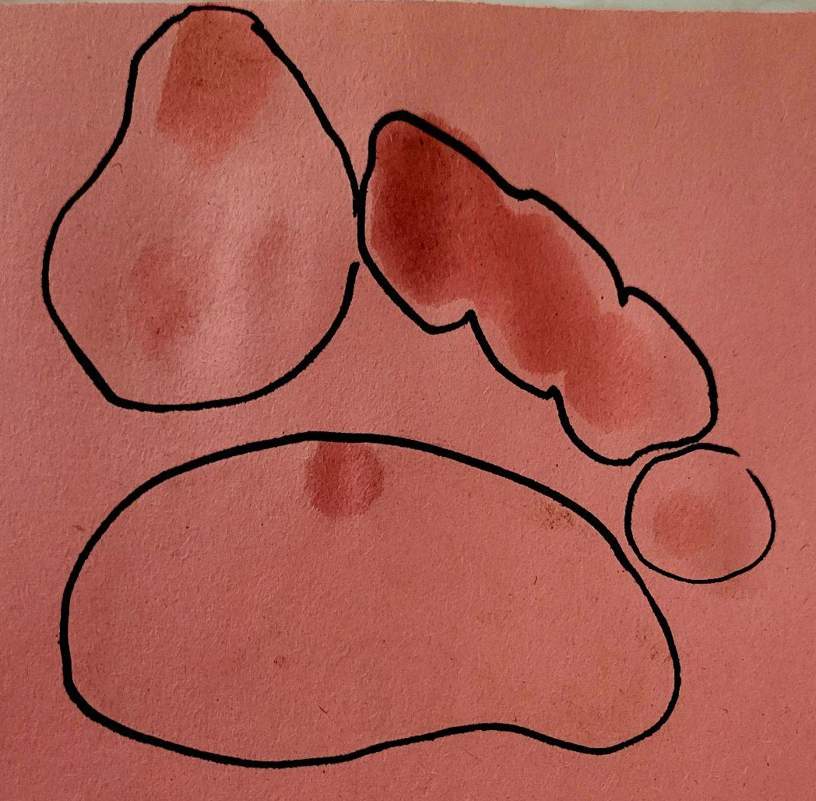
Example of the whole foot versus walking on your toes.

- If your students make their own tracks using Activity 3: Make a Track, you can use playdough to make tracks for students to identify.

In complying with the letter and spirit of applicable laws and pursuing its own goals of diversity, the University of Maine System does not discriminate on the grounds of race, color, religion, sex, sexual orientation, transgender status, gender, gender identity or expression, ethnicity, national origin, citizenship status, familial status, ancestry, age, disability physical or mental, genetic information, or veterans or military status in employment, education, and all other programs and activities. The University provides reasonable accommodations to qualified individuals with disabilities upon request. The following person has been designated to handle inquiries regarding non-discrimination policies: Director of Equal Opportunity and Title IX Services, 5713 Chadbourne Hall, Room 412, University of Maine, Orono, ME 04469-5713, 207.581.1226, TTY 711 (Maine Relay System).

