Maine 4-H Cloverbud Record Sheet
Name: _____________________________________________

Your Picture
(Optional)

County: ___________________________________________

Total Years in 4-H: __________________________________

Age on December 31: _______

Club Meetings Attended This Year  80% attendance is required  4-H Club Name: | Meetings Held | Meetings Attended | Hours Attended | Percent Attended
4-H Club Name:
4-H Club Name:

I have personally prepared this report and believe it to be correct.
4-H Member’s Signature: | Date:
I have personally reviewed this report and believe it to be correct.
4-H Adult Partner’s Signature: | Date:

Section 1: My 4-H Club and Events

Tell us about your 4-H Club! Write, draw, photograph, make a video.
The name of my 4-H Club is:

4-H meetings and events: (check off each item you completed)

- I attended a fair
- I attended 4-H club meetings
- I attended Maine 4-H Days
- I participated in a community service project
- I attended a special event like June Jamboree, 4-H Fun Days, etc.
- I participated in a 4-H Promotional Event (tractor supply, etc.)
- I completed public speaking (demonstration, fair, county event)
- Other:______________________________________________

Which event was your favorite? Write, draw, share a photograph, or make a video.
My favorite event was:
This event was my favorite because:

Section 2: My 4-H Activities

Tell us about your activities! Write, draw, photograph, or make a video.

Members are not limited to four activities. Duplicate this page as needed

The name of my 4-H activity is: | The name of my 4-H activity is:
My favorite thing about this activity is: | My favorite thing about this activity is:
The name of my 4-H activity is: | The name of my 4-H activity is:
My favorite thing about this activity is: | My favorite thing about this activity is:

Section 3: My Community

What do you care about?
Something that I care a lot about is:

That’s great that you care about something! Complete a community service activity for the topic you wrote above.
The community service activity that I completed was:

Congrats on making a difference! Fill in the boxes below (write or draw).
I did a community service activity with others!
Who we helped:
What we did:

When we did it:

Where we did it:

Why we did this:

4-H Life Skills I used in my projects this year:
This is the Life Skills Wheel, it’s how we connect the skills we learn through our projects as they relate to the big picture of what 4-H is. For Cloverbuds, we want you to look at the big 4 in the middle: Head, Heart, Hands, and Health. For now, that’s what we want you to focus on, but see all the amazing skills related just to that one H!

Life Skills Wheel Source: Iowa State Extension

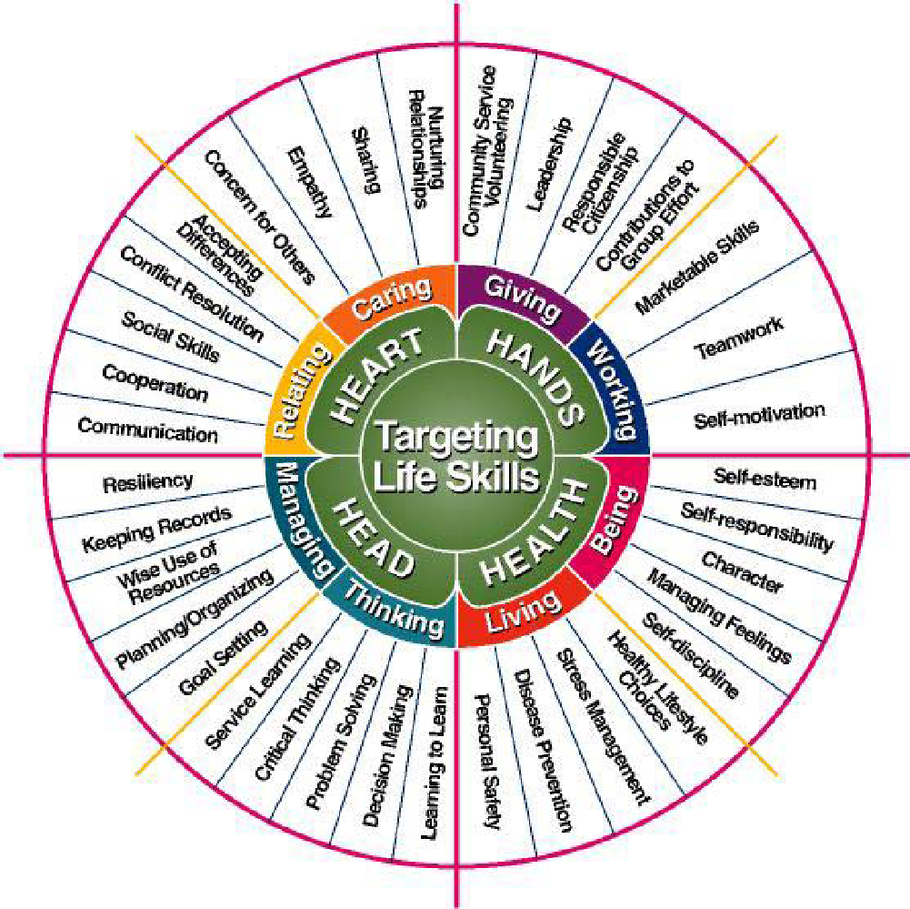

4-H Thinking Hat

1. On the left side of the hat write what is unique about using your head or hands in one of your 4-H activities.
2. On the right side of the hat write what is unique about using health or heart in one of your 4-H activities.
3. On the bottom of the hat write what they have in common.

Rubric - Cloverbud Record Form - Club & County Level

Indicators | Emerging | Developing | Proficient | Distinguished
My 4-H Club and Events | Member meets one or fewer of the following:  - Member knows the name of their 4-H club.  - Member identifies an activity participated in in 4-H.  - Member identifies which 4-H event was their favorite. | Member meets two or fewer of the following:  - Member knows the name of their 4-H club.  - Member identifies a few activities completed in 4-H.  - Member identifies why a 4-H event was their favorite. | - Member knows the name of their 4-H club.  - Member identifies several 4-H events and meetings.  - Member articulates why a 4-H event was their favorite. | - Member knows the name of their 4-H club.  - Member identifies a variety of 4-H events and meetings.  - Member identifies favorite event and connects event to life skill demonstrated.
My 4-H Activities | - Member shares minimal 4-H activities and their favorite thing about each activity.  - Member identifies how they used 2 or fewer life skills connected to Head, Heart, Hands and Health in 4-H. | - Member shares few 4-H activities and lists favorite thing about each activity listed.  - Activity is noted for every project entered in a fair or public display.  - Member identifies how they used 3 or fewer life skills connected to Head, Heart, Hands and Health in 4-H. | - Member shares multiple 4-H activities and describes favorite thing about each activity listed.  - Activity is noted for every project entered in a fair or public display.  - Member identifies how they used life skills connected to Head, Heart, Hands and Health in 4-H. | - Member shares numerous 4-H activities, describes favorite thing about each and connects them to life skills used in the activity.  - Activity is noted for every project entered in a fair or public display  - Member explains how they used life skills connected to Head, Heart, Hands and Health in 4-H.  - Member may use more detailed life skill language in addition to Head, Heart, Hands and Health.
My Community | - Member identifies community service activity completed.  - Member partially connects who, what, when, where and why pieces of the activity. | - Member identifies community service activity completed.  - Member partially connects who, what, when, where and why the activity happened. | - Member identifies community service activity completed.  - Member is able to articulate who, what, when, where and why the activity happened. | - Member identifies community service activity completed.  - Member is able to articulate who, what, when, where and why the activity happened.  - Member is able to describe and make connections between the activity with greater good for the community.
Presentation and Preliminary Information | Record Form meets two or fewer of the following:  - Record Form is partially completed by 4-H member with help from adult.  - Member followed some directions and record book is partially complete and in correct order.  - Record book is legible.  - Member attended at least 80% of club meetings. | Record Form meets three of the following:  - Record Form is partially completed by 4-H member with some help from adult.  - Member followed all directions and record book is complete and in correct order.  - Record book is legible  - Member attended at least 80% of club meetings. | - Record Form is completed by 4-H member with some help from adult.  - Member followed all directions and record book is complete and in correct order.  - Record book is legible and presentation quality.  - Member attended at least 80% of club meetings. | - Record Form is completed by 4-H member with little to no help from adult.  - Member followed all directions and record book is complete and in correct order.  - Record book is legible and presentation quality.  - Member attended 100% of club meetings.

Rubric – 4-H Thinking Hat Cloverbud

Indicators | Emerging | Developing | Proficient | Distinguished
Head or Hands | Member meets one or fewer of the following:  - Describes how head or hands quadrant is unique.  - Describes what the skill has in common. | Member meets two of the following:  - Describes how head or hands quadrant is unique.  - Describes what the skill has in common. | - Uses detail to describe how head or hands is unique.  - Uses detail to describe what the skills have in common. | - Uses detail to describe how head or hands is unique.  - Uses detail to describe what the skills have in common.  - Is able to make connections to both skills.
Heart or Health | Member meets one or fewer of the following:  - Describes how head or hands quadrant is unique.  - Describes what the skill has in common. | Member meets two of the following:  - Describes how head or hands quadrant is unique.  - Describes what the skill has in common. | - Uses detail to describe how head or hands is unique.  - Uses detail to describe what the skills have in common. | - Uses detail to describe how head or hands is unique.  - Uses detail to describe what the skills have in common.  - Is able to make connections to both skills.

Cloverbud Form - Feedback Sheet
4-H Member:_______________________

Check which level is demonstrated in the project record form. There are NO scores for Cloverbuds.
Indicators | Emerging | Developing | Proficient | Distinguished
My 4-H Club and Events
My 4-H Activities
My Community
My Life Skills
Presentation and Preliminary Information

Evaluators Comments:
Section 1: My 4-H Club and Events

Section 2: My 4-H Activities

Section 3: My Community

Section 4: My Life Skills

Presentation and Preliminary Information

Evaluator Initials:

