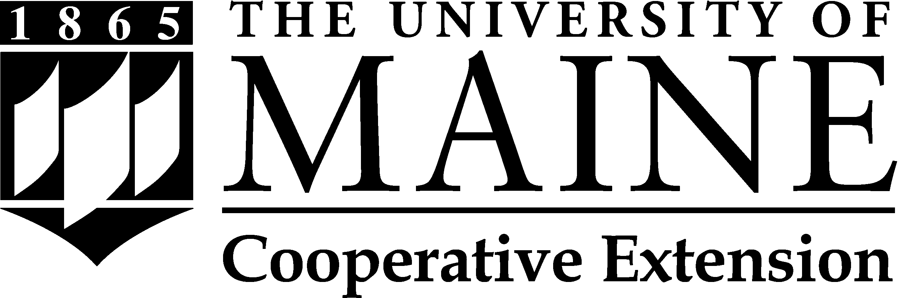
THE BIG E
MORRIS 4-H SCHOLARSHIP
2019

APPLICATION CHECKLIST
Please complete this sheet, and submit it with your application packet.

Name: Date of Birth: Age:

Mailing Address:
Street City State/Zip
Phone:

Number of Years in the 4-H Program:

Years you participated at Eastern States: ______ 2019 ______ 2018 ______ 2017 ______ 2016

Anticipated High School Graduation Year:

Required Application Components:

Letter of Nomination/Recommendation from Animal Science Coordinator or New
England Center Program Coordinator.

Name of Coordinator:

Letter from applicant detailing qualifications for scholarship, including:
- Participation on a Maine ESE team in 2019 or prior;
- Intention to continue education beyond high school in 2019 or 2020, including area of study and possible location;
- Demonstrated leadership as a Maine 4-H member at the local, state, or regional level.

Copy of applicant’s high school transcript or equivalent.
Application materials must be sent to:
Jessy Brainerd
Maine State 4-H Office
491 College Ave
Orono, ME 04469-5741
Fax: 207-581-5720
jessica.brainerd@maine.edu
All applications and supporting materials must be received, by mail, fax, or e-mail, by 4:30 p.m., Friday, August 23, 2019. Incomplete applications will not be considered.

