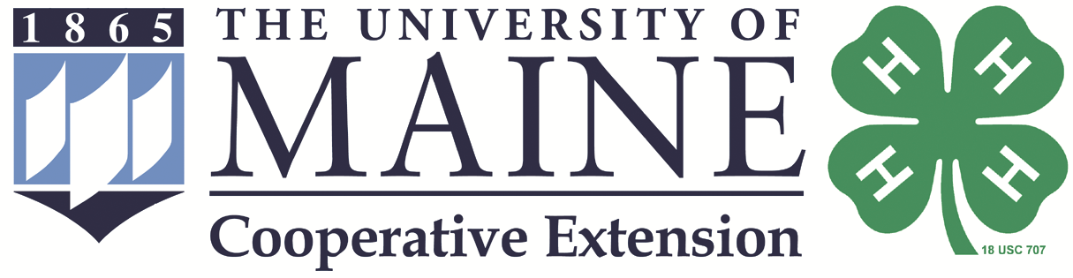

Maine 4-H State Dairy Show

2021

Show dates July 24-25, 2021
Skowhegan Fairgrounds, Skowhegan, ME

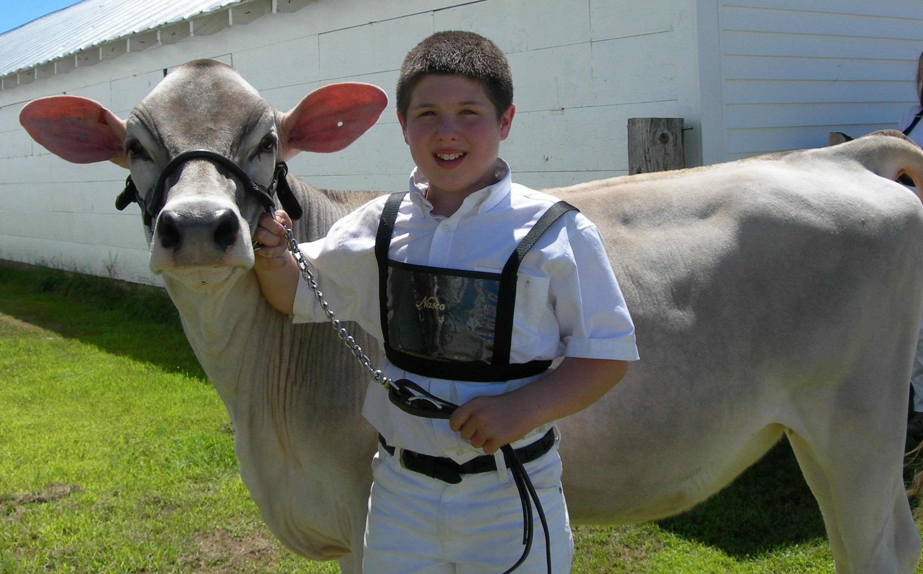

Informational Packet for 4-H Youth

Table of Contents

Welcome Letter 3
Schedule at State 4-H Dairy Show 4
Rules and Information for Maine State 4-H Dairy Show 5
Fitting and Grilled Cheese Contest Rules 7
Classes for Maine State 4-H Show 9
Youth Registration Page 10
Permission and Photo Release Form 11
Health Form 12
Release of Risk Form 13

Dear 4-H Dairy Project Member and Family,

Congratulations on taking the first step toward participating in the Maine State 4-H Dairy Show which is open to all Maine 4-H dairy project members 4-H age 9 and above! Check out this packet and make plans to come to the Maine State 4-H Dairy Show and Eastern States Exposition team tryouts. The State Show will be held from July 24th to 25th at the Skowhegan Fairgrounds.

4-Hers will not need to pre-register animals ahead of time. Just bring the animals you plan to show along with all of their paperwork, and we will record your information at the show office.

4-H’ers do not need to register in advance for the State Dairy Show. In this packet you will find a registration page, a photo release, a Code of Conduct to sign as well as health forms in this packet. These forms can be completed upon arrival. There is also a place for your chaperone and parent to sign if parents will not be attending. There is no registration fee for the show.

Camping spots are available at the fairgrounds for $25 per night.

The tentative dates for the 2021 events are as follows. Please note, Maine 4-H will still not be participating as a team or traveling together to the New England 4-H Fair. Individual 4-H members/families who choose to participate will be responsible for organizing and paying for their own travel (participant and animal), lodging, meals etc. More information on the July 4-H event can be found at www.thebige.com/p/competitions/4-h/packets.

4-H dairy events that are scheduled to take place in September are tentative and additional information about these events will be provided this summer.

July 6 | Registration deadline for New England 4-H Fair
July 24 | Grilled Cheese and Milkshake Contests
July 24 | Fitting Competition
July 24 | Meeting with State Dairy Show Judge after Fitting Contest
July 25 | Maine State 4-H Dairy Show
Sept. 18 | 4-H dairy events at The Big E

Please read this packet carefully and connect with Maine 4-H staff with any questions.

Sincerely,
The Maine 4-H Dairy Science Committee

Schedule for the 2021 State 4-H Dairy Show

Friday | July 23
 | 4:00 pm | Arrival and check in begins
Saturday | July 24
 | 1:00 pm | Grilled Cheese and milkshake competition
 | 5:00 pm | Clipping contest
Sunday | July 25
 | 8:00 am | All animals must be on the grounds
 | 8:30 am | All papers must be checked in
 | 9:00 am- | State 4-H Dairy Show starts
 | afternoon | Meeting on the bleachers after cattle are put away

The State Dairy Committee will be placing barrels and bags in the dairy area to collect bottles and cans to support the state dairy program. Please support the program by dropping your bottles and cans into the marked barrels.

Rules and Information for the 2021 Maine 4-H State Dairy

General Rules

- Eligibility: Exhibitors must be enrolled in a dairy project in the current year; and must have reached their ninth birthday on January 1 of show year and must not be over 18 on January 1 of the show year to be eligible to participate.
- Divisions:
  - A: Seniors members age 14 through 18 as of January 1 of the current year.
  - B: Intermediate members age 12 and 13 as of January 1 of the current year.
  - C: Junior members age 9 through 11 as of January 1 of the current year.
  - D Novice – 1st year participants – Member may elect to show in own age group if desired – but only in 1 group.
- Animals to be Shown Per Exhibitor:
  - __Division A are limited to 5 animals
  - __Division B are limited to 4 animals
  - __Division C are limited to 3 animals
  - __Division D follows the limit per their age group (in Division A-C)
- Entry application: No pre-entry of animals required. Members must register themselves upon arrival (registration forms enclosed). All animal entries will be entered on July 24, prior to Sunday’s show. The 4-H Dairy Project team will check your paperwork. All animals must be on the grounds by 8:00 am Sunday and all paperwork checked by 8:30 am Sunday.

Forms for Animals
The Animal Approval Forms, registration papers, lease agreements (if applicable) and rabies certification must be available for inspection upon arrival of all animals. Problems obtaining registration papers must be reported to the Maine 4-H Dairy Project Team Liaison no later than one week prior to the show for further instructions. This person is Tara Marble at 207-778-4650 or
1-800-287-1478 or e-mail: tara.marble@maine.edu or Sadee Mehuren at 207.342.5971 or by email at sadee.mehuren@maine.edu.The approval form and all papers pertaining to ownership or leasing must be available for inspection upon arrival of all animals.

Rabies Statement
All cattle brought to the Maine State 4-H Dairy Show must be vaccinated for rabies if born on or before January 31, 2021. All 4-H members bringing animals to Maine State 4-H Dairy Show must show a veterinarian certification that their animals have received a rabies vaccination. Certification must be in writing, signed by the veterinarian, and must clearly identify the animal or animals in question.

Health of Animals
Animals showing evidence of external parasites, foot rot, shipping fever or other infectious diseases

(ringworm, pink eye, mange, and warts are considered as infectious diseases) will be excluded and ordered removed from the exhibition unless written verification from a licensed veterinarian is presented upon registration stating animal is not infectious. Animals are subject to State Vet check during event.

Show Uniform
Required dress is white pants and a white collared, button down shirt or blouse that will be tucked in. Belts are suggested to keep shirts/blouses tucked in. Advertising a farm name or breed on clothing, wearing extremely brief shorts, or appearing barefoot will not be allowed. Sturdy shoes or boots are recommended.

Exhibitor Ethics
No interference or abusive language will be allowed when the judges, show officials and state veterinarian are discharging their duties or at any time during the 4-H event. Exhibitors should not leave the ring until excused by the judge. Violation of this rule will result in your not being permitted to show for the rest of the day.
- Bedding, Feed and Equipment The committee will try to get bedding donated. Thanks to generous donations, bedding will be provided. Exhibitors need to bring any hay and grain needed during the event. Members are responsible for their feed/water pails, forks, and equipment. It is recommended that you place your name on all personal equipment.

Judging
The modified Danish System will be used with exhibitors and animals lined up in numerical order. Ribbons will be awarded in three categories: blue, red and white. Rosettes and/or trophies will be awarded in championship classes, the first-place showmanship winners, and the overall showmanship winner.

Showmanship

Members will be grouped according to age of the exhibitor; larger classes may be divided in half to aid in judging. Members must show their own animal in their showmanship class.

Adults are not permitted to fit animals on the show grounds.

FITTING CONTEST RULES

The Fitting Contest will take place on Saturday, July 24 at 5:00 pm in conjunction with the 2021 Maine State 4-H Dairy Show.

  - Participants will provide their own animal for the contest.
  - The contest animal must be unclipped meaning not touched at least six weeks prior to the contest and at the discretion of the judge. The unclipped rule will be strictly enforced.
  - The animal should be head clipped only, clean and dry.
  - Animal must comply with current rabies requirements.
  - Judges will preview the animals.
  - Participants will be given one hour to fit their animal to the best of their ability.
  - The contest will take place in the animal stall/clipping chute.
  - At the close of the hour, the judges will review the animals.
  - Contestants will be called to a central area and the Fitting Contest winners will be announced.

Participants will be divided into 2 divisions for awards:
    - Juniors – age 9-11 years
    - Intermediate/Seniors – age 12 and older

GRILLED CHEESE CONTEST RULES
Objective: To promote teamwork among 4-H participants, provide an interactive and fun learning experience around food preparation and food safety, be a demonstration for visitors and promote public relations around 4-H science programs

2 categories will be judged, teams may compete in just one or both divisions:
- Bread, butter, and cheese (anything from those categories)
- Anything goes (substitute bread and/or butter) grilled cheese with 60% of sandwich filling being cheese)

Best in Show – the best items from each category will compete for Best in Show

Three judges will officiate - they can ask questions during preparation as well as during tasting. Teams will be judged while they are preparing the food, including food handling and food safety. Contestants will be judged on sanitizing stations before, during and after competing. Teams will be responsible to provide recipes, including any spices and garnishes, to the judges.

Each team must supply the following: Mandatory cookware:
- Skillet and hot plate OR an electric frying pan or electric griddle. NO element that cooks 2 sides at once such as deep fryer, George Forman Gill type device or Panini Press, or a toaster oven can be used. Spatulas, knives, other utensils needed to prepare the sandwiches
- Grilling Hats

- Grilling Apron Cutting Boards Hand sanitizer
- Disposable Gloves
- Safe Food Handling Information Sheet
- Tablecloths
- Plates
- Food product

Teams will need to bring supplies and ingredients necessary to make 2 sandwiches for judges. All preparation including cutting of garnishes may NOT be done prior to the start of the competition. No alcoholic beverages may be used in the preparation of recipes.

Supplies cannot be borrowed or added once the setup starts at the beginning of the contest, this includes supplies from other teams, parents, or spectators. You must be prepared.

PLEASE NOTE: Any perishable items MUST be kept in a cooler with ice and be stored at safe temperatures (below 45F), and all foodstuffs must be stored off of the ground, at least 6”. Please be sure to label your bags/coolers with your name. Judges may check temperature.

TEAMS: States will provide 1 or 2 teams of 3 members from their delegation. If the state selects 2 teams the teams will work as 2 separate teams. One adult supervisor per team must be present for safety precautions but cannot assist or provide direction to the team unless it relates to safety and the preparation of food in any manner.

All competitors must wear the grilling hats, aprons and gloves per board of health regulations. When handling Food stuffs, all competitors WILL wear sanitary, disposable gloves. All members of the team will need to wear gloves and maintain a safe food environment.

Time Limits - All grilling will be done in separate 15-minute heats and each competitor will have only 15 minutes to complete their grilling. No exceptions! Spatulas down means spatulas down.

Judging Breakdown:
Youth must as a group present dish of one sandwich per judge and give explanation of their dish and be prepared to answer any questions.
The panel of judges will score teams by the following breakdown: Creativity = possible 10 points
Cleanliness = possible 10 points Food handling/safety = 20 points
Presentation by group to judges = 20 points Teamwork = possible 20 points
Taste = possible 20 points

EXTREME 4-H MILKSHAKE CONTEST RULES

What is an extreme milkshake? It is a giant, drippy milkshake stacked with everything from whole slices of cake and brownies to cookies, chocolates, and other sweets. In 2021, New England 4-H Dairy youth will have the opportunity to develop their own Extreme 4-H Milkshake.

RULES:
1. The Milkshake Team will be comprised of two 4-H youth ages 12-18 years old as of January 1st of the current year.
2. The milkshake must be made from cow’s milk, NO non-dairy milk is allowed such as Almond milk, Soy milk, etc. A2 milk is allowed.
3. Time allocated – 15 minutes prep and 3 minutes for presentation.
4. 16oz Mason Jar Mug is to be used to display the milkshake. Only one milkshake creation per team.
5. Team will supply their recipe with all the ingredients listed.
6. Team will supply their own blender, ingredients, mug, and other supplies needed to produce the milkshake.
7. Design, taste and presentation will be main criteria for judging.
8. You can create a milkshake with embellishments such as cookies, candies, whip cream, sprinkles, etc. Let your creative juices flow or in this case, milk

Classes for Maine State 4-H Dairy Show

- Showmanship – Division A members 14 through 18 as of January 1 of the current year
- Showmanship – Division B members 12 and 13 as of January 1 of the current year
- Showmanship - Division C members 9 through 11 years as of January 1 of the current year
- Showmanship – Novice – 1st year participants – members may elect to show in own age group if desired, but may only show in one group.

Overall Showmanship Champion
- Spring Heifer Calves – March 1, 2021 to April 30, 2021
- Winter Heifer Calves – December 1, 2020 to February 28, 2021
- Fall Heifer Calves – September 1, 2020 to November 30, 2020
- Summer Yearling Heifers – June 1, 2020 to August 31, 2020
- Spring Yearling Heifers – March 1, 2020 to May 31, 2020
- Winter Yearling Heifers – December 1, 2019 to February 28, 2020
- Fall Yearling Heifers – September 1, 2019 to November 30, 2019 not in milk; yearlings which have calved, will show in junior 2-year old class.
- Junior Champion (winners of classes 5-11)
- **Best Junior Animal Bred and Owned by Exhibitor (best bred and owned in classes 5-11)
- Junior 2 Year Olds – March 1, 2019 to August 31, 2019
- Senior Two Year Olds – Sept. 1, 2018 to February 28, 2019
- Three Year Olds – September 1, 2017 to August 31, 2018
- Four Year Old and Older Cows – Born before September 1, 2017
- Dry Cow – any cow that has calved but is not in milk and has not shown in any of the above
classes.
- Senior Champion - winners of classes 14-18.
- **Best Senior Animal Bred and Owned by Exhibitor (best B & O animal in classes 14-18)
- Grand Champion – winners of classes 12 and 19

* Grade animals will be exhibited with the breed they most closely resemble.

** All animals bred and owned (B&O) by exhibitor will receive a special ribbon and be recognized in each type class. Only the highest placing animal bred and owned by exhibitor in each class will compete in classes 13 and 20. Members must have owned the dam at time of breeding to be considered as the breeder of the animal exhibited.

Maine State 4-H Dairy Show Registration Form

NAME ________________________________________________COUNTY ________________________

ADDRESS__________________________________________________________

TOWN____________________________________ ZIPCODE____________

CONTACT PHONE _ Age on 12/31/2020 _____________BIRTHDATE ___________

EMAIL ADDRESS ______________________________________________________________________________________

4-H CLUB NAME ______________________________ 4-H LEADER’S NAME _________________________

EMERGENCY CONTACT ____________________________ PHONE: ___________________________________

NAME(S) OF ATTENDING FAMILY MEMBERS ____________________________ ______________________

Number of animals you will be bringing __________

Sleeping I need the following: ____camper space ($25)

____Parent will help with checking TP in Rest Rooms and light cleaning.

Parental Consent for Chaperone

As this 4-Her’s parent / legal guardian I, ______________________________________________________ _ give my

permission for_______________________________ _to participate in the Maine 4-H State Dairy Show Name of child

Since I am unable to be at ESE Tryouts, I designate _______________________________ to chaperone my child.

_____________________________________________ _________________________________
Signature of Parent/Legal guardian Date

Person who will transport 4-H’er home ________________________________
Print name
Chaperone Agreement Person responsible for 4-Her during stay at Maine 4-H State Dairy Show

_______________________________________________ __________________________________
(Print Name of Chaperone) (Relationship to 4-Her)

As a chaperone for this 4-H’er, I understand that I will be responsible for this 4-H member during entire time of Show.

________________________________________________ ________________________________________
Signature of Chaperone (must be 21 or older) phone number of chaperone while at Tryouts

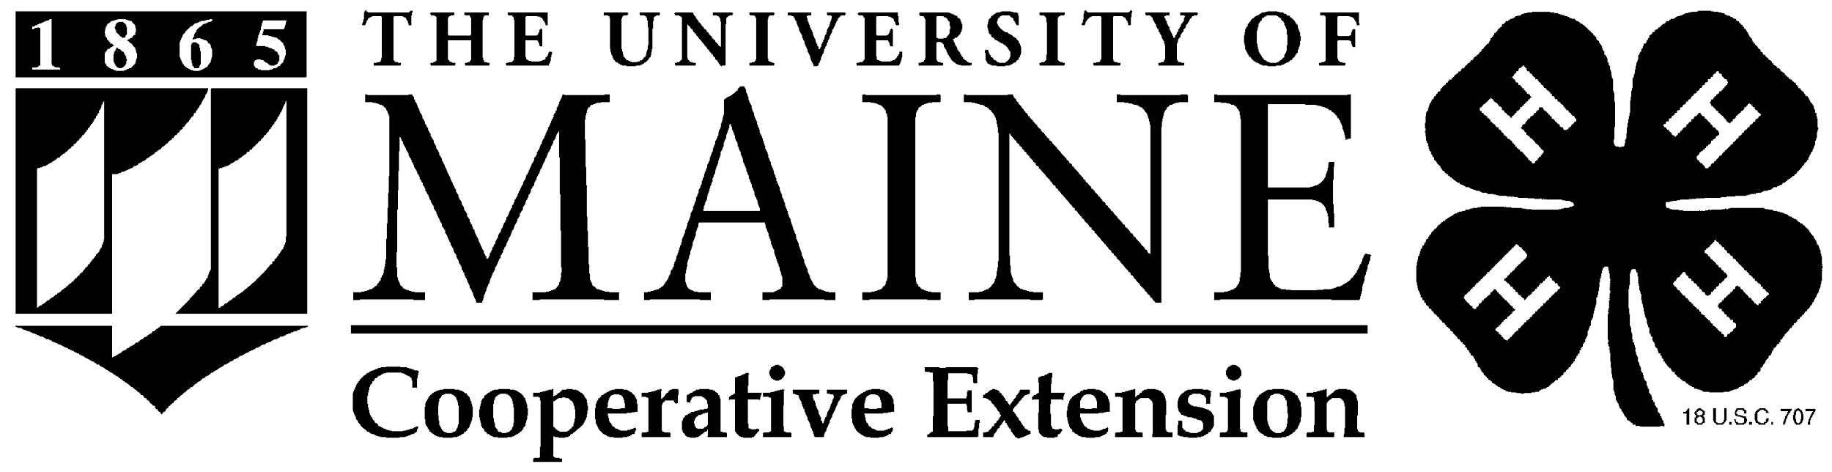

4-H Program Participation Permission,
Agreements, and Photo Release Form

Participant: Please read this form carefully, provide all requested information, and sign and date the bottom of this page.

Name: ___________________________________________________________________________
last, first, middle initial

Mailing Address: ___________________________________________________________________

Town, State, Zip: ___________________________________________________________________

Telephone: (_______) ______________________County____________________________________

Birth Date _______________________ Gender _______________________

Roommate preference (if applicable to this event) __________________, ____________________

As a participant in this program, I understand that I represent myself; my family; my county; Maine; and all Maine 4-H participants, volunteers and staff. By my actions, will 4-H be judged. Therefore, by my signature below, I agree to:

- Participate fully in this program.
- Follow all schedule times including curfew and wake-up hours; to be where assigned, when assigned.
- Follow the Dress code established for this program/event.
- Uphold the highest standards of behavior, manners and language.
- Refrain from using alcoholic beverages, non-prescribed or illegal drugs, tobacco products, or fireworks.
- Respect the rights of others at all times and make every attempt to include all participants in all activities.
- Leave the facilities in the same condition or better than I found them when I arrived.
- Support and follow all leadership and direction received from coordinators, chaperones and any other adult authority.
- Respect the personal space and property of others in all settings including during overnight programs.
- Seek assistance and support from adult chaperones on behalf of myself or others should a situation arise that warrants adult intervention or makes me feel uncomfortable.
- It is the responsibility of the rider or the parent or guardian of the minor rider, to see to it that the headgear worn is properly fitted and in good condition.

I understand that if I break this agreement, I must accept the consequences of my actions, which might include a loss of privileges during this program, loss of 4-H privileges in the future, and/or immediate dismissal from this program as determined by county and/or state 4-H staff.

Signature: ______________________________________________Date: _____________________

Parental Statement – Please sign and date
My daughter/son/ward has my permission to attend this program. I have read and understand the statements they have agreed to above and support this agreement. I realize that I am personally responsible for my daughter/son/ward while they are attending this program. I understand and expect that should my daughter/son/ward break this agreement and the adult coordinators find it necessary to dismiss them from this program, that I am responsible for their transportation home.

Signature: ______________________________________________Date: _____________________

UNIVERSITY OF MAINE SYSTEM AND 4-H PHOTO RELEASE AGREEMENT

I, _____________________________ , (name of person in photo) hereby grant and authorize the University of Maine System, acting through the University of Maine, (hereinafter UMS) and the 4-H Program (defined as 4-H Afterschool, National 4-H Council, 4-H Cooperative Extension System, USDA/NIFA, Maine 4-H Program, 4-H clubs and programs, etc.) its employees and agents to make use of, license or assign the use of, my image, appearance, likeness, voice and/or photograph, and other reproductions of any of these, in still photographs, videotapes, publications, audio, sound recordings, web sites, electronic and other media and/or motion pictures, (hereinafter all of which are included in the term “Material”) obtained during the current 4-H year (October-September) at 4-H-sponsored events, and to do so with or without mention of my name.

I understand and agree that I am to receive no compensation of any kind, monetary or otherwise, on account of or arising from the production, publication, recording, rebroadcasting, or other use of such Material.

UMS shall have complete ownership of the Material produced or published and shall have the exclusive right and license to make such use of that Material as it wishes, including, but not limited to the right of performance, display, reproduction and distribution in all media, and the right to create, perform, display and distribute derivative works of the Material.

I agree to indemnify and hold UMS, the University, its employees, and agents, harmless from and against any and all claims, damages, lawsuits, judgments, and expenses, including reasonable attorneys’ fees that UMS may become liable to pay or defend arising out of or caused by any matter or material furnished or spoken by me in connection with my appearance.

I hereby release UMS, its employees and agents from all expenses, claims and liabilities incurred by me arising out of or in connection with my appearance and/or the use of the Material, except to the extent that those expenses, claims, or liabilities are the direct result of the negligent acts or omissions of UMS, the University, its employees or agents.

This agreement shall be governed and construed according to the laws of the State of Maine.

NOTE: If under 18, must be signed by parent or guardian on last line below.

_______________________________________________________________________________
DATE SIGNATURE OF PERSON IN PHOTO PLEASE PRINT NAME

____________________________________________________________________ ADDRESS PHONE NUMBER
______________________________________________________
SIGNATURE OF PARENT OR GUARDIAN (if applicable)

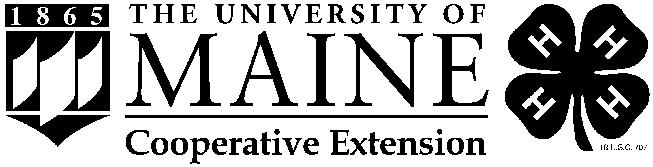
Maine 4-H Health Form

Name: Last First MI Preferred
Home Address: Birth Date Gender Custodial parent(s) or guardian(s) (if under 18):
Name Phone: Home Cell Work
Name Phone: Home Cell Work
Home address (if different from above)
If you are not available in an emergency whom should we notify?
Name Relationship
Phone: Home Cell Work
Address
Insurance Information
Is this person covered by family medical and hospital insurance? Yes ____ No ____
If so, provide carrier and plan name Group #

Health History
The information provided here by the parent, guardian, or adult participant is intended to provide UMaine 4-H health care personnel with the background needed to provide appropriate care, and the program personnel with the information needed to provide a safe, healthy, and appropriate 4-H experience. Any changes to this information should be shared with 4-H staff. This information will not be used to exclude a participant from participation unless the participant cannot perform program requirements with or without a reasonable accommodation, or is determined to be a direct threat to the health or safety of others.

Allergies
- Is this person allergic to any food, medication, or other substance? Yes ____ No ____
If yes, please list all allergens and describe your child's reaction to them:
______________________________________________________________________________________________________________________________________________________________________________________________________________________________________________________________________
- Has this person ever had any unusual reaction to an insect bite or bee sting? Yes ____ No ____
If yes, please explain:
______________________________________________________________________________________________________________________________________________________________________________________________________________________________________________________________________
Medications
- Does this person currently take a prescribed medication or treatment (Including over-the-counter and homeopathic remedies)? Yes ____ No ____ if yes, please complete the Medications section of this form.
- Does this person self-administer any medication, such as an inhaler, or carry and Epipen or Anakit?
Yes ____ No ____

continued on back of form
Please list ALL medications (including over-the-counter medications and homeopathic remedies) taken routinely. Bring enough medication to last the entire program. ALL items should be in their original packaging, bottle, or container that identifies the prescribing physician (if a prescription drug), the name of the medication, the dosage, and the frequency of administration. Attach additional pages if needed.
Medication #1 Dosage Specific times taken
Reason for taking
Medication #2 Dosage Specific times taken
Reason for taking
Dietary Restrictions - Please check all that apply
□ Does not eat red meat □ Does not eat pork □ Does not eat eggs
□ Does not eat poultry □ Does not eat seafood □ Does not eat dairy products
□ Does not eat gluten □ Other (please describe)

Disabilities or Physical Restrictions: Please describe any disabilities or physical restrictions for this person of which you want us to be aware, and any reasonable adaptations or accommodations requested:

Any person who needs accommodations for the program should contact the appropriate UMaine 4-H staff to discuss their needs, preferably at least 21 days in advance.

Please use this space to provide any additional Information about this person's behavior and physical, emotional, or mental health (such as bedwetting, toilet issues, and sleepwalking) that UMaine 4-H staff members should be aware of to provide a safe, healthy, and appropriate experience.

Parent or Guardian Authorization: This health history is correct and complete as far as I know. The person herein described has permission to engage in all program activities except as noted in this Health History. I hereby give permission to UMaine 4-H to provide routine health care, administer prescribed or other medications, and seek emergency medical treatment including ordering x-rays or routine tests. I give permission to UMaine staff to arrange necessary related transportation for my child. In the event I cannot be reached in an emergency, I hereby give permission for the physician selected by UMaine staff to secure and administer treatment, including hospitalization, for my child. This completed form may be photocopied for trips.

Parent, Guardian or Adult Participant Signature

Printed Name Date
I also understand and agree to abide by any restriction placed on my participation in program activities by medical personnel.

Minor or Adult Participant Signature* Date
*if you cannot sign this for religious reasons, contact UMaine 4-H for a legal waiver that must be signed to allow attendance.
A Member of the University of Maine System

University of Maine Release and Assumption of Risk

I, _____________________________ of, __________________________________________
(Parent/Guardian Name) (Address)
acknowledge, declare and agree as follows:

- That I have voluntarily agreed to allow ____________________ (name of child) in the Maine 4-H State Dairy Show from July 24, 2021 to July 25, 2021 and in consideration of my child being permitted to participate in the Program, do voluntarily execute this “Release and Assumption of Risk” on behalf of myself, my heirs and next-of-kin. My personal representatives and my estate.
- That I have been fully informed of the nature, scope and demands of the Program, and understand that the Program may include activities which could be dangerous to my child and other participants and which could cause property damage, bodily injury and/or death.
* See below for specific risks and dangers of the Program
- That the University of Maine System and its University of Maine Cooperative Extension (hereinafter referred to as the “University”) has informed me that there may be dangers and hazards inherent to my child as a result of participating in the Program because of the activities and travel involved, and that I personally recognize and appreciate that such dangers and hazards exist for my child. I accept and assume full responsibility for all harm and injury, of every nature, including death, which may occur to my child or which s/he may suffer or cause to others, and for all damages or loss to any personal property owned by me or damaged by my child or my animal while my child is participating in the Program and during all travel and transportation, and, in furtherance thereof, I agree to indemnify, hold harmless and release the University, its Trustees, faculty, employees, volunteers and agents, from and against any and all claims, demands, actions or causes of action, on account of damage or loss to my personal property, my child’s injury or death, or the bodily injury, death or damage to personal property of others caused by my child or animal , which may occur or result directly or indirectly from my child’s participation in the Program and not as a direct result of any negligent act of the University, its Trustees, faculty, employees, volunteers or agents.
I declare that __________________ (name of child) is able to physically withstand and cope with the indicated rigors of the Program with or without a reasonable accommodation. In complying with the letter and spirit of applicable laws and pursuing its own goals of diversity, the University of Maine does not discriminate on the grounds of race, color, religion, sex, sexual orientation, including transgender status and gender expression, national origin, citizenship status, age, disability, genetic information or veteran status in employment, education, and all other programs and activities. The following person has been designated to handle inquiries regarding nondiscrimination policies: Director, Office of Equal Opportunity, 101 North Stevens Hall, 207.581.1226.
The University provides reasonable accommodations to qualified individuals with disabilities upon request. Any person with a disability who needs accommodations for this program should contact Sarah Sparks to discuss their needs at least 14 days in advance.

- This “Release and Assumption of Risk” shall be construed and interpreted pursuant to the laws of the State of Maine, and if any portion thereof is held invalid, void, unenforceable or illegal, the reminder shall continue in full force and effect.

I declare that I completely understand and have fully informed myself of the terms and conditions of the release and assumption of risk by having read it, or having it read to me, before signing and I intend to be fully bound thereby.

I, _______________________________, the parent or legal guardian of _____________________________________________, agree in consideration of my child being permitted to participate in the Program, to be bound by the terms of this “Release and Assumption of Risk” and hereby indemnify, hold harmless and release the University, its Trustees, faculty, employees, volunteers and agents, in the same manner and with the same force and effect as set forth in section 3 above with regard to my child participating in the Program.

___________________________________ date
Parent or Guardian Signature
(if participant is under age of 18 years)

I (child participant) understand that attendance in Maine 4-H Days is not without risk to myself, members of my family, my guests who may attend, or my animal. I declare that I completely understand the Assumption of Risk” by having read it, or having it read to me, Assented and agreed to on this ____ day of _______________, 20__.

__________________________________
Signature of Participant

*Such dangers, hazards and risks of this activity may include, but are not limited to, injuries inflicted by the following:

Exposure to elements such as severe weather, heat, cold, sun, and biting insects.
Falls from all terrain vehicles, bicycles, skateboards, scooters or other personal transportation devices.
Fall hazards due to varied terrain
Utilizing tools (stove, drill, glue gun, hammer, exposure to hot surfaces, splinters in wood working, etc.) in enrichment workshops.

Revised 06/21

