Approval Form for 4-H Animal Shows
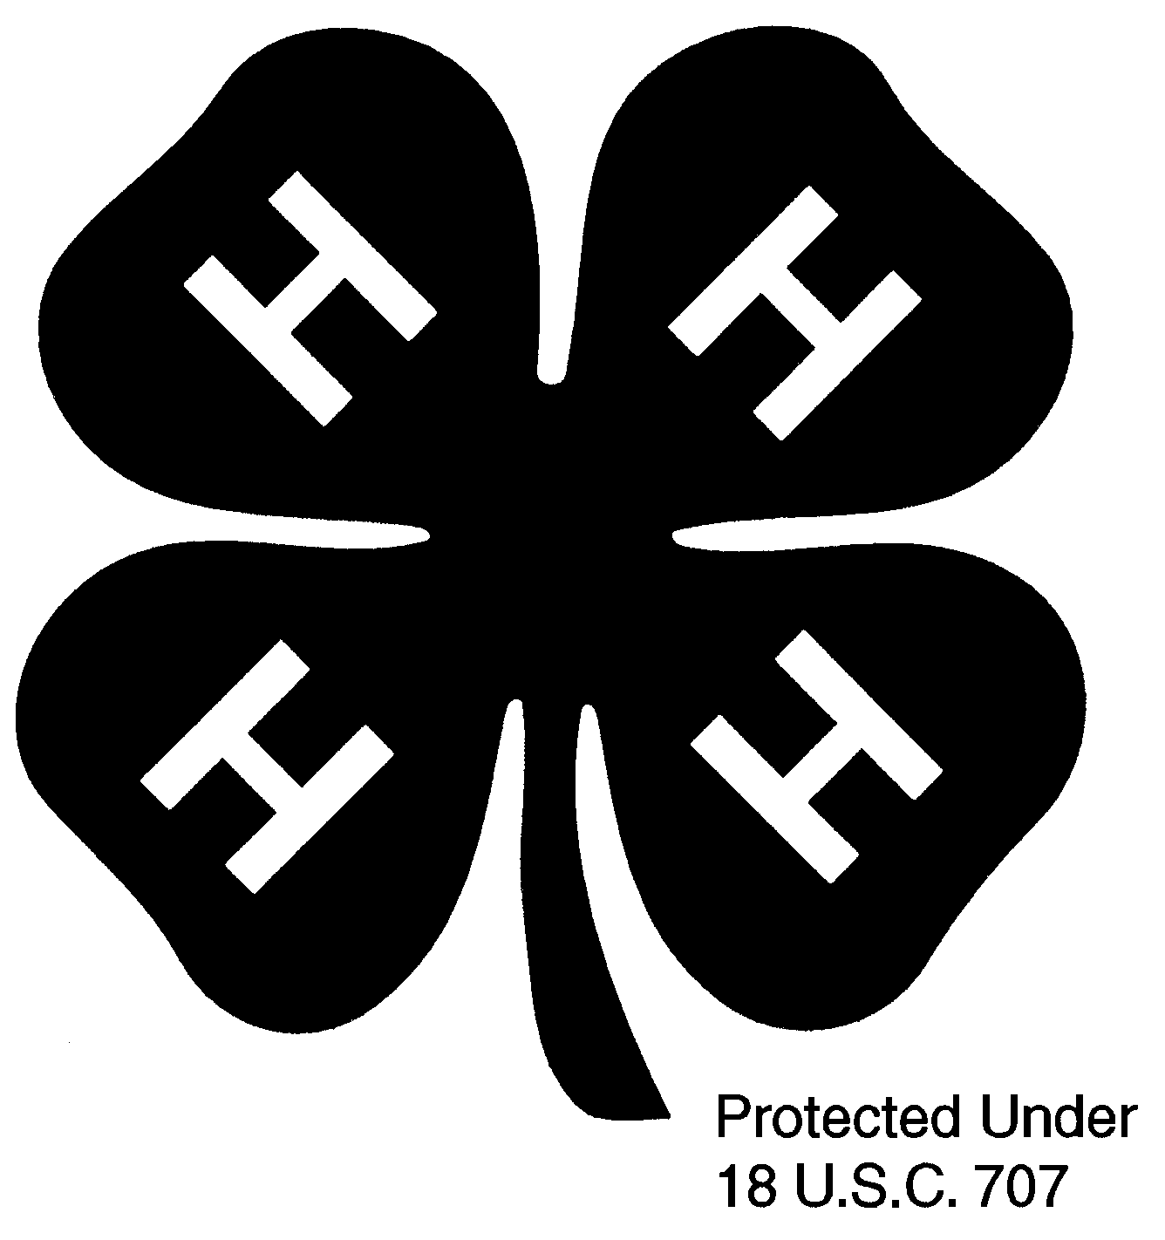

Species of Animal ______________________

Exhibitor’s Name ________________________________________________ Address ____________________________________________
Age as of December 31st of the Current 4-H Year ___________________ Town, State, Zip Code ______________________________________
Club Name (if applicable) __________________________________________ E-mail:
County Where Enrolled _____________________ Telephone # ____________ Statewide Exceptions:
ESE Horses April 1
ESE Dairy May 1
Working Steer May 1

See important instructions for filling out this form on the back.
DEADLINE-All Animals: June 30 Unless an earlier date is designated by a fair premium book.
Name of Animal | Identification Options for each species on back  Chip #, or  Brand, or Ear tag # Tattoo |  | Registration Number | Animal’s  Birth date  Mo/Day/Year | Breed | Show  Class | Date of ownership | Date of Lease | Check Here if Bred by Exhibitor (owned the animal’s dam when she was bred)

There are ______ animals entered on this page.
(number of animals)

Signature of 4-H Staff: _____________________________________________ Date:________________________

Revised 12/2020

DEADLINE-All Animals: June 30 Unless an earlier date is designated by a fair premium book.
Club leader (or advisor for independent member) must sign on the line immediately after last entry. Send form(s)
to County Extension Office. Extension Office will keep original for office records and return an official, embossed photocopy to exhibitor.

Animal Approval form, registration (or a copy), and lease papers should accompany your animal(s) to each show and should be quickly accessible if warranted. Rabbits, poultry and small pets (not including dogs) do not need to be listed on animal approval forms. Each animal must be listed on only one member’s approval form with the exception of horse. Two members who are not siblings or all the children from one family may share the same horse. Members must follow all fair rules concerning the number of animals permitted in shows and will be required to present to fair officials any licenses, registration papers, or certificates of health required by fairs or the state of Maine.

Identification of Animals
- All animals, if they are registered, must provide their registration number.
- If registration has been applied for, sire and dam’s registration numbers must appear on next line. Provide registration number to county office when received.
- Do not use the term “pending” in any column.
Species of Animal | Identification Options
Beef | RFID Tag (“840” tag) – Also list registration # if registered
Dairy | RFID Tag (“840” tag) – Also list registration # if registered
Dog | Staple photo to form, or tattoo
Goat | Tattoo, or microchip #, or scrapie tag -*If using Tattoo or microchip – registration # must also be listed  For kids not born by June 10, list sire and dam registration # on separate lines, or ID of dam and due date or range of due date of doe. When kid’s ID information is submitted at the county office, an amended approval form will be issued.
Horse | Copy of Coggins Test and photo
Sheep | Scrapie tag or microchip – Also registration # if registered
Small Pets/Poultry | An Animal Approval Form is not required for Small Pets/Poultry
Swine | RFID tag, Ear Notching or ear tag - According to fair rules.
Working Steer | RFID Tag (“840” tag) or farm tag *some fair require “840” tags
- Animals to be shown in any 4-H classes this year must be listed on this form. – “Show Class” must be filled in. Fryeburg Sale animals must be listed as “Fryeburg Sale” in this column. NEW THIS YEAR - Your approval form will be handled at the county level. Your steer or lamb should be entered on your regular animal approval form. In the column titled “Show Class” enter Fryeburg Sale. If you do not complete this correctly the animal will not be eligible for Fryeburg’s Sale as there are other sales throughout the state.
- This original form, with 4-H Extension staff’s signature, will be kept in the county office. An official embossed photocopy of this form (copies of photos must be embossed as well) is given to the 4-Her and must be presented to Superintendent of each 4-H show in which you participate, and must agree with information on registration papers.
- Animals with “Registration applied for” may be so indicated, but date of birth of the animal as well as the registration numbers of sire and dam should be listed.
- If animal is “leased,” date should appear in the column headed “Date of Lease.” Copy of lease agreement must accompany the animal approval form. This form does not supersede any requirements in a fair premium booklet.

12/2020 “A Member of the University of Maine System”
In complying with the letter and spirit of applicable laws and pursuing its own goals of diversity, the University System shall not discriminate on the grounds of race, color, religion, sex, sexual orientation, including transgender status or gender expression, national origin, citizenship status, age, disability, or veteran's status in employment, education, and all other areas of the University System. The University provides reasonable accommodations to qualified individuals with disabilities upon request.Questions and complaints about discrimination in any area of the University should be directed to the Executive Director of Equal Opportunity, The University of Maine, Room 101, 5754 North Stevens Hall, Orono, ME 04469-5754, telephone (207) 581-1226 (voice and TDD).

