MAINE 4-H CLOVERBUD PROJECT RECORD

Name: __________________________ Year: ______ County: ______________________

Years in 4-H (include this year): _______________ Age as of 12/31/2022: ____________

Club Name: _______________________________

Section 1: My 4-H Club and Events

Write, draw, photograph, or make a video to tell us about your 4-H Club!

4-H Meetings and Events: (check off each item you did)

- I attended a fair
- I attended 4-H club meetings
- I participated in a community service project
- I attended a special event like June Jamboree, 4-H Fun Days, etc.
- I participated in a 4-H Promotional Event (tractor supply, etc.)
- I completed public speaking (demonstration, fair, county event)
- Other:______________________________________________

CLOVERBUD PROJECT RECORD 1 of 4

Section 2: My 4-H Activities

Tell us about your activities! You can write, draw, share a photograph, or make a video. Duplicate this page as needed.

The name of my 4-H activity is: | The name of my 4-H activity is:
My favorite thing about this activity is: | My favorite thing about this activity is:

The name of my 4-H activity is: | The name of my 4-H activity is:
My favorite thing about this activity is: | My favorite thing about this activity is:

CLOVERBUD PROJECT RECORD 2 of 4
Section 3: My Community

Helping others is important. Let’s learn how to explain your community service project. Use the sentence starters to guide you.
Who we helped:
What we did:
When we did it:
Where we did it:
Why we did it:

Now use the information to write, draw of share a photograph of the community service activity you completed this year.

The community service activity that I completed was:

CLOVERBUD PROJECT RECORD 3 OF 4
Section 4: 4-H Life Skills I Used This Year

This is the Life Skills Wheel, it’s how we connect the skills we learn through our projects as they relate to the big picture of what 4-H is. For Cloverbuds, we want you to look at the big 4 in the middle: Head, Heart, Hands, and Health. For now, that’s what we want you to focus on, but see all the amazing skills related just to that one H!
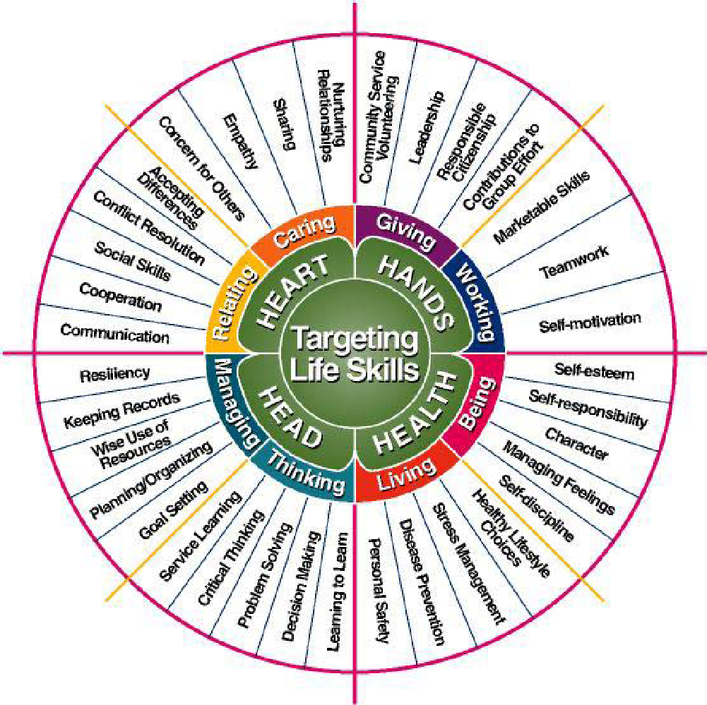
Life Skills Wheel Source: Iowa State Extension

- I have put in my best effort to complete this project record.

___________ _________________________________________
Date Member Signature

___________ _________________________________________
Date 4-H Volunteer/Staff Signature

CLOVERBUD PROJECT RECORD 4 of 4

