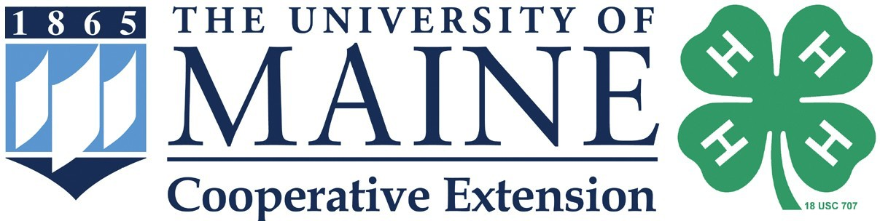

2024 Maine 4-H Sheep Team

Eastern States Exposition Intent to Participate Form

I , am interested in attending the Eastern States Exposition in West Springfield, Massachusetts in September as a member of the Maine 4-H Sheep Team.
I am interested in bringing (number and breed)
Aged Ewe

Yearling Ewe
Yearling Ram
Ewe Lamb

Ram Lamb

Age as of December 31, 2023: (You must be 12 years old as of December 31, 2023)

Number of years in 4-H sheep project:
year)
(You must have completed one year in a sheep project prior to this

Mailing address: Town Zip Code Telephone Number: County of 4-H Enrollment: Youth E-Mail address: Parent’s E-Mail address: Member’s Signature: Parent/Guardian Signature: Date: County Staff will be contacted to verify that 4-H’er re-enrolled by December 31 of the current 4-H year.
This form indicates your intent to participate in the 2024 Eastern States 4-H Sheep Show as a member of the Maine 4-H Sheep Team. This form must be completed and postmarked by April 19, 2024 to be eligible for the 2024 Maine 4-H ESE Sheep Team. This form alone does not enroll the member on the Maine 4-H ESE Sheep Team.
Return Intent to Participate Form to: Megan Cook
megan.cook@maine.edu
UMaine Cooperative Extension Aroostook County Office
25 School St., Suite 210, Houlton, ME 04730

