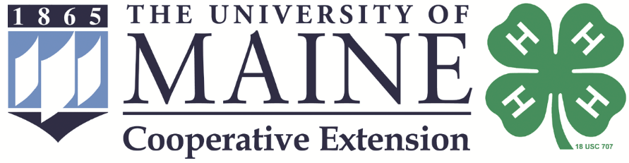

Maine 4-H State Dairy Show

and Eastern States Tryouts

2024

July 19-21, 2024
Windsor Fairgrounds, Windsor, ME

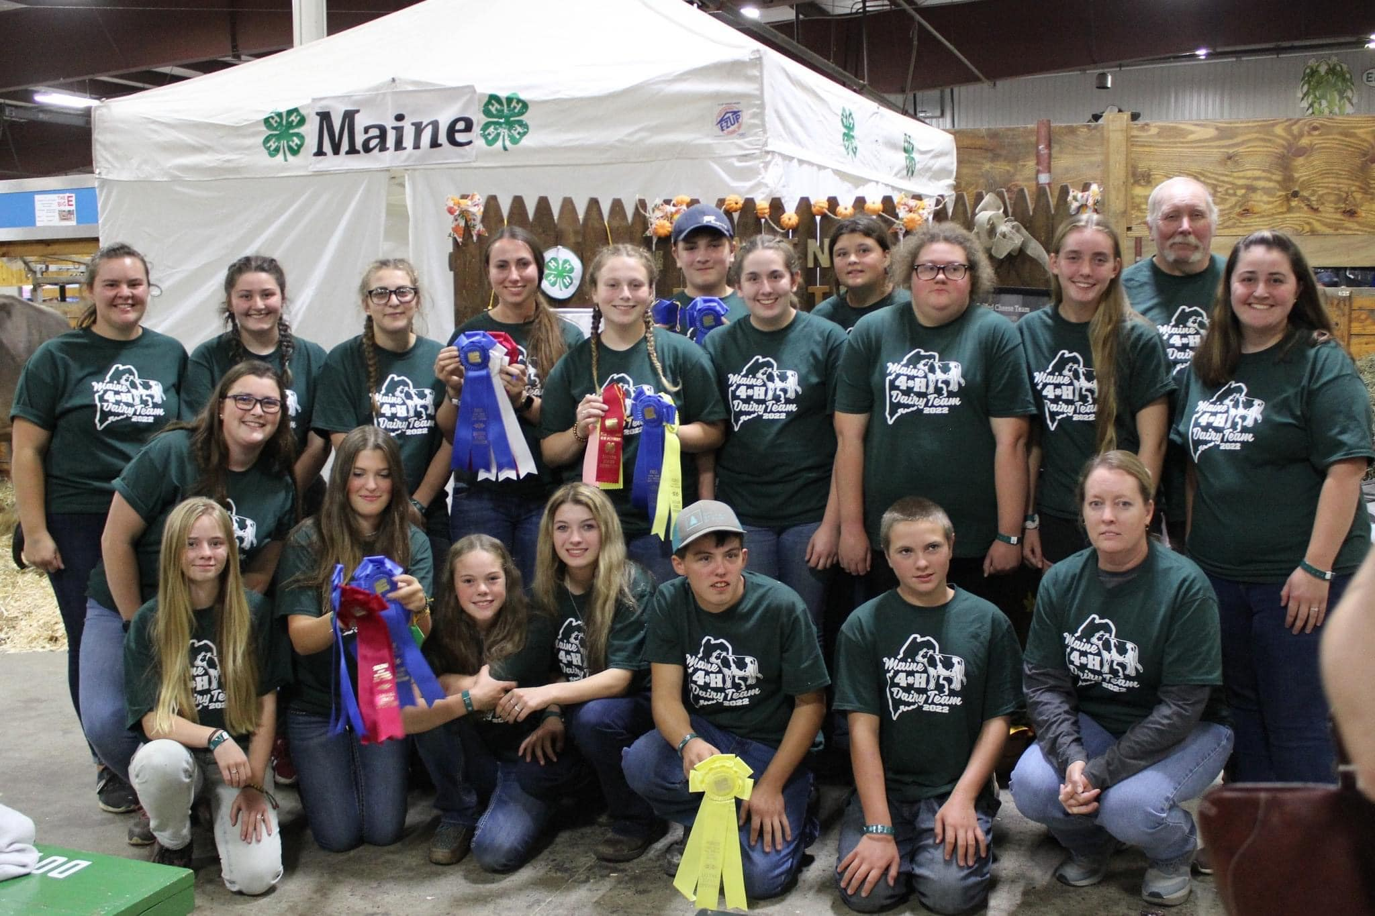

Registration Packet for 4-H Members

Table of Contents
Welcome Letter | 3
Schedule | 4
General Rules and Information | 5
Dairy Fitting Contest | 7
Grilled Cheese/Milkshake Contest | 8
Classes for Maine 4-H State Dairy Show | 10
Guidelines to Qualify for the Maine 4-H ESE Dairy Team | 11
State 4-H Dairy Show Registration Form | 14
Assumption of Risk Form | 15

4-H Dairy Project Member and Family,

Congratulations on taking the first step toward participating in the Maine State 4-H Dairy Show which is open to all Maine 4-H dairy project members 4-H age 9 and above! Check out this packet and make plans to come to the Maine State 4-H Dairy Show and Eastern States Exposition team tryouts. The Maine 4-H State Dairy Show will be held at the Windsor Fairgrounds from July 19th-21st.

4-H’ers will not need to pre-register animals ahead of time. Just bring the animals you plan to show along with all of their paperwork, and we will record your information at the show office.

4-H members who wish to participate in the Maine 4-H Days events (Friday evening and Saturday) will need to register online at https://extension.umaine.edu/4h/maine-4h-days/. Participants need to register in advance for the Maine 4-H State Dairy Show. You will find a registration page, a photo release, a code of conduct to sign as well as health forms in this packet. There is also a place for your chaperone and parent to sign if parents will not be attending. Registration forms can be sent to Sadee Mehuren at 992 Waterville Rd. Waldo, ME 04915 or sadee.mehuren@maine.edu. Registration can also be done online at http://extension.umaine.edu/4h/maine-4-h-state-dairy-show-registration-form/.

All forms are available at extension.umaine.edu/4h/animal-science-resources/dairy/. Please see enclosed State Dairy Show rules as well as Eastern States Selection process rules. Contact the State 4-H Office if you are having problems with this link, 1-800-287-0274 or contact your county Cooperative Extension office.

The dates for the 2024 events are as follows:

February 15 | Intent to participate in Eastern States Exposition Dairy Team
February 17 | 4-H Dairy Quiz Bowl, University of Maine at Augusta
April 13 | 4-H Dairy Judging,
May 1 | 4-H Animal Approval and Lease Forms due for ESE Dairy team members
July 20 | Grilled Cheese Contest 1:00 pm at Windsor Fairgrounds
July 20 | Fitting Competition at 5:00 pm at Windsor Fairgrounds
July 20 | Meeting with State Dairy Show Judge after Fitting Contest
July 21 | Maine State 4-H Dairy Show
Sept 12-15 | Eastern States Exposition in Massachusetts

Whether you are attending for the first time or are a veteran, please read this packet very carefully.

Sincerely,
The Maine 4-H Dairy Science Committee
2024 Schedule
State 4-H Dairy Show and Eastern States 4-H Dairy Team Tryouts

Friday | July 19
 | 4:00 pm | Arrival and check in begin
Saturday | July 20
 | 6:00 am | Arrival and check in continue
 | 2:00pm | 4-H Grilled Cheese/Milkshake Competition
 | 5:00 pm | 4-H Dairy Fitting Contest
 | 7:00 pm | Potluck Dinner and Games
Sunday | July 21
 | 6:00 am | Fundraising breakfast*
 | 8:00 am | All animals must be on the grounds
 | 8:30 am | Check in closes
 | 9:00 am | State 4-H Dairy Show
Directly following the State 4-H Dairy Show will be a Maine 4-H Dairy ESE team meeting/orientation.

Dairy committee members will be available to answer questions for new participants. Please see 4-H dairy committee staff liaisons or activity coordinators for more information.

*Breakfast will be $5 per person. All proceeds support the Maine 4-H ESE Dairy Team.
Rules and Information for the 2024 Maine 4-H State Dairy

- Eligibility: Exhibitors must be enrolled in a dairy project in the current 4-H year and must be 4-H age 9-18 (4-H age is determined by your age on December 31st of the previous year).

- Divisions:
  - A: Seniors: 4-H age 14 - 18
  - B: Intermediates: 4-H age 12 -13
  - C: Juniors: 4-H age 9 - 11
  - D: Novice – any fist year participant regardless of age. Member may elect to show in their age group if desired but may only show in 1 group.
- Animals to be Shown Per Exhibitor:
  - Division A- limit of 5 animals
  - Division B- limit of 4 animals
  - Division C- limit of 3 animals
  - Division D follows the limit per their age group (in Division A-C)
Entry application: Pre-entry of animals required but is strongly encouraged. Animal entry forms can be found online in the State 4-H Dairy Show online registration form as well as in this packet. Those who do not complete the animal entry form prior to the event will need to complete their entries by 8:30AM on the day of the show. The 4-H Dairy Committee members or staff liaison will check your paperwork. You must have a copy of your registration for all animals born prior to January 1, 2024. Pending paperwork will only be accepted for animals born on or after January 1st, 2024. See Eastern States eligibility rules on page 9. All animals must be on the grounds by 8:00 am Sunday and all paperwork checked by 8:30 am.
Members must pre-register themselves (form enclosed and available online).

Forms for Animals: 4-H animal approval forms, lease agreements (if applicable), and registration papers, must be available upon arrival. Problems obtaining registration papers must be reported to the Maine 4-H dairy prior to arrival. This person is Sadee Mehuren at 207.342.5971 or sadee.mehuren@maine.edu or Allison Pollock at allison.pollock@maine.edu.

Health of Animals: Animals showing evidence of external parasites, foot rot, shipping fever or other infectious diseases (including ringworm, pink eye, mange, and warts) will be excluded and removed from the exhibition unless written verification from a licensed veterinarian is presented upon registration stating animal is not infectious. All animals are subject to State Veterinarian checks during the event. Vaccination for rabies is highly encouraged, but not required for participation.

Show Uniform: Required dress is white pants and a white collared, button-down shirt or blouse that is tucked in. Belts are suggested to keep shirts/blouses tucked in. Advertising a farm name or breed on clothing, wearing extremely brief shorts, or appearing barefoot will not be allowed. Sturdy shoes or boots are recommended.

Exhibitor Ethics: No interference or abusive language will be allowed when the judges, show officials and state veterinarian are discharging their duties or at any time during the 4-H event. Exhibitors should not leave the ring until excused by the judge. Violation of this rule will result in your not being permitted to show for the rest of the day.
- Bedding, Feed and Equipment: Bedding will be provided by donation from Hammond Lumber. Each exhibitor is responsible for providing their hay, grain, feed/water pails, forks and equipment. It is recommended that you place your name on all personal equipment.

Judging: The modified Danish System will be used with exhibitors and animals lined up in numerical order. Ribbons will be awarded in three categories: blue, red, and white. Rosettes and/or trophies will be awarded in championship classes, the first-place showmanship winners, and the overall showmanship winner.

Showmanship: Members will be grouped according to age of the exhibitor; larger classes may be divided in half to aid in judging. Members must show their own animal in their showmanship class.

Adults Interference: Adults are not permitted to fit animals on the show grounds.

Maine 4-H Dairy Fitting Contest

The Fitting Contest will take place on Saturday, July 20th at 5:00 pm in conjunction with the 2024 Maine State
4-H Dairy Show. All Maine 4-H dairy members 4-H ages 9-18 are welcome to participate, regardless of whether they wish to try out for the ESE Fitting Team.
Rules for participation:
  - Participants will provide their own animal for the contest.
  - The contest animal must be unclipped (meaning not touched at least six weeks prior to the contest and at the discretion of the judge). The unclipped rule will be strictly enforced.
  - The animal should be head clipped only, clean, and dry.
  - Animal must comply with health requirements.
  - The contest will take place in the animal stall/clipping chute, or other area as designated by the event officials.
  - Contestants will be divided into two categories based on 4-H age: Jr.’s ages 9-11 and Sr.’s ages
  - Placings will be based on quality of the fitting completed as well as quality of the work as it was done.

Contest Instructions: At the start of the contest, instructions will be given, and animals will be previewed by the judge. Participants will give one hour to fit their animal to the best of their ability. At the close of the hour the judge will evaluate the work of the contestants and select his placings.

Team Selection: The top 3 seniors will become the 2024 Maine 4-H Dairy Fitting Team for ESE. Alternates will be listed in order of the judges placing.

Maine 4-H Dairy Grilled Cheese/Milkshake Contest

The grilled cheese and milkshake contest will take place on July 20th at 2:00pm. The objectives of the contest are to provide an interactive and fun learning experience around food preparation and food safety. The contest is open to enrolled 4-H dairy members 4-H ages 9-18. Participants will be divided in to two divisions based on their 4-H age, Jr’s (9-11) and Sr.’s (12-18).

Grilled Cheese Contest
Rules for participation:
- 2 categories will be judged:
- Bread, butter, and cheese (anything from those categories)
- Anything goes (substitute bread and/or butter) grilled cheese with 60% of sandwich filling being cheese
- One judge will officiate the contest. They can ask questions during preparation as well as during tasting.
- Contestants will be judged while they are preparing the food, including food handling and food safety.
- Contestants will be judged on sanitizing stations before, during and after competing.
- All perishable items must be kept in a cooler with ice and stores at safe temperatures (below 45F) and all foodstuffs must be stored off the ground.
- All competitors must wear grilling hats, aprons, and gloves when handling food stuffs.
- Each competitor will have 15 minutes to complete their grilling.

Supplies:
The Maine 4-H Dairy Team will provide the following:
- Electric griddle
- Spatulas, knives, and other utensils needed to prepare the sandwich
- Grilling hats
- Aprons
- Gloves
- Hand sanitizer
- Cutting boards
- Plates
- Bread, butter, and cheese

Contestants must provide the following:
- Any additional ingredients beyond bread, butter, and cheese

Judging Breakdown:
Contestants must present one sandwich to the judge and provide an explanation of their dish.
Contestants will be scored using the following breakdown:
- Creativity = 10 points
- Cleanliness = 10 points
- Food handling/safety = 20 points
- Presentation = 20 points
- Taste = 20 points

Milkshake Contest
Rules for Participation:
- Contestants must provide all materials required to complete their milkshake including supplies, ingredients, and embellishments.
- Milkshakes must be made from cow’s milk- no nondairy milk is allowed.
- Each contestant will have 15 minutes to prepare their milkshake and 3 minutes to prepare for presentation.
- One judge will officiate the contest.
- Each contestant must provide one milkshake for judging.
- Each contestant must provide a recipe with all ingredients listed

Judging Breakdown:
Contestants will provide one milkshake to the judge and provide an explanation of their milkshake.
Contestants will be scored using the following breakdown:
- Design: 10 points
- Taste: 10 points
- Presentation: 10 points

Classes for Maine State 4-H Dairy Show

- Showmanship – Division A members 14 through 18 as of January 1 of the current year
- Showmanship – Division B members 12 and 13 as of January 1 of the current year
- Showmanship - Division C members 9 through 11 years as of January 1 of the current year
- Showmanship – Novice – 1st year participants – members may elect to show in own
age group if desired but may only show in one group.

Overall Showmanship Champion
- Spring Heifer Calves – March 1, 2024, to April 30, 2024
- Winter Heifer Calves – December 1, 2023, to February 28, 2024
- Fall Heifer Calves – September 1, 2023, to November 30, 2023
- Summer Yearling Heifers – June 1, 2023, to August 31, 2023
- Spring Yearling Heifers – March 1, 2023, to May 31, 2023
- Winter Yearling Heifers – December 1, 2022, to February 28, 2023
- Fall Yearling Heifers – September 1, 2022, to November 30, 2022, not in milk; yearlings which have calved, will show in junior 2-year old class.
- Junior Champion (winners of classes 5-11)
- Junior Animal Bred and Owned by Exhibitor (best bred and owned in classes 5-11)
- Junior 2 Year Olds – March 1, 2022, to August 31, 2022
- Senior Two Year Olds – Sept. 1, 2021, to February 28, 2022
- Three Year Olds – Sept. 1, 2020, to August 31, 2021
- Four-Year Old and Older Cows – Born before September 1, 2020
- Dry Cow – any cow that has calved but is not in milk and has not shown in any of the above
classes.
- Senior Champion - winners of classes 14-18.
- Senior Animal Bred and Owned by Exhibitor (best B & O animal in classes 14-18)
- Grand Champion – winners of classes 12 and 19
- Eastern States Selection (see rules). All qualifying animals will be lined up in the same order of in their respective classes from spring calves through four-year-old and over cows.

Grade animals will be exhibited with the breed they most closely resemble. Grade animals are not eligible for Eastern States selection.

All animals bred and owned (B&O) by exhibitor will receive a special ribbon and be recognized in each type class. Only the highest placing animal bred and owned by exhibitor in each class will compete in classes 13 and 20. Members must have owned the dam at time of breeding to be considered as the breeder of the animal exhibited.

Reminder: Each animal must be listed on a 4-H Animal Approval Form signed by your 4-H leader and your Extension 4-H Staff. An animal may only appear on one 4-H member’s approval form. Approval forms must be signed and embossed prior to May 1, 2024, to be eligible for Eastern States consideration. Animal Approval Forms must be dates by June 30th for all other members. If you lease an animal, the lease form must also accompany your approval forms. All forms are available at extension.umaine.edu/4h/forms.

Guidelines to Qualify for the Eastern States Dairy Team

Eastern States Team Selection

Please be sure to read these rules as they are different than the state show.

Registration: Members and their animals must be entered in the Maine 4-H State Dairy Show in accordance with the general rules and application forms.

Eligibility of Members
  - Maine 4-H members may attend Eastern States in up to, but no more than, two commodities for which they qualify, in any given year, if their participation in two commodities does not prevent the participation of another 4-H member who would be attending in only one commodity and if the two commodity programs at the Eastern States Exposition do not conflict or overlap during the Exposition.
  - Member must be 12 years of age or older but not over 18 as of December 31st of the previous year.
  - Any member exhibiting a milk cow will be the only person allowed to milk his/her animal. No other 4-H’er is allowed to care for the animal. If your cow needs to be milked between 10 pm and 6 am you must ask a Maine chaperone to do this for you. 4-H’ers may not leave the dorm at night.
  - Members must have completed at least one year in the Maine 4-H Dairy Program.
  - Members must participate in a showmanship class at the State 4-H Dairy Show and show their own animal to bring an animal to ESE.
  - Must have completed an ESE Intent to Participate Form prior to February 1 of the current show year.
  - Members must have participated in at least one of the following three programs/categories during the current 4-H year.
    - State 4-H Dairy Quiz Bowl Contest
    - State 4-H Dairy Judging Contest
    - State 4-H Dairy Fitting Contest (at the 2023 Maine 4-H Dairy Show)

Eligibility of Animals

- Selection is limited to registered female animals. The percentage RHA must follow breed requirements to show. For example, any Holstein must be at least 87% RHA to be allowed to show at ESE.
- All animals must have a registration paper and/or satisfactory lease agreement showing the date of ownership as of or before May 1st of the current year for calf and yearling classes, and May 1st of the year in which the animal was a yearling for cow classes. The Maine 4-H lease form must be used to be eligible for Eastern States and the State 4-H Dairy Show. Obtain lease form online or at your county office.
- The approval form, rabies certificate, the registration paper, and the lease agreement (if applicable) must be available for inspection upon arrival at the fairgrounds. This will enable the animal’s papers to be checked against the animal’s color markings or a tattoo. The animal approval form can be obtained from your county office.
- Animals must be listed on a signed and embossed copy of the 4-H members animal approval form that was received at their county office by May 1st of the current year. Each animal will be listed on only one member’s approval form.

Selection Process
- Although each state is limited to 35 youth delegates and 35 alternates, the Maine 4-H ESE Dairy Team does not have to equal the limit.
- The Maine 4-H Dairy Fitting Team will consist of three members who must have been 12 years of age on December 31st, 2023. Fitting team members for ESE must meet the eligibility requirements as if taking an animal to ESE. The contest to select the team will be held at the Windsor Fairgrounds on July 22, 2023, in conjunction with the Maine 4-H State Dairy Show. Each State may send one fitting team consisting of three members to Eastern States.
- The Eastern States Selection class will immediately follow the Grand Champion and Best Senior Animal Bred and Owned by Exhibitor classes at the State 4-H Dairy Show if youth desire this opportunity. Animals will be lined up in the order that the judge feels best represents the State of Maine. If a member qualifies with more than one animal the member may choose which animal will be taken to ESE by August 1st provided an alternate application paper has been submitted. If the alternate is needed, you must check with the Maine 4-H Dairy Project Team Liaison, Sadee Mehuren at 207.342. 5971 or e-mail sadee.mehuren@maine.edu.
- All ESE team members must attend an orientation meeting immediately following the conclusion of the State 4-H Dairy. This is where you will receive information of who your chaperones are as well as youth and animal transportation providers. You will also have the option to order team attire.
- ESE Dairy Cattle Signature Forms are due to the Maine 4-H Dairy Staff Liaison by August 20th. Please send them to Sadee Mehuren at the University of Maine Cooperative Extension, 992 Waterville Rd. Waldo, ME 04915. No entries will be accepted after this date. Failure to return the entry application by this date will result in loss of team membership to the highest available alternate. Please plan to fill out your paperwork and turn in your ESE paperwork at the State 4-H Dairy Show. ESE requires that a copy of your animal’s registration paper be submitted with your application.
- All delegates are responsible for completing their own online entries for their animals. Online entries can be done online at https://thebigel.fairwire.com/ and must be completed by August 24th for participation. Those who do not meet the entry deadline will not be eligible for participation.
- Payment for any transportation to ESE will be required with your ESE entry application. Checks for transportation are made out to the University of Maine in the amount of $60.00. If your money has not been received, you will not be allowed to go to ESE. If you have any questions regarding this matter, please contact Sadee Mehuren at 207.342.5971 or sadee.mehuren@maine.edu.
- Delegates and alternates are encouraged to have a veterinarian conduct necessary tests early enough to meet Eastern States Exposition health requirements. A health chart is required for travel to ESE and may be done any time after January 1st, 2024.

Transportation of Animals
Animal transportation and team transportation is arranged through the State 4-H Office by Sadee Mehuren. All team members will use this transportation. We must pay for the bus and all team members are expected to ride home on the bus. In certain cases, exceptions are made. These exceptions must be made prior to leaving. If you are considered for this exception, you may not leave until all the equipment and cattle are loaded and the last team truck has left. The exception paperwork must be completed, signed by parent, and given to the coordinator prior to boarding the bus to ESE.

ESE Barn Dress Code
  - All clothing shall be neat, clean, acceptable in repair and appearance, and shall be worn within the bounds of decency and good taste as appropriate for 4-H events and activities.
  - 4-H shirts and state logos are strongly encouraged.
  - Clean knee-length shorts, pants or dress jeans are strongly encouraged. The inseam length of shorts must be 4” or longer.
  - Hair should be clean and neatly combed.
  - Footwear deemed appropriate by your respective program must be worn. No open toed shoes or flip-flops will be allowed in the barns.
PROHIBITED ATTIRE
- Clothing displaying profanity, products or slogans are prohibited.
  - Cut off shorts, torn or frayed jeans are prohibited.
  - Exposed bare midriffs (front or side), bare chests, visible cleavage, undergarments (including bra straps) or transparent (see-through) clothing are prohibited. Blouse straps should be least 2” wide.
  - Spaghetti straps, tank tops, shirts that expose a bare back, halter tops and tube tops are prohibited.
  - Excessive baggy or tight clothing is prohibited.

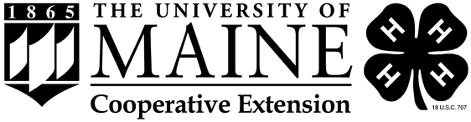
Maine State 4-H Dairy Show Registration Form

NAME:____________________________________ 4-H AGE _________________________________

ADDRESS:__________________________________________________________________________

TOWN:____________________________________ ZIPCODE:_______________________________

PHONE: __________________________________ EMAIL:__________________________________

EMERGENCY CONTACT: ________________________________ PHONE: _____________________

Number of animals you will bring: _____________
Seniors (age 14-18): limit of 5 animals
Intermediates (age 12-13): limit of 4 animals
Juniors (age 9-11): limit of 3 animals

What day do you plan to arrive? ________________________________________________________
Arrival begins Friday at 4:00pm. All animals must be on the grounds by 8:00am on Sunday.

Do you intend to participate in the following:

_____ Maine 4-H Fitting Contest (you will need to bring an unclipped heifer to use in the contest)

_____ Maine 4-H Grilled Cheese/Milkshake Contest

Please return completed forms to Sadee Mehuren via email to sadee.mehuren@maine.edu or mail to:

Waldo County Cooperative Extension Office
Attn: Sadee Mehuren
992 Waterville Rd.
Waldo, ME 04915

Completed registration forms must be received by July 20, 2024.

Registration form can also be completed online at extension.umaine.edu/4h/dairy/maine-4-h-state-dairy-show-registration-form/.
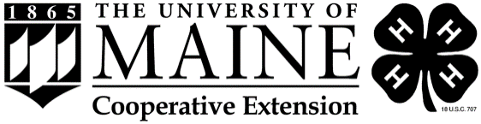
A Member of the University of Maine System

UNIVERSITY OF MAINE SYSTEM RELEASE AND ASSUMPTION OF RISK
I, ______________________________ of ________________________________________________ (Name) (Address)
having been born on _______________________________, acknowledge, declare and agree as follows: (Date of Birth)
1. That I have voluntarily agreed to participate in the Maine 4-H State Dairy Show from July 19, 2024 to July 21, 2024 and in consideration of being permitted to participate, do voluntarily execute this "Release and Assumption of Risk" on behalf of myself, my heirs and next-of-kin, my personal representatives and my estate.
2. That I have been fully informed of the nature, scope and demands of this activity, and I understand that participating may include activities which could be dangerous to me and others and which could cause property damage, bodily injury and/or death. *See below for specific risks and dangers of the activity
3. That the University of Maine System and its University of Maine Cooperative Extension, (hereinafter referred to as the "University") has informed me that there may be dangers and hazards inherent to participants because of the activities involved, and that I personally recognize and appreciate that such dangers and hazards exist. I accept and assume full responsibility for all harm and injury, of every nature, including death, which may occur to me or which I may suffer or cause to others, and for all damages or loss to any real or personal property owned by me or damaged by me, while I am participating and during all travel and transportation, and, in furtherance thereof, I agree to indemnify, hold harmless and release the University, its Trustees, faculty, employees, volunteers and agents, from and against any and all claims, demands, actions or causes of action, on account of damage or loss to my real or personal property, my personal injury or death, or the personal injury, death or damage to real or personal property of others caused by me, which may occur or result directly or indirectly from my participation in the activity and not as a direct result of any negligent act of the University, its Trustees, faculty, employees, volunteers or agents.
4. I declare that I am able to physically withstand and cope with the indicated rigors of this activity with or without a reasonable accommodation. If an accommodation is needed, I will contact ___________________.
5. This "Release and Assumption of Risk" shall be construed and interpreted pursuant to the laws of the State of Maine, and if any portion thereof is held invalid, void, unenforceable or illegal, the remainder shall continue in full force and effect.
I DECLARE THAT I COMPLETELY UNDERSTAND AND HAVE FULLY INFORMED MYSELF OF THE TERMS AND CONDITIONS OF THIS "RELEASE AND ASSUMPTION OF RISK" BY HAVING READ IT, OR HAVING IT READ TO ME, BEFORE SIGNING AND I INTEND TO BE FULLY BOUND THEREBY.
Assented and agreed to on this _____ day of _____________, 20____.
________________________________________________________
(Signature of Participant)
I, _____________________________, the parent or legal guardian of, _________________, agree, in consideration of my child being permitted to participate in this activity, to be bound by the terms of this Release and Assumption of Risk and hereby indemnify, hold harmless and release the University, its Trustees, faculty, employees, volunteers and agents, in the same manner and with the same force and effect as set forth in Section 3 above with regard to my child participating in the activity.
_______________________________________________________
Parent or Guardian Signature (if participant under the age of 18 years)
* Such dangers, hazards and risks of this activity may include, but are not limited to, injuries inflicted by the following:
Exposure to elements such as sever weather, heat, cold, sun, and biting insects.
Falls from all-terrain vehicles, bicycles, skateboards, scooters, or other personal transportation devices.
Fall hazards due to varied terrain.
Direct contact with livestock.
Potential exposure to COVID-19 while in a small outdoor group setting.
Use of cooking equipment including a griddle, knives, etc.

Maine 4-H Dairy Show
Animal Entry Form

Exhibitor__________________________ 4-H Age _______________ Birthdate ______________ (Age on January 1 of this year)

Animal Information:
Animal #1

Breed_______________________ Show Class__________________ Birthdate_________________

Name_________________________________________ Registration #_______________________

ID or Tattoo # ___________LE __________ RE Bred & Owned Y or N

Animal #2

Breed_______________________ Show Class__________________ Birthdate_________________

Name_________________________________________ Registration #_______________________

ID or Tattoo # ___________LE __________ RE Bred & Owned Y or N

Animal #3

Breed_______________________ Show Class__________________ Birthdate_________________

Name_________________________________________ Registration #_______________________

ID or Tattoo # ___________LE __________ RE Bred & Owned Y or N

Animal #4

Breed_______________________ Show Class__________________ Birthdate_________________

Name_________________________________________ Registration #_______________________

ID or Tattoo # ___________LE __________ RE Bred & Owned Y or N

Animal #5

Breed_______________________ Show Class__________________ Birthdate_________________

Name_________________________________________ Registration #_______________________

ID or Tattoo # ___________LE __________ RE Bred & Owned Y or N

