Final Report
Assessing the Farm Safety Needs of Farmers & Farm Workers in Maine
Submitted to Northeast Center for Agricultural & Occupational Health (NEC)
By Dr. Richard J. Brzozowski
July 15, 2010

Objectives
This project will identify benchmarks for current farm safety issues and needs of farmers and farm workers. The safety needs will be determined and prioritized so as to better address these needs through educational programming.

Procedure
A survey was drafted by Principal Investigator, Richard J. Brzozowski in the fall of 2009 and reviewed by Dr. John May of the Bassett Hospital; Dr. Ron Jester retired Extension Farm Safety Specialist, University of Delaware; Cooperative Extension colleagues in Maine; Cooperative Extension colleagues outside of Maine (NY and Wisconsin); and Maine Department of Education (Vocational Agriculture state coordinator).

The survey instrument as well as the process was submitted for approval for use with human subjects at the University of Maine in Orono, Maine in November, 2009. The survey was adapted with the necessary statements and directions for the user. Due to policy requirements of the University of Maine, no one under the age of 18 was invited or allowed to complete this survey.

The survey was first used in a hard copy version with over 100 beef producers at the Maine Beef Producers Seminar held on Saturday, December 2, 2009 in Bangor, Maine. As an incentive, a pair of safety glasses was given to each individual who completed the written survey. It appeared that the participants understood the questions and the feedback after the survey was positive. It took approximately 15 minutes for each person to complete the questionnaire. Participants were asked not to provide their own identity or the identity of any person mentioned in their responses.

Following this statewide seminar, the survey was formatted electronically and prepared to be sent out to farmers throughout the state of Maine. Brzozowski acquired mailing lists from Extension colleagues all over the state. They included livestock producers, dairy producers, vegetable and small fruit producers, apple producers and potato producers from existing Extension mailing lists. These lists were merged so as to eliminate duplicate addresses. A listing of email addresses was separated. The survey was sent to the email mailing list initially. Over the next few weeks several hundred were sent in hard copy form to others (where no email address was known). See the attached cover letter that was sent with the survey.

As incentive to complete the survey, a chance at one of five prizes was offered. After completing their survey, each person was asked to send an email message or a special post paid notification card to the investigator stating they completed the survey and they wished to be a part of a random drawing for a possibility of receiving one of five $50 gift certificates. The certificates would be purchased from a local seed dealer, farm & feed store, agricultural supplier, equipment dealer or hardware store depending on the winner’s choice.

In addition, Brzozowski worked with the two statewide organizations; the Maine Farm Bureau (MFB) and the Maine Organic Farmers & Gardeners Association (MOFGA). MFB and MOFGA sent the survey electronically to their respective clientele.

We estimate that the survey reached more than 3,000 individuals across Maine.

Survey Results Summary
In the following pages, the results of the survey will be presented in graphic form with comments. The charts and graphs are presented in numerical order as they appeared in the survey.
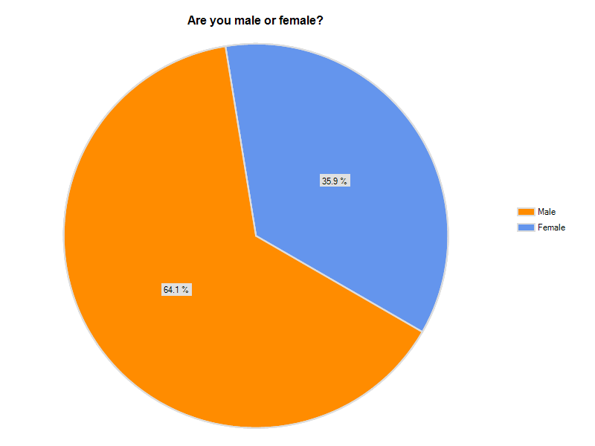
Question 1 Results

Comments: This response from survey respondents is closely reflective of the 2007 US Agriculture Census data for Maine where men comprised a bit over 60% of farm operators in and women a bit less than 40% of farm operators. Following is the link to the appropriate page of the Ag Census.
http://www.agcensus.usda.gov/Publications/2007/Full_Report/Volume_1,_Chapter_1_State_Level/Maine/st23_1_049_049.pdf

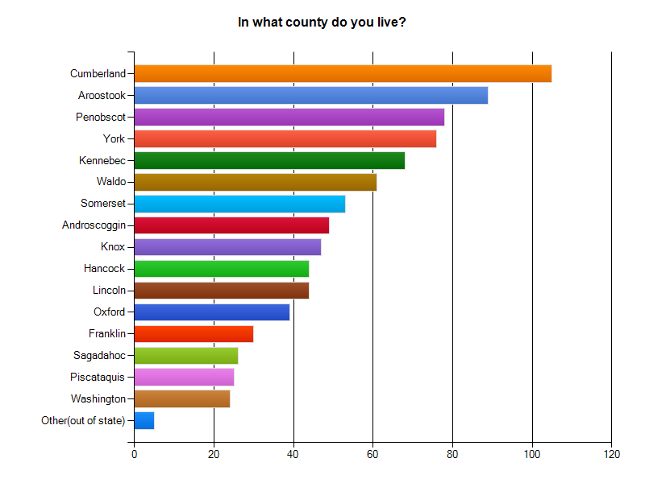
Question 2 Results
Comment: Individuals from every county in Maine participated in completing the farm health and safety survey. The results for this query reflects the availability of accurate mailing lists and not the farming population of Maine. However, the principal investigator was satisfied with the response rate statewide and the distribution of respondents throughout the state.
Question 3 Results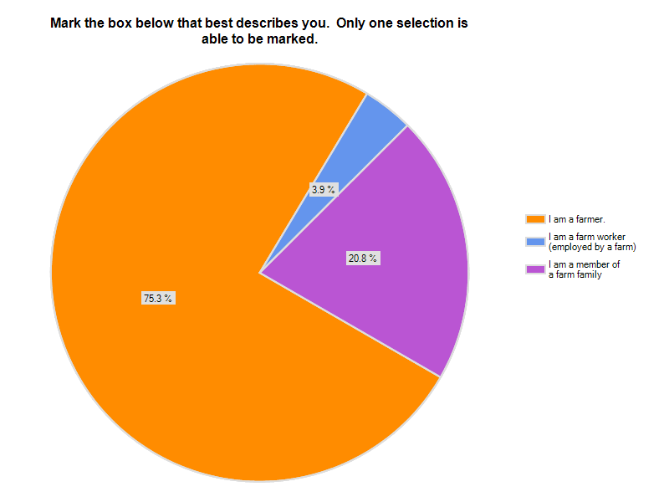
Comment: As you can determine from the chart most respondents to the survey considered them-selves farmers. Farm family members represent a fairly sizable portion of survey respondents. It was difficult to reach farm workers (those employed by farmers) as Extension and other organizations in Maine do not maintain farm worker data bases.

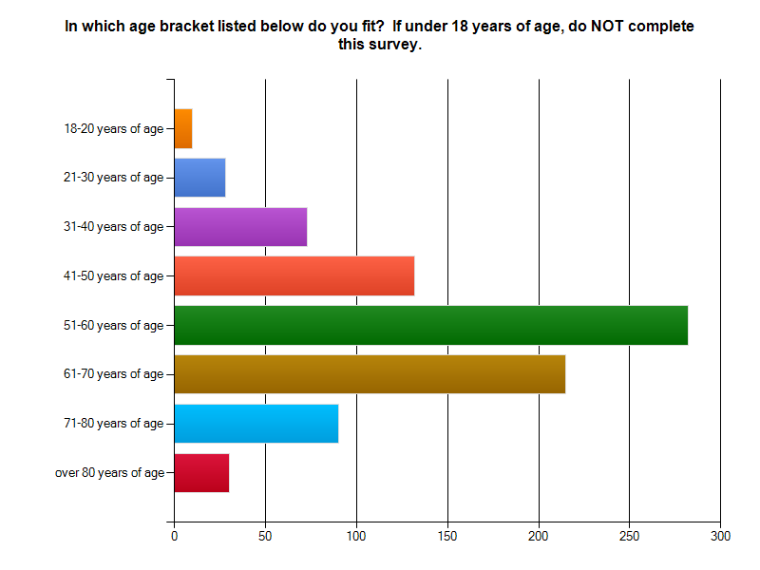

Q4 Results
Comment: The age of Maine farmers who completed this survey closely reflects the age of farmers in the United States. The figures presented below from the 2007 US Agriculture Census for Maine compares closely with that of the respondents.

Age Group of All Farm Operators in Maine:
Under 25 years ............................................... 221
25 to 34 years ................................................. 792
35 to 44 years .................................................1,838
45 to 54 years .................................................3,662
55 to 64 years .................................................3,542
65 to 74 years .................................................1,851
75 years and over ........................................... 937
Average Age 54.2

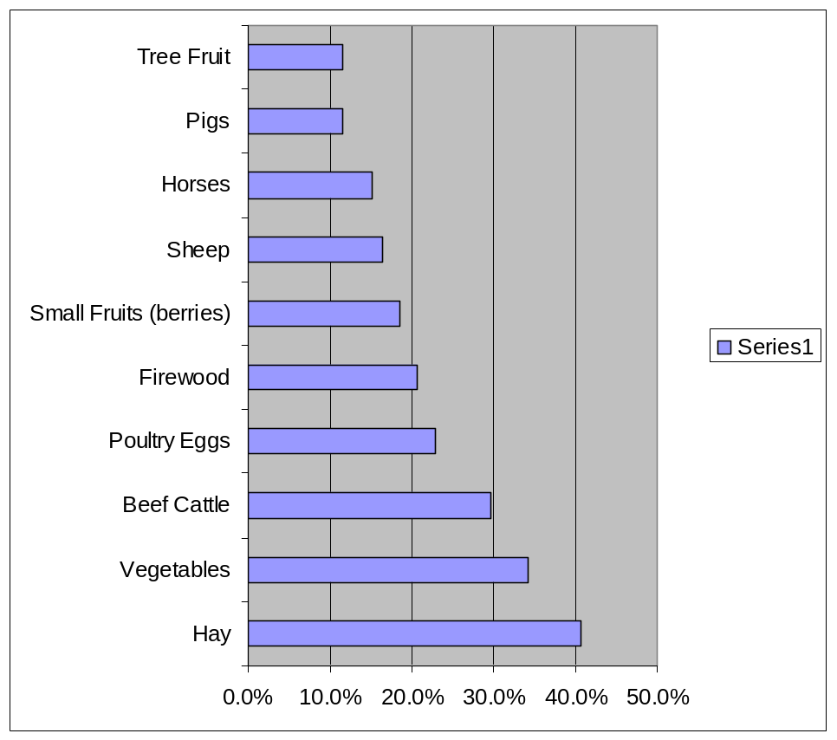
Question 5 Results
The enterprises presented in this chart reflect the top ten enterprises listed by respondents to the survey. Many more enterprises were designated by respondents. It should be noted that the enterprises listed here could determine the safety hazards that are typical or common to these particular types of farming operations. For instance tractors and other field implements are more apt to be used on farms with hay, vegetable and beef cattle enterprises. Chainsaw are more apt to be used with firewood enterprises.
What are the primary products or services on your farm (or on the
farm which you are a farm worker)?

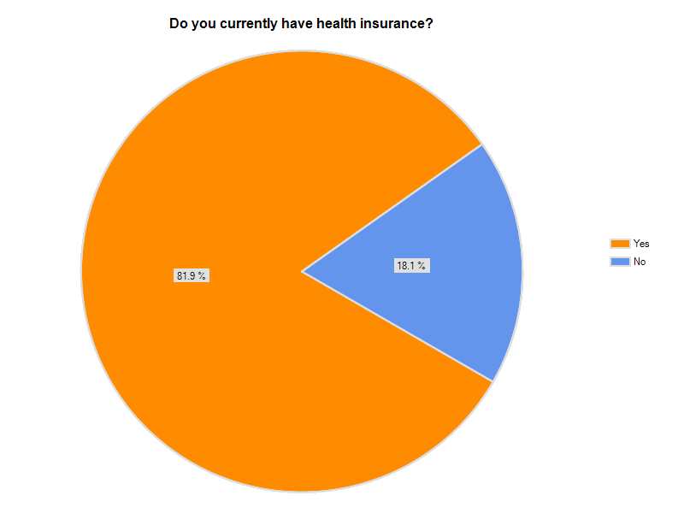
Question 6 Results
Comment: This result of having health insurance was surprising to the principal investigator. I believe this data reflect that farm families may have family members working off the farm for health insurance purposes.
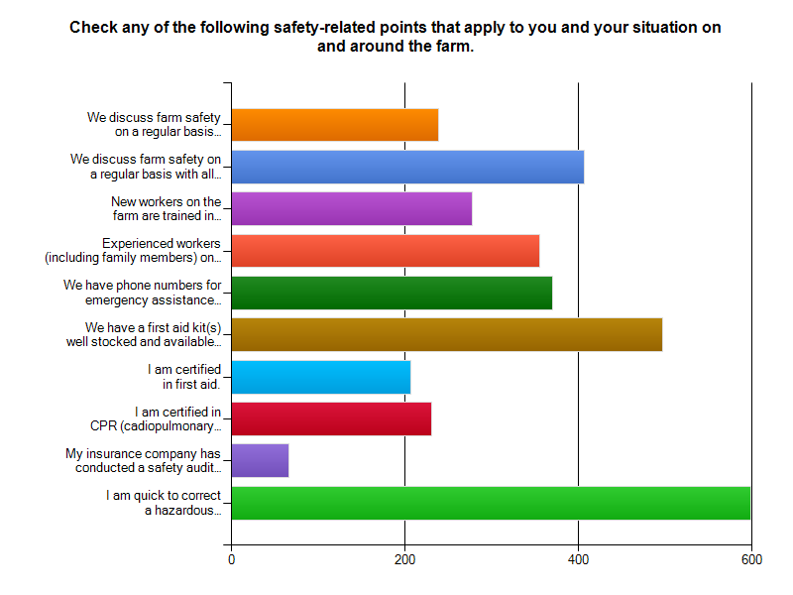
Question 8 Results
The information presented in this chart is encouraging and shows that farmers and their family members take the time and energy necessary to address safety concerns on a fairly regular basis. Everyone (farmers, family members and farm workers) benefits when safety is discussed. The chart also shows that some farmers make an extra effort in preparation for possible accidents as presented in the data related to first aid and CPR training
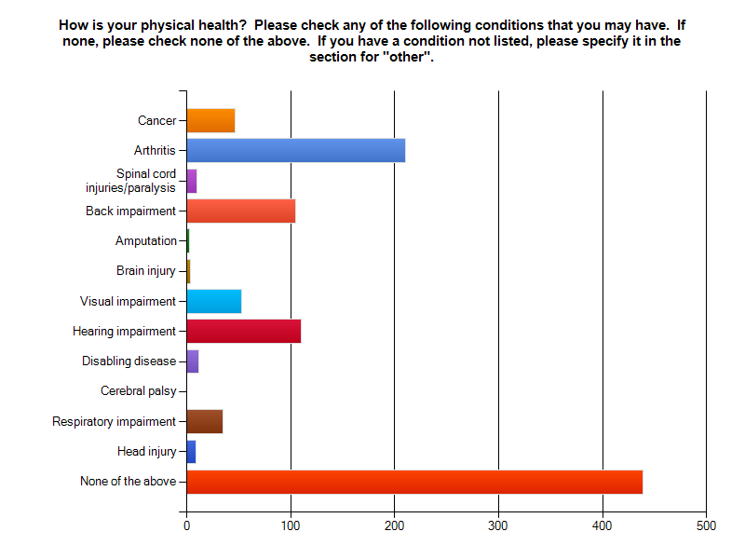
Question 9 Results
This chart portrays that many respondents felt they were in good health. However, it should be noted that the top health conditions of respondents included: arthritis, back impairment and hearing impairment. These particular health conditions ought be the focus of future farm health programming in Maine.

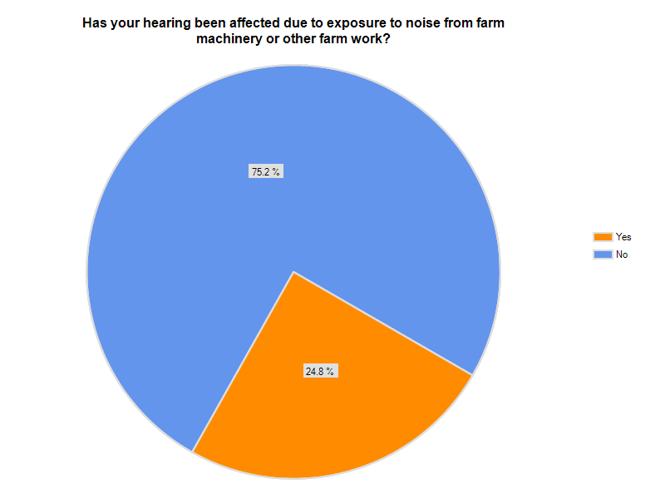
Question 10 Results
Comment: This chart portrays that hearing impairment is a significant condition of survey respondents.

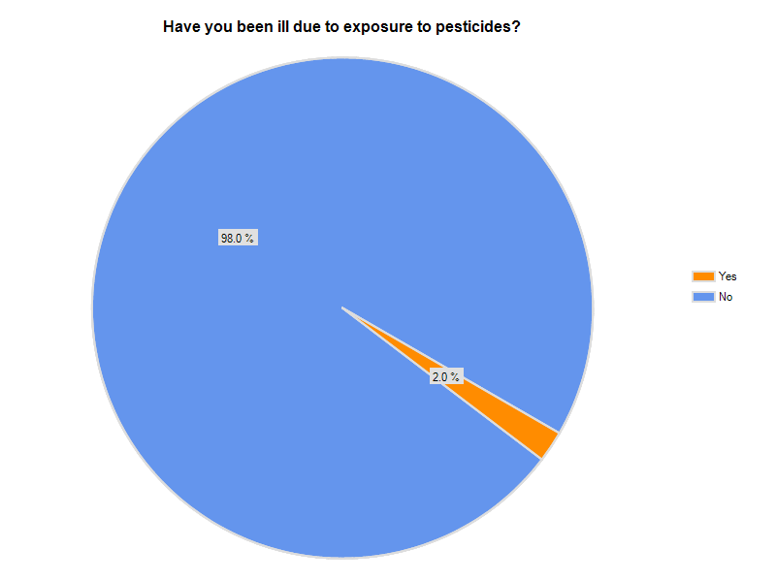
Question 11 Results
Comment: Pesticides have a effect on the health of a small percentage of farmer and farm workers.

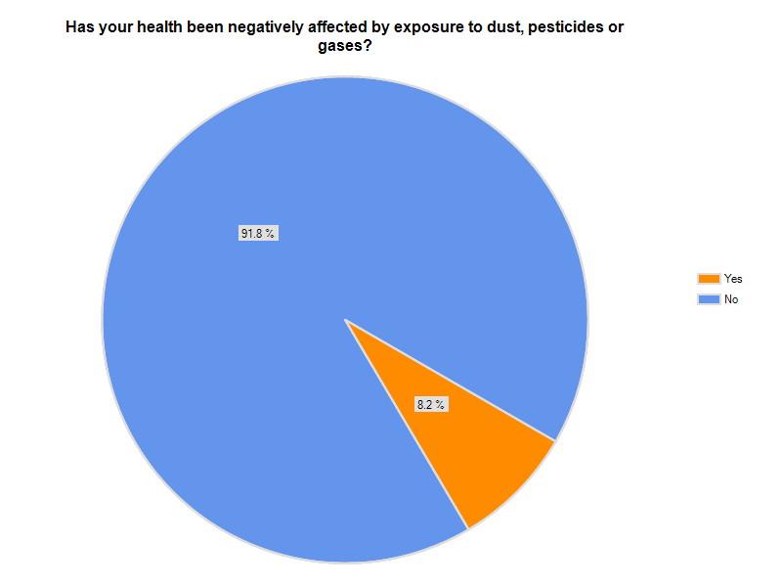
Question 12 Results
Comment: When dusts and gases are added to pesticides as how these materials have negatively effected the health of farmers and workers, the percent of effected individuals increase over 4 times (from 2.0 to 8.2%).

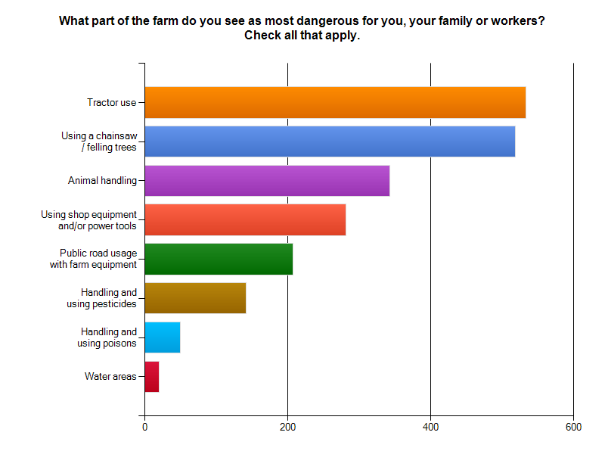
Question 13 Results
These results show that tractors, chainsaws and animal handling are seen by respondents as the most dangerous aspects to farming.
What unsafe practices have you noticed on other farms or by other farmers?

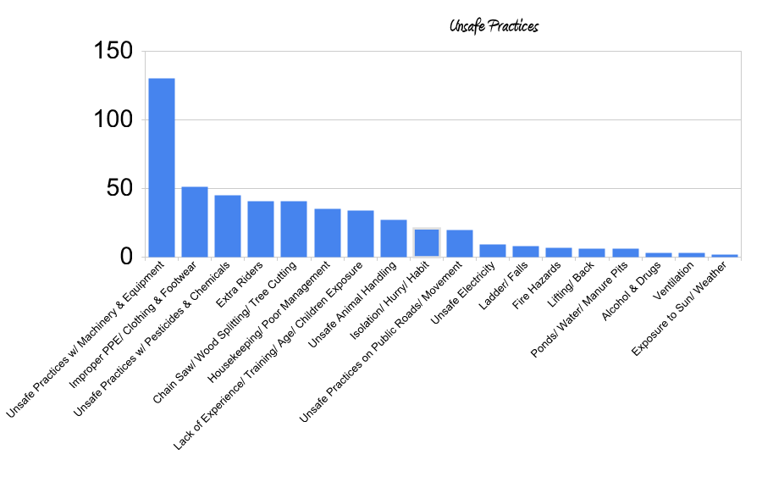
Question 14 Results
Many farmers are very good at noticing safety concerns on other farming operations. Unsafe practices with machinery and equipment is by far the most common category of unsafe practices noted. The farming community ought to be involved in drawing attention to unsafe practices by neighboring farms. Farmers ought to think safety, practice safety and teach safety (on their own operations and with family members and employees).

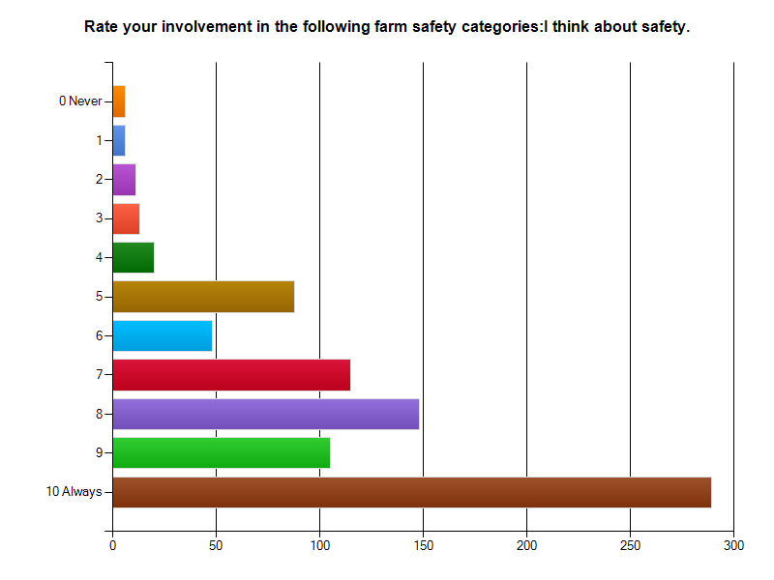
Question 15
The results of this chart are positive and encouraging.
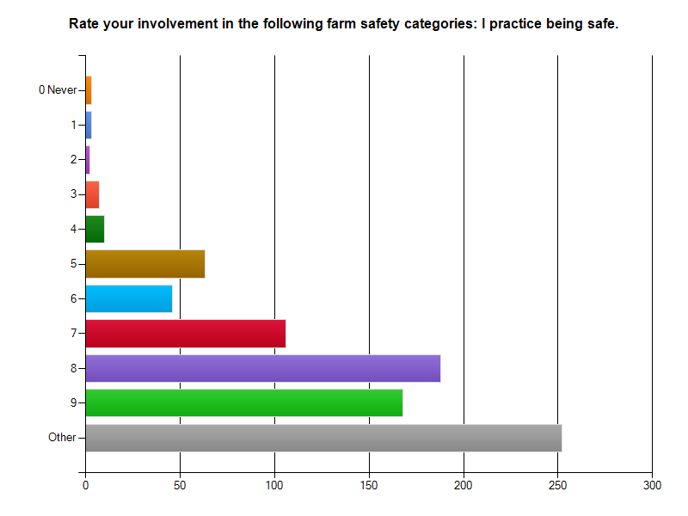
Question 16
The results of this chart are positive and encouraging.
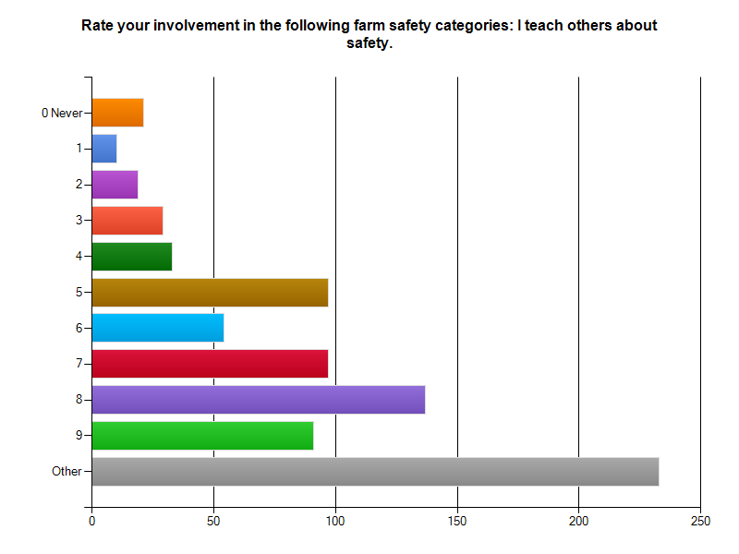
Question 17
The results of this chart are positive and encouraging.

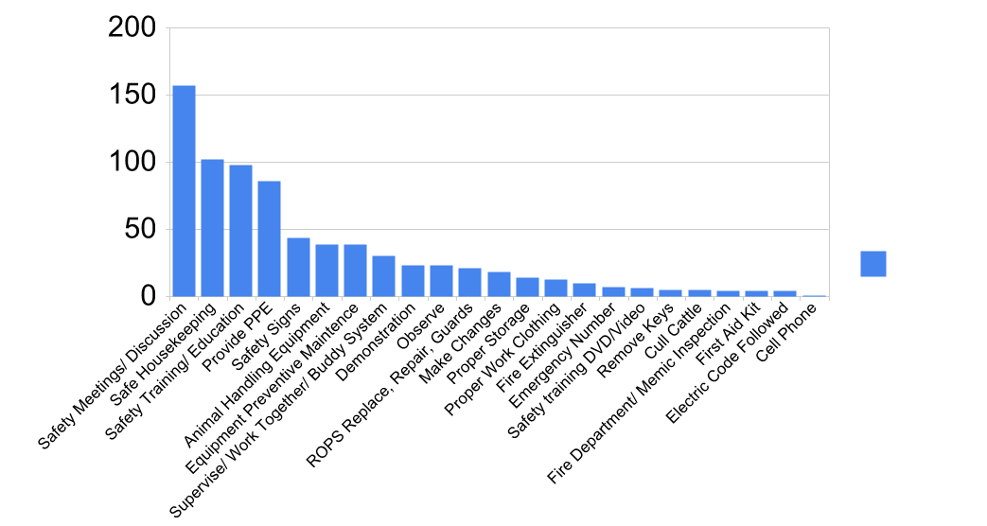

What steps do you take (or have taken) to make your farm and the people (yourself, your family, farm workers, visitors, etc.) on it safer?

Question 18 Results

This bar chart portrays that a variety of actions have been taken by farmers and families to make their operations safer. It is evident from this chart, that having informal safety meetings and discussions are popular methods used by farmers. Proper housekeeping about the farm and involvement in special safety trainings were also common responses.

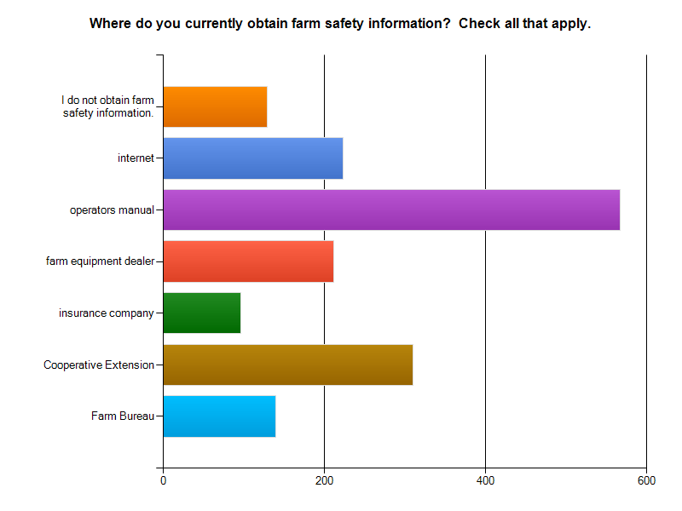
Question 19
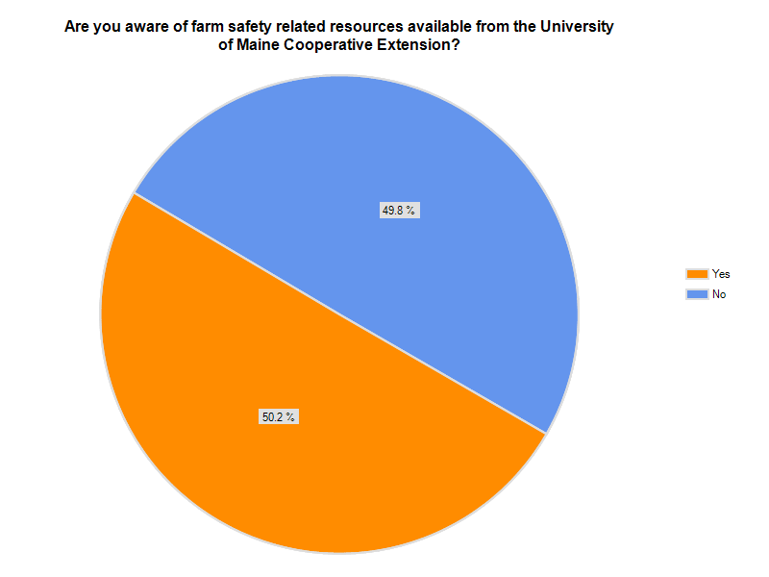
Question 20
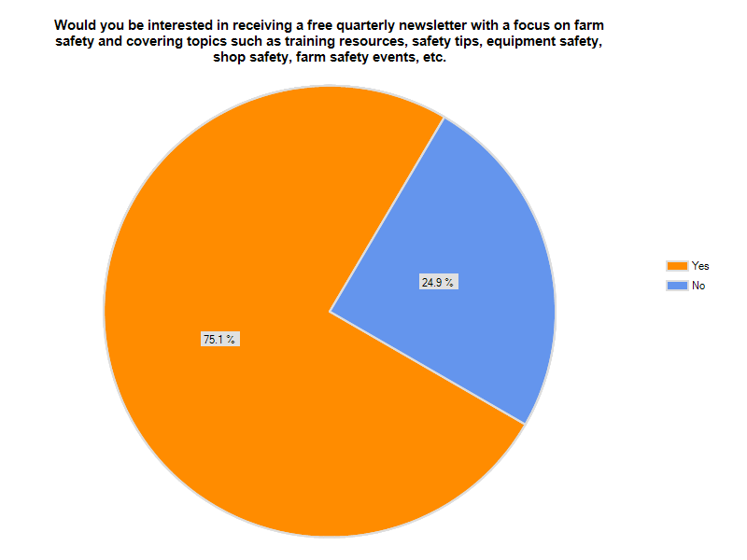
Question 21
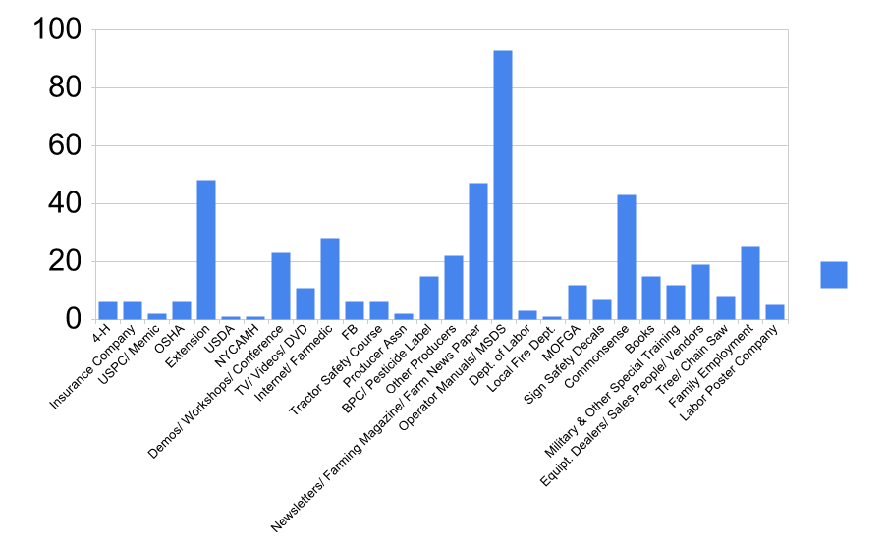
Question 22
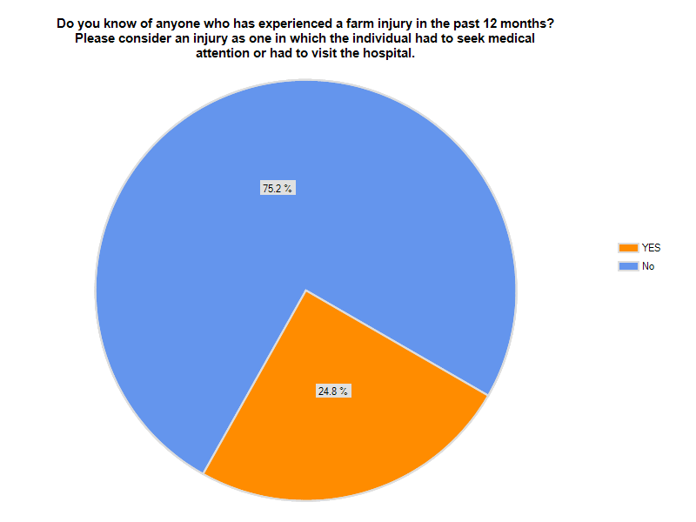
Question 23
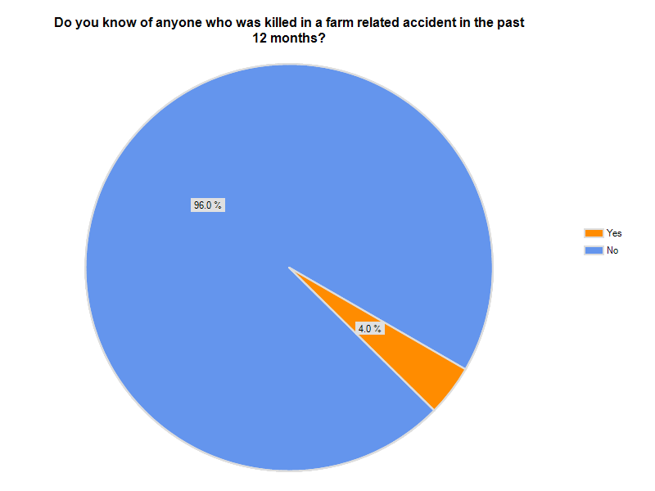
Question 24
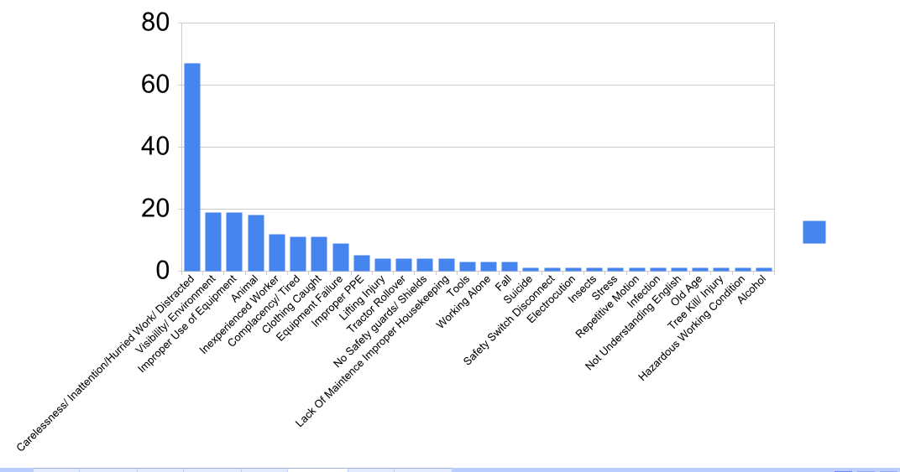
Question 25
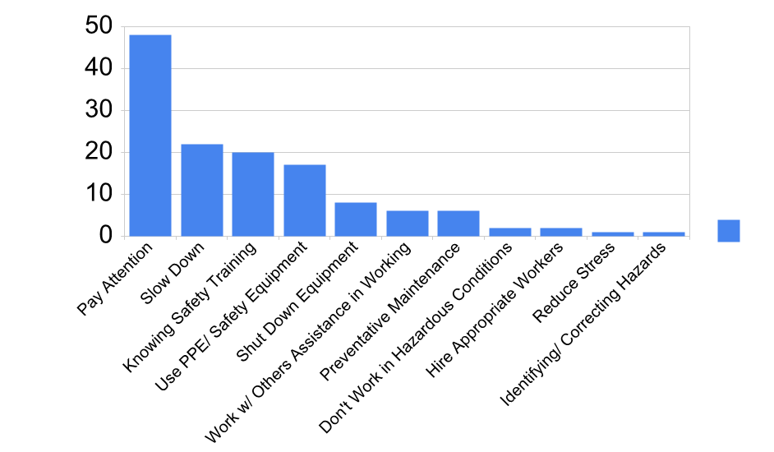
Question 26
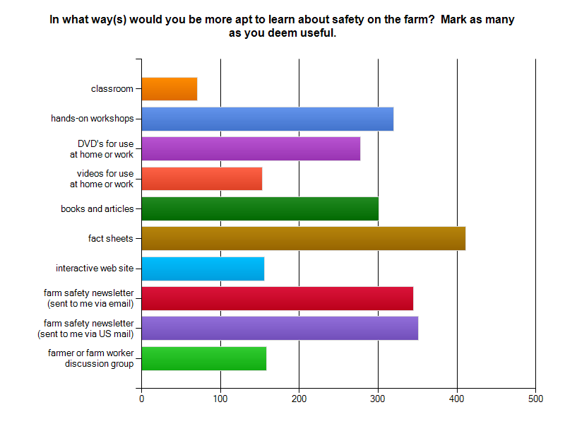
Question 27
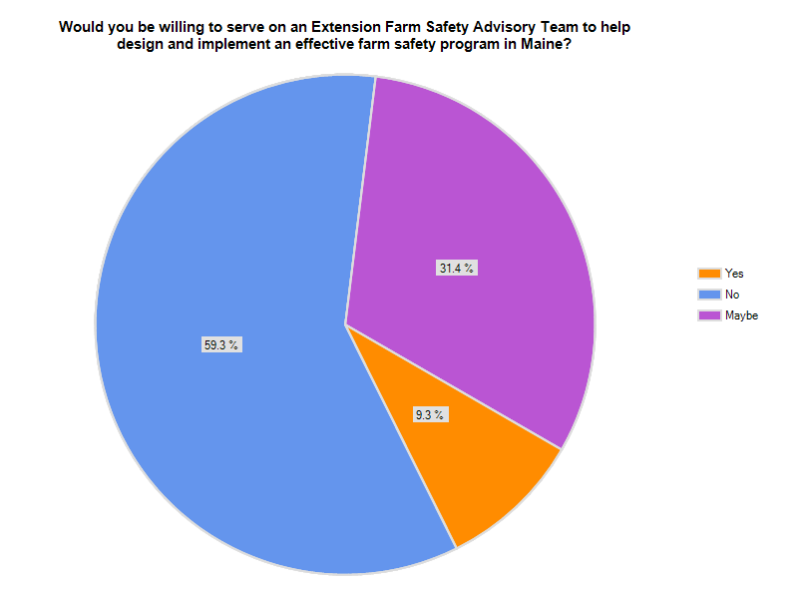
Question 28
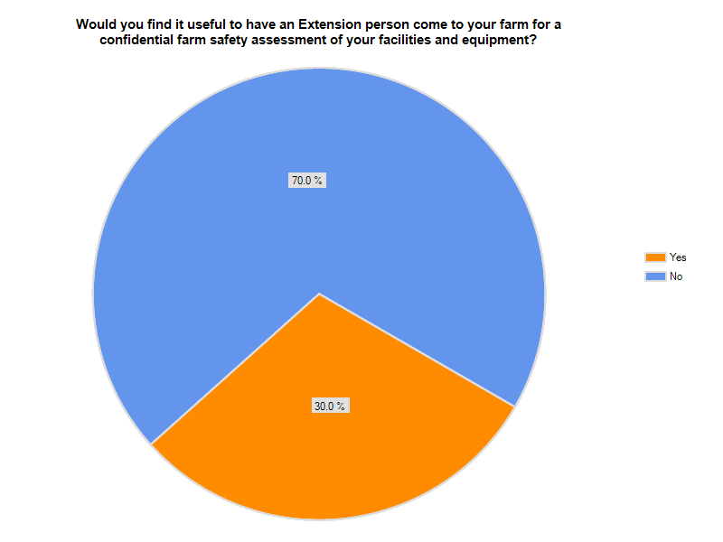
Question 29
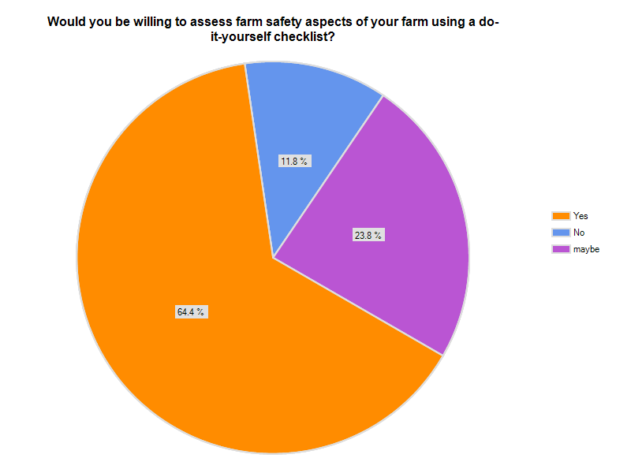
Question 30

Conclusions:
- The University of Maine Cooperative Extension might consider establishing a data base for farm workers (those individuals who are employed by farmers).
- Arthritis, back impairments and hearing impairments ought be the focus of future farm health programming in Maine.
- Safety educational programming should continue to focus on safe operation of tractors and chainsaws and in the proper handling of livestock as these are seen by survey respondents as the most dangerous aspects to farming.

