Androscoggin/Sagadahoc FSA Office
254 Goddard Rd.
Lewiston, ME 04240

Oxford County FSA Office
17 Olson Rd., Suite #1
South Paris, ME 04281
marcia.hall@me.usda.gov
www.fsa.usda.gov
Contact:
Marcia Hall (207)753-9400, Ext 2 or
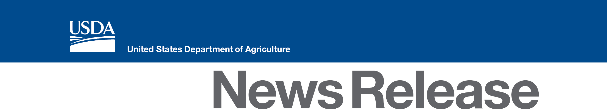
(207) 743-5789, Ext 2
marcia.hall@me.usda.gov

FSA County Committee Nomination Period in Androscoggin/Sagadahoc and Oxford Counties Now Open

(LEWISTON/OXFORD/Maine), June 24, 2015 –Androscoggin/Sagadahoc and Oxford County USDA Farm Service Agency (FSA) County Executive Director (CED) Marcia Hall, announced that the nomination period for local FSA county committees began on June 15, 2015. Nomination forms must be postmarked or received in the Androscoggin/Sagadahoc and Oxford County FSA Office by close of business on Aug. 3, 2015.

"County Committees are unique to FSA and allow producers to have a voice on federal farm program implementation at the local level," said CED Hall.

To be eligible to serve on the FSA county committee, a person must participate or cooperate in an agency administered program, be eligible to vote in a county committee election and reside in the Local Administrative Area (LAA) where they are nominated.

This year, nominations and elections in Androscoggin/Sagadahoc County will be held in LAA 3, which includes Livermore Falls, Leeds, Greene, Wales, Lewiston, Lisbon and Sabattus and in LAA 4 which includes Richmond and Bowdoin. In Oxford County there will be nominations and elections held in LAA 3 which includes West Paris, Sumner, Hartford, Buckfield, Paris, Hebron, Oxford, and Otisfield.

Producers may nominate themselves or others as candidates. Organizations representing minority and women farmers and ranchers may also nominate candidates. To become a nominee, eligible individuals must sign form FSA-669A. The form and more information about county committee elections is available online at: www.fsa.usda.gov/elections.

Elected county committee members serve a three-year term and are responsible for making decisions on FSA disaster, conservation, commodity and price support programs, as well as other important federal farm program issues. County committees consist of three to 11 members.

"It is important that county committees are comprised of members who fairly represent the diverse demographics of production agriculture for their community," said CED Hall. "All producers, including women, minority and beginning farmers and ranchers are encouraged to participate in the nomination and election process."

FSA will mail election ballots to eligible voters beginning Nov. 9. Ballots are due back in the Androscoggin/Sagadahoc and Oxford County Office by mail or in person no later than Dec. 7, 2015. All newly elected county committee members and alternates will take office January 1, 2016.

“Nominating potential county committee members, voting for candidates and serving on the committees are truly services to your community and the agriculture industry,” said CED Hall. “County Committee members make important decisions on how federal farm programs are administered locally to best serve local needs and interests.”

For more information about county committees, please contact the Androscoggin/Sagadahoc and Oxford County FSA office at (207) 753-9400, Ext 2 - Androscoggin/Sagadahoc or
(207) 743-5789, Ext 2 - Oxford or visit www.fsa.usda.gov/elections.
#

USDA is an equal opportunity provider and employer. To file a complaint of discrimination, write: USDA, Office of the Assistant Secretary for Civil Rights, Office of Adjudication, 1400 Independence Ave., SW, Washington, DC 20250-9410 or call (866) 632-9992 (Toll-free Customer Service), (800) 877-8339 (Local or Federal relay), (866) 377-8642 (Relay voice users).

