2016 Crop Insurance Deadline and New Options for Apple Growers

The sales closing date for 2016 Maine apple crop insurance policies is November 20, 2015. Producers can choose to cover 50 to 75% of their average yield from multi-peril losses. The indemnity price for fresh apples will be $15.95 bu⁻¹ for 2016. Apple crop insurance is sold through private crop insurance agents (see link below). Read the 2016 Apple Crop Insurance Factsheet for more information.

New Supplemental Coverage Option
The Supplemental Coverage Option (SCO) is a new option for Maine apple growers and is purchased as an endorsement to an apple crop insurance policy.

How SCO works- SCO provides additional coverage for a portion of an underlying crop insurance policy deductible. SCO differs from the underlying policy in how a loss payment is triggered. SCO pays a loss on an area basis and an indemnity is triggered when there is a county level yield loss. The underlying policy pays a loss on an individual basis and an indemnity is triggered by an individual yield loss. SCO begins to pay when the county average yield falls below 86% of its expected level. The full amount of the SCO coverage is paid when the county average yield falls to the coverage level of the underlying policy. SCO payments are not affected by whether you receive an individual indemnity and its possible to receive an individual loss without a SCO payment and vice-versa.

The cost of SOC- The Federal Government pays 65% of the SCO premium and cost varies with county, and coverage level you select. For more information on SCO, contact an agent or visit the RMA SCO webpage.

Updated Whole-Farm Revenue Protection Policy
Apple growers marketing more than one crop may be interested in the Whole-Farm Revenue Protection (WFRP) policy to protect against the loss of revenue earned from multiple crops, animal, nursery, and resale products. Recent policy changes may make WFRP more attractive for Beginning Farmers and direct marketers. You can buy WFRP alone or with additional Federal crop insurance policies at the buy-up levels only. The WFRP sales closing date is March 15, 2016.
For more information visit the WFRP webpage.

Buying crop insurance, SCO, WFRP
Agents serving Maine can be found using the RMA Agent Locator online or contact Crop Insurance Education Program Manager Erin Roche (erin.roche@maine.edu or 207.949.2490).

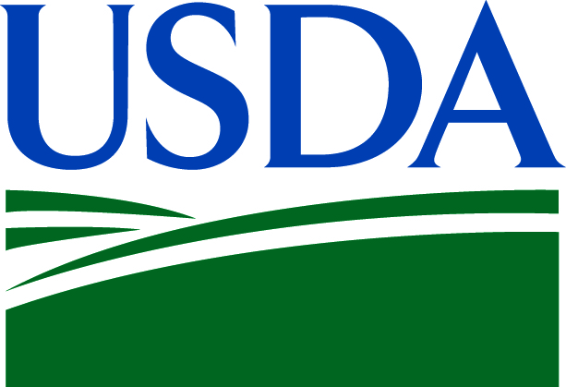
The University of Maine Cooperative Extension is in partnership with the USDA RMA to deliver crop insurance education in Maine. For more information, please visit the UMaine Risk Management and Crop Insurance website.

