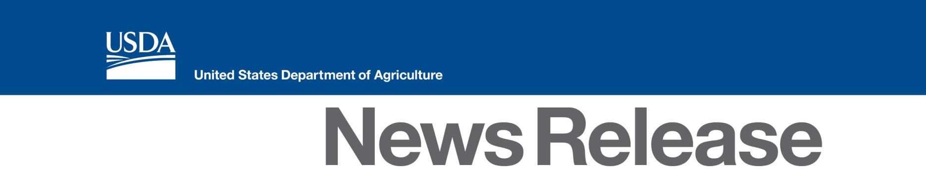
U.S. Department of Agriculture
1400 Independence Ave, SW
Washington, DC 20250
www.usda.gov

Contact:
Kent Politsch (202)720-7163

USDA Announces Safety Net Assistance for Milk Producers Due to Tightening Dairy Margins
May/June 2016 Average Margins Below $6

WASHINGTON, Aug. 4, 2016 – Agriculture Secretary Tom Vilsack today announced approximately $11.2 million in financial assistance to American dairy producers enrolled in the 2016 Margin Protection Program for Dairy (MPP-Dairy). The payment rate for May/June 2016 will be the largest since the program began in 2014. The narrowing margin between milk prices and the cost of feed triggered the payments, as provided for by the 2014 Farm Bill.

“We understand the nation’s dairy producers are experiencing challenges due to market conditions,” said Vilsack. “MPP-Dairy payments are part of a robust, comprehensive farm safety net that help to provide dairy producing families with greater peace of mind during tough times. Dairy operations enrolled in the 2016 MPP-Dairy program will receive approximately $11.2 million this month. I want to urge dairy producers to use this opportunity to evaluate their enrollment options for 2017, as the enrollment period is currently scheduled to end Sept. 30, 2016. By supporting a strong farm safety net, expanding credit options and growing domestic and foreign markets, USDA is committed to helping America’s dairy operations remain successful.”

Dairy producers who enrolled at the $6 through $8 margin trigger coverage level will receive payments. MPP-Dairy payments are triggered when the national average margin (the difference between the price of milk and the cost of feed) falls below a level of coverage selected by the dairy producer, ranging from $4 to $8, for a specified consecutive two-month period. All final USDA prices for milk and feed components required to determine the national average margin for May/June 2016 were released on July 29, 2016.

The national average margin for the May/June 2016 two-month consecutive period is $5.76277 per hundred weight (cwt.), resulting in the following MPP payment rates:

Margin Trigger Coverage Levels | Payment Rate/cwt.
$6.00 | $0.23723
$6.50 | $0.73723
$7.00 | $1.23723
$7.50 | $1.73723
$8.00 | $2.23723

State specific payment amounts can be found at www.fsa.usda.gov/dairy.

Since 2009, USDA has worked to strengthen and support American agriculture, an industry that supports one in 11 American jobs, provides American consumers with more than 80 percent of the food we consume, ensures that Americans spend less of their paychecks at the grocery store than most people in other countries, and supports markets for homegrown renewable energy and materials. USDA has also provided $5.6 billion in disaster relief to farmers and ranchers; expanded risk management tools with products like Whole Farm Revenue Protection; and helped farm businesses grow with $36 billion in farm credit. The Department has engaged its resources to support a strong next generation of farmers and ranchers by improving access to land and capital; building new markets and market opportunities; and extending new conservation opportunities. USDA has developed new markets for rural-made products, including more than 2,500 biobased products through USDA's BioPreferred program; and invested $64 billion in infrastructure and community facilities to help improve the quality of life in rural America. For more information, visit www.usda.gov/results.

To learn more about the Margin Protection Program for dairy, visit the Farm Service Agency (FSA) online at www.fsa.usda.gov/dairy or stop by a local FSA office. Producers may visit www.fsa.usda.gov/mpptool to calculate the best levels of coverage for their dairy operation. To find an FSA office near you, visit http://offices.usda.gov.
#
USDA is an equal opportunity provider, employer and lender. To file a complaint of discrimination, write: USDA, Office of the Assistant Secretary for Civil Rights, Office of Adjudication, 1400 Independence Ave., SW, Washington, DC 20250-9410 or call (866) 632-9992 (Toll-free Customer Service), (800) 877-8339 (Local or Federal relay), (866) 377-8642 (Relay voice users).

