*A revenue-protection policy for diversified farms.*



**Whole-Farm Revenue Protection Crop Insurance**and a Perspective from Circle B Farms

The Whole-Farm Revenue Protection (WFRP) policy is a new crop insurance program that protects the farmer’s adjusted gross revenue from production losses or drops in market prices. Unlike other types of crop insurance, WFRP acts as an umbrella policy for the whole farm because growers can insure revenue from multiple crops, livestock, and nursery products under this one policy. The sales closing date is March 15, 2017 for insurance during the 2017 growing season, but farmers must begin the sign-up process with a crop insurance agent well in advance of the deadline to ensure coverage.

**A WFRP Perspective from the Field**

Sam Blackstone is the owner and operator of Circle B Farms in Caribou. His 75-acre farm consists of 10,000 highbush blueberry plants (4,500 in full production), 600 apple trees (250 in full production), pear trees, nursery stock, and winterberry. At the height of the season the farm is open for “U-pick” blueberries and apples, but Sam’s products can also be found at farm stands, hospitals, schools, and in about 50 grocery stores including Hannaford.

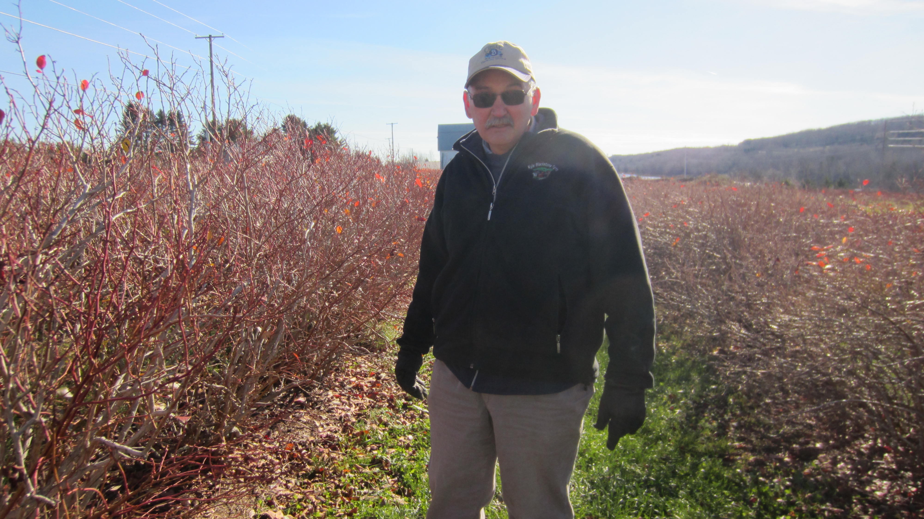

**On Farm Risks**

“Mother nature is our greatest ally and also our greatest enemy in northern Maine. The cold winters keep a lot of the insects away, as does being 180 miles north of all the real fruit production. But we've been here long enough so that all the major diseases are here too.”

Sam Blackstone, Circle B Farms

**Managing these Risks**

“We are IPM (Integrated Pest Management), we will spread mulch to suppress the weeds, herbicides as well, we will field scout on a regular basis looking for anything at all. We do quite a bit of pre-sales, we have a freezer here for back up for slow sales or when we are picking faster than the markets are taking them. We do winter sales which mitigates risk and gives us a year round market. The blueberry cooler is also full right to the doors today with apples, you know its just another crop. If you're going to maintain an operation of this size you've got to have year-round people. Having good employees is also risk management.” In addition, Sam buys WFRP crop insurance.

Table 1. Percentage of total premium government-subsidized.

**On WFRP Crop Insurance**

|  |  |  |  |  |  |  |  |
| --- | --- | --- | --- | --- | --- | --- | --- |
| **Coverage level** | **50%** | **55%** | **65%** | **70%** | **75%** | **80%** | **85%** |
| 1 Commodity | 67% | 64% | 64% | 59% | 55% | NA | NA |
| 2 Commodities | 80% | 80% | 80% | 80% | 80% | NA | NA |
| 3 Commodities | 80% | 80% | 80% | 80% | 80% | 71% | 56% |

Crop insurance premiums are government-subsidized and the farmer pays a portion of the premium (Table 1). With WFRP, the number of commodities produced determines the level of coverage the farmer is eligible for and the premium subsidy. As Sam put it, “We bill that premium into our pricing structure. For us it was around $1,300 to cover the whole operation. It’s either that [crop insurance] or you've got to put that money in the bank every year, and like most farmers we're not real good at putting money in the bank. Realistically putting it in there and leaving it there is definitely hard for farmers, so crop insurance is basically a savings account.”

Table 2. WFRP coverage from 2015 on Circle B Farms

**Enrolling in WFRP: Records Required and Coverage**

|  |  |
| --- | --- |
| 1. Approved adjusted gross revenue | $72,075 |
| b) Coverage level selected | 75% |
| c) Income trigger (a x b) | $54,056 |
| d) Total premium | $6,649 |
| e) Subsidy | $5,319 |
| f) Actual revenue | $50,000 |
| g) Farmer premium (d – e) | $1,330 |
| h) Indemnity (c – f) | $4,056 |

To determine the farmer’s historic adjusted gross revenue, 5 years of Schedule F tax records are needed. The policy will be based off of the lower of the farmer’s historic adjusted gross revenue (adjusted for growth) or the farmer’s expected revenue for the insurance year. For his 2015 WFRP policy, Sam’s approved adjusted gross revenue was $72,075 from highbush blueberries, apples, pears, winterberry, and nursery stock (Table 2). As shown in Table 1, the number of commodities produced determines the level of coverage and the premium subsidy. Each commodity must make up a significant portion of the total farm revenue to be counted while commodities providing small amounts of revenue may be grouped together to meet the qualification. In Sam’s case he was insuring 5 crops, but based on his expected revenue from each commodity, he qualified as having 2 commodities. He selected the 75% coverage level, which came with an 80% premium subsidy (Table 1). Verifiable or direct market sales records, inventory reports, and accounts receivable and payable are also needed to justify the revenue produced on the farm, a complete list is in Table 3.

**How WFRP Works when a Loss Occurs**

WFRP covers natural causes of loss and decline in market price during the insurance period. Taxes must be filed for the insurance year before any claim can be made. When revenue to count is lower than the income trigger, a loss payment will be made. Sam experienced his first claim in 2015. “We had 2 nights in April, one -20° F and one was -19.8° F. Blueberry plants will stand that temperature but not in April because they've lost some of their winter hardiness due to the warm days. We froze everything to the snow line and in April, there was very little snow here. When the weather hit and turned that cold that quick I went out and looked around a little bit and I called the agent just as soon as I thought there might be a problem.” After discovering a loss or a potential loss, the insured must notify their agent within 72 hours. As Sam expected, the drop in temperature negatively affected his yields and overall revenue, “2015 was not a good year. All our berries were in the bottom 18" of the plant. Apples the same way, our honey crisp took a pounding.”

**Indemnity Payments**

Sam’s actual revenue on his 2015 Schedule F fell below his income trigger meaning he was eligible to receive a loss payment or indemnity for the difference (Table 2). Sam received his indemnity payment in January after he filed his taxes and submitted his Final Farm Operation Report. “The loss sure crimped the cash flow and of course the check didn't last long once it came, but it got us through.”

**Interested in WFRP?**

Act now to ensure you are enrolled by the March 15 deadline for 2017 coverage as the enrollment process takes time. WFRP is sold from private licensed crop insurance agents. Agents serving Maine can be found using the online RMA Agent Locator at prodwebnlb.rma.usda.gov/apps/AgentLocator/#/ or contact Crop Insurance Education Program Manager, Erin Roche (erin.roche@maine.edu or 207.949.2490).

|  |  |  |
| --- | --- | --- |
| **Farmer records** | **Why?** | **More Details** |
| Schedule F tax records from the previous 5 years (2011-2015) | To prove historical gross revenue and expenses. | Qualifying beginning farmers may be allowed to supply Schedule F’s from the previous 3 years. |
| Intended farm operation report | Lists commodities to be produced and the expected revenue from each for the insurance year. | A ‘Revised’ report is due during the insurance year if the production plan changes. A ‘Final’ report is due at the end of the insurance year. |
| Verifiable sales records | To verify Schedule F revenue and final production for the insurance year. | Allowable records include:  1) Third party verifiable documentation (i.e. accounting records, farm management records, warehouse receipts, ledger sheets, sales receipts, etc.);  2) Direct marketing sales records which can be contemporaneous records made at the time of commodity sale (i.e. at a farmer’s market), must include name of insured, market name, date, total cash receipts, and listed names of the commodities sold. For final reporting, estimated % of total cash receipts per each commodity sold, and revenue per commodity received is required. |
| Farm Inventory Report | Used to adjust approved revenue to only revenue produced during the insurance period. | For animals, animal products, nursery, and greenhouse products only because they are valued at the beginning and end of the insurance period. |
| Accounts receivable/payable | To show revenue from commodities produced during the insurance period that have been sold and are no longer on the farm but for which payment has not been received. Only required for the insurance year. |
| Pre-Acceptance Worksheet | To verify acreage and to determine insurability of perennial crops. | Discuss with your crop insurance agent for more detail. |

Table 3. WFRP required records for 2017 enrollment



*The University of Maine Cooperative Extension is in partnership with the USDA RMA to deliver crop insurance education in Maine. For more information, please visit the UMaine Risk Management and Crop Insurance website at https://extension.umaine.edu/agriculture/maine-risk-management-and-crop-insurance-education-program/*

The University of Maine does not discriminate on the grounds of race, color, religion, sex, sexual orientation, including transgender status and gender expression, national origin, citizenship status, age, disability, genetic information or veteran status in employment, education, and all other programs and activities. The following person has been designated to handle inquiries regarding nondiscrimination policies: Director, Office of Equal Opportunity, 101 North Stevens Hall, 207.581.1226.

**extension.umaine.edu**

**extension**