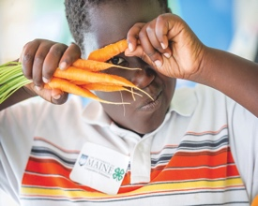
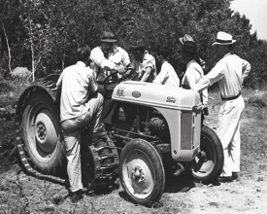
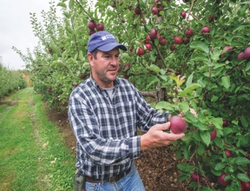
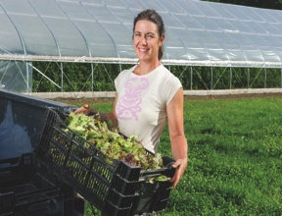
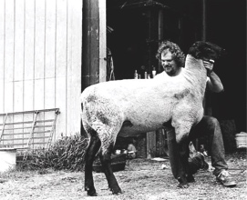
University of Maine Cooperative Extension
Androscoggin-Sagadahoc Counties
Annual Report 2015
The University of Maine is an equal opportunity/affirmative action institution.
Putting university research to work
in homes, businesses, farms, and communities
for over 100 years.

Our annual report features highlights
of recent accomplishments and the difference
we make in the lives
of Maine citizens and their communities.
Color photos by Edwin Remsberg
County Highlights
Tori Lee Jackson, Associate Extension Professor

Assessing the Viability of Maine’s Commercial Elderberry Industry
Elderberries are native to Maine. The flowers and fruit have many possible uses in functional food and medicinal products, as natural dyes, and other applications. In response to a group of hobby and small elderberry growers asking for UMaine Extension research in elderberries as a commercial crop, a growers’ meeting was held in Lisbon Falls on February 10, 2015. About 30 growers attended the meeting to learn about basic cultivation practices and give feedback on their research and other technical support needs. The highest-priority issue that arose during the meeting, and through a subsequent survey, was determining which diseases impact elderberries. Fungal diseases are most common, but can be managed. Elderberries are also susceptible to a virus, Tomato Ringspot Virus (ToRSV), for which there is no treatment or cure. The presence of the virus could impact recommendations about increasing commercial acreage of elderberries. In March, I applied for and received a small Maine Agriculture Center grant to fund this research. Late June and early July were spent in all corners of the state, trying to determine if ToRSV is already impacting elderberries in Maine. I collected samples from 20 locations using plants of varying ages, varieties, both wild and cultivated, and ToRSV was not detected. These results were received with much relief and enthusiasm by the growers at a December meeting.

Also in late June, a tour of several elderberry farms in Freeport and Monmouth allowed growers to share their experiences and growing practices amongst themselves.

Knowing that the ToRSV threat is not immediate, the emphasis has switched to developing profitable models for elderberry operations in the northeast. Growers are considering forming an association and at UMaine Extension, we are seeking funds to install a variety trial at Highmoor Farm in Monmouth during the upcoming growing season.

The University of Vermont is also beginning to work on commercial elderberry production and reached out to UMaine to partner on research and publications. An elderberry production guide will by published by UVM late in 2016, with input and photos from Maine.

Future work is likely to focus on value-added food and nutraceutical products as a way for growers of all sizes to achieve and maintain profitability.

UMaine Extension’s Alpaca School
In early 2015, the Maine Alpaca Association (MAA) requested speakers from UMaine Extension to help producers become more business savvy. I gave several talks focusing on online marketing and using social media at two regular MAA meetings. I also conducted a needs assessment survey to determine producers’ educational needs, which resulted in a day-long Alpaca School in March, 2016.

Twenty-four current alpaca producers, and a few contemplating the industry, turned out for a full-day workshop on Saturday, March 12th at the Lisbon Falls Extension office. The morning featured three UMaine Extension speakers, including Gary Anderson who spoke about alpaca nutrition, Rick Kersbergen who covered pasture management, and myself. I spent an hour on business planning and how to transition a hobby farm into a business. After lunch, everyone packed up and headed to Graceland Alpaca Farm in Lisbon Falls, owned by Laila Roukounakis, for a hands-on experience. Laila introduced everyone to her animals and explained a bit about her operation. Large animal veterinarian, Dr. Meghan Flanagan joined us for a primer on parasites and general alpaca health concerns.

Feedback from the training has been very positive. Some long-time producers are keen to begin making money, and were pleased to have some guidance. A beautiful afternoon on a farm may have convinced one or two to make the leap and start their own herds.

Master Gardener Volunteers
The 2015​ Master Gardener Volunteers training was held at the Topsham Public Library.
Seventeen people completed their training at the end of May. Nearly 400 hours of volunteer work had been done by these trainees by the end of the year.

2015 was a very busy for the MGV program. We began partnering with several organizations to create new projects and develop current projects even further. These included transforming the the Lisbon Community Garden in Lisbon Falls, expanding the Dempsey Center Garden of Hope in Auburn and jump starting a number of projects at the Topsham Public Library.

Collaboration with the City of Auburn, the National Parks Service, the Androscoggin Land Trust and St. Mary’s Nutrition Center has also been instrumental in formation of a new community garden at 61 Webster Street in Auburn. The site work was done in the fall and the garden will open in Spring 2016.

In total, sixty Master Gardener Volunteers from Androscoggin and Sagadahoc Counties volunteered 1,545 hours (an estimated in-kind value of these volunteers is $35,643.15 based on Independent Sector’s 2014 valuation of volunteer hours at $23.07 per hour). Additionally over 1,500 pounds of produce was collected and donated to UMaine Extension initiative, Maine Harvest for Hunger.

4-H Youth Development
Kristy Ouellette, Associate Extension Professor

4-H supports young people from elementary school through high school with programs designed to shape future leaders and innovators. Fueled by research-driven programming, 4-H'ers engage in hands-on learning activities in the areas of science, citizenship and healthy living. Extension Educator, Kristy Ouellette and Community Education Assistant Maisy Cyr work with youth, volunteers, teachers and afterschool providers to strengthen and support the 4-H Youth Development program locally. 4-H Community Central Professional Laura Personette works specifically with the 4-H Community Central program in Lewiston.

The 4-H Youth development program in Androscoggin and Sagadahoc counties currently serves youth in traditional club programs and in school or community based programs in both counties.
Local Impacts 4-H Youth Development
has on youth:
- 86% of 4-H teens that have graduated from high school have gone on to higher education. Teens reported the information learned through 4-H assisted them in being better prepared for college.
- 52% of 4-H youth have annually participated in 2 hours of community service. This time is equivalent to value of over $3,800.00 based on Independent Sector’s valuation of volunteer hours ($23.07 per hour).
- 81% of 4-H youth participated in programs focused on expanding Science life skills.

Long Term Impacts:
- In reviewing data from 2009-2015, 15% (25) of youth have been enrolled in the 4-H program for 4 or more years. 30% (50) of youth have been enrolled for 2 or more years.
- Nationally, Youth in 4-H Science programming reported having high educational aspirations. When asked how far they want to go in school, half of youth surveyed want to finish college.
- Nationally 4-H youth have higher educational achievement and motivation for future education than non 4-H youth.
Local Impacts of 4-H Volunteers
- In 2015, 45 volunteers collectively provided over 16,500 hours of annual service to this program, an investment of over $380,655.00* in high-quality, hands on, positive interactions with young people in Maine (*an estimated in-kind value of these volunteers is $380,655.00 based on Independent Sector’s valuation of volunteer hours at $23.07 per hour).
- 35% of volunteers have been engaged in the county 4-H program for over 4 years. These volunteers have provided leadership, educational programs and support to over 400 youth members.

Selected Program Highlights:
Maine Community Central: Integrating 4-H Science and Life Skills with Schools, Communities and Families
UMaine 4-H is reaching new audiences and investigating innovative practices through the 4-H Community Central project in Lewiston, and Portland. 4-H history is at the heart of Community Central. UMaine 4-H received funding through the USDA’s Children, Youth, and Families At-Risk (CYFAR) program for a pilot project to identify the best practices of establishing 4-H in public housing sites.
Our program model is to place UMaine Extension staff in public housing sites to 1) provide out of school time education and 2) to link crucial ecological entities (family, elders, school, after-school, and faith community) in the lives of school age youth in order to reduce learning loss, increase science literacy and improve critical life skills of youth. Through applying the ecological systems framework (Bronfenbrenner 1969) to Maine neighborhoods, UMaine 4-H is on the cutting edge of serving an important and vulnerable population.

In year two of this project in Lewiston, 128 youth in grades 3-6 and 6 Teen Leaders participated.

Expanding Science Programming

Youth in Androscoggin/Sagadahoc counties are not alone in their science deficiency. Prior to 2008, youth who wanted to enroll in 4-H in Androscoggin/
Sagadahoc Counties were limited to animal science projects. In 2015, Science programming including

programs in Robotics, Wind Energy and

Environmental Science was offered at

Androscoggin/Sagadahoc counties, serving over 100 youth.

4-H Summer of Science
Since the 1970s, out-of-school research has demonstrated repeatedly that students’ access to engaging, enriching, hands-on activities during the hours beyond the traditional school day, including summer, help bridge the academic achievement gap (Afterschool Alliance, 2009; Alexander, Entwisle, & Olson, 2001; Heyns, 1978).

To increase science proficiency in underserved communities, UMaine Extension volunteers and staff created and delivered 4-H Summer of Science curricula to youth in grades 3–8 at 14 free or reduced-lunch sites, 3 libraries, and 5 summer camps in 4 Maine counties. Participants included 617 youth, of whom 25% were minorities and more than 50% were girls. At 8 sites, UMaine Extension staff recruited, trained, and supervised 18 teens to deliver the curriculum. The teens offered a total of 162 hours of programs.

Trainings for 4-H Volunteers and Educators
Remote Coaching for Afterschool Providers Pilot
The Maine Mathematics and Science Alliance is developing, assessing, and documenting a new model of professional development that targets out-of-school educators who want to embrace STEM education more deeply. MMSA’s Dr. Sue Allen directs this project. The pilot program has ended, and the resulting project ACRES (Afterschool Coaching for Rural Educators in STEM) which began in Summer 2015.
Working in close collaboration with the University of Maine Cooperative Extension 4-H program’s Associate Professor Kristy Ouellette and Dr. Lisa Phelps from University of Maine, MMSA investigated the possibilities for remote coaching in STEM skills for afterschool providers, incorporating existing cutting-edge video-based resources, like the Click2Science materials and adapting these for use in rural communities where educators are separated by very large distances and cannot easily meet in person.

UMaine Extension is your doorway to University of Maine expertise. For more than 100 years, we’ve been putting university research to work in homes, businesses, farms, and communities—in every corner of Maine. Our educational efforts focus on the Maine Food System, Positive Youth Development, and Community and Economic Development.

Androscoggin-Sagadahoc Counties

University of Maine Cooperative Extension’s successful educational programs result from a federal, state and county government partnership. Since 1919, when the Maine Legislature passed the County Extension Act*, the University of Maine has been in all Maine communities with a county office whose operations are funded by county government. Our educational programs anticipate and respond to local and state needs and issues. We also communicate those issues and opportunities to UMaine faculty to influence their research and development plans.

A sampling of our educational program areas:
- 4-H
- Agriculture
- Business & Community
- Food & Health
- Gardening & Horticulture

- Home, Family & Youth
- Insect & Plant Disease Management
- Maine Food System
- Natural Resources
- Safety & Preparedness

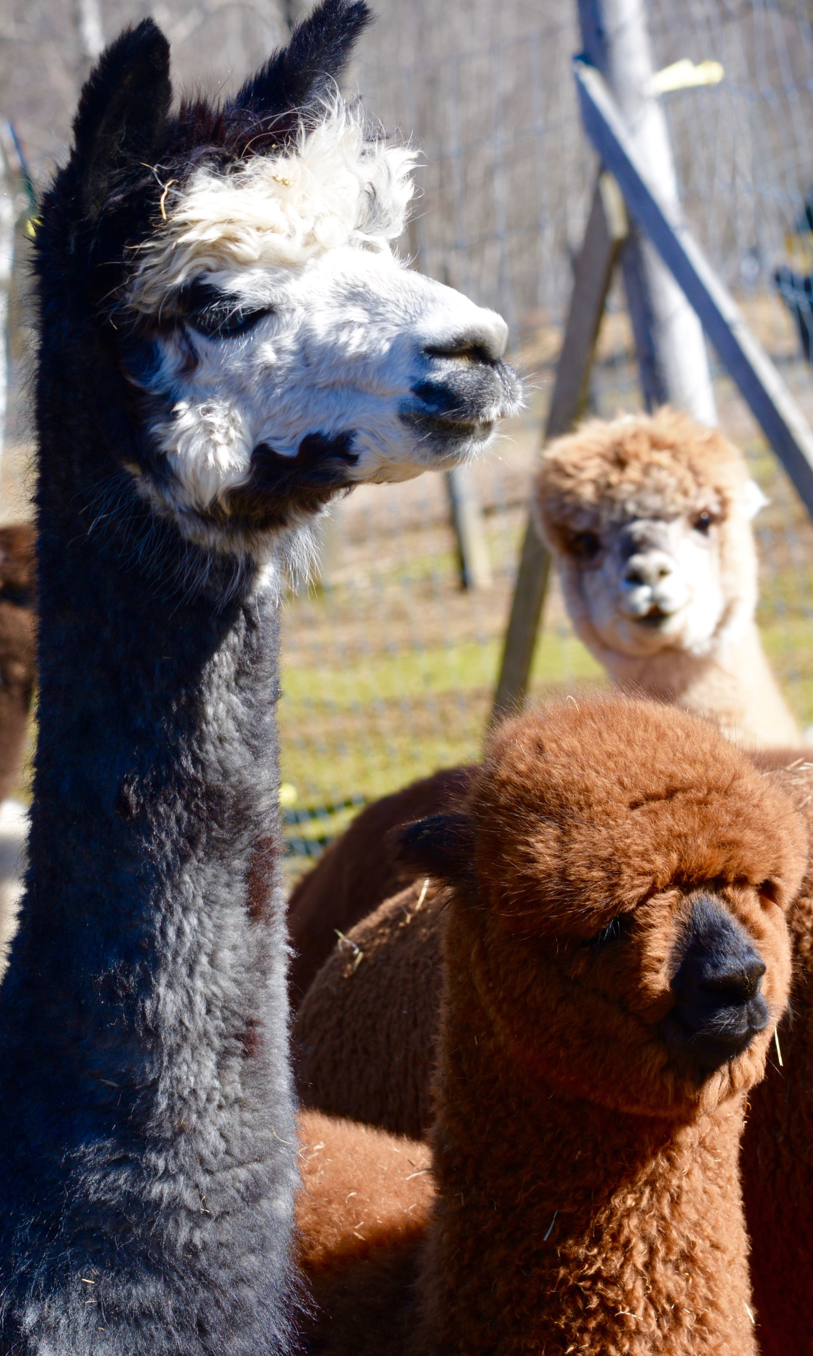
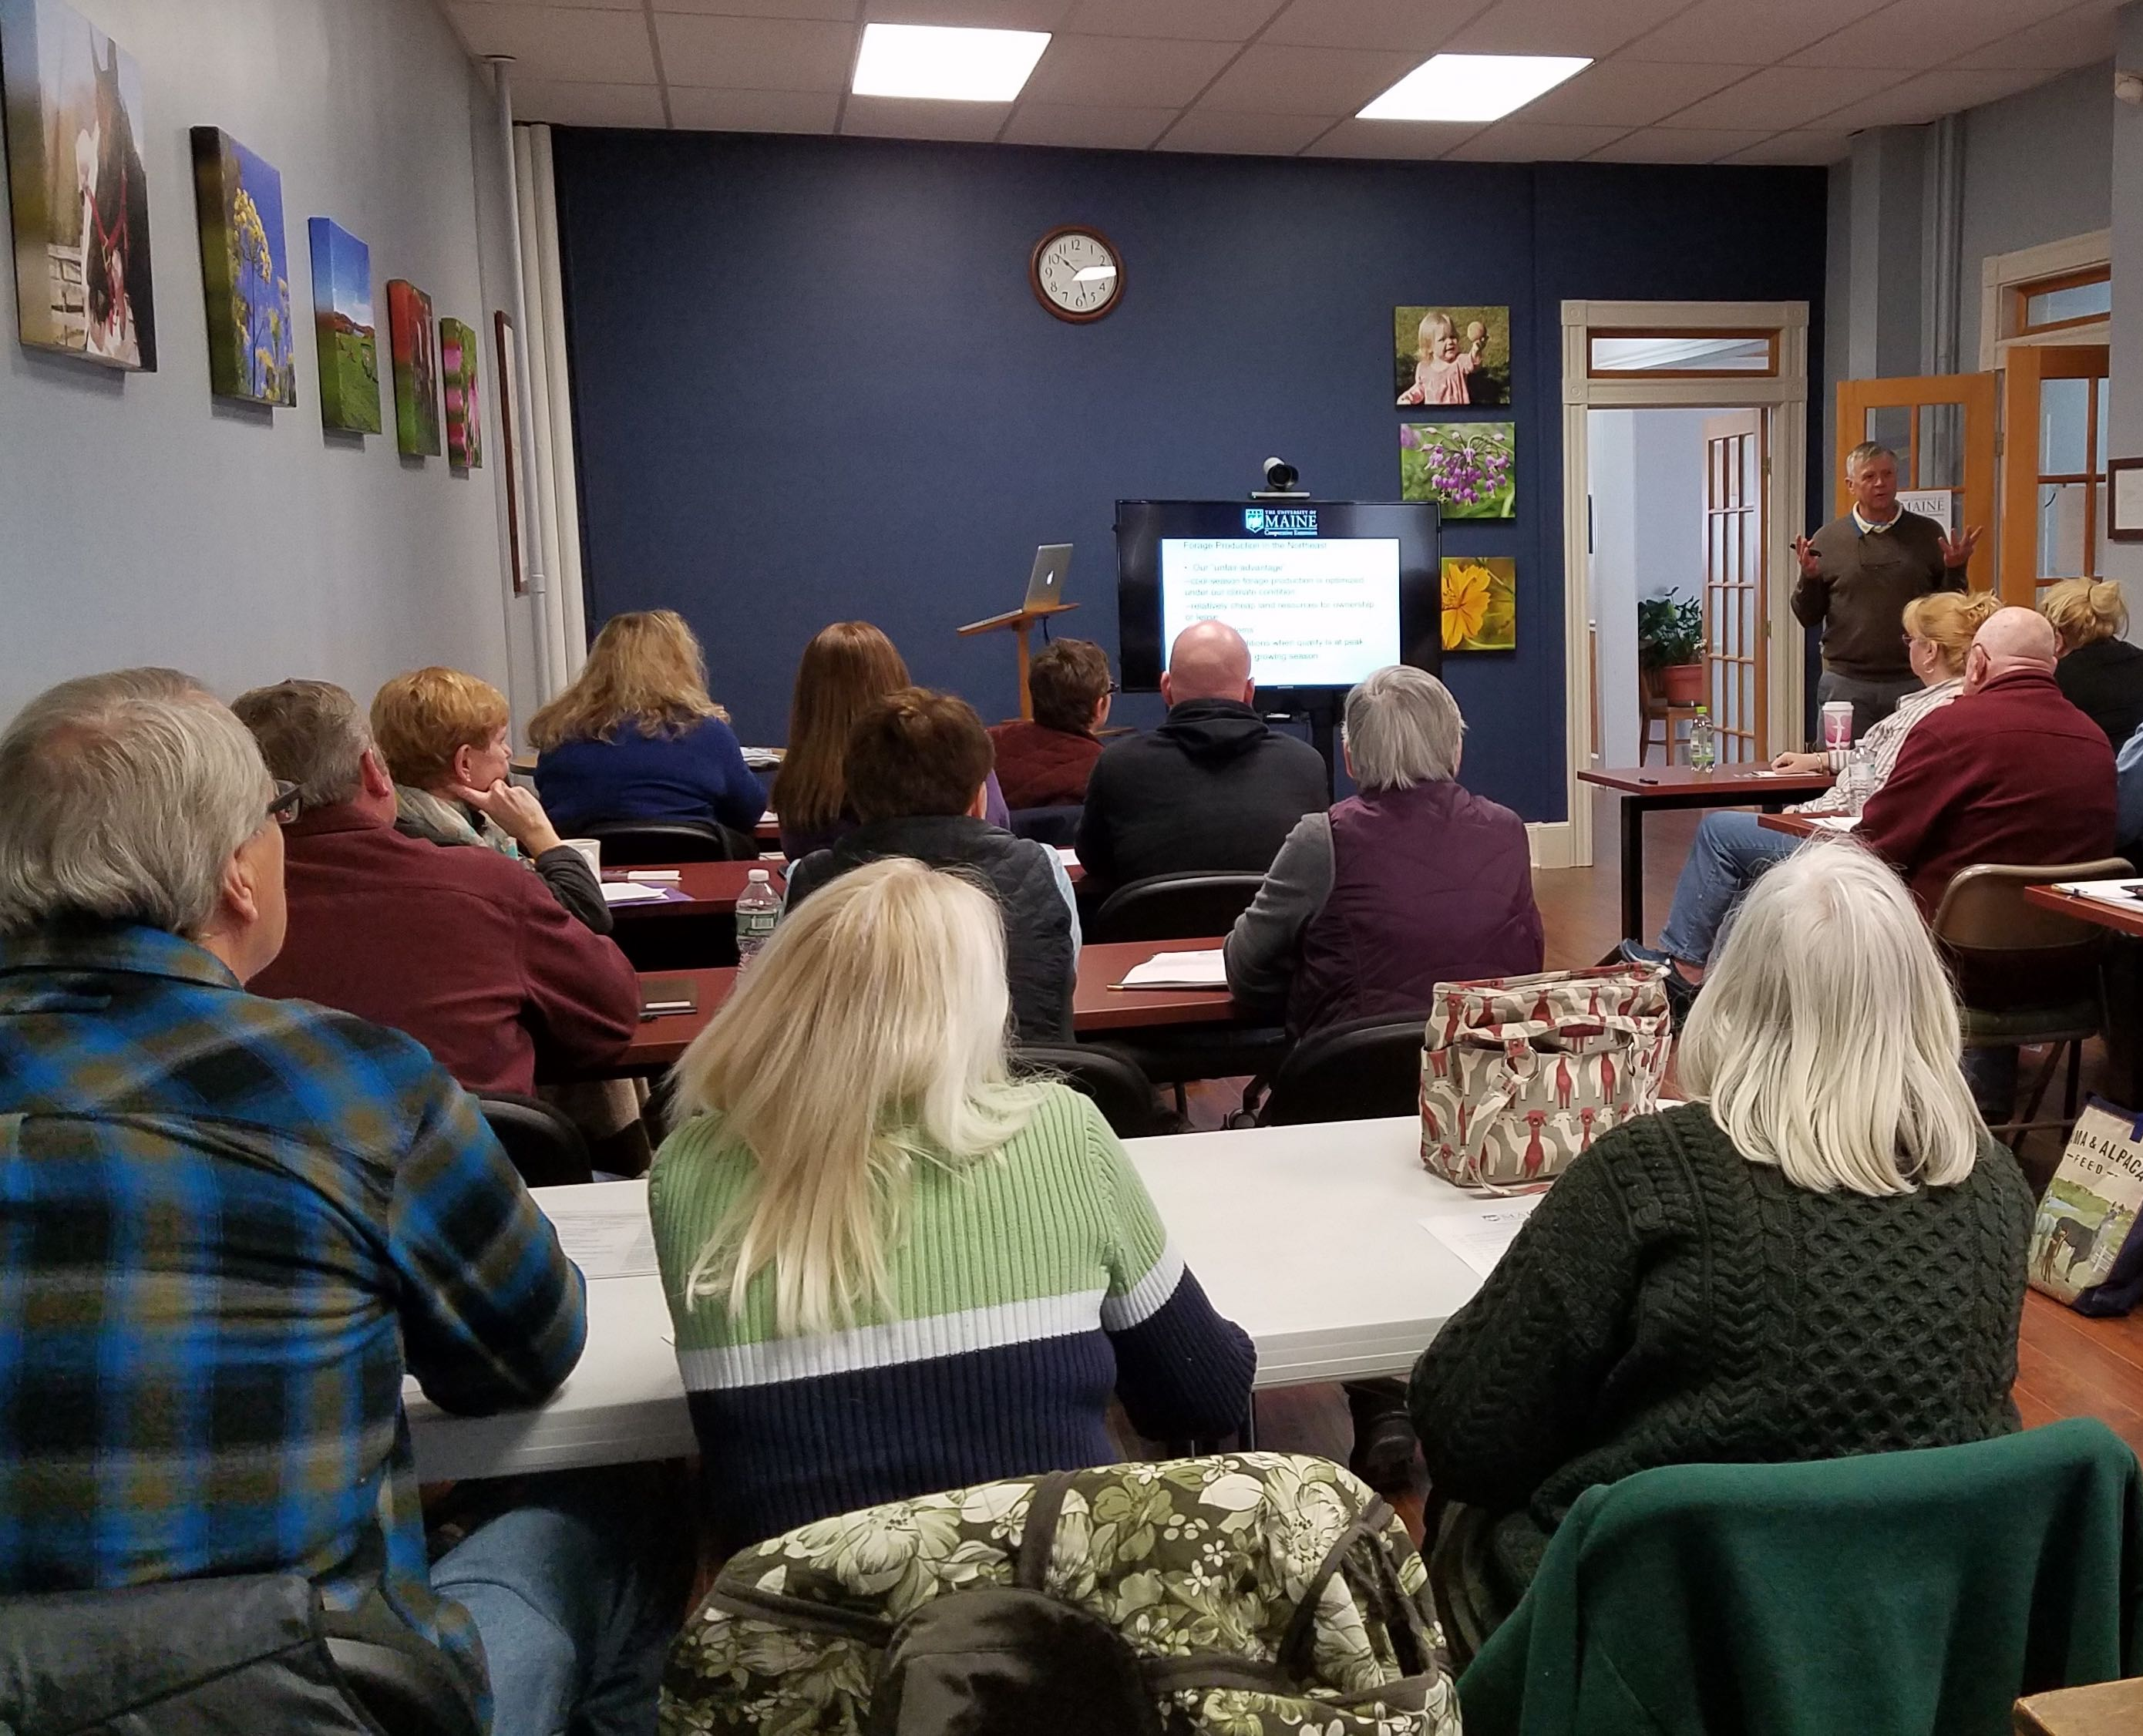
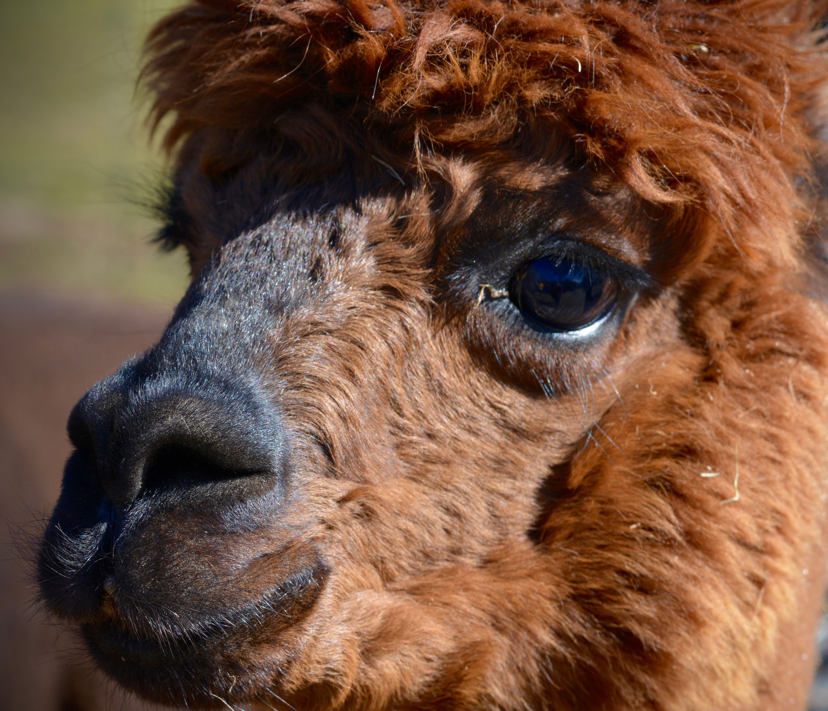
County highlights continued
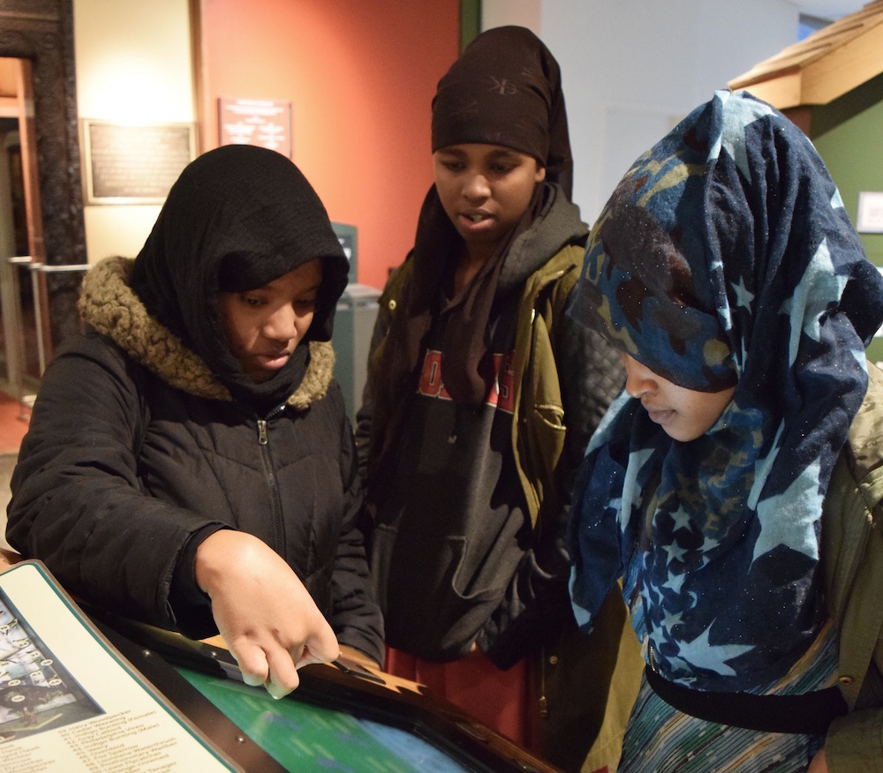
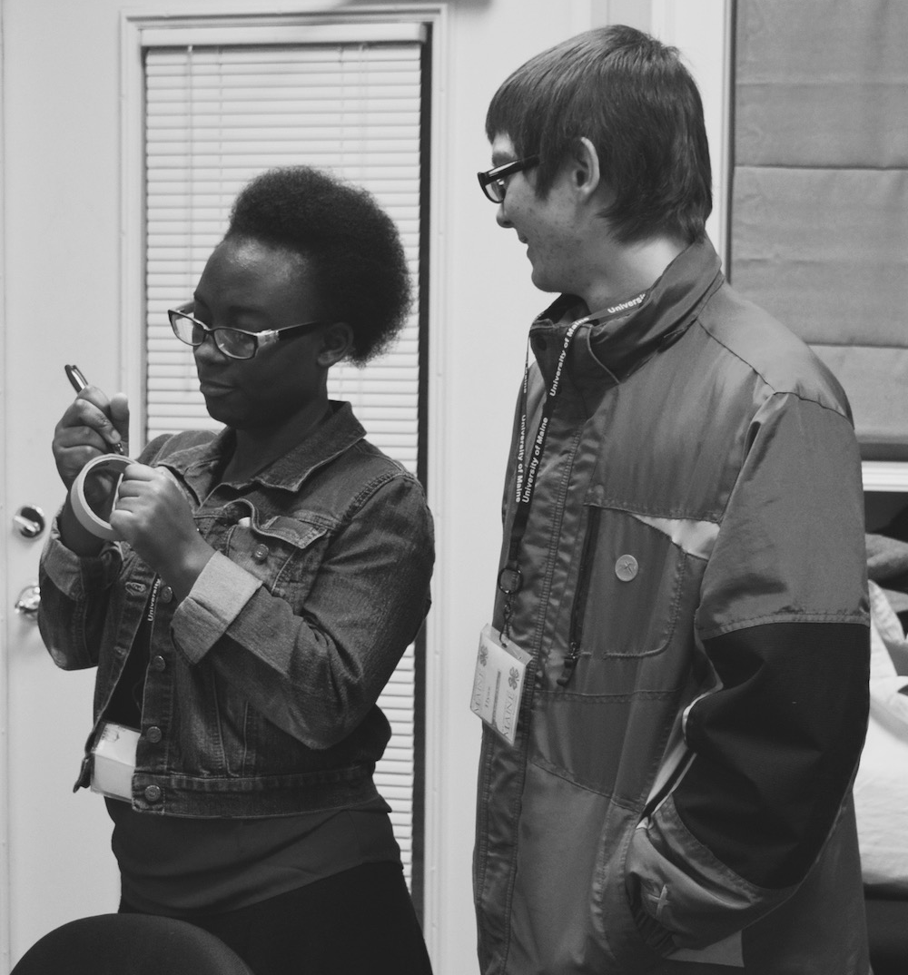
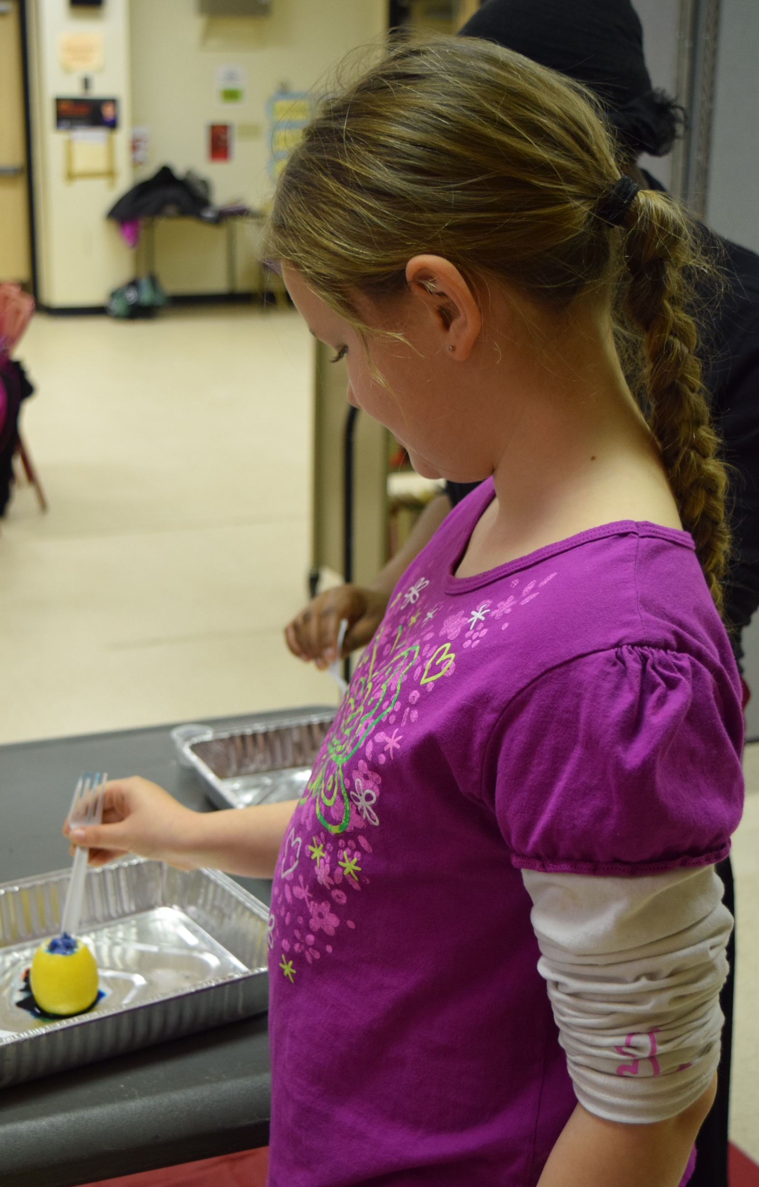
Left; 4-H Teen Leaders, Sahro, Isnino, and Gamano at the Boston Science Museum. Below; Odrine and Jacob, teen leaders presenting at the ASCEA Executive Committee meeting. Bottom left; Faythe.

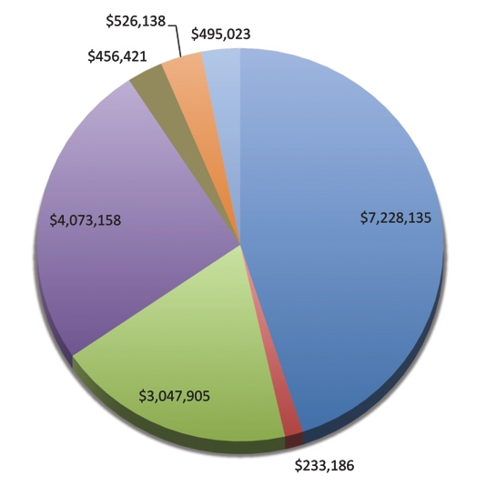
University of Maine Cooperative Extension Support for Androscoggin-Sagadahoc Counties
Without statewide support, UMaine Extension would not be present in this county. Funds for projects are provided through the University of Maine, Federal Formula Funds, grants, contracts, and fees. Dollars from other sources support salaries and benefits for Extension Specialists, County Educators, Extension administration, computer equipment and networking, publications, postage, telephone, and travel.

Statewide Extension Funding
As a unique partnership among federal, state and county governments, UMaine Extension uses funding from Maine counties and the University to match and leverage support from the United States Department of Agriculture, other federal grantors, state agencies and private foundations. Each county UMaine Extension office is also part of a statewide organization and the national Extension system.

Androscoggin-Sagadahoc Counties CY 2015
———————————————————————
Salaries and Benefits $467,036
Prorated Support from UMaine* $457,772
Computer Equipment & Networking $3,317
Statewide Animal Diagnostic Lab $3,039
Publications $816
Postage $1,411
Telephone $601
Travel $16,760
——————
Total $952,630
Prorated support from UMaine* reflects salaries & benefits for administrative and statewide support.
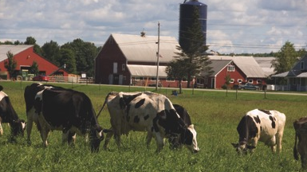
Local Partnership

Our County Extension Association is the vital link between the county, our communities and UMaine. The Association’s Executive Committee is comprised of local volunteers who represent community interests by advising UMaine Extension staff on educational programs, advocate for and secure funding from county government to support the county office, oversee the office budget and facilities, and guide UMaine Extension staff in identifying their programming goals.
Protecting Maine’s Poultry and Egg Industry
Maine’s poultry and egg industries are worth over $75 million yearly. Because the University of Maine Animal Health Lab (UMAHL) provides the FDA-required salmonella testing for medium- to large-sized egg producers in Maine, New Hampshire, and Vermont, these farms can operate within FDA’s Egg Rule. This work aids in prevention of human salmonellosis (SE) that might be acquired through eggs. The estimated cost to the egg industry of an SE outbreak could be higher than 10% of production. The impact of salmonella prevention is estimated to be more than $7 million per year. UMAHL handled over 6,000 avian samples during reporting year 2015. During 2015, highly pathogenic avian influenza (HPAI) caused the death of more than 49 million poultry in the United States. If this disease comes to our region, substantial losses to the commercial egg industry would result. UMAHL is working with small and large producers to increase biosecurity and preparedness for emergencies such as HPAI.

Protecting Maine’s Dairies
Many of Maine’s more than 8,000 small farms have dairy animals. Increasingly, organic and small ruminant dairies are producing a diverse collection of artisanal cheeses and alternative milk products. For public safety and quality control, dairies must keep pathogenic bacteria out of their dairy animals and dairy products. Culturing milk samples is key to protecting all of Maine’s dairies. In 2014-2015, the UMaine Animal Health Lab cultured approximately 2,000 milk samples for mastitis; 4.5 percent were positive for Staphylococcus aureus, which can cause serious human illness. Because S. aureus cannot usually be cleared from the udder, culling chronically infected cows is advised to protect the public and avoid the spread of this disease on dairies. Maine’s dairy owners and dairy product consumers benefit from our local, responsive mastitis diagnostic service. We screen samples from both large and small dairies for mycoplasma, S. aureus, and other pathogens. Allowing farmers to administer antibiotics appropriately, and to avoid excessive antibiotic use by culling animals with incurable infections, saves money and protects public health.

IPM Strategies for Sweet Corn
Sweet corn comprises nearly half of the commercial vegetable acreage in Maine but may bring only marginal profits due partly to high pest management costs. Sweet corn is an ideal candidate for integrated pest management (IPM) strategies. UMaine Extension set up insect traps and trained student field scouts to monitor sweet corn pest populations. Information gathered was summarized and shared with growers, ag consultants, and extension educators around Maine through a weekly newsletter and blog. Corn IPM techniques were demonstrated at two grower field days. Growers adopting these techniques noticed significant reductions in pest management costs and reduced risk of pesticide exposure to themselves and the environment. Of the participants responding to a post-season survey, 61% used the information to reduce the number of pesticide sprays they applied, 69% found the program significantly reduced pest management costs, and more than 75% found that IPM techniques improved their crop yield and quality. Applying sample results to numbers from recent state agricultural statistics suggests that Maine growers conservatively reduced insecticide applications by over 100,000 gallons this season and saved over $100 per acre on insecticide costs.

Expanding and Diversifying Maine’s Local Wheat Economy
UMaine Extension secured over $1 million of funding in 2015 for a diverse program that generates region-specific, research-based information and provides educational and networking opportunities for participants in the grain economy. Key collaborators include MOFGA, the Maine Grain Alliance, the University of Vermont, and the US Organic Grain Collaboration. Maine and New England farmers have access to ground-truthed information on local grain production, markets, quality standards, and economics. Research trials started in 2013 on field peas as a rotation crop for cereal grains inspired and informed at least 5 farmers to grow about 800 acres of field peas in 2015 for local markets. Three winter grain farmers adjusted seeding and fertility methods based on on-farm research results, affecting another 800 acres. Aroostook County farmers grew approximately 1,000 acres of organic grains. Two farmers planted a specialty heirloom rye for a new Nordic restaurant in New York City as a result of our connections and 3 years of trialing. With our guidance, a cooperating farmer produced Maine’s first crop of blue tag certified organic grain seed, and one of the region's first certified seed of an heirloom variety. Farmers are successfully supplying new and expanding grain markets with high quality grain.
Food Safety Education for Families and Commercial Food Producers
Each year 48 million people in the U.S. contract foodborne illnesses. Food safety risks exist in home food preparation and preservation, in people serving crowds, and in retail and commercial manufacturing and sales. These groups prepare or process food for others, often without proper food safety training, leading to increased occurrences of foodborne illness. UMaine Extension provides food safety training programs including food preservation; home food safety; Cooking for Crowds; industrial food sanitation; Good Agricultural Practices; Hazard Analysis Critical Control Points (HACCP) certification; and soon, Food Safety Modernization Act trainings. Extension provides private food safety consulting and process authority food product reviews to companies statewide. These programs directly reached and trained over 10,000 people in Maine in the past year and we estimate that over 500,000 consumers of food produced by New England-based food businesses have a reduced potential to contract foodborne illness because of our trainings.
In addition, the food process authority lab reviewed over 500 products, leading to added income and jobs across Maine and New Hampshire. In almost all cases one-on-one food safety consulting led to increased revenue, retention of jobs, and/or increased hiring. One new startup company hired 171 employees and said, “Extension’s work with our company has contributed to the safe production of 7.2 million pounds of lobster per year with a value of over $36 million.” These results are decreasing the occurrences of foodborne illness and increasing overall health in Maine and wherever Maine foods are sold and consumed.

The “Whole Schools Whole Communities” Initiative
The Environmental Living and Learning for Maine Students (ELLMS) Project secured a $275,000 grant to implement the Whole Schools Whole Communities Initiative. The project partners—UMaine’s 4-H centers, Chewonki, the Schoodic Institute, and the Ecology School—joined with 10 Maine school districts. The ten Maine public school districts, representing nearly 8,000 students, are deeply engaged in the process of envisioning and which implementing significant change in teaching and learning. The process includes facilitated planning sessions during school leaders, teachers, community stakeholders, and ELLMS Project representatives are collectively shaping the future of education to include meaningful connection to community through service learning opportunities, leadership development, place-based curricula, outdoor field science, and STEM. The ELLMS partners are also conducting an integrated research project using “Most Significant Change” methodology. The research is designed to ascertain the longitudinal impact of quality environmental education opportunities for students and teachers.

Maine Harvest for Hunger
Maine has the highest rate of food insecurity in New England, and ranks twelfth in the United States. Forty-three percent of food-insecure people do not qualify for food stamps or other government program. It is challenging for food-insecure people to afford fresh, nutritious food, and donations of fresh produce to Maine’s emergency food system have declined recently. Since 2000, UMaine Cooperative Extension’s statewide Maine Harvest for Hunger (MHH) program has mobilized gardeners, farmers, businesses, schools, and civic groups to grow, glean, and donate high quality produce to distribution sites and directly to neighbors in need. The objective is to mitigate hunger, improve nutrition and health, and help recipients develop lifelong positive nutritional habits. Through a dialogue between recipients, donors, and staff, the team has made significant progress in expanding the variety of offerings readily accepted and used by recipients, minimizing donation waste and extending the donation season. In 2015, record-breaking donations of over 318,000 pounds (value of $537,000, based on an average $1.69 per pound) went to 188 distribution sites and to individuals. Nearly 500 volunteers in 14 counties collectively logged more than 5,000 hours.

Eat Well: Responding to Food Insecurity
Maine Cooperative Extension’s EFNEP paraprofessionals educate Maine’s limited-income families and youth to help them make better lifestyle choices and improve their nutritional well-being. EFNEP participants learn how to eat well on a budget and apply what they learn to their daily lives. These positive changes will eventually help reduce the incidence of obesity and chronic disease of limited income families in Maine. As a result of completing the Eat Well program (320 adult participants surveyed): 74% showed improvement in one or more food resource management practice, 81% showed improvement in one or more nutrition practice, and 68% showed improvement in one or more food safety practice. Eat Well graduates reported increasing fruit and vegetable intake by one-half cup per day and self-reported increases in fiber, calcium, and vitamin D intake. 15% of Eat Well graduates also reported increasing physical activity to at least 30 minutes per day.

Eat Well… Supporting Children’s
Learning and Health
In Maine, more than a quarter of school-aged youth are overweight or obese, and nearly a quarter of the state’s children are food insecure. UMaine Extension’s Eat Well Program (funded by federal EFNEP dollars) provides limited-income youth in grades K-12 free education on healthy habits. Eighty percent of participants improved their ability to choose foods according to USDA MyPlate recommendations; 45 percent used safe food handling practices more often; and 32 percent improved their physical activity. Developing a solid foundation of healthy habits in childhood will help improve the health of Maine’s population long term.

Parent Education: Laying the Foundation for
Future Success and Well-Being
Research demonstrates that the experiences a child has during the first three years of its life affect the developing brain and lay the foundation for future well-being. Adverse experiences can have lasting negative outcomes and affect physical and emotional health, school achievement, relationships, self-sufficiency, and overall functioning and success. With federal, state, and local funding, Parenting Education Professionals (PEPs), part of the Maine Families Program, supported families in 3 counties. Seven certified PEPs made 1,984 home visits to 248 families. Using the Parents as Teachers model, PEPs met with families in their homes to share activity ideas to support child development, build parenting skills, and provide links to community resources. Results from the annual parent survey showed that 99% of families used the child development information they received during home visits, 92% of families reported the program to be helpful, and 97% reported increased confidence as parents. In addition, breastfeeding rates for participating children were above the statewide average, 98% of children enrolled prenatally were up to date with well child visits, 94% of eligible children completed developmental screening, and all enrolled families were assessed for basic needs and referred to services as appropriate.

4-H Camps Connecting Youth to Positive Community Experiences and Mentorship

In 2015 UMaine 4-H summer camps served 1,732 youth from all sixteen counties in Maine, thirty states, and three countries. Through living and working together, campers and staff became part of an interconnected community committed to a sustainable future. In living and working alongside positive adult mentors and peers, youth become members of a community to which they make positive contributions. The opportunities to develop mastery of skills happens in the context of the residential camp and learning center setting where the “implicit curriculum” includes healthy nutrition and activities, inclusive and safe learning environments, and intentional leadership development. Youth and program alumni report that the 4-H Camp and Learning Center experience has helped them develop greater self-confidence, civic engagement, and personal and academic success.

Protecting Wildlife Health
Maine has joined a group of laboratories that can “link” regional agencies with local diagnostic assistance for wild animals, the Northeast Wildlife Disease Cooperative (NWDC). Collaboration with the Department of Inland Fish and Wildlife has yielded information about the health of Maine and New Hampshire moose. We have documented health status at capture of over 200 radio-collared moose over a 3-year period, performed surveillance of hunter-killed moose lung parasites, and provided diagnostic services for radio-collared moose dying of natural causes. The University of Maine Animal Health Lab (UMAHL) has hosted wildlife biologist trainings, provided diagnostic information for wildlife cases, and assisted in investigations of lead toxicosis in waterfowl. Participation in the NWDC is bringing more expertise to the region and to the UMAHL. UMaine Students benefit from opportunities to work with wildlife disease researchers and biologists benefit from improved safety in the field due to the information conveyed at the workshops. Regionally acquired information provides better disease surveillance, which is useful to wildlife managers. A 2014 report to the Maine Office of Tourism and the Maine Department of Inland Fisheries and Wildlife found that moose and waterfowl hunting brought more than $33 million to Maine annually, and supported more than 450 full- and part-time jobs. The work of the UMAHL helps ensure continued hunting opportunities in Maine.
Protecting Maine Citizens Against Lyme Disease
There were approximately 1,400 reported cases of Lyme disease in Maine last year (estimated to be a fraction of the actual number of cases). Providing outreach and services related to this increasingly common public health threat is an important issue in Maine. In 2014 UMaine Extension created and implemented an in-state tick identification program. This program has been expanded by creating and consistently updating an informational website, providing public presentations on ticks and vector-borne disease, and developing informational tick cards for distribution. Program activities also aided in the passage of an $8 million bond for construction of a new biosecure laboratory that will be able to test ticks for pathogens. Clients now have access to a wide range of tick information targeted specifically at issues relating to Maine. Tick specimens can be identified more quickly within the state, and upon completion of the new lab, ticks will be tested for pathogens, a service that is not currently offered in Maine.
Photos, opposite page: Edwin Remsberg, tick: G. Dill, moose: U.S. Fish and Wildlife Service

Statewide Highlights
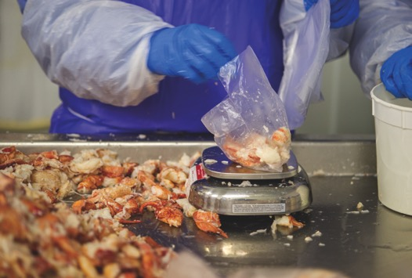

The County Extension Act

The County Extension Act explains the role of county government in funding local Extension offices.

Cooperative Extension work shall consist of the giving of practical demonstrations in agriculture and natural resources, youth development, and home economics and community life and imparting information on those subjects through field demonstrations, publications and otherwise. For the purpose of carrying out this chapter, there may be created in each county or combination of two counties within the State an organization known as a “county extension association,” and its services available to all residents of a county. The county extension is viewed as a unique and important educational program of county government. The executive committee of each county extension association shall prepare an annual budget as requested, showing in detail its estimate of the amount of money to be expended under this chapter within the county of counties for the fiscal year. The executive committee shall submit to the board of county commissioners on a date requested by the county commissioners, and the county commissioners may, if they deem it justifiable, adopt an appropriate budget for the county extension program and levy a tax therefore. The amount thus raised by direct taxation within any county or combination of counties for the purposes of this chapter shall be used for the salaries of clerks, provision of office space, supplies, equipment, postage, telephone, a contribution toward the salaries of county educators and such other expenses as necessary to maintain an effective county extension program.¹

¹Excerpted from Title 7, Chapter 7 of the Maine Revised Statutes, §191–§195.

UMaine Extension’s Eat Well Program brings nutrition education to limited-income families and youth in Maine.
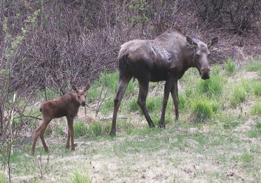
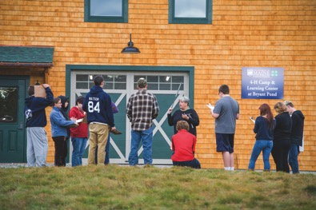
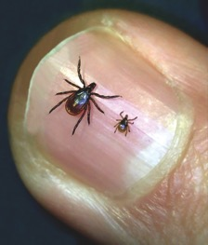


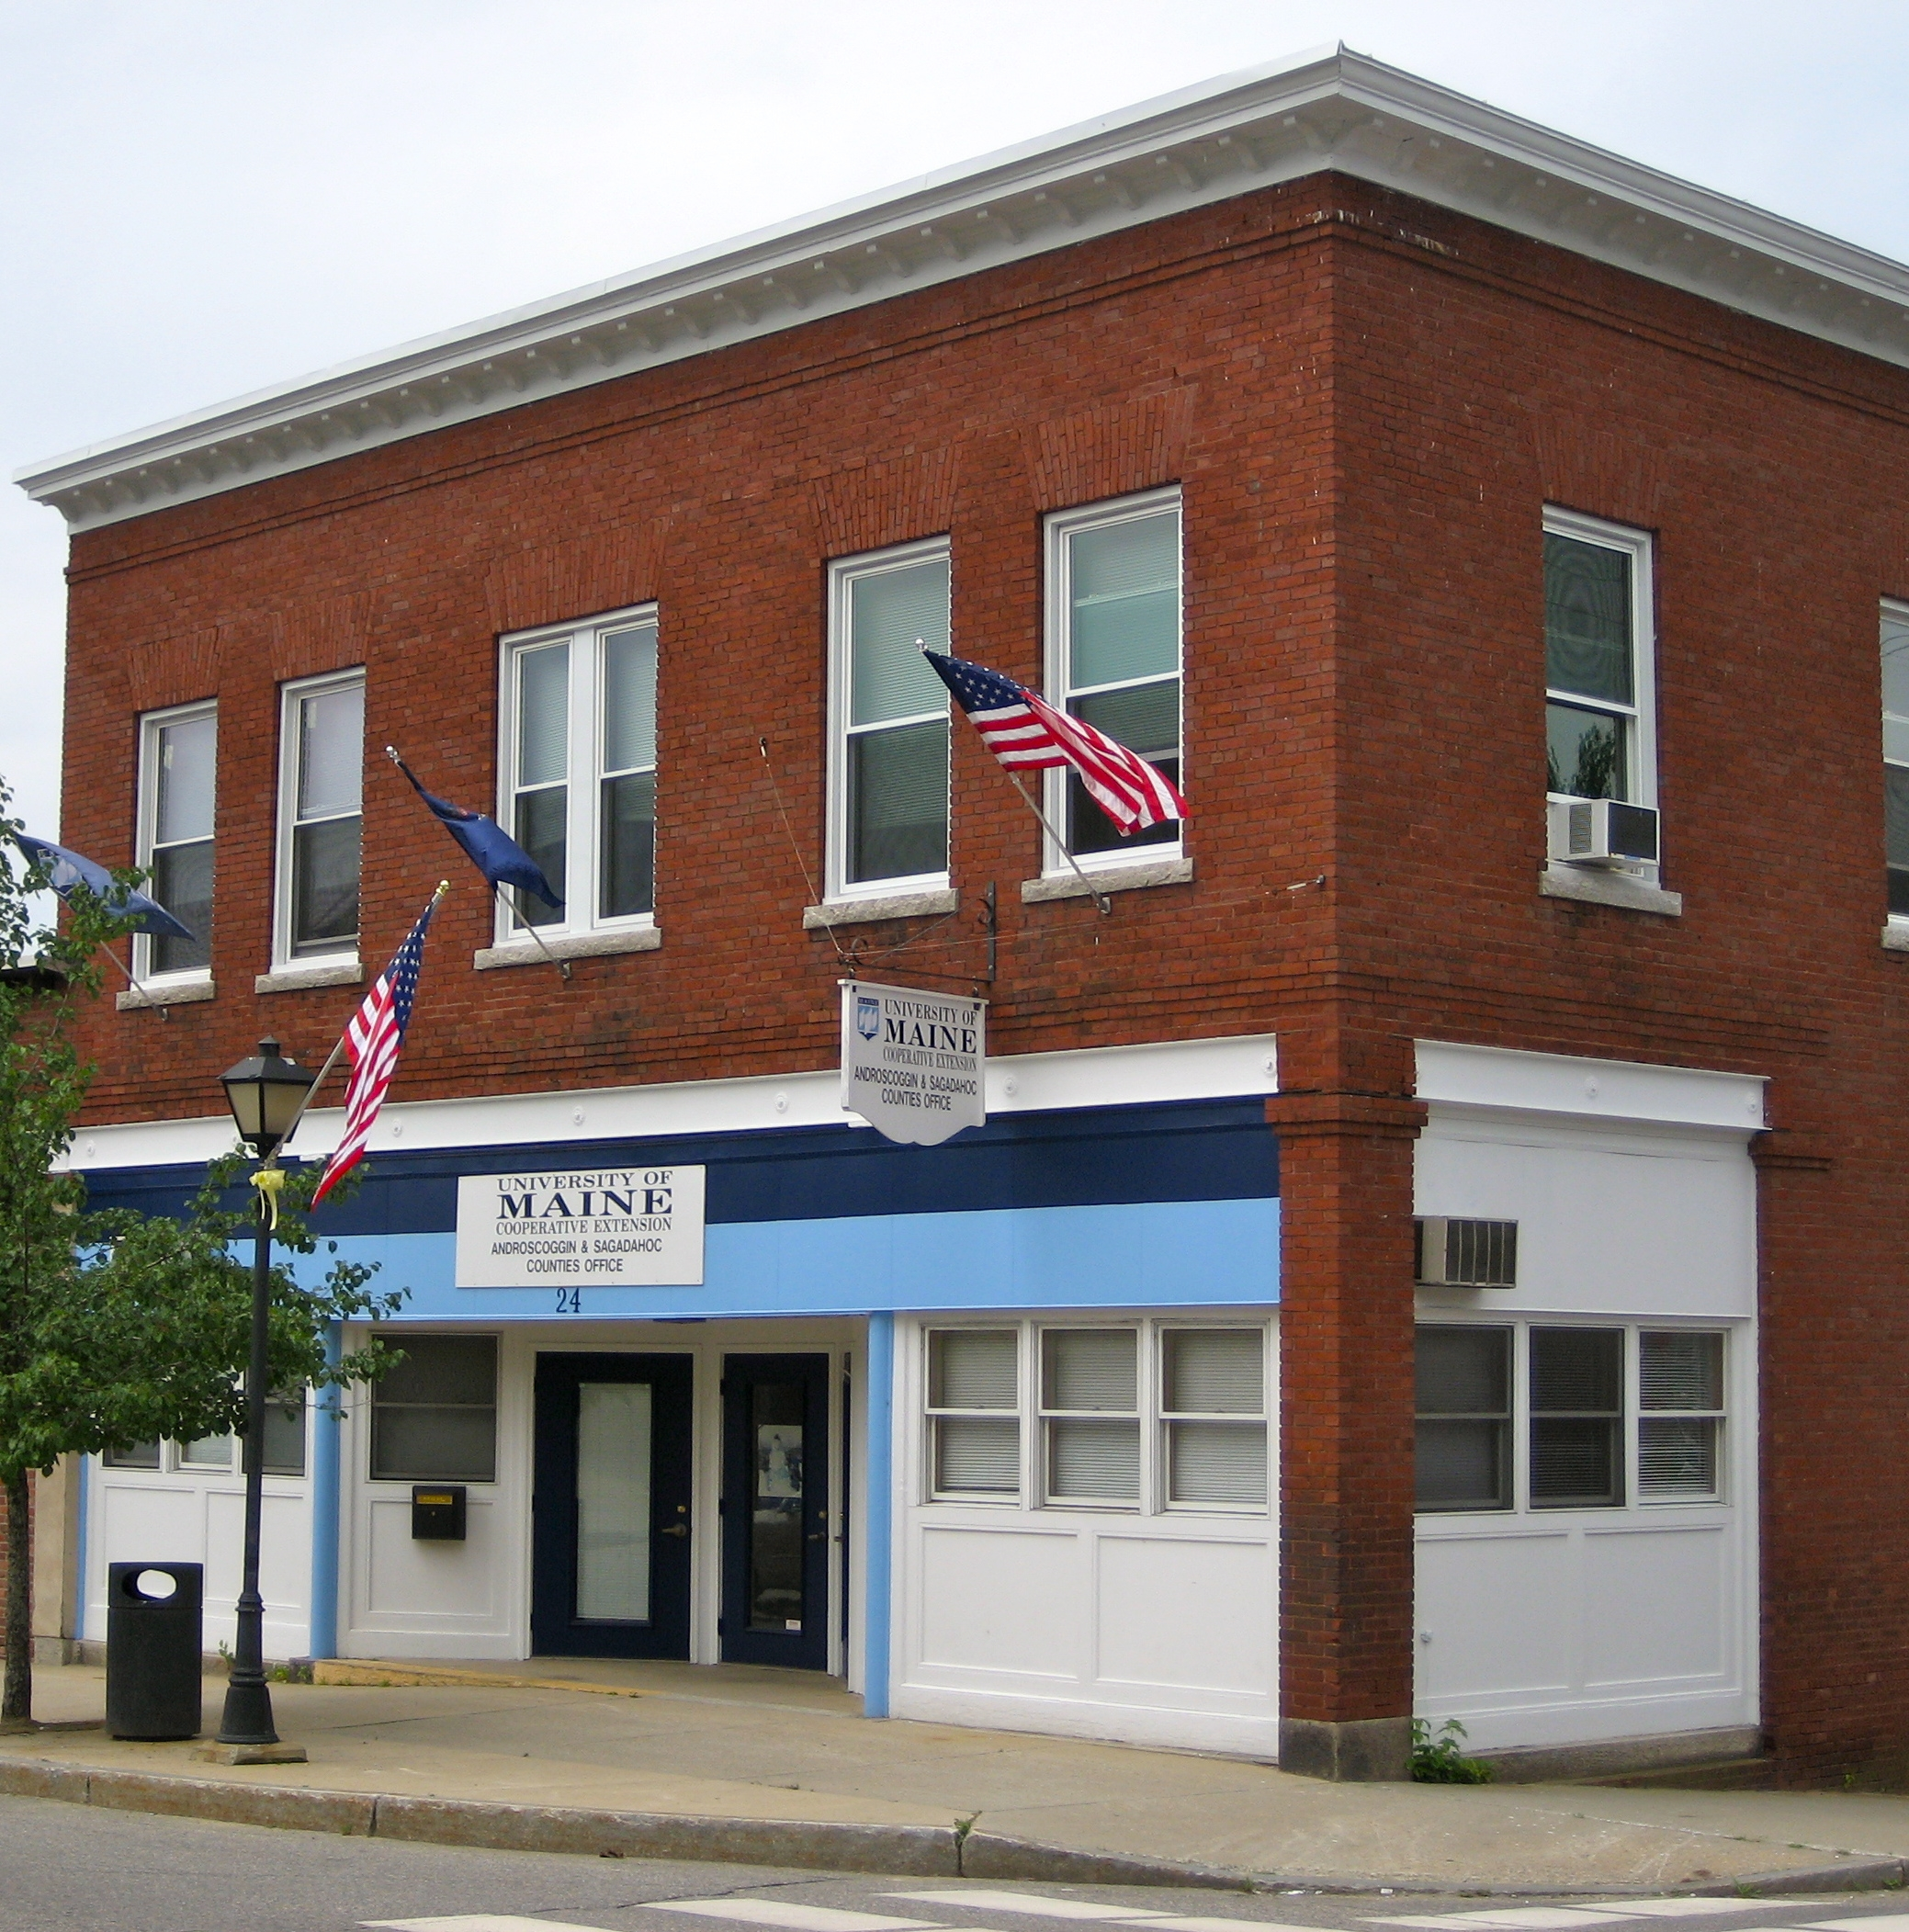
Photo by Tori Lee Jackson, Extension Educator, Associate Professor
Androscoggin-Sagadahoc Counties Cooperative Extension Office

University of Maine Cooperative Extension
Androscoggin-Sagadahoc Counties
24 Main Street, Lisbon Falls, ME 04252
207.353.5550, 1.800.287.1458 (in Maine only)
Fax: 1.866.500.9088

http://extension.umaine.edu/androscoggin-sagadahoc/

andsag@maine.edu
A Member of the University of Maine System

Published and distributed in furtherance of Cooperative Extension work, Acts of Congress of May 8 and June 30, 1914, by the University of Maine and the U.S. Department of Agriculture cooperating. Cooperative Extension and other agencies of the USDA provide equal opportunities in programs and employment. 04/13
The University of Maine does not discriminate on the grounds of race, color, religion, sex, sexual orientation, including transgender status and gender expression, national origin, citizenship status, age, disability, genetic information or veteran’s status in employment, education, and all other programs and activities. The following person has been designated to handle inquires regarding nondiscrimination policies: Director, Office of Equal Opportunity, 101 North Stevens Hall, 207.581.1226.

