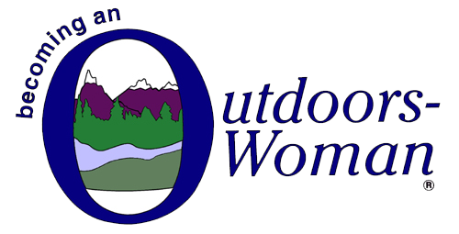

Winter BOW- Health screening

Prior to your arrival for our winter BOW session we ask that you watch for the following symptoms. Should you be experiencing any of the below symptoms we ask that consider testing prior to your arrival or if you are not feeling well enough to attend, please notify us and we will be happy to credit your account for use during a future session.
______________________________________________________________________________________
People with COVID-19 have had a wide range of symptoms reported – ranging from mild symptoms to severe illness. Symptoms may appear 2-14 days after exposure to the virus. People with these symptoms may have COVID-19:
- Fever or chills
- Cough
- Shortness of breath or difficulty breathing
- Fatigue
- Muscle or body aches
- Headache
- New loss of taste or smell
- Sore throat
- Congestion or runny nose
- Nausea or vomiting
- Diarrhea
This list does not include all possible symptoms. CDC will continue to update this list as we learn more about COVID-19.

