INSECT MANAGEMENT 2014
Prepared by Charles D. Armstrong

Action Thresholds
In sweepnet sampling, the average number for a pest count that we use to trigger a management action is only a rule of thumb. It serves as an indication that a pest is being sampled at numbers that are considered high and worthy of attention. If you expect to get no more than 40 cents per pound for your cranberries, you should consider using the ‘Alternative’ thresholds in the table below, rather than the ‘Traditional’ thresholds because they may not be economically sound under such conditions. Reminder: If your sweepnet average is equal to or just 1 or 2 away from the threshold you are using, it is both appropriate and wise to take additional sweep sets (in different portions of the bed) until the count is farther away from the threshold, in one direction or the other, so you can be more confident of the ‘true’ pest situation you are being faced with.

PESTS | TRADITIONAL  THRESHOLD  (Avg. per 25 sweeps) | ALTERNATIVE  THRESHOLD  (When berry price is below $0.40/lb.)
Black-headed Fireworm or any other fireworm species | 1 to 2 | 4
Blunt-nosed Leafhopper | No threshold available but consider using 1 per 25 sweeps regardless of berry price because it is a carrier of the virus-like disease called False Blossom!
Red-headed flea beetle | 15 | 30
Cranberry Weevil | 4.5 - spring population  9 - summer population | 7 for spring population  14 – summer population
Cutworms (such as False  Armyworm & blossomworm)  or Humped Green Fruitworm | 4.5 | 7
Gypsy Moth Larvae | 4.5 | 7
Total of cutworms + humped green fruitworm + blossom-worms + gypsy moth larvae | 4.5 | 7
Spanworms | 4.5 | 9
Cranberry Tipworm* | no traditional threshold | 30% of tips infested or damaged*
Cranberry Fruitworm | 1 viable egg  per 200-250 berries | 3 viable eggs  per 200-250 berries

* Given that severe late-season cranberry tipworm damage can potentially significantly reduce one’s crop in the subsequent season, one
should base the decision to abide by the alternative threshold estimate of 30% tip infestation (30% of tips infested or damaged) on his or her own bed history with this pest, and whether or not higher prices are expected the following year.

Start scouting bogs no later than ~ May 25th. Always gauge pest levels of insect caterpillars in their early stages! As the caterpillars of many species grow larger, they cling more tightly to the vine or hide in the daytime and are harder to pick up in daytime sweeps. Thus, at that point, sweeping at night is encouraged in order to gauge numbers. Small black-headed fireworm caterpillars may cling to the top of the net. Continue sweeping at least until the start of bloom. Be aware that some serious pests—namely cranberry weevil and black-headed fireworm—are still active during and after bloom, so if you have a history of problems with any serious pests, you should continue to closely monitor your bed(s) during such times in some capacity—if sweeping is stopped, then at least close visual inspections should be made, with a keen eye for any webbing of uprights or other anomalies. Be aware that some pests, particularly cranberry weevil, gypsy moth, and black-headed fireworm, may be very patchy and can thrive in coves or along edges, so thorough assessment of total acreage is warranted.

Sweepnetting. [12” net and 180° sweeps made partway into the vines] Sweep at least once a week from late May through early August (and once or twice during bloom is a good idea in spite of the blossoms you knock off). A sweep set consists of 25 sweeps taken across the bed (a diagonal or ‘W’ pattern is good, with a different start location each time). Any insect pests in the net need to be identified, counted, and the numbers recorded. Conduct 1 set of 25 sweeps for each acre. For larger pieces, at least 1 sweep set for every 2 acres is advisable. Calculate the average per 25 sweeps of each pest in all of your sweep sets. Consider treating (or taking action) only after the average number of a pest meets or exceeds the Action Threshold. Consider other factors as well such as cost of application, expected returns, weather, etc.
Pheromone traps. Traps can be helpful for timing one’s management of cranberry girdler, black-headed fireworm, and Sparganothis fruitworm. We have not had any problems with girdler in Maine, however, and Sparganothis fruitworm has been an insignificant pest in recent years as well. That is probably why using the traps in Maine has proven difficult because trap numbers have often been so consistently low that it is hard to observe any peaks in capture numbers. For example, the difference between our daily captures and the peak flight number might be only 3 or 4 moths in some years, making peaks hard to pinpoint. Due to this uncertainty, coupled with the fact that trap catch numbers don’t correlate well with the presence or absence of infestations, I don’t recommend that Maine growers use these traps. The time they require would likely be better spent sweeping and examining the vines for the first signs of any larvae and/or problems.

Bacillus thuringiensis (B.t.) based products. Examples include Dipel ES (1 to 4 pt/A), as well as Biobit, Xentari, and Dipel DF (each at ½ to 2 lb/A). These products may have varying activity. Check labels for directions. Consider treating before the threshold is reached. Early attention to infestation is critical. Maximize effectiveness by treating young caterpillars, less than 1/4". Cutworms larger than 1/2" are difficult to control. Addition of 3-6 oz of Pyronyl to Dipel ES will improve performance. For larger caterpillars, low rates of synthetic insecticides added to Dipel – e.g. 3-6 oz Pyronyl or very low rates of Diazinon or Sevin – improves performance. Thorough coverage is essential and repeat applications may be necessary. Caterpillars stop feeding soon after eating compounds but they may take several days (3-10) to die. New growth subsequent to treatment is not protected; rain, irrigation, or excessive water after application as a result of a poorly-timed or large-acreage chemigation system, will remove the active material. Use aerial application or low-volume ground applications when possible as it usually improves performance. Spot-applications of low gallonages with backpack sprayers are a good option. Check the label for bee toxicity. Addition of a spreader/sticker (e.g. Bond, Stik) may be critical; check the label.

Altacor (1st product of its kind, belonging to a new class of potent insecticides called anthranilic diamides). Anthranilic diamides are nitrogen-containing aromatic compounds that are selective targets of the ryanodine receptor used in muscle function in insects. They cause paralysis of the insect by sustained contraction of the muscles. Altacor is an excellent IPM tool because it’s a selective insecticide (phenomenal against cranberry fruitworm) with low toxicity to pollinators and other beneficial arthropods. It also has long residual activity and is safe to key mite predators. A good chemigation system (under 6 minutes) is likely necessary for getting good efficacy. Ground applications using at least 30 gallons of water per acre and preferably 100-150 gallons per acre may be the most effective delivery method.

Insect Growth Regulator (IGR) products (Intrepid, Confirm, Rimon). Growth regulators are, primarily, caterpillar-specific, with Rimon being one IGR that has a broader host range. But in general, these products help to conserve beneficial insects. Intrepid is a restricted-use product. Use low-volume ground applications when possible to improve performance. Well-timed chemigation systems are probably critical for good efficacy. Consider treating before thresholds are reached. Efficacy may vary widely depending on conditions. Thorough coverage is essential and repeat applications are necessary. New growth subsequent to treatment is not protected; rain, irrigation, or chemigation washout will remove the active material. A spray adjuvant should be used, with the exception of Rimon which does not allow it. Five to six hours of drying time following application is required. Death of the caterpillars may not be observed until a week or more has passed. Pollinator-friendly! Check labels for directions.

Neonicotinoid products (Admire, Actara, Assail, Belay, Scorpion and Venom). These represent a class of insecticides that are modeled after nicotine. They mimic the action of the neurotransmitter, acetylcholine (ACh). Admire (imidacloprid) was the first of them to be introduced (Europe & Japan in 1990 & the US in 1992). Most of them—including all six of these—are systemic, meaning that they are transported in the xylem to the roots, leaves, stems (and sometimes pollen), etc. of the host plant. Clothianidin (the a.i. in Belay®) is very active on sucking insects and is used not only on fruits, but also on vegetables, cotton, turf and ornamentals as well. Clothianidin has a long half-life (average of 214 days in aerobic soil) and is highly toxic to bees. Scorpion and Venom are intended in cranberry mostly for controlling leafhoppers and flea beetles, providing “suppression only” of all our other major cranberry insect pests that we have in Maine (tipworm, fireworm, fruitworm, weevil, and spanworms).

Spinosyn-based products (Delegate, Entrust). Spinosad is a fermentation metabolite of a soil-inhabiting microorganism, Saccharopolyspora spinosa. It has a novel molecular structure and mode of action that provides both contact and stomach activity against caterpillar pests, with long residual activity. Spinosyn-based products are fast-acting and are reduced-risk. 7 days needed between applications. These are the better tools to use (compared to Intrepid or Confirm) once the caterpillars have reached a larger size. When chemigating, a short rinse time (6 minutes or less) is necessary for good efficacy. Only use lowered rates if chemigation system is 4 minutes or under. Keep in mind that spinosyn products are moderately toxic to aquatic invertebrates and highly toxic to bees, when wet (once thoroughly dry, the residues are safe to bees; thus, spray at night, when conditions lend themselves to being dry by daybreak).

Restricted-Use Pesticides (Lorsban, Diazinon, Intrepid, Actara, Scorpion, and Venom) A pesticide license (private applicator certification) is required for you to apply these compounds.

MAINE CRANBERRY INSECT PESTS

BLACK-HEADED FIREWORM (2-3 Generations per season) (Larva with shiny, black head & cream body)
HILL FIREWORM (only 1 generation per season) (Larva has a dull black head & dark brown/gray body)

The status of black-headed fireworm—Rhopobota naevana (Hübner)—is on the rise in Maine and in New Brunswick. During the past four years, there have been five outbreaks of this pest in Maine – two were severe and widespread, while the others in 2005, 2006 and 2007 were patchy and more confined. Areas of infestation subsequently look like they were burned – hence the ‘fire’ in its name. Note: A Hill Fireworm larva was found in 2006 in an isolated case (no infestation was found). This fireworm species only goes through one generation per season, and is in its larval stage during the month of June (early to late June depending on the year: early June if early Spring; otherwise later in June).

Black-headed fireworm larvae hatch in mid to late May; closer to mid-May in unusually warm/early Springs or following unusually warm winters. 2nd-generation larvae appear during bloom. Infestations move rapidly, particularly during the 2nd generation. If you have a history of high fireworm populations, consider the use of pheromone traps (see page 34) to possibly help time management of the 2nd generation. The pheromone trap often picks up a much larger, non-pest moth, however. Black-headed fireworm moths are only ¼" long and are black and gray.

While sweeping in May and very early June, look for the very small fireworm larvae on the rim of the sweep net. They do not get picked up in sweeps very easily, so if you catch 1 to 3 larvae in 25 sweeps, you need to be on guard and perhaps take action depending on the Action Threshold you are using. Further, fireworm infestations are often patchy, and larvae are often more numerous along edges, where vines are lush & overgrown, where leaf trash has accumulated, or where winter flooding was truncated. Spot-treatment is desirable in those cases. Mating disruption is a tool that can be used against this pest (if product is available), although good results are less likely for small acreages (1 acre or less) or when populations are very high due to the increased likelihood of ‘chance’ encounters between male and female moths.

Visual sampling is recommended as the most effective means of early detection of spring fireworm infestations. Monitoring should begin as soon as larvae begin to hatch. The earliest activity will be detected in warmer bed edges by inspecting buds and leaves for mining/skeletonizing, webbing, and brown pellets of frass. 1-2 weeks after the very first larvae are seen, more extensive monitoring can be done by 'visual sweeps.’ This involves crouching down to closely examine areas of about two ft². Repetition of 10 'visual sweeps' is recommended / acre.

NOTE: Bold-face selections are being touted as the best choices for management.

Altacor 3-4.5 oz / A Low rinse time required for efficacy; target eggs or tiny larvae only.

Confirm 2F 16 fl oz / A Growth regulator products. Efficacy may vary depending on conditions. Thorough
Rimon 0.83 EC 12 fl oz / A coverage is essential & repeat applications may be necessary. New growth is not protected; rain, irrigation, or chemigation washout may remove active material. A spray adjuvant should be used with Confirm but is prohibited with Rimon. Must be eaten by the caterpillars for best results, and death may not be observed until a week or more later. Pollinator friendly! 7-day spray interval with Rimon; up to 3 Rimon sprays per season.

Intrepid 2F 10–16 fl oz / A Improved activity versus Confirm (good for at least 14 days and holds
up well to irrigation and rainfall). Restricted use. Safe for bees & natural enemies!

Assail 30 SG 4.0-6.9 oz / A 7-day minimum for reapplication. Coverage and timing are critical as
insect pests must ingest the material. 2 appls / season. 1-day PHI.

Avaunt 6 oz / A Minimum of 7 days between applications; 30-day PHI.

Diazinon 50 W 4 lb / A Highly toxic to birds. Hold water for at least 3 days. 5-day REI.
Diazinon AG 500 2 qt / A Limit of 3 applications per season; 7-day PHI; 14-day spray
Diazinon AG 600 WBC 51 fl oz / A interval, except AG500 which has a 7-day spray interval.

Imidan 70W 1.33–4 lbs / A Efficacy may be reduced if water used is high in pH (pH 6-7)

Lorsban 4E, and Nufos 4E 3 pt / A Rates as low as 2 pts (chemigation) reported to give satisfactory Chlorpyrifos 4E AG 3 pt / A control. 2 applications/season. Do not mix with other insecticides.
Lorsban Advanced, Hatchet 3 pt / A Note 60-day PHI. Impound water 5 days, then release gradually.
- more materials (choices) on the next page -
Lorsban 75 WG 2 lb / A 75 WG formulation is not restricted use.

Orthene 97, Acephate 97UP 1 lb / A 1 application/season. 24-hr REI. Do not apply from 10 days
Acephate 90WSP and 90 WDG 1.1 lb / A prior to bloom until all berries set; 90-day PHI except for
Acephate 90 Prill 1.1 lb / A some of the Acephate products (75-day PHI); check label.

Sevin XLR Plus 1.5-2 qt / A Avoid applying Sevin within 10 days of start of bloom. Sevin XLR Plus
Sevin 4F & Carbaryl 4L 1.5-2 qt / A is formulated to have minimal bee toxicity once the spray dries. Limit
Sevin 80S (Solupak) 1.88–2.5 lb / A of 5 applications/season, 7-day spray interval and 7-day PHI.

Delegate WG (spinetoram) 3–6 oz / A Do not exceed 19.5 oz/season. 7 days between applications.
Entrust 80W (spinosad) 1.25-3 oz / A Do not exceed 9 oz/season. USDA organic approved.
For both spinosad products: rinse time should be 6 minutes or less for good efficacy, and use lower rates only with very good chemigation systems of 4 minutes or less for rinse time. Very toxic to bees when the material is wet.

Spring flood for 48 hours prior to roughneck stage! (if later, serious crop reduction and increase in fruit rot)

CUTWORMS (BLOSSOMWORM, FALSE ARMYWORM) and HUMPED GREEN FRUITWORM
Count all cutworms, humped green fruitworms, and gypsy moths together. They all tend to loop like spanworms when they are very small. Early detection is important because they consume the terminal buds before new growth starts. As cutworms get older they will likely not be picked up in day sweeps. Night sweeping is encouraged to adequately gauge infestations.

Blossomworm – Epiglaea apiata (Grote): This cutworm appears quite consistently each year on Maine beds, but rarely do its numbers—independent of other caterpillar pests—reach threshold. When added to false armyworm counts, however, the threshold is frequently surpassed. Each blossomworm that matures destroys many cranberry blossoms (while still in the bud stage), and once they are half grown, they switch from feeding during the daytime to feeding mostly at night. They overwinter as eggs, deposited singly in October on fallen leaves or pieces of dead vine on the floor of the bed. In Maine, they begin to hatch by the end of May (a few weeks later following a Late Water flood). [See also pages 16-17 of Cranberry Insects of the Northeast by A.L. Averill & M.M. Sylvia – There is a nice photo of the moth on page 16 of that book. The moths are around during harvest.] Sweepnet First Dates (for detecting the young caterpillars in Maine): 6/2/2000, 6/8/01, 5/29/02, 5/24/06, 6/6/07, and 5/14/09 (Average of these = May 29th)
This is the only cutworm listed on the Rimon label!

False Armyworm – Xylena nupera (Lintner): The false armyworm caterpillar has been consistently found in significant numbers on Maine cranberry beds annually, usually starting in the middle of May. Control attempts have been very successful, however. Very good results have been obtained with any number of products, including B.t. by those growers who have used it. The larva feeds on leaves, stems and buds (basically consumes entire uprights), and gets quite big when mature (2” long), at which point it feeds almost exclusively at night as it can’t take the heat of the sun and is too attractive and noticeable to ‘hungry’ birds. It has yet to infest any beds where Late Water (pp 46-48) is held, and seldom appears on beds that are not winter-flooded. Female moths, after having overwintered and mated, lay a total of about 600 eggs—in masses of about 100 eggs each—on the cranberry stems or the backs of the leaves. 15 to 20 days later, the eggs hatch. Sweepnet First Dates (Average First Date = May 23rd): 6/6/97, 5/28/98, 5/28/99*, 5/24/00, 5/31/01, 5/13/02*, 5/24/05, 5/25/07, 5/14/08, 5/14/09, 5/16/2013* and 5/20/2014* [* = 1st day scouting for that year]

Humped Green Fruitworm – Amphipyra pyramidoides (Guenée): This pest has an affinity for apples, but in addition to cranberry, it has also been collected from plum, peach, black cherry, flowering almond, and crab apple, as well as on 20 deciduous trees and shrubs (basswood, elm, oak, white birch, and willow especially). Its numbers in Maine looked for awhile to be on the rise most everywhere, but now only a few are found on any given bed. Remember that the humped green fruitworm is in its larval stage early in the season, and so all of its feeding is done solely on early-season foliage as opposed to the berries. It will feed on vines during the day and will not leave the vines at night to rest in the soil like true cutworms do.

GYPSY MOTH
Add the number of these larvae to any cutworms and humped green fruitworms found when determining your average counts (for comparing against the threshold). This insect is cyclic and in the past has undergone major outbreaks every 9 to 10 years in the northeastern U.S. and Canada. The larva is one of North America’s most devastating forest pests and is especially fond of oak and aspen. It has no problem eating cranberry foliage as well. Check for patchy infestations that can be spot-treated, e.g. along bed edges facing trees that might be infested. Check previously infested areas – eggs can overwinter on flooded beds. Early detection is key: larvae consume terminal buds and any new growth that has begun. To learn even more about gypsy moth, visit:
http://extension.umass.edu/landscape/fact-sheets/gypsy-moth

Insecticides (such as Avaunt, Diazinon, Lorsban, Delegate/Entrust) applied for cutworms or spanworms can simultaneously provide control for gypsy moth. Sevin, Delegate, and Intrepid are the compounds of choice for gypsy moth control. Holding Late-Water will kill their eggs and physically block outside larvae from settling in.

SPANWORMS (GREEN SPANWORM, BROWN SPANWORM, HORNED SPANWORM, CHAINSPOTTED GEOMETER, SPINY LOOPER, BIG CRANBERRY SPANWORM, WINTER MOTH, etc.) (Winter moth not yet confirmed on any of our cranberry beds; females cannot fly, so very slow spread and there are only some pocket southern and coastal towns in Maine where it has been found so far)

NOTE: The terms spanworm, inchworm, looper, and geometer, are all synonymous.

Spanworms (Family Geométridae), many of which find cranberry foliage tasty, make up the second largest family of Lepidoptera in eastern forests. Many of them find themselves in cranberry beds by accident, having been deposited there by the wind. As a rule, they are masters of camouflage—mimicking foliage, sticks, petioles, and other plant parts. With but a few exceptions, all can be readily recognized by the possession of only a single pair of mid-abdominal prolegs. Being so endowed, they tend to loop rather than crawl, hence the term, ‘looper’.

During three out of the past 14 years (1999, 2001 & 2002), high spanworm populations were observed on Maine cranberry beds. The most problematic years were 2001 and 2002, with 33% of monitored sites surpassing the Action Threshold (AT) in 2001, and 19% of sites surpassing the AT in 2002. The key factor appears to be the weather. Each of the three high-spanworm summers were very hot and dry, just the way spanworms and many other cranberry insects like it. The summers of 1999, 2001 and 2002 had 17% below normal rainfall, 22% below normal rainfall, and 20% below normal rainfall, respectively. 2001 saw Maine’s 13th driest summer on record since 1895, and 1999 and 2002 tied for a ranking of 15, where 1 = the driest and 108 = the wettest.

Many spanworm caterpillars first appear in early-season sweeps (late May to early June). Newly-hatched spanworms cling to the inside of the sweepnet. Be aware of spanworm infestations during bloom. They may be quite clumped in patches throughout the bed.

Green Spanworm - Itame sulphurea (Packard): This spanworm hasn’t been found in very high numbers on Maine cranberry beds, but it is capable of doing considerable harm. The action threshold (AT), however, is different from all of our other spanworms (18 per 25 sweeps). Where it is often found in combination with other spanworms, though, I believe using an AT of 4.5 (or 9 depending on berry price) per 25 sweeps makes management easier and safeguarding the crop less risky. It is still seen in very high numbers on a few Massachusetts bogs, and in 1920 and 1921, it devastated the entire crop on a very large scale for many Massachusetts growers. [See also pages 27-28 of Cranberry Insects of the Northeast by A.L. Averill & M.M. Sylvia]

Horned Spanworm - Nematocampa resistaria: This peculiar-looking spanworm is unmistakable with its double set of dorsal white-tipped tentacles (‘horns’) on the 2nd and 3rd abdominal segments. Besides eating cranberry, it feeds on many softwood and hardwood trees and goes through two generations in our part of the country. So far, it has been found only occasionally on Maine cranberry beds.

Chainspotted Geometer - Cingilia catenaria (Drury): This spanworm is most often found in low numbers on Maine cranberry beds. It may be on the rise, however, and a very high population of moths were observed on a cranberry bed in Washington County in early October, 2004. Literature from an entomologist (Baker) from 1972 says that the species prefers blueberries, huckleberries, and small trees growing in pastures or cut-over areas. With blueberries in that list, this is a pest for us to be watchful for, and explains why it is also seen in New Jersey cranberries. [See also pages 32-33 of Cranberry Insects of the Northeast by A.L. Averill & M.M. Sylvia]

Spiny Looper - Phigalia titea (Cramer): The populations of this spanworm apparently cycle in forest stands, similar to other forest caterpillar pests, where it is typical to have several years of very low populations, followed by one or two years of extremely high populations that subsequently crash due to external factors such as viruses, fungi, lack of food, predators and parasitoids, etc. It was been reported on one Maine cranberry site in 2006, where numbers were quite high in distinct portions (patches) of the bed—highly characteristic of this spanworm—and left the infested area looking brown and burned. The larvae feed on the leaves of new growth. Some larvae nip the stem of new shoots, which then fall over. Its seasonal history has not been studied on cranberry. Over the last several years, though, it has become a significant problem for many Massachusetts growers so we may be learning more about this spanworm in the future. [See also pages 31-32 of Cranberry Insects of the Northeast by A.L. Averill & M.M. Sylvia]

Big cranberry spanworm - Eutrapela clemataria (J.E. Smith): Though only a few of these have been seen on Maine beds per season, they can be extremely destructive in small patches of a bed, resulting in fairly circular areas of damaged vines. They prefer to sever the flower buds and blossoms. Larvae appear in late June in Maine. They are dark brown with bumps across their back and grow to 2.5" in size. Spot-treating is usually the best approach if we should ever discover a problem with this particular spanworm.
SPANWORM CONTROL:

Bacillus thuringiensis (B.t.) based products Dipel ES (1-4 pt / A), Biobit, Xentari, and Dipel DF (each 0.5-2 lb/A). Multiple applications, addition of an adjuvant, and good coverage in low gallonage are essential.

Avaunt 6 oz / A Minimum of 7 days between applications; 30-day PHI.

Confirm 2F 16 fl oz / A Growth regulator products. Efficacy may vary depending on
Rimon 0.83 EC 12 fl oz / A conditions. Thorough coverage essential; repeat applications
Intrepid 2F 10–16 fl oz / A may be needed; new growth is not protected. Pollinator-safe!

Lorsban 4E, and Nufos 4E 3 pt / A Toxic to bees – do not apply when bees are present. Limit of
Chlorpyrifos 4E AG 3 pt / A two applications per season. Do not mix with other insecticides.
Lorsban Advanced, Hatchet 3 pt / A Observe 60-day PHI. Impound water 5 days, then release gradually.
Lorsban 75 WG (not restricted use) 2 lbs / A

Orthene 97, Acephate 97UP 1 lb / A 1 application/season. 24-hr REI. Do not apply from 10 days
Acephate 90WSP and 90 WDG 1.1 lb / A prior to bloom until all berries set; 90-day PHI except for
Acephate 90 Prill 1.1 lb / A some of the Acephate products (75-day PHI); check label.

Pyronyl Crop Spray 12 fl oz / A Spot treating using low gallonage may be helpful for patchy
Pyganic EC 1.4 16-64 fl oz / A infestations. Beware bee toxicity – do not apply when bees
Pyganic EC 5.0 4.5-18 fl oz / A are present.

Delegate WG (spinetoram) 3–6 oz / A Do not exceed 19.5 oz/season. 7 days between applications.
Entrust 80W (spinosad) 1.25-3 oz / A Do not exceed 9 oz/season. USDA Organic approved.
For both spinosad products: rinse time should be 6 minutes or less for good efficacy, and use lower rates only with very good chemigation systems of 4 minutes or less for rinse time. Very toxic to bees when the material is wet.

SPARGANOTHIS FRUITWORM – Sparganothis sulfureana (Clemens)

Since 1999, hardly any Sparganothis fruitworm larvae have been spotted on commercial beds in Maine, even at organic sites. Unless you have wild cranberry patches close by, you are probably not at much risk from this pest presently. Spray programs for our existing cranberry insect pests are probably simultaneously keeping populations of Sparganothis in check. In Massachusetts, there have been large areas of Lorsban-resistant Sparganothis populations to contend with in past years, so this has been a much more formidable pest for them than it has been for us in Maine. [See also pages 51-56 of Cranberry Insects of the Northeast by A.L. Averill & M.M. Sylvia, or the Massachusetts Cranberry Chart Book online at the UMass Cranberry Experiment Station’s website.]

TIPWORM (CRANBERRY TIPWORM) - Dasineura oxycoccana (Johnson)

Order: Diptera (flies) || Family: Cecidomyiidae--Gall Midges or Gall Gnats

The cranberry tipworm and the blueberry tip midge (or blueberry gall midge) are presumably the same insect. It is a tiny fly larva which damages the growing tips of cranberry uprights. Damage late in the season gives rise only to vegetative bud formation rather than fruiting bud formation, thereby reducing yield the following season. It has been a real scourge for growers in Maine, particularly those in Washington County, although growers in the rest of Maine are now battling high tipworm levels as well.

Cranberry tipworm is a member of the gall midge family, Cecidomyiidae. This family is in the order Diptera, which includes flies, gnats, and mosquitoes. There are reportedly over 1200 species of gall midges in North America! Gall midges are small insects, often less than half the size of a mosquito (the cranberry tipworm fly and the final instar larva is just 2 mm long). The adults have two wings, long slender legs, and bristly, beaded antennae (the beads on the male’s antennae are very prominent under a dissecting scope).

Life Cycle and Feeding Damage: Eggs are laid by the adult female midge in late May or very early June (in Maine). The eggs are laid on the leaves—mostly the upper surface—of the growing tip. The egg hatches in 3 to 5 days into a tiny, headless, legless maggot-like larva. It feeds in a scraping or rasping manner on the very tip of the uprights, causing the upper leaves to curl inwards and turn white. Continued feeding eventually destroys the terminal growing point. On Maine beds with a history of tipworm, it is common to find 3 to 4 maggots per tip, and sometimes as many as 12-15! Lateral re-budding often occurs, but is then vulnerable to injury from 2nd and 3rd generations of larvae. As the larva grows, its color changes, first to white (2nd instar), then to a very distinctive and bright orange color (3rd instar). When fully grown and done feeding, the larva spins a silken cocoon in the damaged stem tip, and transforms to the pupa stage within this cocoon. An adult midge eventually emerges. After mating, the females—which are also orange; males are black—begin laying eggs, thereby completing the life cycle, which can take as little as two weeks. This extremely short life cycle leads to multiple generations per season, with a lot of overlap taking place as the season progresses. At least three generations can be expected in Maine, and more likely four. The final generation finishes its larval stage in Maine generally by mid to late August, which may or may not leave the plants enough time to recover and grow new buds before the onset of dormancy. It is not uncommon to see 90% or more of the uprights in a bed with serious cumulative damage from tipworm by the end of the growing season.

Cranberry Tipworm Control:
- Diazinon is labeled for cranberry tipworm. Some resistance by the tipworm to diazinon has probably occurred in Maine in the past. Resistance is suspected in Massachusetts, where it was found to be only 20% effective, so spraying for tipworm in that state has not been encouraged by researchers there. Late-season tipworm injury is also rare in Massachusetts, which is another reason why sprays are not recommended there for tipworm.
- Rimon 0.83 EC (Insect Growth Regulator product – Group 15; chitin inhibitors) (novaluron): Made by Chemtura AgroSolutions; This material must be eaten by the tipworm maggots in order to work. It is a hormone mimic that disrupts the formation of the cuticle, so each time the tipworm larva needs to molt from one instar to the next instar, it is unable to do so, and subsequently dies. Since it affects the molting process, adult bees are unaffected by Rimon, but do not use while bees are actively foraging in order to prevent the material being carried back to the hive, where it could—theoretically—harm or even kill the developing brood. Timing: Apply at the start of egg-hatch, and for the best resistance management strategy, be sure to rotate Rimon sprays with compounds from different insecticide classes that have a different mode of action (such as diazinon and Belay). Also, do not use Rimon more than once within each tipworm generation cycle (I would suggest no less than an 18-day spray interval to be safe).
- Belay (neonicotinoid – Group 4A) (clothianidin): Post-bloom use only! This is also labeled for fruitworm (both Cranberry Fruitworm and Sparganothis), and for cranberry weevil, but because it is so highly toxic to bees [found to be the most toxic of 16 of our current cranberry insecticides – whereas Assail, another compound in the same class as Belay, has been found to be “practically non-toxic”], Massachusetts researchers are recommending it only for use against weevils, so use it with a great deal of caution. Massachusetts would likely not be opposed to its use against late-season tipworm populations as well, if late-season tipworm injury were more common there than it is. So, despite its high toxicity to bees, it might be a very useful product to use against our tipworm populations late in the season, well after the time when any bees would still be present on the beds.
- Sanding suppresses tipworm, but levels can bounce back after just a few weeks. The deeper and more widespread the layer of sand, the better the tipworm suppression (<1” sanding is not very effective).

WEEVIL (CRANBERRY WEEVIL) – Anthonomus musculus (Say)

Adult weevils can be found throughout the growing season, and their numbers are on the rise in Maine. There have been a few localized and sometimes heavy ‘summer-generation’ outbreaks in Maine since 2007. Look for weevils mostly on warm, calm, and sunny days, during early afternoon. When high ‘spring-generation’ weevils are found, it may be advisable to wait a week before treating, because weevil numbers may continue to rise as they migrate in from upland sources (namely, forested areas). However, waiting becomes risky as blossom buds appear. Female weevils lay their eggs inside blossom buds, and often clip them off afterwards, or chew just enough at the base of the blossom pod to create a ‘point of weakness’ that may break off at a later time as the developing larva prepares for pupation. Adults also feed on leaves, buds and flowers, but it is their egg-laying habit that is so damaging.
- Let sweepnet contents settle for several minutes: weevils ‘play dead’ very well when disturbed.
- Look carefully: Do not count non-pest gray weevils (count only maroon-colored ones).

Avaunt 6 oz / A Labeled only for use against the spring generation, prior to bloom (not effective against the summer generation; (2 apps allowed) (toxic to bees)

Actara 2-4 oz / A Labeled (and works well) for both spring and summer weevil populations. Do not exceed 12 oz per season; 7 days between applications. 30-day PHI. Restricted use product; low rate works well; Highly toxic to bees.

Belay 4 fl oz / A Post-bloom only, against summer weevil generation. Highly toxic to bees and for more than 5 days after treatment; 12-hr REI and 21-day PHI.

Lorsban 4E, and Nufos 4E 3 pt / A Be aware of Lorsban-resistant weevil populations, which have been
Lorsban Advanced, Hatchet 3 pt / A found in Massachusetts. Do not mix with other insecticides. 60-day
Lorsban 75 WG (not restricted use) 2 lbs / A PHI. Impound water 5 days, then release gradually. Toxic to bees.

CRANBERRY FRUITWORM – Acrobasis vaccinii (Riley)

MANAGEMENT NOTES:
- Every pump system should be scouted separately as 1 piece.
- To be valid, sampling of berries must be random because moths select larger berries, particularly along bed margins and inner ditches.
- Use a magnifier—or best yet, a dissecting scope—to look for eggs. Look at eggs carefully to see if they are viable. As the fruitworm season progresses, many eggs will be found dead (black in color) or parasitized.
- Target only the eggs. Do not treat in an attempt to control caterpillars already in the fruit. Research shows that sprays made after caterpillars have entered the fruit are not very effective at all.
- For beds with high fruitworm pressure, it makes good sense to apply Intrepid 2F in lowest gallonage at 50% out-of-bloom. There is no risk to pollinators with this compound.
- Delegate and Altacor are regarded as the two best choices for providing the most fruitworm control.

STANDARD PRACTICE
1st treatment - Calculate % out-of-bloom ( ½ OF BLOSSOMS HAVE LOST PETALS OR BECOME FRUITS)
To time your first spray, you must calculate the % out-of-bloom every couple of days as pinheads start to form, usually around the end of June. For each acre, randomly collect 10 uprights and record the number of pods, flowers, pinheads, and fruit. Calculate using the following:

% out-of-bloom = total number of pinheads and fruit x 100
total number pods, flowers, pinheads, and fruit
Remember,slight
change
in timing! (since 2009)

Apply 1st treatment 7-9 days after 50% out-of-bloom for Howes and Early Blacks, but right at 50% out-of-bloom for earlier varieties such as Ben Lear and Stevens. Timing of this 1st spray is critical.

2nd treatment - Apply 2nd treatment about 10 days after the 1st treatment.

ADDITIONAL TREATMENTS - MONITOR EGGS TO TRIGGER SPRAYS
A week after your 2nd treatment, inspect 50 randomly picked berries/A (with a minimum of 200 berries per piece no matter how small the piece is) for eggs. Follow guidelines in table below to determine necessity of spray. If egg numbers trigger spray, spray ASAP. If no egg is found, repeat berry inspection process every 3-4 days until Aug. 20th.

SCOUTING PRACTICE
Apply 1st treatment 7-9 days after 50% out-of-bloom for Howes and Early Blacks, 5-7 days for Ben Lears and 3-5 days for Stevens. Five days after the treatment, inspect 50 randomly picked berries/A (with a minimum of 200 berries) for eggs. Follow guidelines in table below to determine necessity of spray. If egg numbers trigger spray, spray ASAP. If no egg is found, repeat berry inspection process every 3-4 days until Aug. 20th.

LATE WATER PRACTICE
Late Water may effectively reduce fruitworm pressure. It is possible that sprays can be eliminated for cranberry fruitworm, but berries must be monitored for eggs throughout the fruitworm season as the moths are very mobile and may move into your bed from external sources (from areas where there are wild cranberries).

TREATMENTS - MONITOR EGGS TO TRIGGER SPRAYS (Difficult without a microscope)
As fruits set, begin inspecting 50 randomly-picked berries/A (with a minimum of 200 berries per piece) for eggs. Follow the guidelines in the table below to determine if a spray is warranted. If egg numbers trigger a spray, spray ASAP. Otherwise, repeat the berry inspection process every 3-4 days until Aug. 20th. If fruitworm pressure is low through fruit set, it may be safe to extend intervals between berry sampling dates.

TABLE USED (for all practices) TO DETERMINE NECESSITY OF SPRAYING FOR
CRANBERRY FRUITWORM
Number of Acres | Number of Berries Checked | Number of Viable Eggs Needed to Trigger Spray during profitable berry prices | Number of Viable Eggs Needed to Trigger Spray during very low berry prices
0-5 | 200-250 | 1 | 3
6 or 7 | 251-350 | 2 | 4
8 or 9 | 351-450 | 3 | 6
10 or 11 | 451-550 | 4 | 8
for each additional 2 acres | add 100 berries | add 1 egg | double this result

Delegate and Altacor are regarded as the two best choices for providing the most fruitworm control while simultaneously protecting bees and other beneficial insects and spiders.

Altacor 3-4.5 oz / A Low rinse time required for efficacy; Bee-safe! Spray at 50% out-of-bloom; do not exceed 9 oz. per season; 7 days between applications.
Assail 30 SG 4 – 6.9 oz / A 7 days between apps; 1-day PHI; coverage & timing critical as
larvae must ingest the material. 2 appls / season. Toxic to bees!

Delegate WG (spinetoram) 3–6 oz / A No more than 19.5 oz/season. 7 days between apps. Highly toxic to bees when wet; thoroughly dried residues are safe to bees, so spray at night.

Diazinon 50 W 4 – 6 lb / A Highly toxic to birds & bees. Hold water at least 3 days. Limit of
Diazinon AG 500 2 – 3 qt / A three applications allowed per season; 7-day PHI; 14-day spray
Diazinon AG 600 WBC 51 – 76.5 fl oz / A interval, except AG500 which has a 7-day minimum interval.

Imidan 70W 1.33–4 lbs Toxic to bees; efficacy results in Massachusetts have been quite variable. Efficacy may be reduced if water used is high in pH (pH 6-7)

Intrepid 2F (restricted use) 10–16 fl oz / A Good for at least 14 days & holds up well to irrigation + rainfall. Ground apps
highly effective; chemigation gives moderate/good control in well-timed systems. Safe for bees and natural enemies!

Late-Water Flood Holding Late Water greatly reduces fruitworm; however, moths are very mobile and may move into LW-treated beds from other areas of infestation.

Lorsban 4E, and Nufos 4E 3 pt / A Toxic to bees – do not apply when bees are present. Limit of
Lorsban Advanced, Hatchet 3 pt / A two applications per season. Do not mix with other insecticides.
Lorsban 75 WG (not restricted use) 2 lbs / A Observe 60-day PHI. Impound water 5 days, then release gradually.

Sevin XLR Plus 1.5-2 qt / A Avoid applying Sevin within 10 days of start of bloom. Sevin
Sevin 4F & Carbaryl 4L 1.5-2 qt / A XLR Plus is formulated to have minimal bee toxicity once the Sevin 80S (Solupak) 1.88–2.5 lb / A spray dries. Limit 5 applications/season, 7-day spray interval,
7-day PHI.

CRANBERRY GIRDLER, BLACK VINE WEEVIL, STRAWBERRY ROOT WEEVIL, SCARAB GRUBS, STRIPED COLASPIS, CRANBERRY FLEA BEETLE, and SOUTHERN RED MITE

With little exception, these insects are not known to be a problem in Maine cranberry beds as yet. We did see a massive outbreak of Red-headed Flea Beetle at one location in 2009. Actara, Delegate, Sevin, Diazinon, Assail, Scorpion and Venom may all be used against flea beetles. (NOTE: Very little digging has been done for scarab grubs in Maine cranberry beds, but none were found in those rare instances when it seemed that grubs could possibly be present.)

MANAGEMENT NOTES FOR ALL INSECT RECOMMENDATIONS

- READ AND FOLLOW LABEL INSTRUCTIONS. Do not use a pesticide for control of a pest not on the label unless a specific recommendation is made by a person authorized to do so (FIFRA 2EE). Pesticide-treated beds may need to be posted. Check labels. Workers and scouts should be notified prior to treatments, and informed about re-entry times. See label for variation in restricted entry times and worker protection standards (WPS). ONLY APPLY INSECTICIDES IF DAMAGING NUMBERS ARE PRESENT--DETERMINE THIS BY SCOUTING EACH BED.

- LATE-WATER FLOOD – Late-Water research shows that this flood severely reduces mites, cranberry fruitworm, false armyworm, and gypsy moth.

3. REFLOODING –
- About May 25th to May 27th for 10 hours controls false armyworm and blossomworm.
- About June 7-19th for 10 hours controls green spanworm, small black-headed fireworm, spotted and black cutworms and armyworms, but is likely to increase fruit rot and seriously reduce the crop.
- About May 12th and holding up to July 15-20th kills all insects, but with the loss of the crop.
- Sept. 20th-30th. Flooding within this time for a week every third year discourages girdler and blossomworm. A 3 or 4-week flood at this point will manage cranberry fruitworm. These floods are best done when berries have been removed.
Cranberry Insecticide Groupings & Traits
by Charles Armstrong (April 2014).
Univ. of Maine Cooperative Extension || Pest Management Office || 491 College Ave || Orono, ME 04473

The table shown here provides an overview of many of our cranberry insecticides. When rotating insecticides to avoid insecticide resistance, it is best to rotate between classes / groups. Many insecticides are highly toxic to bees, either on direct exposure or to residues left on the vines and/or nearby weeds. Do not apply or allow to drift to cranberries that are in bloom or to nearby blooming plants/weeds if bees are foraging. If application is necessary, spray at night so products that are safe (when dry) have time to dry by morning, or, run sprinklers early the following morning to delay bee foraging activity.

Chemical Group | Product Common Name | Example brand name | Spectrum | IPM fit | Mammalian toxicity (oral)
Anthranilic diamides  (Group 28) (sustained muscle contraction / paralysis) | chlorantraniliprole | Altacor® | very narrow | very good | very low (no acute toxicity)
Tetronic acid  derivatives (Group 23)  (lipid synthesis inhibitors) | spirotetramat | Movento®  (hoping for 2015) | narrow | very good | very low (no acute toxicity)
Oxadiazines  (Group 22) [nervous system] (sodium channel blockers) | indoxacarb | Avaunt® | fairly narrow | good | moderate
Organophosphates (Group 1B) [nervous system] (cholinesterase inhibitors) | acephate | Orthene® | broad | poor | slight
 | chlorpyrifos | Lorsban® | broad | poor | moderate
 | diazinon | Diazinon® | broad | poor | slight
 | phosmet | Imidan® | broad | poor | moderate
Carbamates  (Group 1A) [nervous system] (cholinesterase inhibitors) | carbaryl | Sevin® | broad | poor | slight
Neonicotinoids  (Group 4A)  [nervous system]  acetylcholine agonists (mimics)  Shaded ones are highly toxic to bees! | thiamethoxam | Actara® | narrow | ok | low
 | imidacloprid | Admire® | narrow | ok | moderate
 | imidacloprid | Alias® | narrow | ok | moderate
 | acetamiprid | Assail® | narrow | good | very low
 | clothianidin | Belay® | narrow | so-so | very low
 | dinotefuran | Scorpion® | narrow | medium | low
 | dinotefuran | Venom® | narrow | medium | low
Insect Growth Regulators (Group 18A) | tebufenozide | Confirm® | very narrow | good | low
Insect Growth Regulators (Group 18A) | methoxyfenozide | Intrepid® | very narrow | good | low
[ecdysone mimics] | Disruptors or mimics of the insect hormone ecdysone, which induces premature molting and metamorphosis.
Insect Growth Regulators (Group 15)  [chitin inhibitors] | novaluron | Rimon® | very narrow | good | low
Bacillus thuringiensis (Group 11B2) | Bt | DiPel® | very narrow | good | Essentially  non-toxic
Spinosyns  (Group 5) (Naturalytes) | spinosad | Entrust®  Delegate® | very narrow | good (but toxic to bees when wet) | low

Note that the information in the above table does not imply any endorsement by the University of Maine of these products over other products.

ORGANIC CONTROL OPTIONS FOR INSECT MANAGEMENT
With help from Anne L. Averill’s section in the UMass Cranberry Chart Book.

Cranberry insect management is difficult even with all the commercial synthetic compounds available. Be aware that organic production may not be a viable option unless there is low insect pressure and a good water supply available. Cranberry fruitworm, black-headed fireworm, cranberry weevil, and perhaps cranberry tipworm, pose the greatest threats to viability. Blunt-nosed leafhopper may also be a re-emerging and serious pest to contend with in Maine.

Maine growers who wish to be certified by an organic certification organization need to go through MOFGA Certification Services, LLC, a wholly-owned subsidiary of the Maine Organic Farmers and Gardeners Association (www.mofga.org/). They are a USDA-accredited organic certifier, operating principally in the state of Maine. MOFGA has operated a certification program since 1972, the first state-level program in the country. Every certifier must work under standardized USDA rules and all inputs must be listed with OMRI (Organic Materials Review Institute). This list can be found on the web www.omri.org and a hard copy is supplied with certification. Some products are referred to as ‘Restricted.’ The restricted products have certain conditions attached to them that have to do with the generic materials in the product (amounts or frequency of application, etc.). OMRI also puts out a Generic Materials List. Three years of no synthetic chemical applications are necessary before a crop can be certified organic.

Use of cultural practices (sanding and/or flooding) is the most effective way of managing insects organically.
- Late-Water (LW) Flood – This is an excellent choice to greatly reduce cranberry fruitworm levels; however, moths may move into LW-treated beds from other areas of infestation, including areas with wild cranberries. False armyworm, blossomworm, and southern red mite may be managed with LW. Holding LW kills gypsy moth eggs laid on the bog as well as prevents establishment of many tiny caterpillars that drift in from infested uplands.
- Sanding -- If you can sand, populations of most insects should be less abundant. A minimum depth of 1” is best for suppressing cranberry tipworm populations.
- Winter Flood -- If you can winter flood, populations of most insects should be less abundant.

The following are options that are cleared for organic management on cranberry:

Azadirachtin products
Aza-Direct at 1-3.5 pt / A Target small caterpillars with this biological insecticide – it serves as a repellent,
Neemix 4.5 at 4-16 fl oz / A and antifeedant, and interferes with the molting process. Restricted. Neemix was
sprayed on a small test plot in downeast Maine in 2004, targeting cranberry tipworm, but infestation and tip damage levels did not decline.

Bacillus thuringiensis (B.t.) products These compounds are most effective when applied multiple times in low
Dipel DF (kurstaki strain) ½-1 lb / A gallonage against small caterpillars feeding on foliage. Treating early infestations
Biobit HP (kurstaki strain) ½-1 lb / A is critical. Well timed chemigation systems are critical for good efficacy (6 min
Xentari (aizawai strain) ½-1½lb / A or less rinse time). Be aware that not all B.t.’s are certified organically or have
cranberry on the label.

Grandevo 2-3 lb No chemigation allowed; Chromobacterium subtsugae strain; EPA fact sheet available
at www.epa.gov/pesticides/chem_search/reg_actions/registration/fs_PC-016329_20-Aug-12.pdf

M-pede Insecticidal Soap || 1-2% solution || no chemigation allowed.

Neem Oil Products Useful as a dormant application for suppression of southern red mite egg hatch. Do not chemigate.
Trilogy Use 1% rate for ground application. Be aware that it accelerates plant growth stage and adjust frost protection accordingly. Also suppresses eggs and motile mites post bloom.

Nematodes (Availability limited) Expensive, but a good organic option for grub and girdler management.

Pyganic EC 1.4 16-64 fl oz / A Restricted. Spot-treating using low gallonage may be helpful for patchy infestations.
Pyganic EC 5.0 4.5-18 fl oz / A Note that any Pyrethins with added piperonyl butoxide are not allowed.

Spinosyn products Entrust is an effective, fast-acting, but quite short-lived insecticide. Do not exceed 9 oz
Entrust 80W 1.25-3 oz / A per season. This is the better tool to use (compared to Bt) once caterpillars have already
Entrust SC 4-10 fl oz / A reached a larger size. When chemigating, a short rinse time (6 minutes or less) is
necessary for good efficacy. Only use lowered rates if chemigation system is 4 minutes or under. Keep in mind that Entrust is moderately toxic to aquatic invertebrates and is highly toxic to bees until it is thoroughly dried (residues are then safe to bees). Thus, spray at night, and when drying conditions are optimal overnight (needs to be dry by morning).

Maine Cranberry Insect Pests

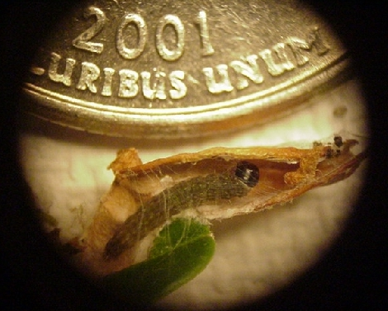  Black-headed fireworm larva | 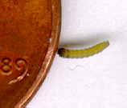  Black-headed fireworm larva | 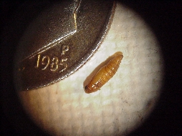  Black-headed fireworm pupa | 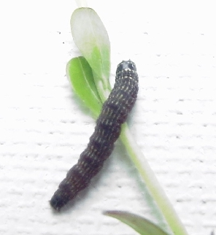  Hill fireworm larva
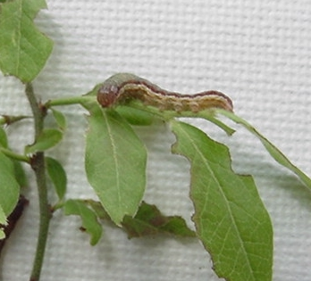  Blossomworm larva | 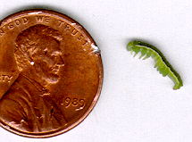  False armyworm  (grow to be 1.5” – 2” long) | 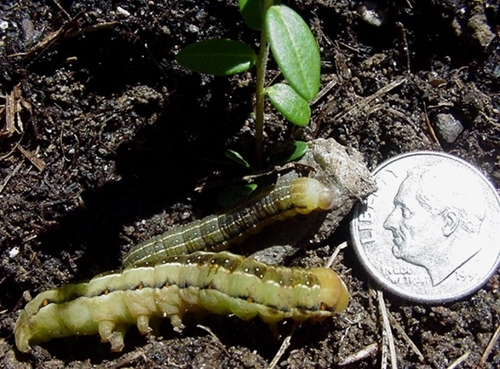  pair of False armyworms | 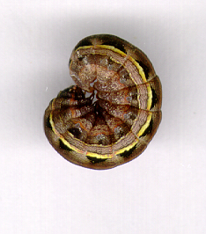  A species of cutworm
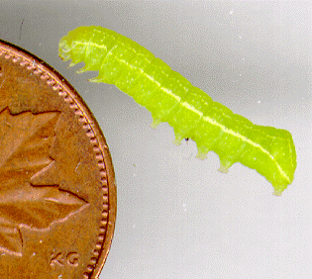  Humped green fruitworm | 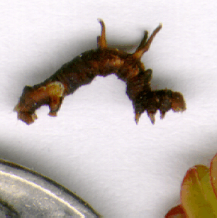  Horned spanworm | 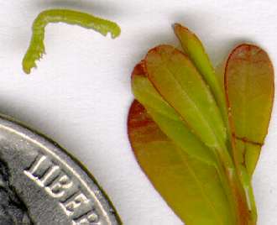  Green spanworm | 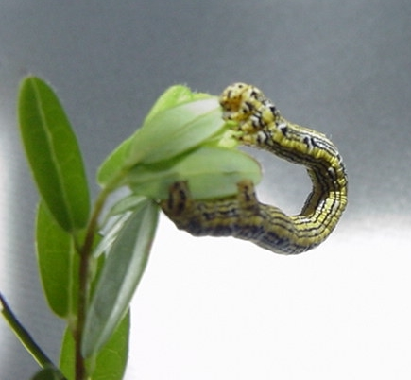  Chainspotted geometer
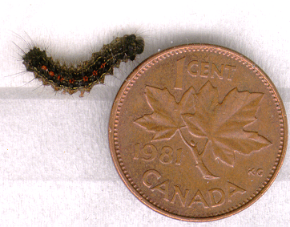  Gypsy moth larva | 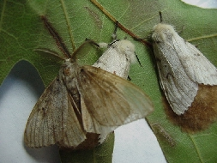  Gypsy moths  (females are white) | 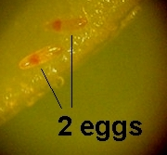  Tipworm eggs | 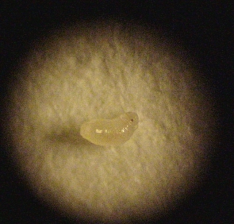  Tipworm (2nd instar)
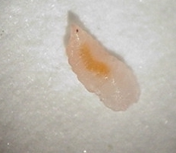  Tipworm (start of 3rd instar) | 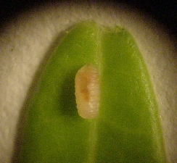  Tipworm (3rd instar) | 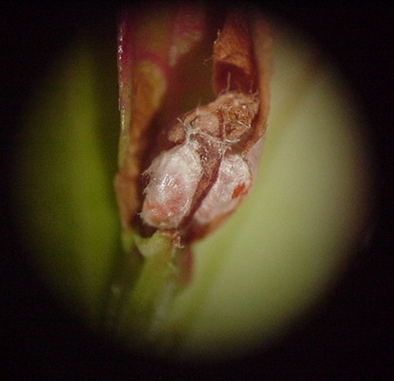  2 Tipworm cocoons | 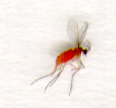  Female tipworm fly  (males are black)
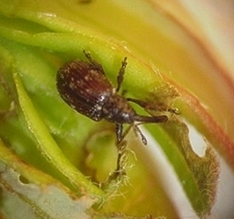  Cranberry weevil | 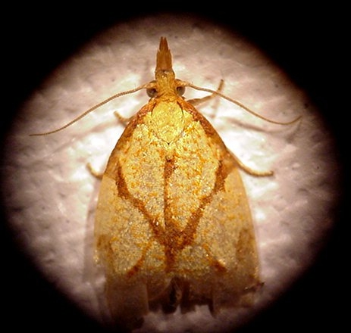  Sparganothis fruitworm moth | 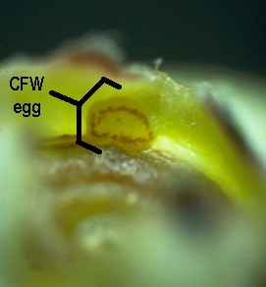  Cranberry fruitworm egg  (always in calyx end of berry) | 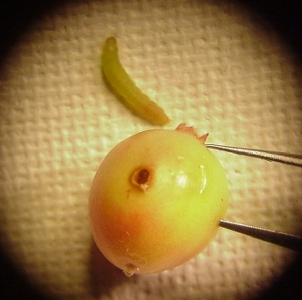  Cranberry fruitworm larva  and berry damage

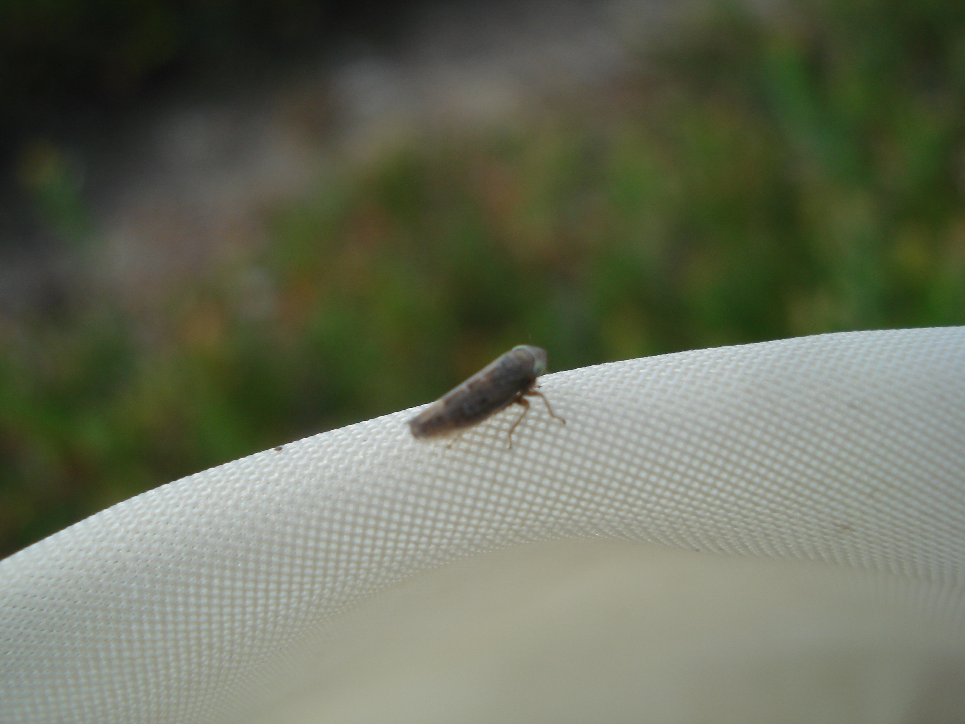
Blunt-nosed Leafhopper (detected in 2011 at two Maine locations. It is a carrier of False Blossom disease, a serious virus-like pathogen that may be on the verge of making a comeback because of this particular leafhopper.)
CFW egg photo courtesy of UMass (by J.E. O’Donnell); all other photos by Charles Armstrong, UMaine Extension. 6/13/2014.
The University of Maine does not discriminate on the grounds of race, color, religion, sex, sexual orientation, including transgender status and gender expression, national origin, citizenship status, age, disability, genetic information or veteran’s status in employment, education, and all other programs and activities. The following person has been designated to handle inquiries regarding non-discrimination policies: Director, Office of Equal Opportunity, 101 North Stevens Hall, 207.581.1226 or 1.800.287.0279 (voice and TDD), TTY 207.581.8957.

