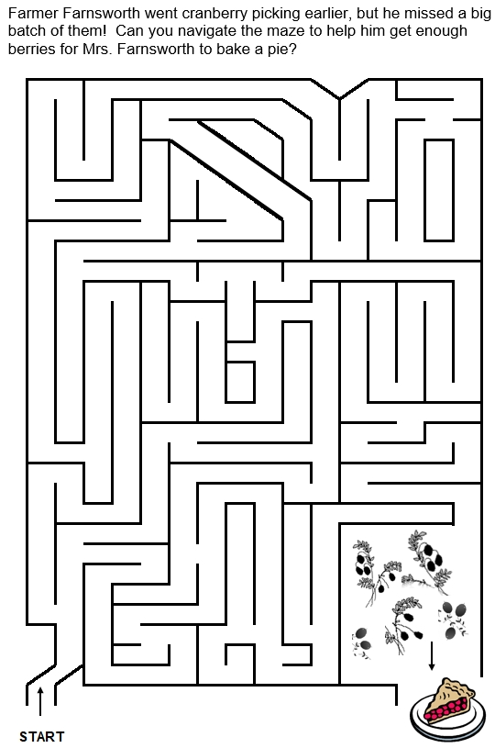Cranberry Maze

Source: University of Maine Cooperative Extension. The University of Maine is an EEO/AA employer, and does not discriminate on the grounds of race, color, religion, sex, sexual orientation, transgender status, gender expression, national origin, citizenship status, age, disability, genetic information or veteran’s status in employment, education, and all other programs and activities. The following person has been designated to handle inquiries regarding non-discrimination policies: Sarah E. Harebo, Director of Equal Opportunity, 101 North Stevens Hall, University of Maine, Orono, ME 04469-5754, 207.581.1226, TTY 711 (Maine Relay System).

