
Maine Cranberry Insect Pests
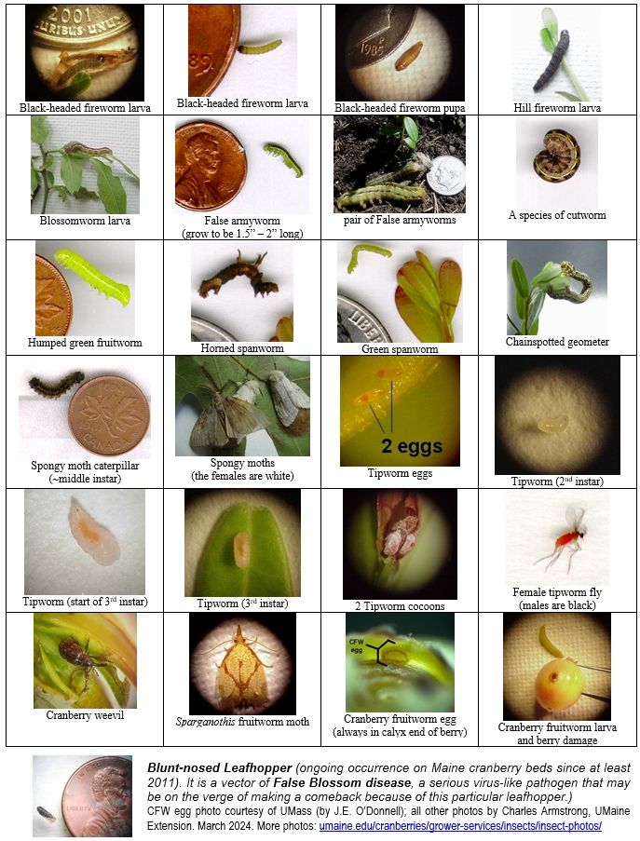

In complying with the letter and spirit of applicable laws and pursuing its own goals of diversity, the University of Maine System does not discriminate on the grounds of race, color, religion, sex, sexual orientation, transgender status, gender, gender identity or expression, ethnicity, national origin, citizenship status, familial status, ancestry, age, disability physical or mental, genetic information, or veterans or military status in employment, education, and all other programs and activities. The University provides reasonable accommodations to qualified individuals with disabilities upon request. The following person has been designated to handle inquiries regarding non-discrimination policies: Director of Equal Opportunity, 5713 Chadbourne Hall, Room 412, University of Maine, Orono, ME 04469-5713, 207.581.1226, TTY 711 (Maine Relay System).

