

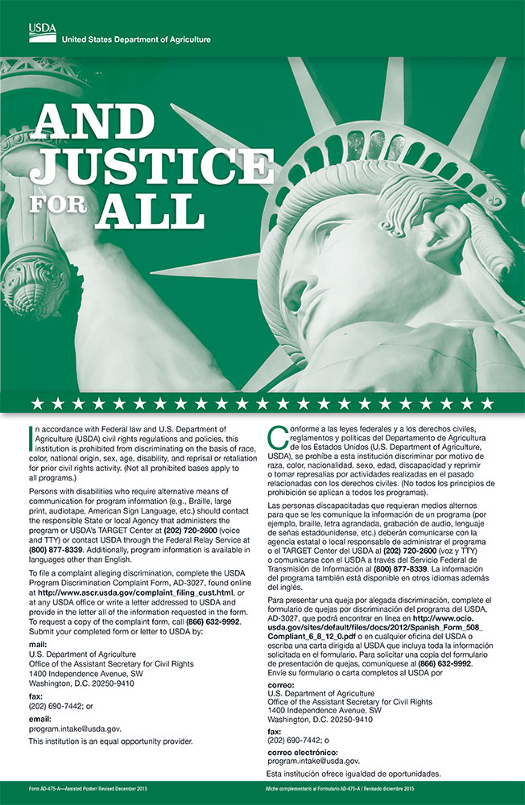

To: UMaine Cooperative Extension

From: _____________________________________

(Name of volunteer or group)

Subject: Assurance of Non-Discrimination Status

I/We confirm that we do not discriminate on the grounds of race, color, religion, sex, sexual orientation, including transgender status and gender expression, national origin, citizenship status, age, disability, genetic information or veteran’s status in employment, education, and all other programs and activities. To ensure participation in Extension programs, reasonable accommodations will be provided. I understand that I/we will work with the appropriate Extension staff member to provide accommodations.

___________________________________________________

(Signature of Group Representative or Individual)

______________

(Date)

_________________________

(Name Printed)

Rev. 9/18