University of Maine Cooperative Extension
Prepared By Laura Wilson, 4-H Science Professional

Expanding Your Horizons
2019 Final Report

Expanding Your Horizons:

Expanding Your Horizons at the University of Maine is part of a nationwide conference experience program dedicated to inspiring girls to recognize their potential and pursue opportunities in STEM (Science, Technology, Engineering, Math). The Expanding Your
Horizons Network is a 501(c)3 nonprofit organization dedicated to providing gateway STEM experiences to middle and high school girls that spark interest in STEM activities and careers. They are guided by the understanding that engaging with female STEM role models and participating in hands-on STEM activities can help girls begin to see themselves pursuing STEM activities and careers. At its core, the EYHN’s unique nationwide network of STEM conferences provides a gateway for empowering girls to see themselves as future participants in STEM and STEM-related careers.

At Expanding Your Horizons Conferences:

- Girls meet and interact with female adult STEM role models and participate with their peers in high quality hands-on STEM activity through EYHN’s unique conference model.
- Girls discover the fun and relevance of STEM through participating in hands-on activities at the conferences.

The University of Maine Cooperative Extension hosted the 2019 UMaine Expanding Your Horizons conference on October 15.
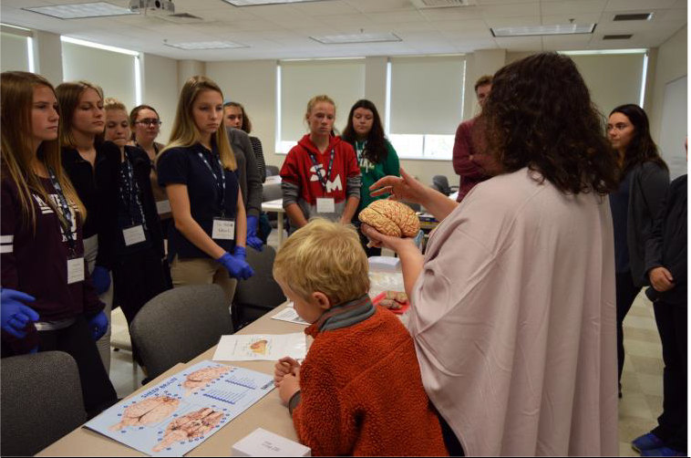

Photo: Jessica Brainerd

Planning Committee:

In addition to staff from the UMaine Cooperative Extension’s 4-H Youth Development Program, the 2019 EYH planning committee included representation from the following UMaine departments:

  - Maine EPSCoR (host)
  - UMaine College of Engineering
  - UMaine Rising Tide Center/Women’s, Gender and Sexuality Studies
  - UMaine Advanced Structures and Composites Center
  - UMaine Conferences and Institutes

Also serving on the planning committee were staff from the following:

  - Challenger Learning Center of Maine
  - Girl Scouts of Maine
  - Maine Science Festival

Support was provided for this event by Maine EPSCoR, the University of Maine Division of Lifelong Learning, UMaine Conferences and Institutes, ThermoFisher Scientific, and the University of Maine Foundation, with major funding support from the UMaine Office of the Executive Vice President for Academic Affairs and Provost.
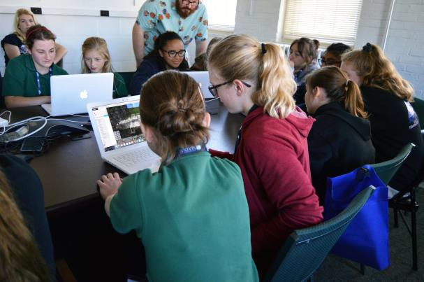
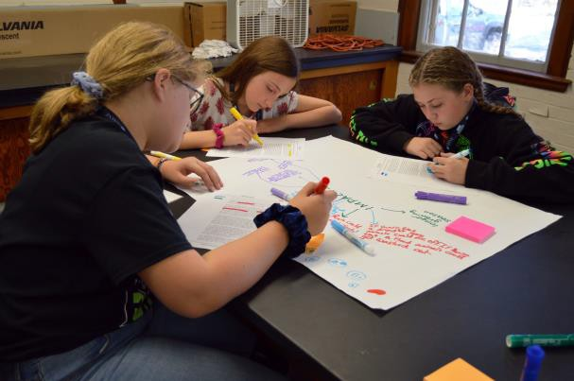
Photo: Jessica Brainerd

Participants:
Over 300 seventh and eighth grade girls from the following schools attended EYH 2019 at UMaine:

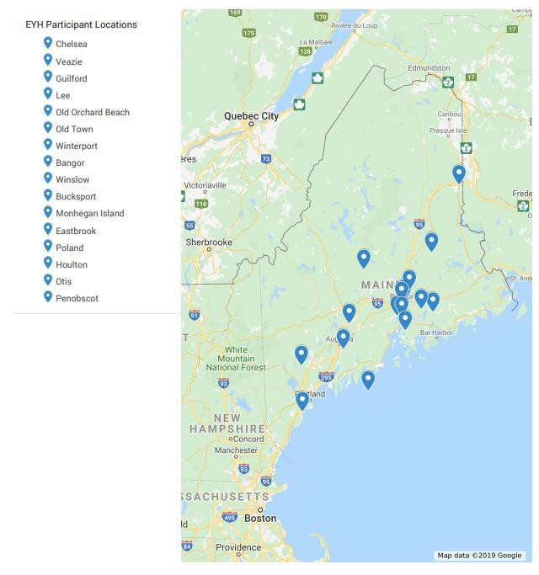

EYH 2019 Agenda:

9:00 – 9:30 AM | Special welcome from UMaine President Ferrini-Mundy  Keynote: Elisabeth Kilroy  PhD Candidate in Graduate School of Biomedical Science and Engineering, NSF Graduate Research Fellow, and President of GSBSE Student Body
9:45 – 10:45 | Workshop 1
11:00 – 12:00 | Either Lunch/Fab Female workshop OR Workshop 2
12;15 – 1:15 | Either Lunch/Fab Female workshop OR Workshop 2
1:30 – 2:00 PM | Closing, evaluations & raffle prizes

Teachers were invited to attend the following professional development session offered by staff at the Research in STEM Education (RiSE) Center at UMaine:

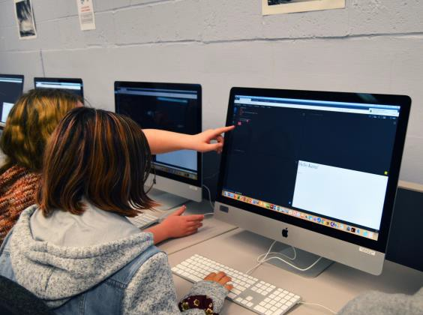
Computational thinking and computer science are becoming increasingly important for today's students to learn. Come learn about how we can help our students grow these skills starting in elementary school. We'll do
some fun computational thinking activities that can be done without a computer and learn to program Edison Robots! We'll also share some current research projects happening in Maine schools in addition to STEM resources that are available to K-12 teachers. This will be a fun, hands-on morning!

Workshop presenters at EYH included UMaine faculty, staff, and students as well as presenters from Husson University, New Balance, General Electric and ThermoFisher Scientific. A full listing of presenters is attached.

Photo: Jessica Brainerd

In addition to STEM workshops, UMaine and UMaine Extension faculty, staff and students and staff from the Girl Scouts of Maine presented workshops on gender equity in STEM. These workshops focused on female scientists from the past. Presenters led youth in discussions of the barriers for females to succeed in STEM careers, then and now. Twenty-six University of Maine students and one UMaine staff member volunteered to guide groups of youth around campus. These volunteers stayed with the same groups of youth throughout the event and shared information about themselves and their academic program as well as life as a UMaine student.

Results:

STEM workshop presenters reported that they had sufficient information to be able to provide a high-quality workshop for youth. Suggestions from presenters for improvement include to plan for shorter workshop times as groups were late to their

sessions, and to allow youth to self-select workshops rather than travel with their school groups.

Educators reported mixed impressions of the professional development session. Many who gave poorer reviews of the session either had prior experience with the content or wanted to travel with their students to the STEM workshop sessions. Those with more favorable reviews commented on the fantastic session presenter. Educators universally spoke highly of the keynote speaker and the energy entering the Collins Center for the Arts. Other feedback from educators include:

- We were extremely pleased with this opportunity and hope to bring more girls in the future.
- Use this event to develop a closer connection with the University system to help us bring STEM and STEM career/educational choices into our schools.
- My students gave up a no school day to be there and they all reported having a great time and enjoyed their sessions!
- Schedule time for a campus tour for our students, many of whom have never set foot on a college campus
- Have one event closer to Southern Maine!
- Could girls choose what session they attend beforehand??
- This was one of the best organized events at UMaine that we have been to!

Youth participants reported that the conference was fun (80%). Over 95 percent reported learning something about STEM careers at the event. Over 90% of the youth learned more about women in STEM at the event. 75% plan to participate in more STEM-related activities in the future.

Other youth feedback included that they appreciated that the activities were hands-on. Youth participants reported being empowered by the keynote speaker, and they learned a lot about female scientists in the past. Most importantly, many walked away understanding that they could do anything they put their minds to.

STEM presenters:

Name: | Organization/Institution:
David Hiebeler | Dept of Mathematics and Statistics, UMaine
Lisa Neuman | University of Maine
Kate Garland | UMaine Cooperative Extension Penobscot County
M Scarlett Tudor | UMaine Aquaculture Research Institute
Eileen Molloy | UMaine Food Science and Human Nutrition
Renee Kelly | UMaine Foster Center for Student Innovation
Bailey Blair | UMaine Molecular and Biomedical Sciences
Alicyn Smart | UMaine Cooperative Extension
Erin Percival Carter | Maine Business School, UMaine
Sara Walton | UMaine Chemical Engineering

Charlene Gray | UMaine Evironmental Horticulture
Meghan Collins | Advanced Structures & Composites Center UMaine
Don Hummels | University of Maine College of Engineering
Sheila Pendse | University of Maine College of Engineering
Karissa Tilbury | University of Maine College of Engineering
Carly Sponarski | University of Maine
Kristy Townsend | University of Maine
Laura Gurney | Husson University
Ami Gaspar | University of Maine System
Sonja Birthisel | University of Maine
Colleen DeMaris | University of Maine
Amanda Collamore | University of Maine
Roberta Lynn Trefts | Husson University
Joarly Arnold | General Electric
Kim Fyreberg | New Balance
Jennifer Violette | ThermoFisher Scientific

Gender Equity Presenters:

Vanessa Klein | UMaine Extension/4-H
Joarly Arnold | General Electric
Samantha Lott Hale | Girl Scouts of Maine
Allison Small | University of Maine
Shelby Helwig | University of Maine
Sadee Mehuren | UMaine Extension/4-H
Anica Miller Rushing | University of Maine
Abigail Elkins (student) | UMaine Extension/4-H
Alice Philbrick | UMaine Extension/4-H
Mari Glatter | UMaine Extension/4-H

