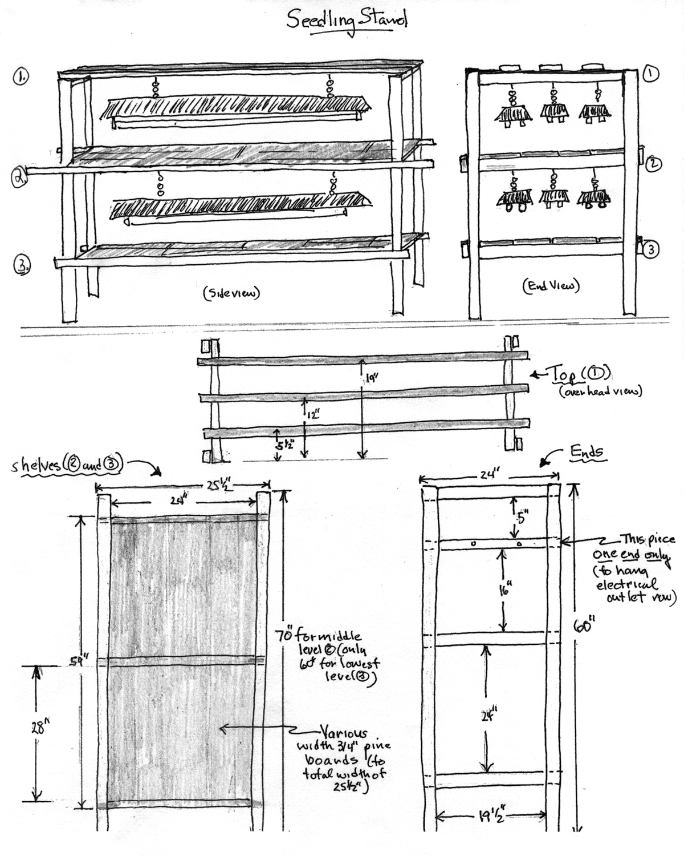

Materials List

Use of 1 x 3 inch Strapping is recommended for the frame. Strapping is inexpensive, strong and usually comes in bundles of 10 pieces at either 6 foot or 8 foot lengths. 1 buddle of 6 foot length will be more than enough to make a frame.

1 x 3 inch Strapping
- 2 pieces x 70 “, (for the level 2 shelf frame, the extra length gives you a handle).

- 9 pieces x 60 “, (3 of these are to hang the top lights; 4 are for the two end frames, bottom right), 2 are for the bottom shelf frame).

- 11 pieces x 24 “, (3 for each of the two shelves = 6, 3 for one end frame, 4 for the second end frame – allowing you to attach an electrical plug strip to the one marked as such).

- Wood for the two shelves can be made of any material – old pine planking, ½ “ or ¾ “ plywood or whatever you have on hand. You will need enough to cover the two shelves frames each shelf being 24” wide by 6o” long.

- 12 cup hooks to hold the chains for the lights. 2 on each of the 3 top light hanging pieces of strapping for hanging lights over shelf number 2. The other 6 go on the bottom shelf # 2 to hang the 3 sets of lights for shelf number 3.

- 1 5/8 inch sheet rock screws for

- One plug strip to attach to the frame and plug you lights and seedling heat mat into.

- One timer to plug the light strip into *set for 16 hour days).

- 6 sets of shop lights. Buy the ones that come with chains. They are the cheapest, usually ranging from $7 - $10 each. If you like start with 3 sets of shop lights for the top shelf and buy 3 more when you expand onto the lower level.

- Recommended 1 seedling heat mat.


A Member of the University of Maine System

© 2009
Published and distributed in furtherance of Acts of Congress of May 8 and June 30, 1914, by the University of Maine Cooperative Extension, the Land Grant University of the state of Maine and the U.S. Department of Agriculture cooperating. Cooperative Extension and other agencies of the U.S.D.A. provide equal opportunities in programs and employment.

