IPM Achievement Award
nomination packet for
Maine State Pomological Society
February 14, 2006
Nominee:
Maine State Pomological Society
c/o Peter Ricker, President
11 Ricker Hill Road, Turner ME, 04282
Phone: 207 225 5169, Fax 207 225 2790
Email: APPLEBOY26@aol.com

Submitted to:
Jennifer Snyder, Chair, jsnyder@ag.arizona.edu
Fifth National IPM Symposium Awards Committee
University of Arizona Maricopa Agricultural Center
37860 W. Smith-Enke Road, Maricopa AZ 85239
Phone: 520 568-2273 x266, Fax: 520 568-2556

From:
Glen Koehler, Associate Scientist IPM
University of Maine Cooperative Extension
491 College Avenue, Orono ME 04473
Phone: 207 581 3882, Fax: 207 581 3881
Email: gkoehler@umext.maine.edu

Contents:
Nomination letter - Glen Koehler and Renae Moran, University of Maine.

Attachment 1 - Maine Apple Orchard Scouting Co-op
Attachment 2 - excerpts from “Apple Pest Model 2005 Web Traffic Report”
Attachment 3 - excerpts from “2004 New England Apple Pest Management Survey”

Letters of recommendation from three commercial Maine apple growers and IPM practitioners – Marilyn Meyerhans, Judy Dimock, Evan McDougal.
Letter of recommendation John Bunker, President of the Maine Organic Farmers and Gardeners Association.
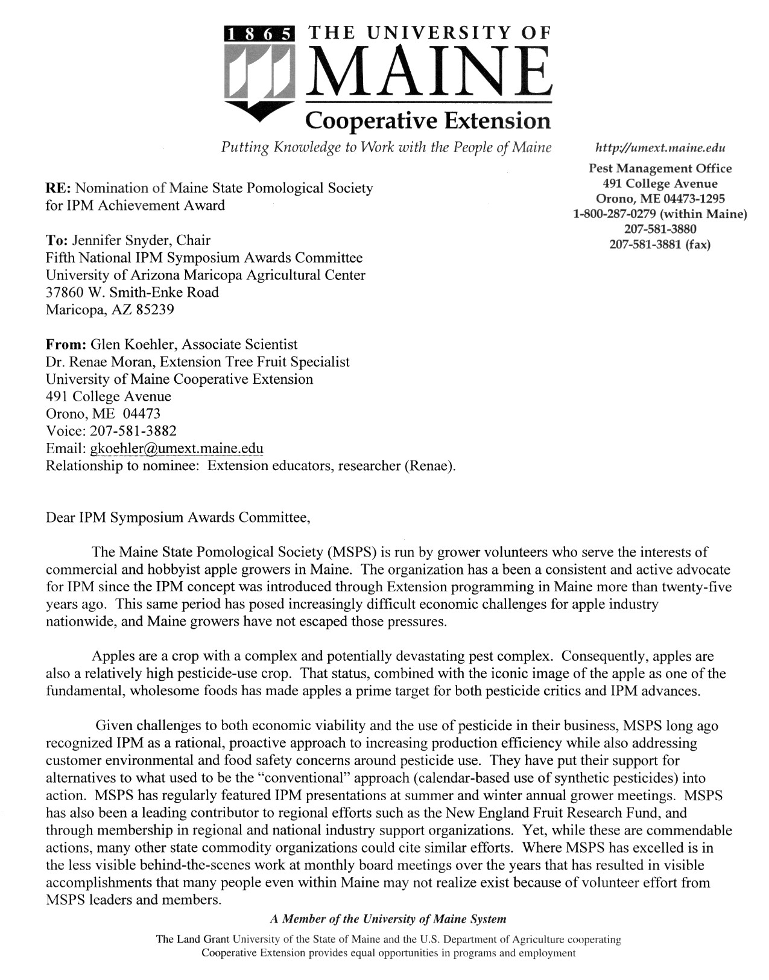

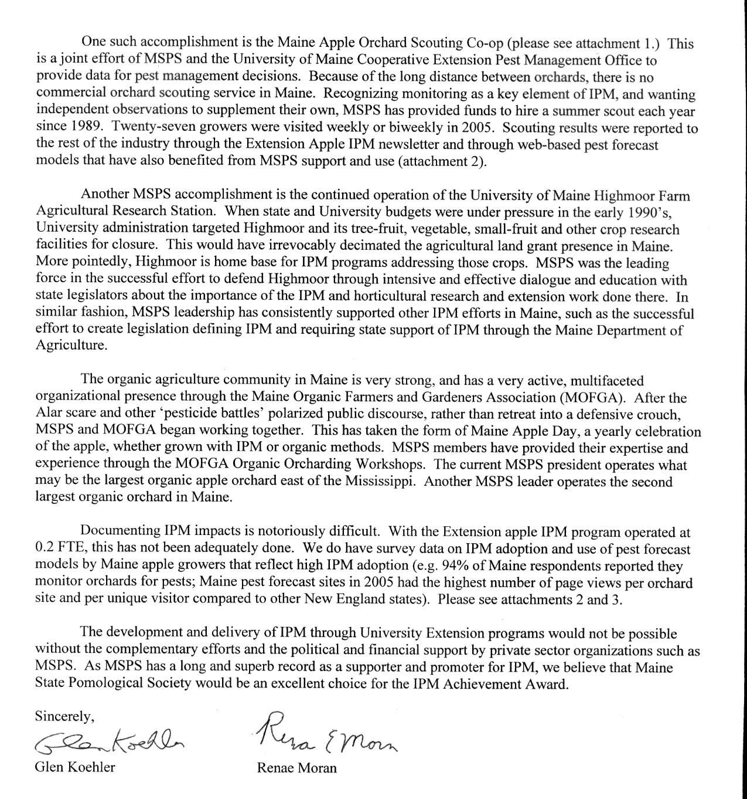

Attachment 1
Maine State Pomological Society
support for the
Maine Apple Orchard Scouting Co-op

Travel time between orchards has prevented the availability of commercial scouting service in Maine. Making such service possible provides direct benefit to the growers involved. Estimated total cost to hire and transport a scout is about $6000 for the June – August growing season. Extension cannot pay the full cost. The Maine State Pomological Society provides funds to make hiring a scout feasible. Extension provides the scout training, supervision, insurance, office support, and vehicle costs. Wages are the largest single expense. Extension and the Maine State Pomological Society share the cost for wages, with each organization paying about half. This arrangement has been ongoing since 1989. In some years, participating growers have been billed per hour to defray expenses.

In 2005, twenty-seven orchards were visited weekly or biweekly. To qualify, an orchard must cover at least one acre. Membership in the Maine State Pomological Society is not required. At each visit, the scout collects sample observations on one to three key apple pests that are high priority for monitoring and possible management at that time. The scout follows standardized monitoring methods to insure neutral, reliable results. Each visit lasts for a minimum of one hour. A few larger orchards receive additional time. The pests checked each week vary through the season. The Scout Co-op does not provide traps, but does check traps supplied by growers. Observations are communicated with a written report to the grower. The scout does not discuss management options. Growers with questions on management recommendations are referred to the Extension Apple IPM program coordinator or to the Extension Tree Fruit Specialist.

Scouting reports from individual orchards are kept confidential and not discussed with other growers. Copies of the scouting reports are sent to the Extension Apple IPM program coordinator who uses them to track pest conditions statewide, which benefits the Maine apple industry at large. The information from scouting reports provides useful information shared through the University of Maine Cooperative Extension Apple Pest Report newsletter, pest forecasts models, and in grower consultations.

Financial and political support by the Maine State Pomological Society makes it possible for the scouting co-op to assist Maine apple growers with IPM decisions by providing independent observations to supplement their own monitoring.
Attachment 2
Excerpts pertinent to
National IPM Symposium IPM Achievement Award
from Apple Pest Model 2005 Web Traffic Report
Glen Koehler, University of Maine Cooperative Extension, 2005
Complete report is available online at http://pronewengland.org/Content/PROpubs/WebTraffic/AppleModelWebTraffic2005.pdf

********EXCERPT 1********
To measure quantitative differences in use of Orchard Radar for sites in the five states, use statistics were segregated so that sites in each state were analyzed as separate groups. Results are shown on a per site basis to correct for the fact that there were four sites per state in MA and ME, and two per state in CT, NH, and RI (Figures 2 and 3).

Figure 2. Number of visitor sessions and page views per site for five individual Orchard Radar sites in 2005.

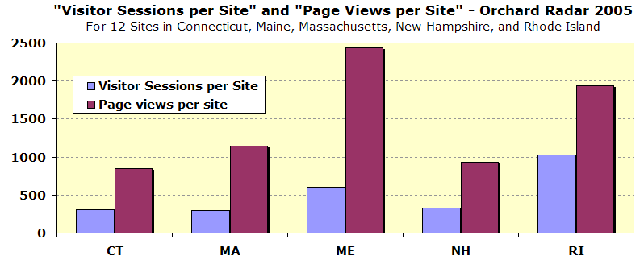
The Maine sites had the highest number of page views per site, the highest number of page views per unique visitors, and the second highest number of visitor sessions per site (Figures 2 and 3).

While non-orchardist visitors could account for much of the Orchard Radar traffic, the visitor sessions and page view counts do not correlate with state population. Nor do they correlate with the number of apple growers in each state. For example, Massachusetts has more than four times as many citizens as Maine (6.2 million versus 1.3 million) and about the same number of growers (338 vs. 374, 2002 Census of Agriculture, USDA) but less than half as many Orchard Radar visitor sessions per site and page views per site (Figure 2).
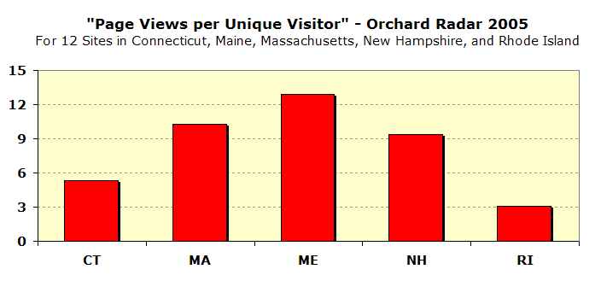
Figure 3. Number of page views per unique visitor (each presumably being an individual person) for Orchard Radar sites five New England states in 2005.

********EXCERPT 2********
Conclusions:
Using web pages to inform orchard management decisions requires grower familiarity with the resources available and confidence in how to use them. Orchard Radar has been operated for Maine sites for more years and without interruption since 1997, and presumably been more frequently mentioned in newsletter articles and presentations to Maine apple growers than in the other four states.

It seems that increased grower awareness and familiarity with web-based decision support for orchard management decisions is the reason for the higher level of overall use, and for greater number of page views per unique visitor for the Maine sites. This suggests that growers are more likely to use web-based tools for orchard decision support if those tools are frequently discussed and explained in grower contacts, Extension newsletters, and presentations. In short, the more growers know about it, the more likely they are to use web-based decision support for orchard management.
********EXCERPT 3********
Web traffic for individual representative sites by state
The same filtering out of automated computer-generated visitor sessions as described in the main body of the report was used for individual state analyses.

Maine 2005 – Four sites: Sanford, Gorham, Monmouth, Old Town
2,399 visitor sessions. 9,729 page views.
(=600 visitor sessions and 2,432 page views per site).
757 unique visitors. 183 visited more than once,
58 visited five+ times, 29 visited ten+ times.
Average of 3.2 sessions per unique visitor.
Average of 12.9 page views per unique visitor.

The Monmouth site was used more than the other Maine sites. Of direct access users to the Monmouth site, frequencies of categories for pages viewed were:
Weather | 39.47%
Scab | 27.92%
Calendar | 4.57%
Plum curculio | 3.08%
Other Insect & Mite | 2.40%
Flyspeck | 2.03%
Horticulture | 3.93%
Fire blight | 2.51%
Codling moth | 2.78%
Apple maggot | 1.77%

********END of EXCERPTS********
Full report is available online at
http://pronewengland.org/Content/PROpubs/WebTraffic/AppleModelWebTraffic2005.pdf
Attachment 3
Excerpts pertinent to
National IPM Symposium IPM Achievement Award
from the
2004 New England Apple Pest Management Survey
Comments by Glen Koehler, University of Maine Cooperative Extension
Original survey by Natalia Clifton, University of Massachusetts, 2005.

INTRODUCTION

A thorough Dillman method (Dillman, 2000) survey of New England apple grower pest management practices was conducted in the late summer and fall of 2004 for the New England Pest Management Network by Natalia Clifton, University of Massachusetts Cooperative Extension. Analysis of the responses was completed in 2005. The complete survey results are online at http://pronewengland.org/Content/PROInfoSurvey.htm

The survey methodology included mailings to every name on Extension apple grower mailing lists for each New England state, and repeat mailings to persons who did not respond to the initial request. The overall response rate was over 50%. Responses were received from 170 growers in the six New England states. This is probably the most complete and scientifically rigorous survey ever done of New England commercial apple grower pest management practices. Thirty-seven Maine growers responded to the survey. While not an impressively large number in itself, replies from 37 commercial orchards represents a sizeable portion, probably a majority, of the orchard businesses in Maine that provide a substantial portion of family income.

The results shown were extracted from Maine apple grower responses to the survey. The data presented are the most recent available measures of IPM adoption by Maine apple growers. The intent in presenting the Maine grower response to the survey is to support the assertion that the Maine State Pomological Society has been an effective IPM advocate over many years.

For questions 5, 6, and 9, answers from the 37 apple Maine growers are compared to responses from growers in the other five New England states. In doing so, there is no intent to imply that Maine apple growers are more fervent IPM practitioners than other New England orchardists. The survey was not designed to address that question, which would require accounting for that fact that pest threats are not identical across the region. To a remarkable degree, apple IPM in New England works as a cooperative interstate effort. Maine growers have benefited from IPM research and education provided by university, private sector, and grower contributions from the other New England states. In particular, New England has benefited from having two subject matter world experts in our neighborhood: University of New Hampshire plant pathologist Bill MacHardy, and the late University of Massachusetts entomologist Ron Prokopy.

The purpose in comparing the Maine responses to those from the rest of New England is to provide some context for the Maine values. National survey responses to identical survey questions or other independent measures of apple IPM adoption are not available for comparison. Comparing the Maine and New England responses demonstrates that Maine apple growers do not lag behind in IPM adoption when compared to growers dealing with similar economic and environmental conditions.

Finally, the survey results do not prove a cause and effect relationship between actions by the Maine State Pomological Society and IPM practices by Maine apple growers. However, I believe the survey responses do reflect a proactive approach to IPM by Maine apple growers. I also believe that it is reasonable and accurate to credit Maine State Pomological Society as a major influence in fostering that approach among Maine orchardists. Direct evidence for that proposition is provided by the support letters from individual growers included in the nomination packet.

RESULTS

With apologies for such a long preamble, here are IPM adoption questions from the 2004 New England Apple Pest Management Survey and Maine responses that support the nomination of the Maine State Pomological Society for the IPM Achievement Award.

********************

1. How important are these sources of information in making your pest management decisions? (Please circle your answers)

Comments: 97.3% of Maine growers who returned the survey answered this question. The IPM related information resources shown below were rated as Very Important, Somewhat Important, or Not Important. Percentages in bold are for Maine growers who rated the item as Very or Somewhat Important. Values in parentheses show the distribution of Very : Somewhat : Not Important ratings. Totals do not add up to 100% because not every grower who responded to the question gave an answer for each item.
Overall, these responses indicate high use of available IPM resources.

89% (75:14: 3) University/Extension staff
86% (78: 8: 8) New England Pest Management Guide
86% (72:14: 6) Newsletters
86% (50:36: 8) Off-season educational meetings
75% (50:25:17) Web sites

********************
2. How would you describe your crop production practices? (Please circle your answer)

Comments: 92% of Maine growers who returned the survey answered this question. Percentages below are from the Maine growers who answered this particular question. Values in parentheses are for all Maine growers who returned the survey, whether they answered this particular question or not. The “Conventional” option has been reworded for use of this question in subsequent surveys because now IPM is the convention now among Maine apple growers. It is not known how the 27% of growers who chose “Conventional” interpreted that label.
74% (68%) IPM
27% (24%) Conventional
9% ( 8%) Organic
6% ( 5%) Other

********************

3. What kinds of pest monitoring do you use for pest management decisions? (Please circle the single answer that fits best)

Comments: 92% of Maine growers answered this question. Percentages in bold are for the Maine growers who answered this particular question. Values in parentheses are for all Maine growers who returned the survey, whether they answered this particular question or not. The intent of the question was to have growers place themselves on a continuum from less to more intensive IPM implementation.
Of the Maine growers who answered this question, 82% reported that they use monitoring and pest thresholds (option c), or an even higher degree of IPM information with pest tracking models (option d).
23% (22%) a) Informal observations influence decisions, but no special field visits for pest observations
27% (24%) b) Field visits made for purpose of pest observations, but not following a standard procedure and threshold
50% (46%) c) Sampling according to standard procedures or traps, and comparing observations to pest threshold
32% (30%) d) Use of pest forecast and tracking models and equipment to determine need or adjust timing for sampling or control measures

********************
4. If sampling procedures or pest models are used in making pest management decisions, who collects that information? (Please circle ALL that apply)

Comments: 84% of Maine growers answered this question. Percentages in bold are for the Maine growers who answered this particular question. Values in parentheses are for all Maine growers who returned the survey, whether they answered this particular question or not. Of the growers who answered, 94% reported scouting their own orchards. Multiple answers were possible. For the responding growers, an average of 1.5 people scout the orchard.

94% (78%) You
26% (22%) Private IPM scout/consultant
22% (19%) Farm employee or family member
3% ( 3%) Other (specify: __________________)
********************
5. Which of the following practices do you use to manage insects and/or mite pests? (Circle all that apply.)

Comments: 97.3% of Maine growers who returned the survey answered this question. Percentages in bold are for the Maine growers who answered this particular question. Values in parentheses are for apple growers in the other five New England states who answered the question.

86% (82%) Orchard monitoring of pest and beneficial populations

44% (52%) Trapping

39% (35%) Use degree-day models to time applications

22% (41%) Border row spraying rather than entire orchards
64% (68%) Orchard floor groundcover/habitat management

39% (34%) Remove wild/alternate hosts and abandoned orchards

********************
6. Which of the following practices do you use to manage diseases? (Circle all that apply.)

Comments: 97.3% of Maine growers who returned the survey answered this question. Percentages in bold are for the Maine growers who answered this particular question. Values in parentheses are for apple growers in the other five New England states who answered the question.

78% (78%) Spring/Summer monitoring of scab maturity and infection periods
39% (19%) Autumn assessment of potential inoculum levels
50% (31%) Flailing or elimination of leaves
33% (11%) Application of urea (to break down scab inoculum)
42% (25%) Remove wild/alternate hosts and abandoned orchards

********************
7. How often do you use the following weather information in making your pest management decisions? (Please circle your answers)

Comments: 97.3% of Maine growers who returned the survey answered this question. Responding to varying weather conditions is a key component of apple IPM, especially disease management and to avoid drift conditions. Growers were asked to rate different types of weather information were as being frequently, occasionally, or never used for pest management decisions. Values shown are percent of respondents who said they frequently used that type of weather information.

100% Forecasts for next rain

72% Rainfall totals (for effect on spray residue)

56% Humidity and/or leaf wetness hours

44% Temperatures (for degree day models)

86% Wind speed forecast

********************

8. How important are these factors to you when choosing pesticides for use on your farm? (Please circle your answers)

Comments: 97.3% of Maine growers who returned the survey answered this question. The IPM related responses shown below were among 10 items rated as Very Important, Somewhat Important, or Not Important. Percentages in bold are for Maine growers who rated the item as Very or Somewhat Important. Values in parentheses show the distribution of Very : Somewhat : Not Important ratings. Totals do not add up to 100% because not every grower who responded to the question gave an answer for each item.
Overall, these responses indicate high consideration of factors beyond pest lethality in choosing pesticides.

89% (64:25: 3) Impact on beneficial species (parasites, predators, pollinators)
83% (58:25: 8) Customer relations (food safety concerns)
81% (53:28: 6) Other potential nontarget and environmental impacts

********************
9. Please estimate your average number of pesticide applications for apples used in a typical year:

Comments: 92% of Maine growers who returned the survey answered this question. Numbers in bold are from the Maine growers who answered this particular question. Values in parentheses are for apple growers in the other five New England states who answered the question.

5.7 (7.0) Number of times you spray specifically for insects each year
1.4 (1.4) Number of times you spray specifically for mites each year
1.0 (1.2) Number of times you spray specifically for weeds each year
7.5 (8.9) Number of times you spray specifically for diseases each year

****************************************************************

In a separate survey conducted for Extension IPM Program evaluation in 2003, over 90% of responding Maine apple growers reported that IPM helps them reduce crop damage. Maine apple growers estimated an average of $112 per acre in annual pesticide savings and 30% less pest damage due to the use of IPM.

****************************************************************
Citation: Dillman, D.A.; Mail and Internet Surveys: The Tailored Design Method. 2nd Edition..; John Wiley Co., New York; 2000
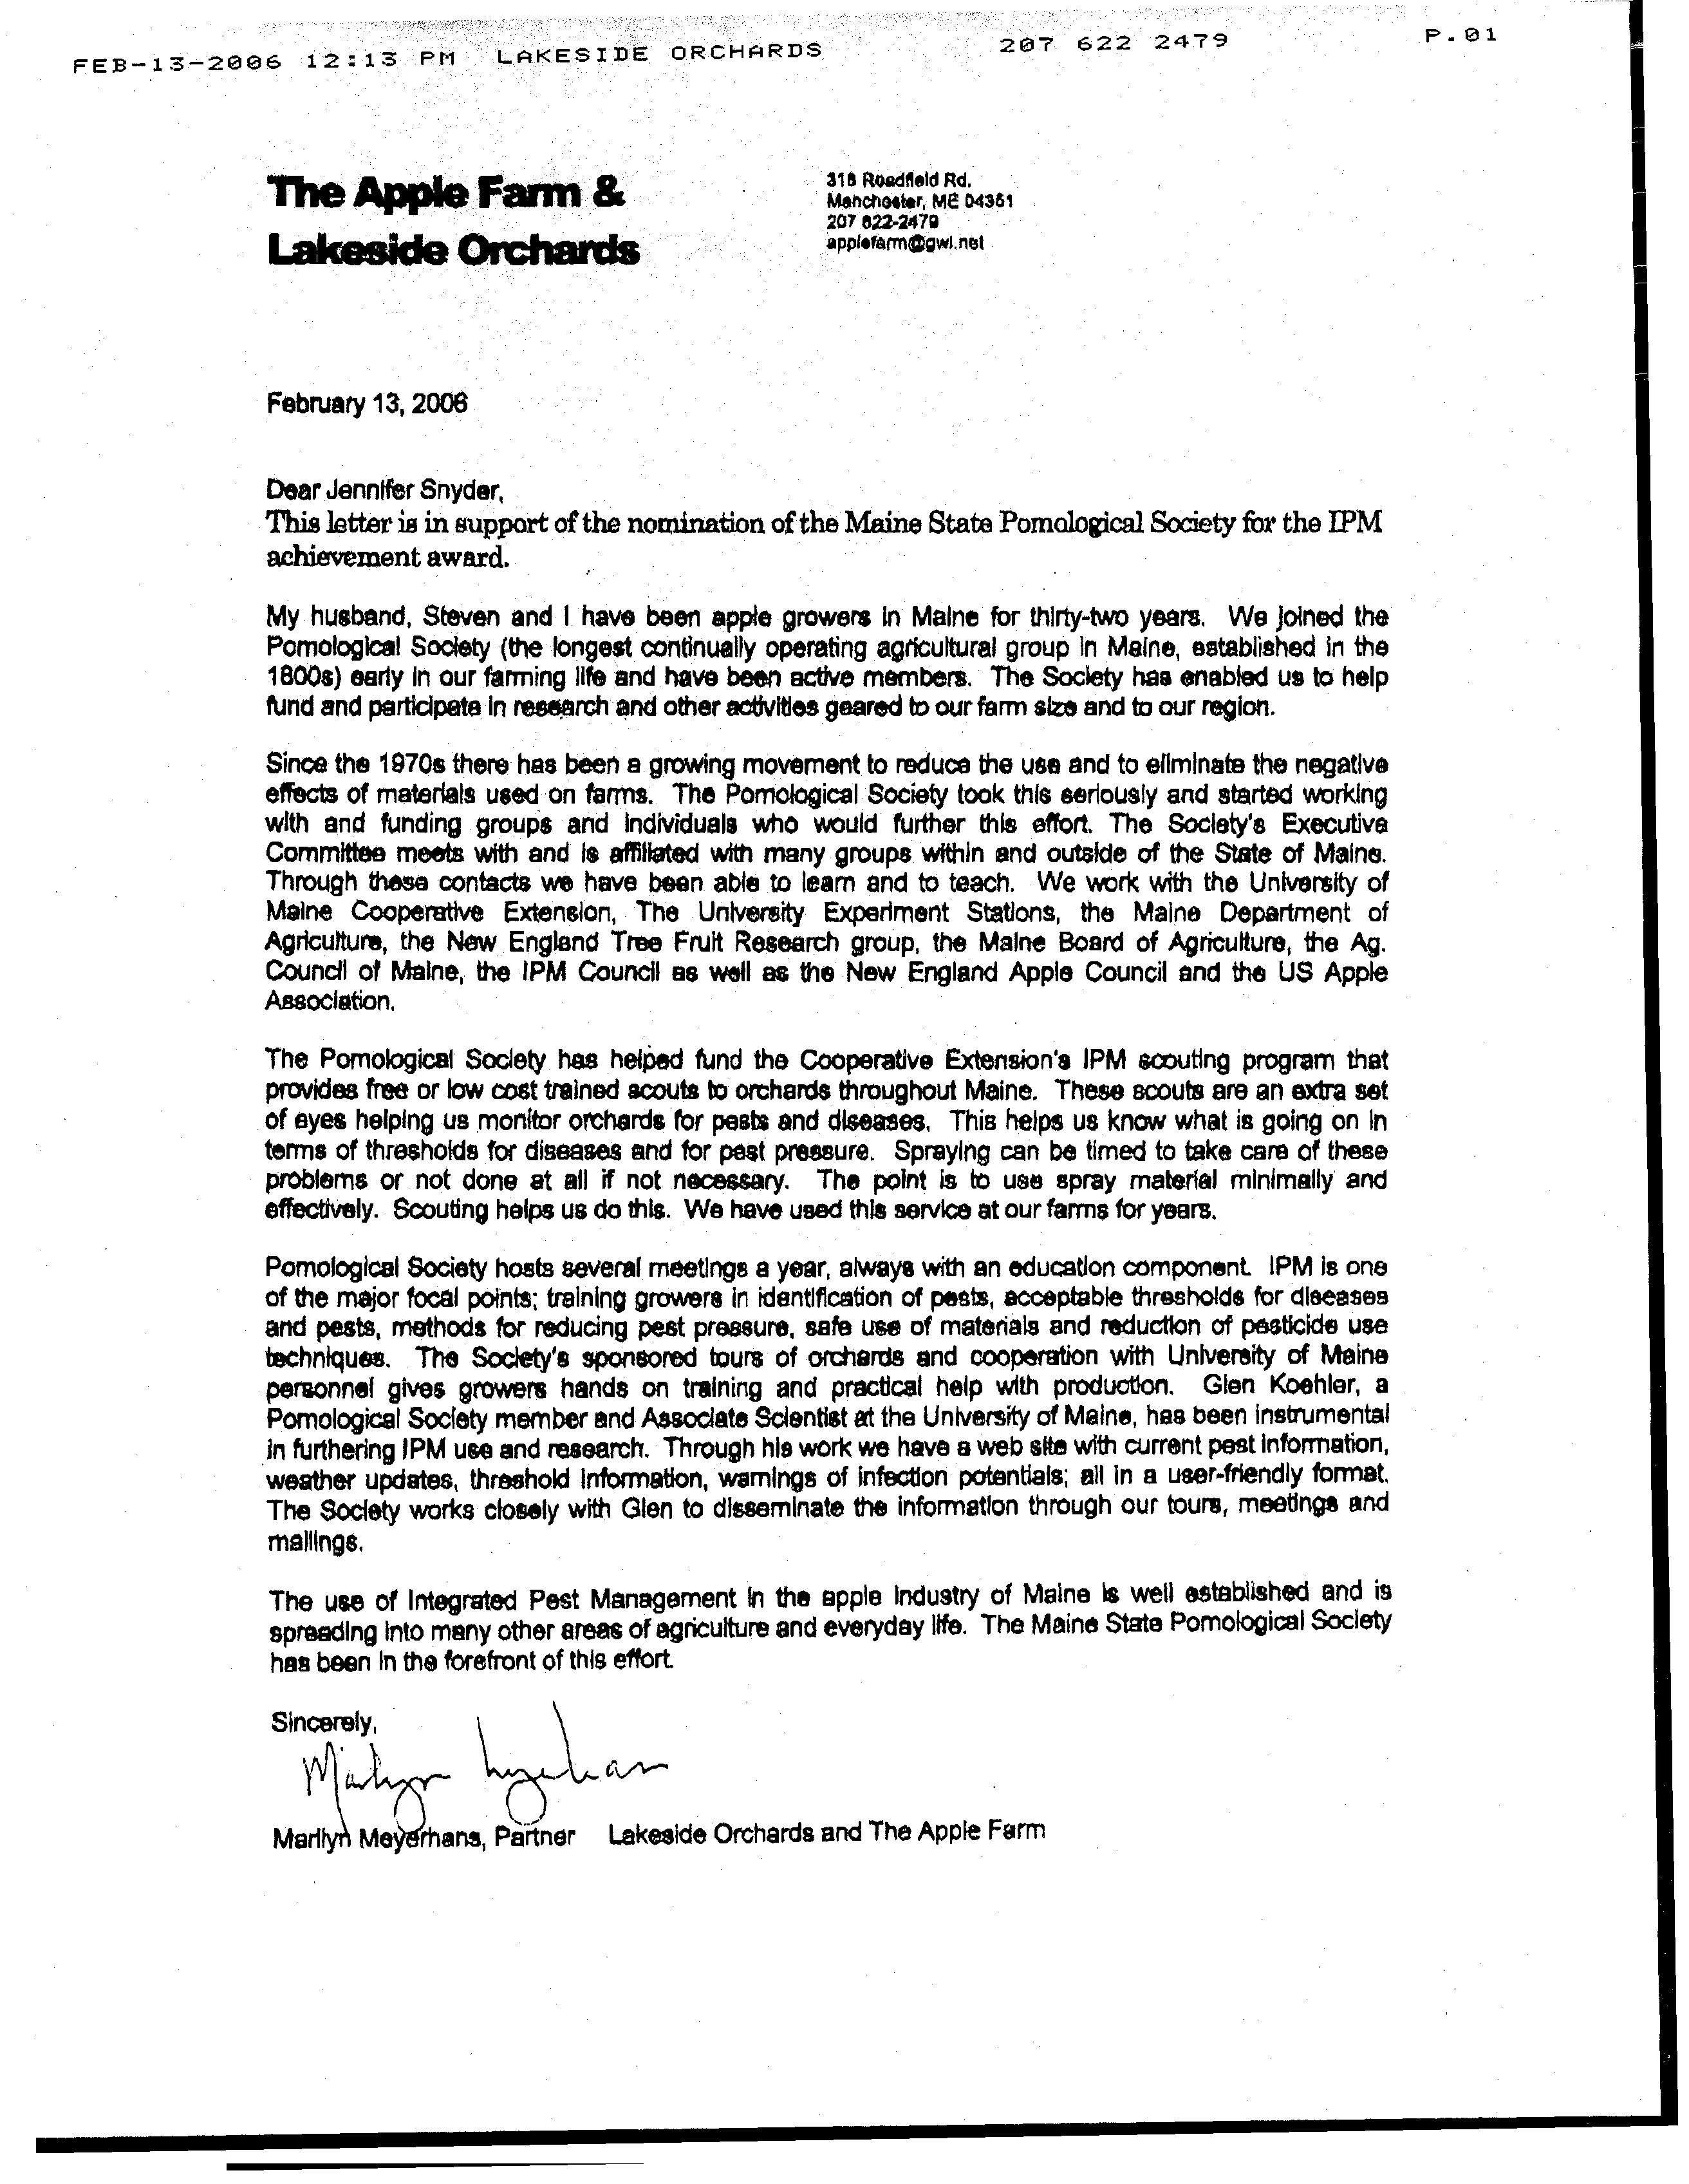
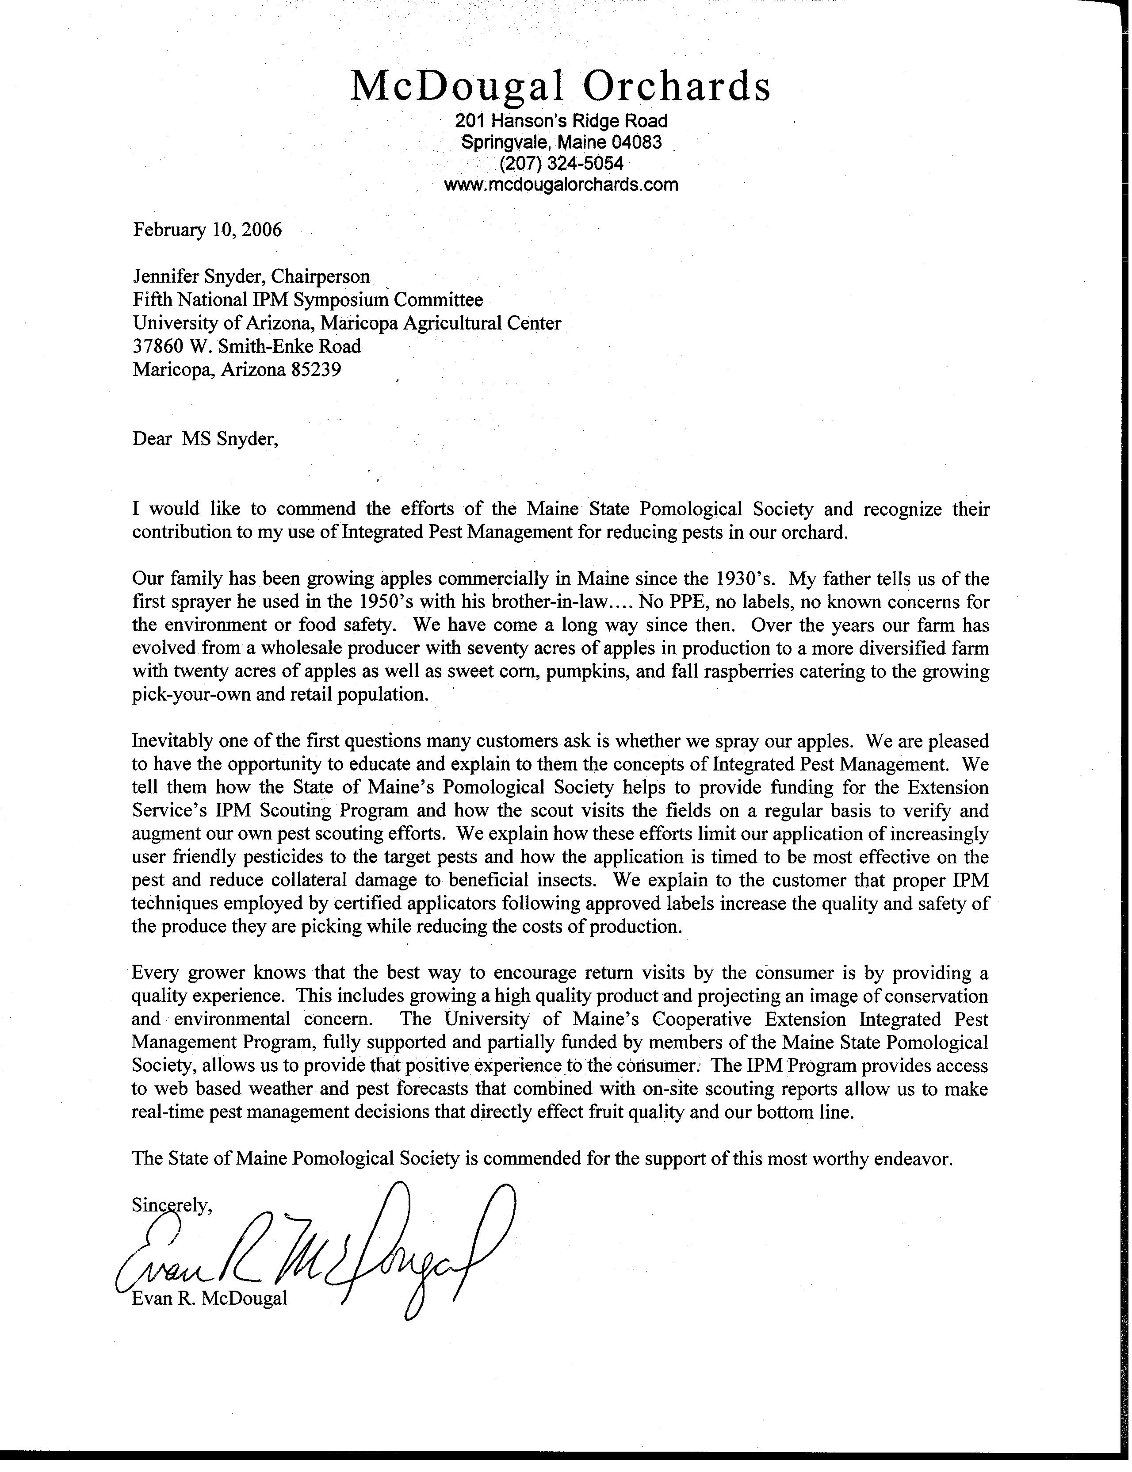

Maine Organic Farmers and Gardeners Association
PO Box 170 Unity Maine 04988
- 568-4142
jbunker@gwi.net

Jennifer Snyder, Chair
Fifth National IPM Symposium Awards Committee
University of Arizona Maricopa Agricultural Center
37860 W. Smith-Enke Road
Maricopa, AZ 85239
February 10, 2006

Dear Ms Snyder:

This letter is in support of the nomination of the Maine Pomological Society for an IPM Symposium Award. The Maine Organic Farmers and Gardeners Association (MOFGA) is Maine’s premier sustainable agricultural institution. Founded in 1971, and serving a membership of over 5,000 individuals and families, our annual Common Ground Fair draws over 50,000 people every September. Our permanent educational farm in Unity features two experimental orchards. Every year we offer a wide range of educational workshops and classes including a popular series of classes in organic orcharding.

We owe a huge ongoing debt to the Maine Pomological Society –“Pom Soc”- for the success of the orchard program at MOFGA. The two organizations have cultivated a strong bond. Pom Soc has shown a clear commitment to practicing sustainable and environmentally sound cultural practices. Pom Soc understands the need for and the value of a strong local agriculture. Several of the members of Pom Soc have donated their time to teach our orchard classes. We have jointly hosted Maine Apple Day for the past five years. The annual fall family event features a range of educational workshops and provides an opportunity for growers to meet the public and market their fruit.

As the public becomes more aware of the need for local, sustainable agriculture, agricultural organizations have the opportunity to become key players or risk becoming obsolete. The Maine Pomological Association has chosen to step in and play that key role in the Maine orcharding community. The progress Maine has made is directly – and almost entirely – due to their efforts. As chair of MOFGA’s orchard committee, I have been continually impressed with the knowledge, experience and generosity of those who have contributed their time to directing the course of Maine’s agriculture for the future.

Sincerely,

John P Bunker, Jr.
President, Maine Organic Farmers and Gardeners Association

