April 1 Webinar Quiz
The April 1, 2020 Maine Tree Fruit Webinar recording is online at
https://tinyurl.com/METFwebinar-2020-04-01
(link is not active in PDF file, you will need to type it into browser)
Name __________________________ Email address ______________________________
State that issued your pesticide applicator license ________
Pesticide Applicator License number ____________________________________________
You must choose the correct answer for 8 or more of the 10 quiz questions to qualify for two pesticide applicator recertification credits.
Send the completed quiz as an email attachment to: John.T.Pietroski@maine.gov,
or mail a paper copy to: Maine Board of Pesticides Control, 28 State House Sta., Augusta, ME 04333-0028. Quizzes should be sent within two weeks of the training date.
For license holders in other states who send in a quiz with a passing grade, the Maine Board of Pesticides Control will send confirmation that recertification credit was earned to their state agency if that state shares reciprocity for recognizing pesticide applicator credits.

***************************
Quiz After each statement 1-10, circle whether the statement is TRUE or FALSE.
1. Decision support systems combine data such as weather and orchard observations with computer models to generate information to help people make decisions. TRUE FALSE
2. On-farm observations, called “biofixes”, are never used to help online computerized weather-based models make more accurate predictions. TRUE FALSE
3. The NEWA program by Cornell University is a website where Farmers, Extension, and Private consultants share insect pest trap counts. TRUE FALSE
4. RIMpro and Ag-Radar are online weather-driven computerized apple pest models that can use gridded weather data. RIMpro was developed in Europe, Ag-Radar was developed in Maine. TRUE FALSE

5. There is company servicing orchards in WA state that provides weather data sensors for every individual acre, digital camera traps, and pheromone dispensers for $150 per acre.
TRUE FALSE

6. Land for Good is nonprofit organization that helps farm families develop a generational transfer plan TRUE FALSE

7. The Maine Agricultural Mediation Program consider both sides of a dispute and issues a legally binding judgement for who is right and who is wrong. TRUE FALSE

8. The coronavirus crisis has added stress to farm families and businesses. But because farmers get regular fresh air and exercise, they are immune to stress or other mental health concerns.
TRUE FALSE

9. Acute stress can be energizing as people respond to threats. But acute stress can also cause people to get overwhelmed and stuck in indecision or inaction. TRUE FALSE

10. These are all ways to deal with stress: Breathe deeply and slowly. Take a walk. Have a laugh. Talk to someone. Plan for contingencies. Communicate with business partners, suppliers, lenders. TRUE FALSE

Other key points from the April 1 webinar presentations.
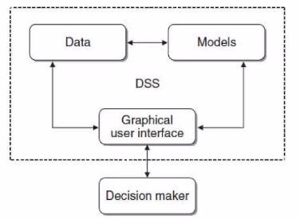
Jon Clements presentation

Figure 1. Outline of a Decision support system. “Data” can be temperature, rain or other weather variables; insect pest, disease or weed observations, crop growth stage, planting date etc.
These statements are all TRUE.
Different model presentations answer different questions. For example, a scab model may focus on hourly timing of post-infection sprays or on the infection risk on a daily time scale.

The NEWA apple carbohydrate thinning model measures the susceptibility of apple trees to chemical thinners.

RIMpro and Ag-Radar combine gridded weather data from government weather agencies with forecasts. Both platforms can also use station data instead of gridded data, but the station data output files must be configured to match the RIMpro or Ag-Radar specifications.
All forecast weather data is pulled from a grid because weather stations cannot measure what has not happened yet.

Weather from professionally generated weather grids is not perfect. Small scale rain events can fall below grid scale resolution. Glen pointed out that data from on-farm weather stations is not perfect either, and requires the quality equipment be properly sited, calibrated, and receive regular maintenance.

There are electronic insect traps with a camera that send a picture of what has landed in the trap to your computer, thus saving you from having to check the trap in person.

Robots and drones are emerging technologies for orchard management.

Leslie Forstadt presentation
These statements are all TRUE.
Mediation is a process to clarify understanding and priorities and improve communication to help resolve conflicts.
The rapid, unexpected onset of coronavirus is a source of acute stress. As the crisis continues it will likely also become a source of chronic stress.
People differ in how much they use intuition versus data and analysis in making decisions. But all people’s decision making is influenced by their values.
When under stress, intuition may feel fuzzy, or data may be uncertain.
Discussing and listing your values can help define criteria in choosing between decision options.
When dealing with stress, consider the tools and resources available to help you. You are not alone as you may feel in facing difficult situations.
This is a time of exceptional uncertainty. It is also a time of opportunity – to open into uncertainty with curiosity.
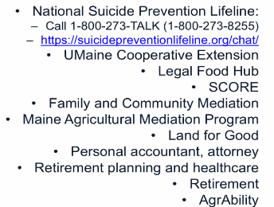
Resources to get help with farm or family stress, conflict resolution, business planning, farm transfer, etc.
* Stress/Crisis/Suicide emergency: Call 211

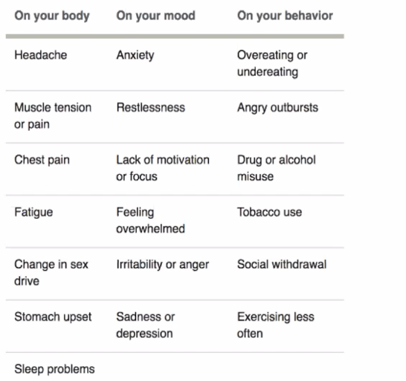
Effects of Stress

