Water: The first thing your hatchlings will need is clean, fresh water. Use equipment designed specifically for chicks. Avoid open water containers as chicks tend to walk in them, soil the water and may drown.

It’s often useful to place a few shiny dimes or marbles in the base of the waterers.
The hatchlings will peck at them and discover the water more quickly. Chicks will promptly learn from each other how to drink and the objects can be removed after a couple of days. Once they begin to drink, the waterers should be raised to a height that is level with the chicks’ backs.
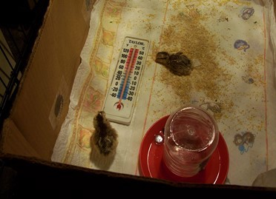
Photo by Dee Hawksley

Feed: Chicks will also need food as soon as you can get them home. Commercial brands of Chick Starter offer nutritionally complete rations. For the first couple of days in addition to feeders, placing a couple of jar lids filled with feed just outside the arc of the light in the brooder helps them to find food more easily.
Once they have found food use the same rule for feeder placement as with waterers – level with the height of their backs. This helps to prevent contamination and waste.

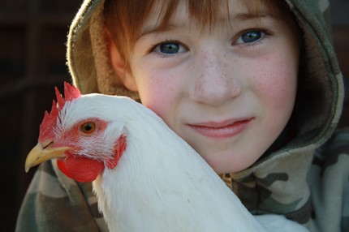
STARTING FROM SCRATCH

extension.umaine.edu

maine.gov/dacf www.nesare.org

Additional resources:

Maine Poultry Growers Association
mainepoultrygrowers.org

Central Maine Bird Fanciers
centralmainebirdfanciers.org

New Hampshire Poultry Fanciers
newhampshirepoultryfanciers.com

Your local veterinarian
A vital and key contract to all who raise livestock. Find one, make contact and build a relationship. Don’t wait until you have a crisis.
SIMPLE STEPS TO STARTING HEALTHY CHICKS

Your local feed and farm stores

This material is based upon work that is supported by the National Institute of Food and Agriculture, U.S. Department of Agriculture, under award number ENE-14-131. Any opinions, findings, conclusions, or recommendations expressed in this publication are those of the author(s) and do not necessarily reflect the view of the U.S. Department of Agriculture.

The University of Maine does not discriminate on the grounds of race, color, religion, sex, sexual orientation, including transgender status and gender expression, national origin, citizenship status, age, disability, genetic information or veteran status in employment, education, and all other programs and activities. The following person has been designated to handle inquiries regarding nondiscrimination policies: Director, Office of Equal Opportunity, 101 North Stevens Hall, Orono ME, 04469, 207.581.1226, eoinfo@umit.maine.edu.

Chickens are very social animals

Maine Animal Welfare regulations require chicks less than eight weeks old be sold in lots of two or more.

How to Start Chicks

Be prepared before they arrive! Once you have ordered your chicks, you should start planning your brooder and coop.
Biosecurity: This means doing everything you can to keep disease out of your flock and off your premises. Start new hatchlings in a clean, disinfected brooder. Do not start your chicks in an environment where you are already raising other birds. Separate new birds from any other birds for at least 30 days to prevent any exposure to disease.

Order your chicks or check with your seller to insure your chicks come from an NPIP- certified salmonella, avian influenza and mycoplasma-free source. Also, chicks with Marek’s Disease vaccination and Coccivac vaccine will be protected from Marek’s Disease and Coccidia.

Chicks can also carry Salmonella and may pose a risk to your family. Be sure to wash hands after handling chicks. This is vital information to help prevent you, your flock and others from disease.

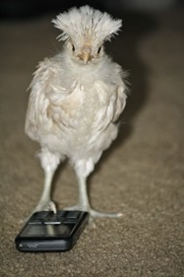
Brooder: A brooder isn’t expensive or difficult to design, it is simply an enclosed area that will keep the hatchlings warm, dry, away from drafts and safe from harm until they are larger and have grown enough feathers to keep
themselves warm.
This usually takes
Photo by Dee Hawksley
About 5-6 weeks

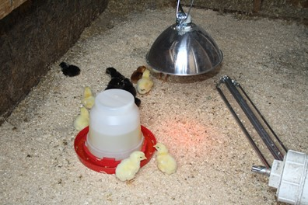
Photo by Dee Hawksley

Equipment: Have your brooder ready to use the day before your chicks arrive.
Check to be sure all equipment is clean and water and feeders full. Test heating and lighting connections to be sure they are in good working order and properly secured. It is not recommended to have brooders in your living area for fire safety reasons.

Space: Allow adequate space for your chicks to grow. Like all babies, chicks eat and sleep a lot. As they grow, they become more active and need more room for sanitary reasons and to be able to move away from the heat if necessary.

Heat Lamp: A safe, reliable heat source is essential to keep the chicks warm and to regulate their temperature since they can’t do it themselves. Be sure to choose one with a porcelain fixture and attach it securely so that it cannot become dislodged by curious children, pets or even active growing chicks. Attaching it to a chain and hanging it from a 2X2, 2X4, or a metal rod that is laid across the top of the brooder works well. Begin with a distance of 18”—20” above the bedding material, but never any closer than 15”.
Thermometer: A non-mercury indoor thermometer is best. Place it in a corner of the brooder at chick level to help determine the temperature of the brooder. You can adjust the heat by lowering or raising the lamp, or switching to lower or higher wattage bulbs.
Start with a temperature of 90°-95°F and reduce by 5 degrees each week until the temperature is balanced with the temperature in the space where they will live. The chicks’ behavior will tell you if the temperature is correct.
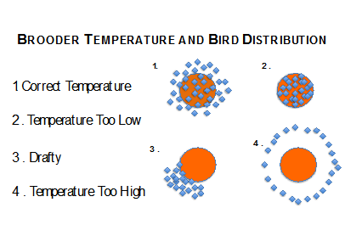
Draft Free: Any brooder must be sheltered from breezes and drafts. A brooder in a garage or outbuilding needs to be shielded on top to prevent excessive heat loss and to provide protection from predators.
Bedding: Bedding helps to keep your chicks dry from manure droppings and water spills. Wet, dirty bedding can lead to disease so clean often. Do not put hatchlings on smooth, slick surfaces like newspaper as it can cause leg injuries. For the first week or two, paper towels or burlap make good bedding. Hatch- ings tend to peck at everything and can ingest loose bedding which can cause them to become impacted and unable to eat their food. After two weeks, a looser bedding such as pine shaving or ground corncobs can be used.

