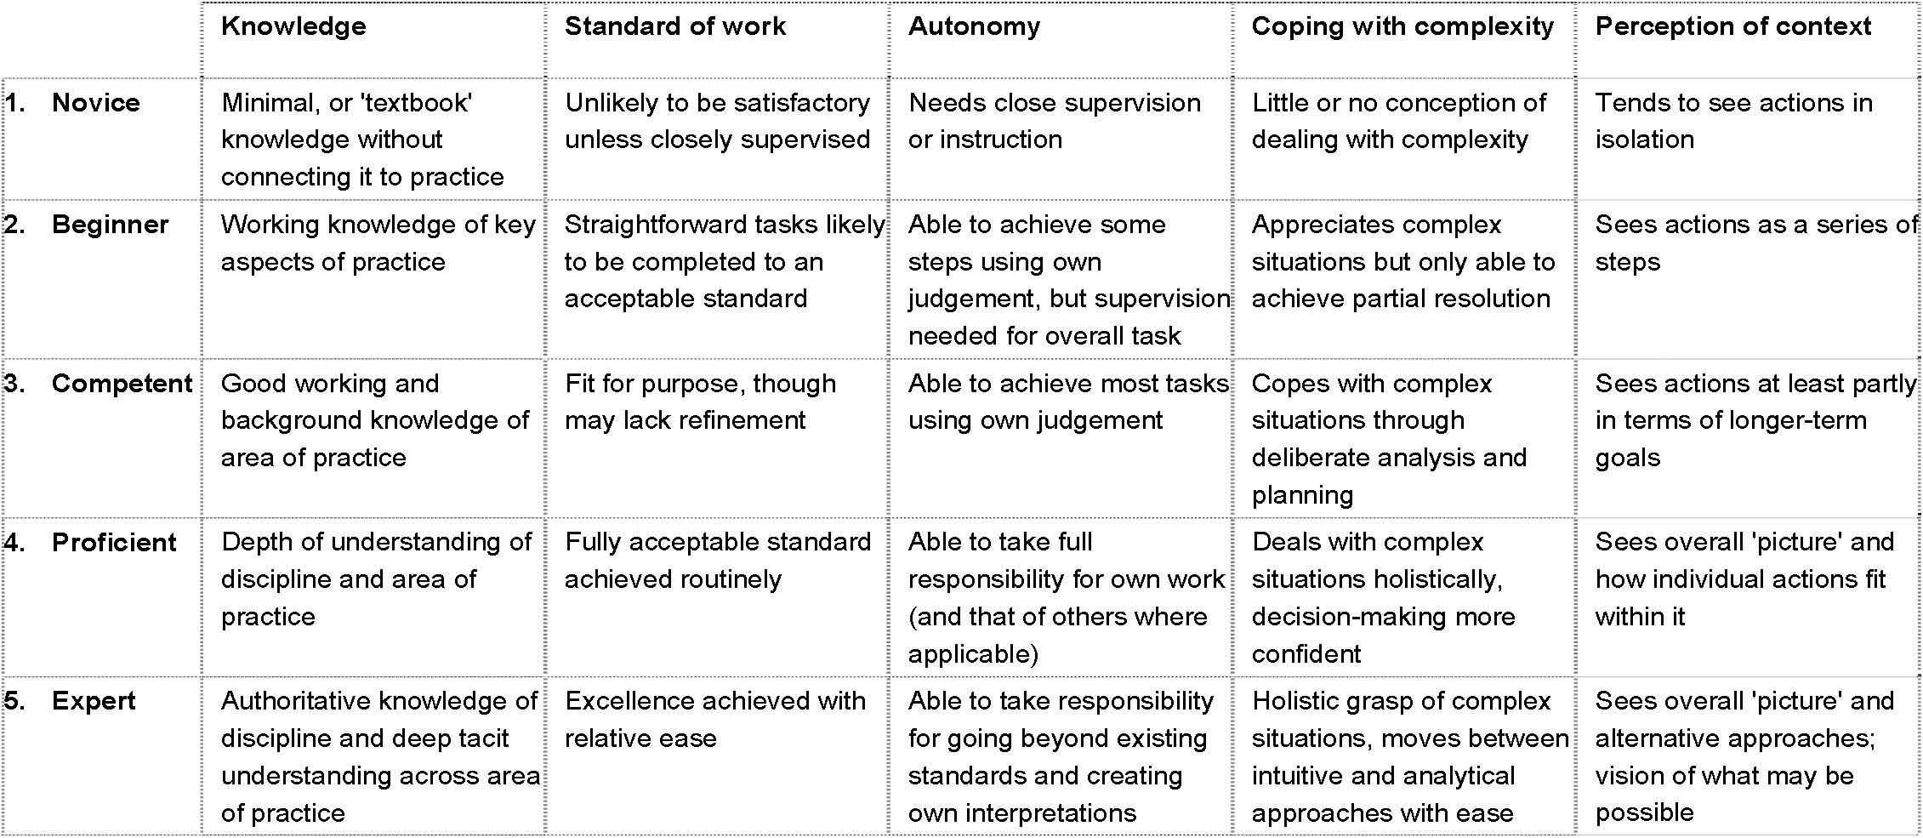
From the professional standards for conservation, Institute of Conservation (London) 2003 based on the Dreyfus model of skill acquisition.

