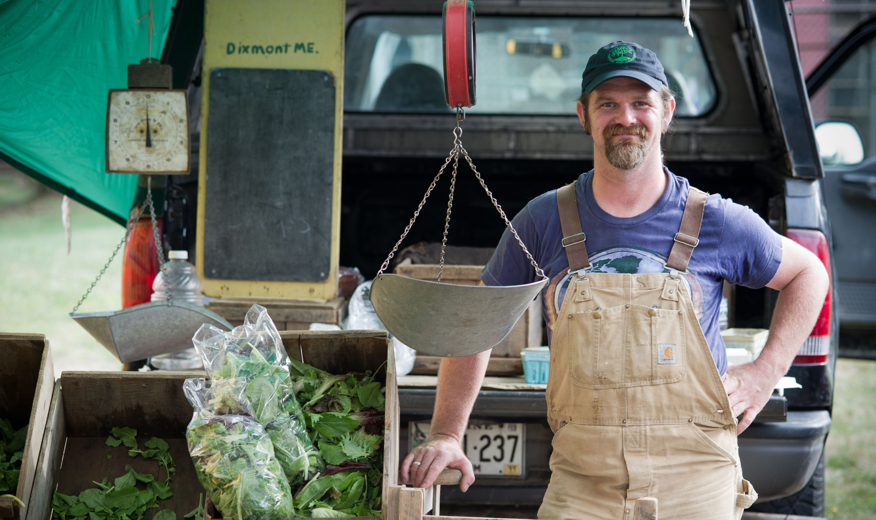
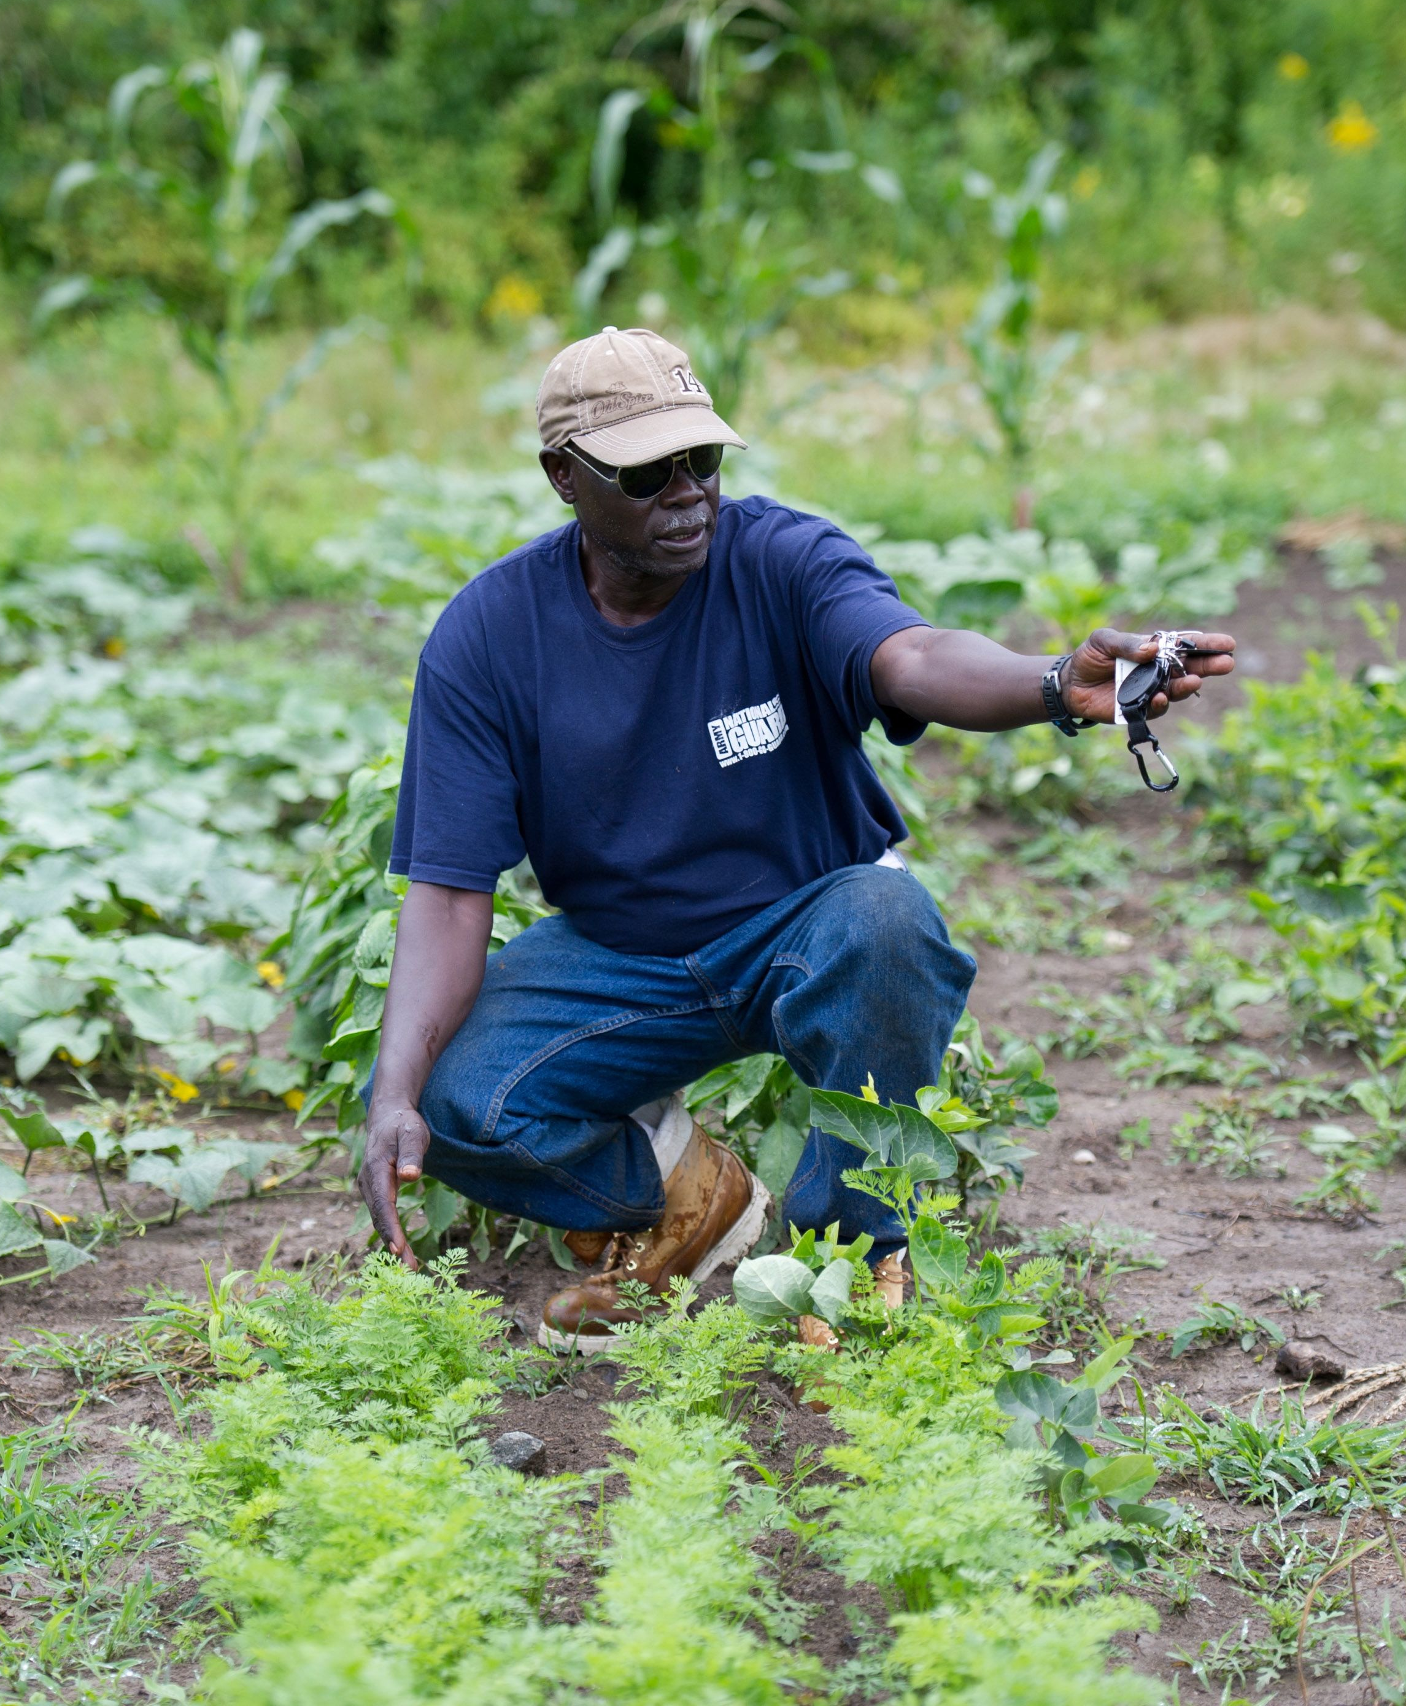
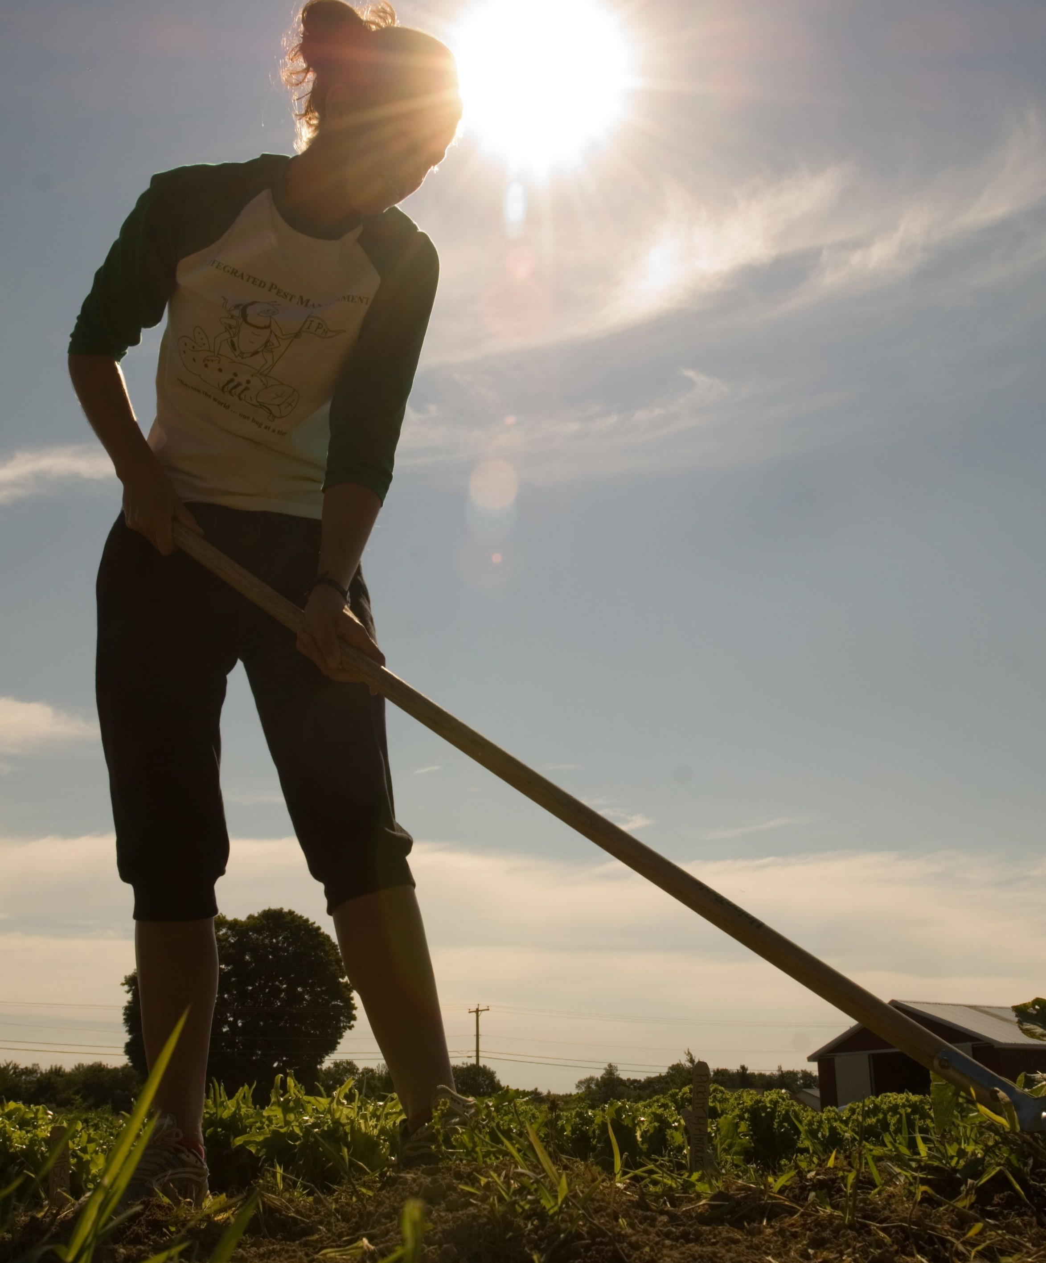
So You Want to Farm in Maine?
A Short Course for Individuals Who Want
a Profitable Farm Operation.

www.extension.umaine.edu
University of Maine
Cooperative Extension
75 Clearwater Dr. Falmouth, ME 04105
(207) 781-6099
lynne.b.hazelton@maine.edu

The University of Maine does not discriminate on the grounds of race, color, religion, sex, sexual orientation, including transgender status and gender expression, national origin, citizenship status, age, disability, genetic information or veteran’s status in employment, education, and all other programs and activities. The following person has been designated to handle inquiries regarding non-discrimination policies: Director, Office of Equal Opportunity, 101 North Stevens Hall, 207.581.1226.

If you are a person with a disability and need an accommodation to participate in this program, please call KymNoelle Hopson at 207.353.5550 or email at kymnoelle.hopson@maine.edu to discuss your needs. Receiving requests for accommodations at least 7 days before the program provides a reasonable amount of time to meet the request, however all requests will be considered.

Sponsored by
The University of Maine Cooperative Extension

Course Location: 75 Clearwater Dr. Suite 104 Falmouth, Maine
Course Time: Tuesday, October 9, 16, 23, 30, and 1 follow-up meeting.
5:30PM-8:30PM
Instructors and Contact Info:
Tori Jackson tori.jackson@maine.edu; - (207) 353-5550 x11
Frank Wertheim frank.wertheim@maine.edu; (207) 324-2814
Rebecca Long rebecca.j.long@maine.edu; (207) 743-6329
Jason Lilley jason.lilley@maine.edu (207) 781-6099

Course Overview: Do you have a vision of starting and running your own farm? Have you been running a farm for a while, but need help with the business end of things? This course will help you decide if farming is right for you. It is specifically designed to help prospective and beginning farmers to holistically evaluate your ideas, analyze opportunities, and to develop plans and goals to help your business be successful.
An important aspect of starting a farm business is familiarizing yourself with the various ag service providers, including USDA agency representatives; seed, fertilizer and implement dealers; bankers; farmer cooperative officials, and others before you commit yourself to a major action, such as buying land. You will be introduced to several of these people throughout the course.
The course will hold a maximum of 25 participants. The course registration fee is $50. Criteria of successful completion of the course will be based on the FSA vendor requirements document section [7 CFR 764.454(d)]. FSA employees are welcome to attend.

Course Objectives:
- Participants will feel comfortable evaluating and starting a farm-based business.
- Participants will understand the need for and have a framework for a business plan.
- Participants will select and use a recordkeeping system.
- Participants will understand how to use Cooperative Extension and other agencies as resources for their farm business.
- Participants will understand the importance of and basics of marketing their products, including customer surveys.

Course Reading:
Handouts: Text Book, New Farmer Packet, Worksheets and Flash Drives
Text: Starting and Running a Small Farm Business by Sarah Aubrey

