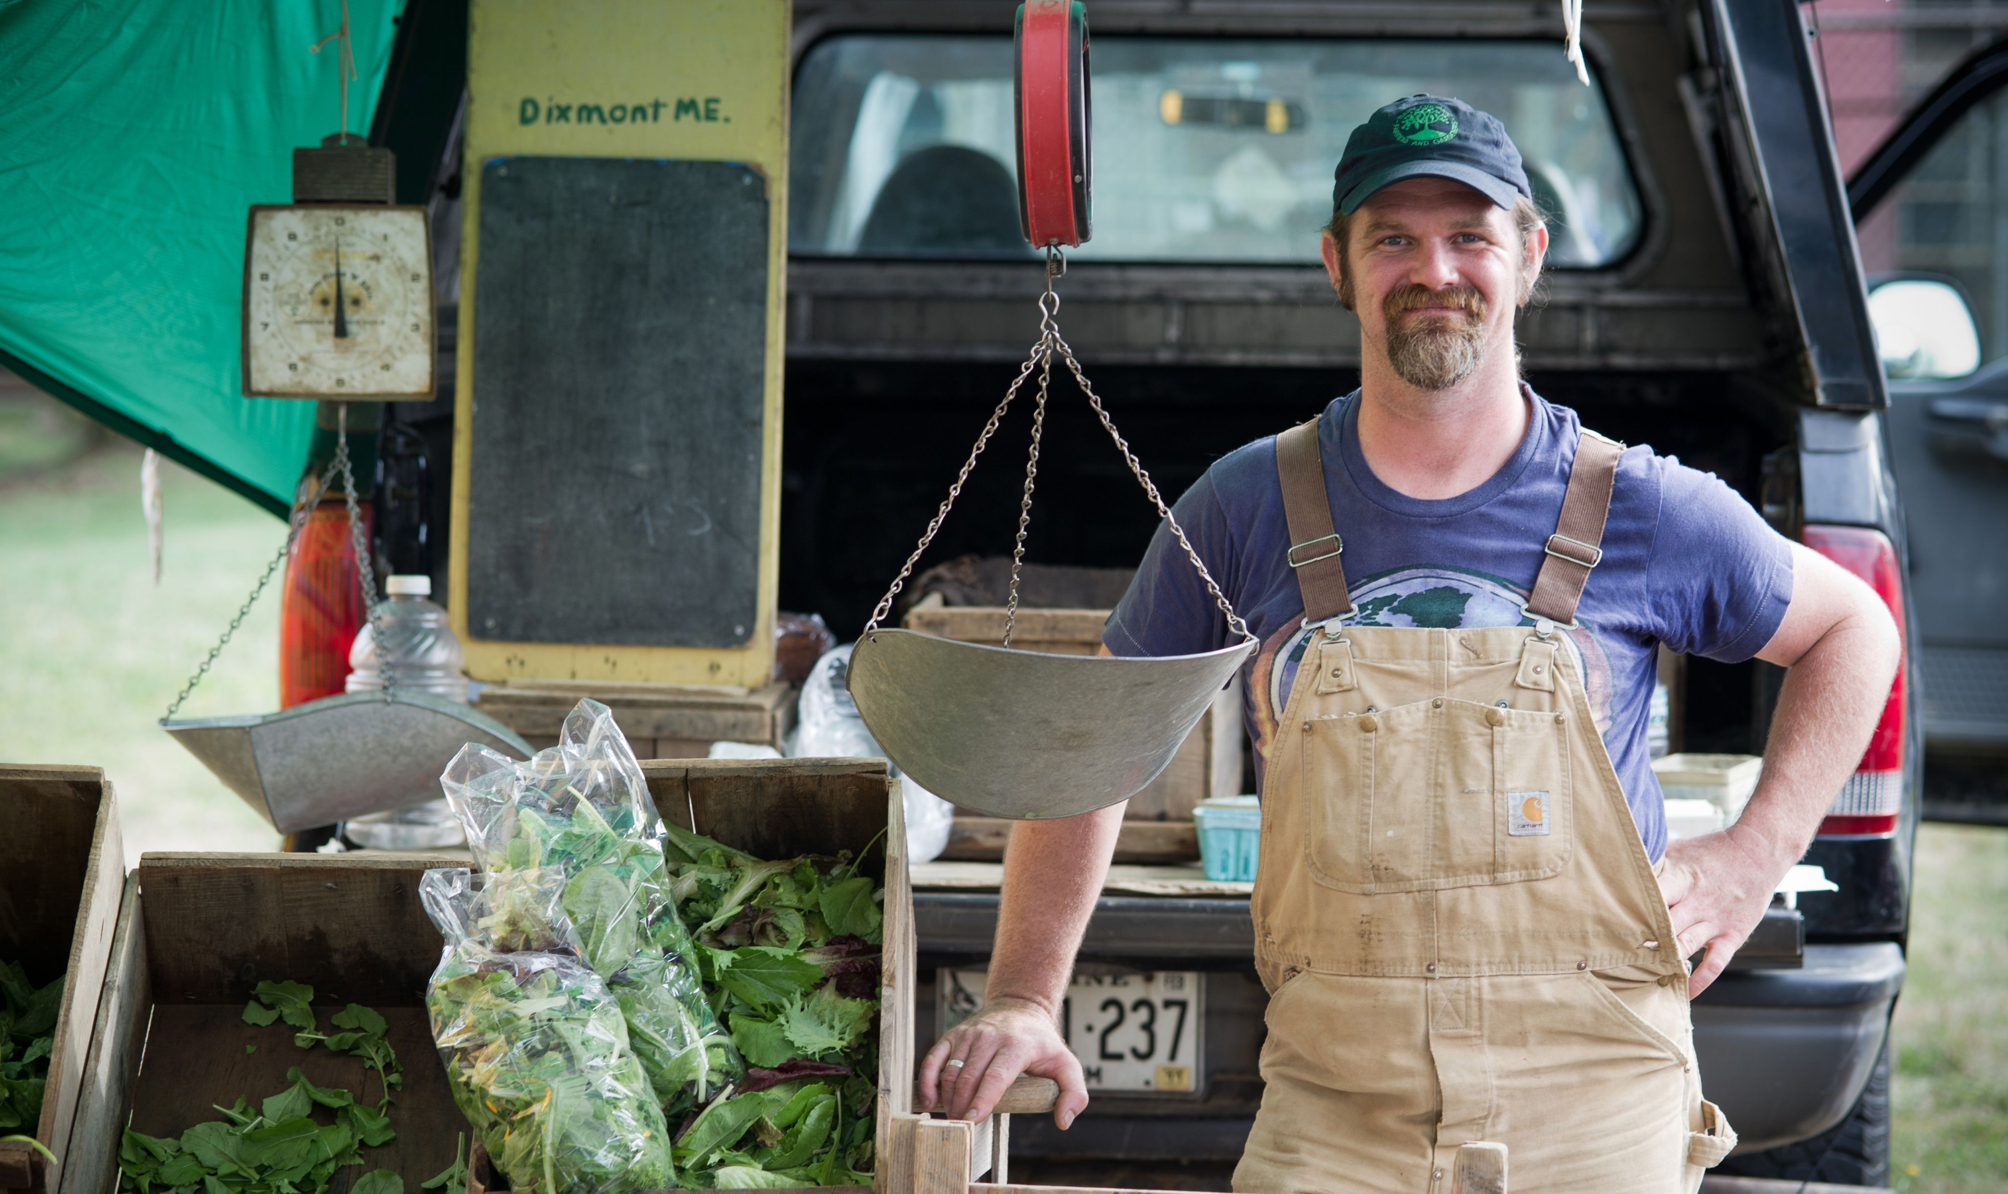
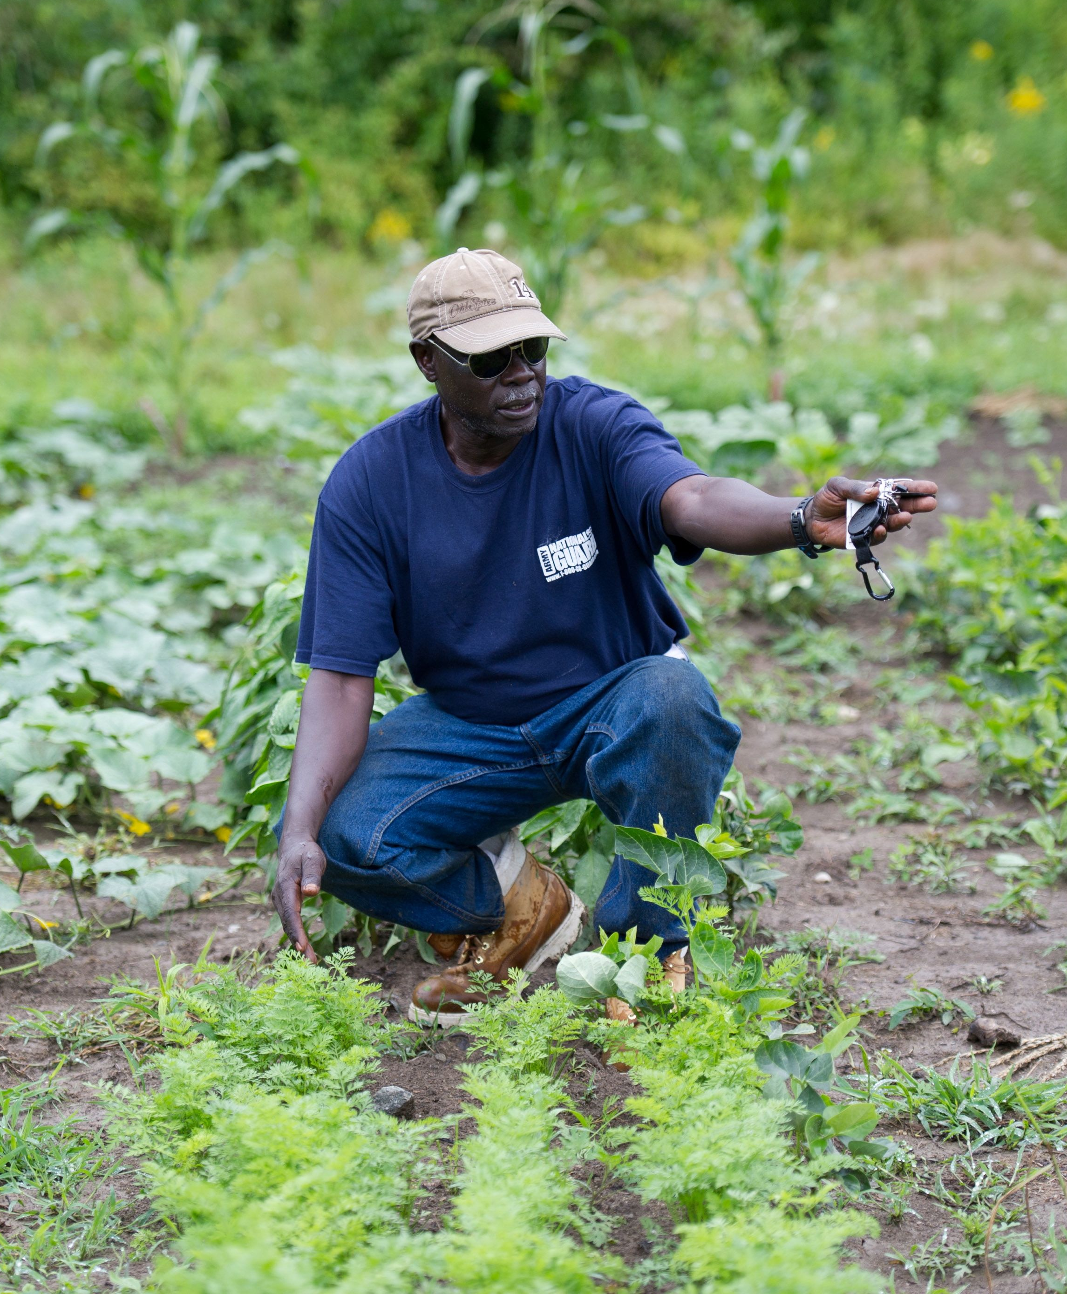
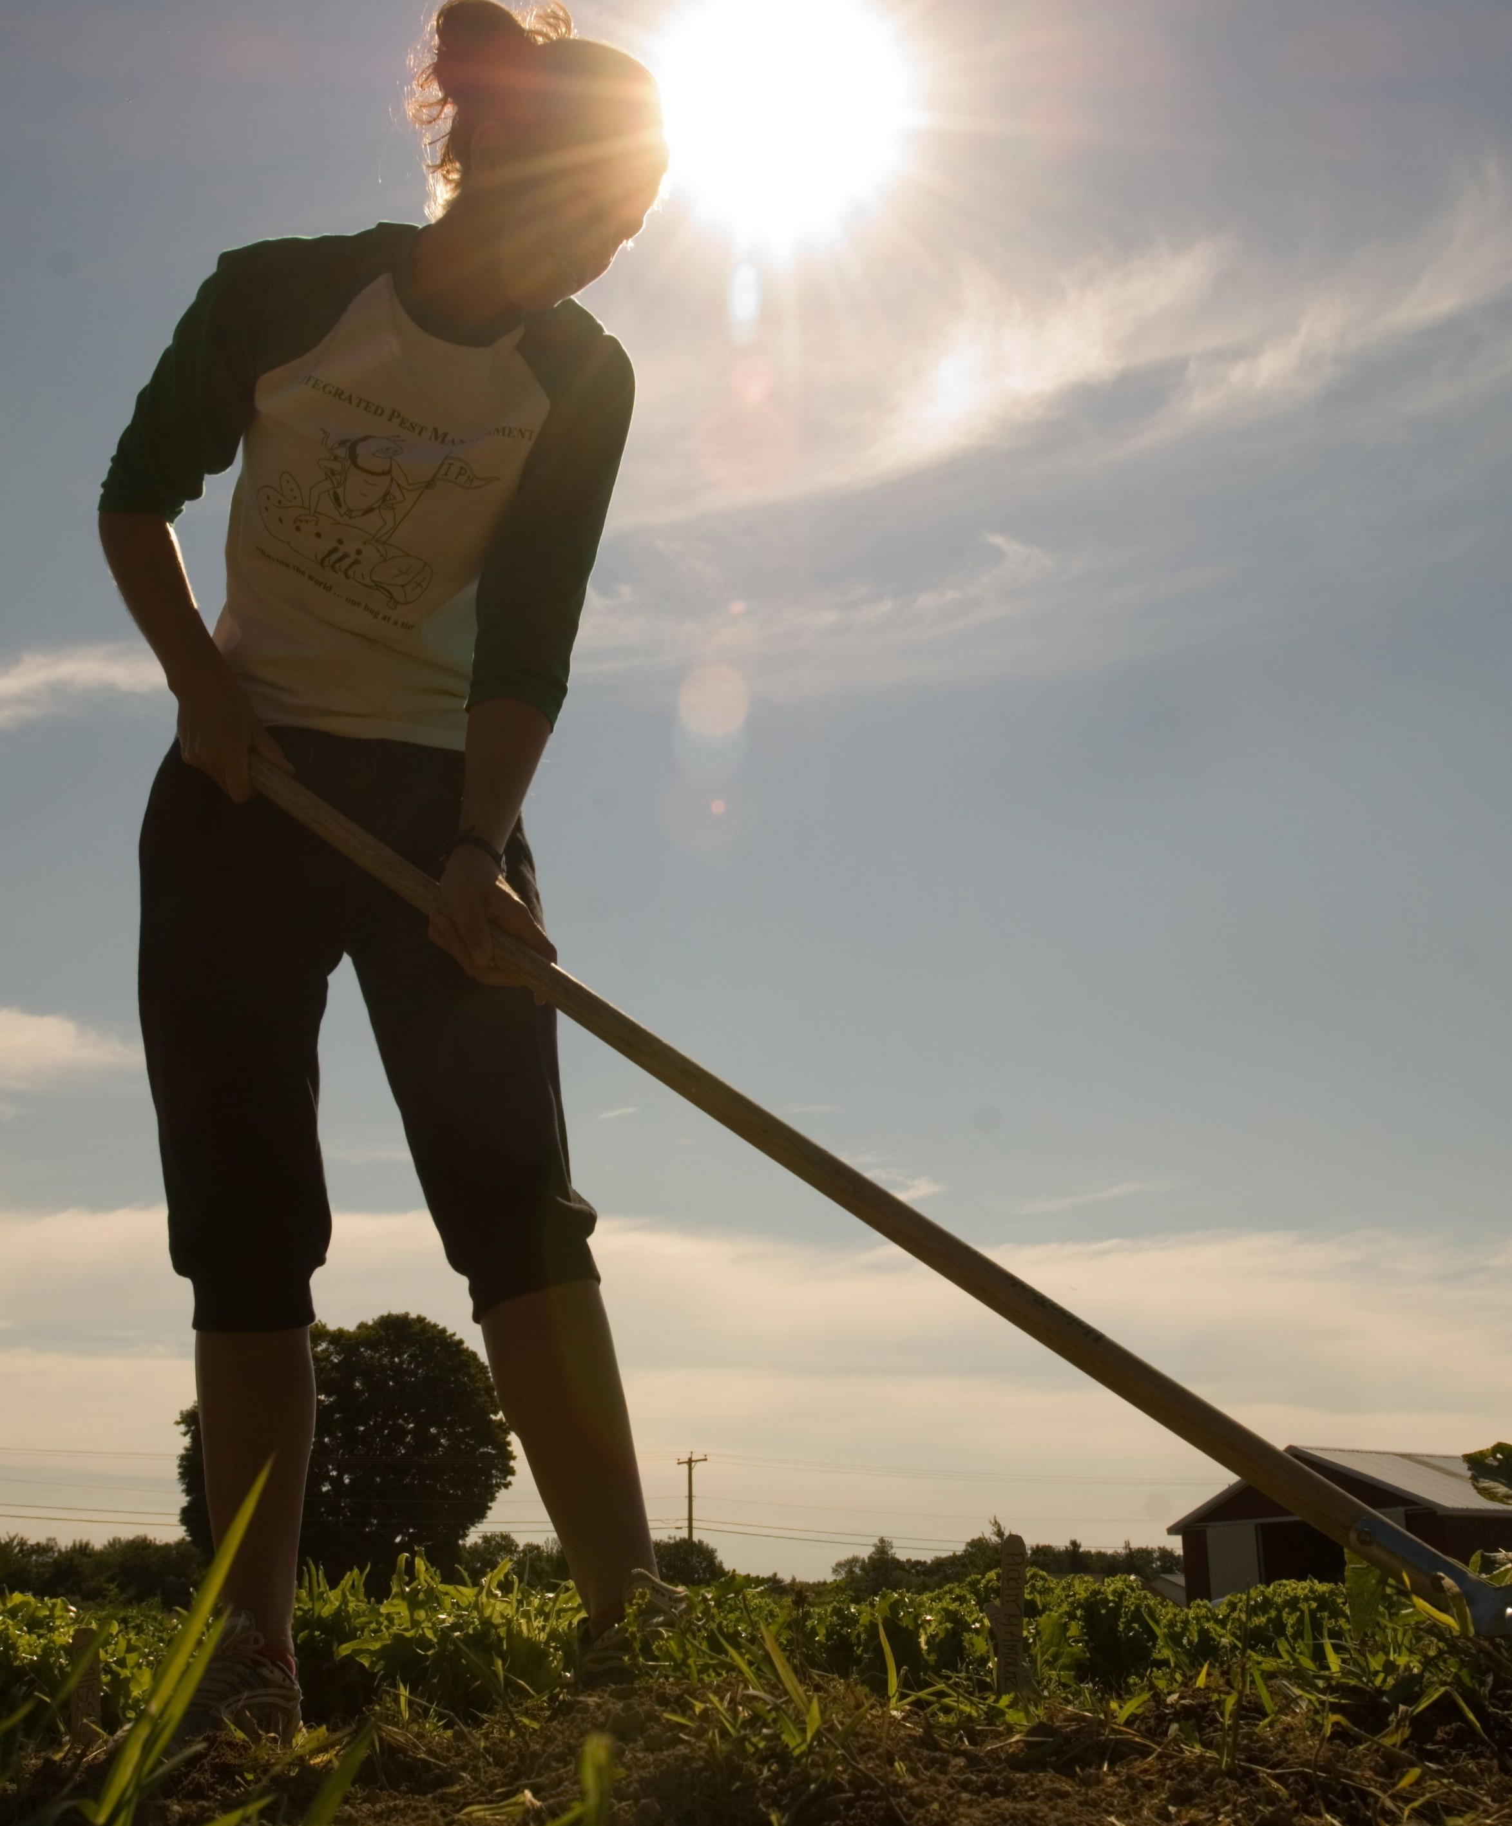
Sponsored by
The University of Maine Cooperative Extension
So You Want to Farm in Maine?
A Short Course for Individuals Who Want
a Profitable Farm Operation.

October 9, 2018

Session 1 Agenda

5:30 Introductions/ Goals of participants/ Orientation Tori

5:50 Overview of fact sheets, etc. on flash drives Jason

6:00 Evaluating farm enterprises Frank

6:30 Enterprise budget examples Tori
6:50 BREAK

7:00 Developing a framework for your business plan Tori

7:30 Assessing soils & other farm characteristics Becca

8:20 Homework and Wrap-up (Panel Discussion Suggestions)

8:30 Adjourn

www.extension.umaine.edu
University of Maine
Cooperative Extension
24 Main Street, Lisbon Falls, ME 04252
207.353.5550
kymnoelle.hopson@maine.edu
The University of Maine does not discriminate on the grounds of race, color, religion, sex, sexual orientation, including transgender status and gender expression, national origin, citizenship status, age, disability, genetic information or veteran’s status in employment, education, and all other programs and activities. The following person has been designated to handle inquiries regarding non-discrimination policies: Director, Office of Equal Opportunity, 101 North Stevens Hall, 207.581.1226.

If you are a person with a disability and need an accommodation to participate in this program, please call KymNoelle Hopson at 207.353.5550 or email at kymnoelle.hopson@maine.edu to discuss your needs. Receiving requests for accommodations at least 7 days before the program provides a reasonable amount of time to meet the request, however all requests will be considered.

