MANURE UTILIZATION GUIDELINES
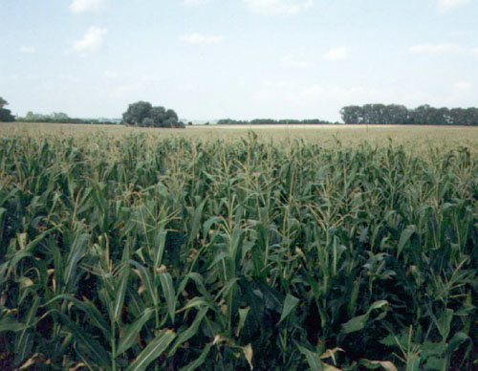

Published by:

MAINE DEPARTMENT OF AGRICULTURE

FOOD AND RURAL RESOURCES

STATE HOUSE STATION # 28
AUGUSTA, MAINE 04333

November 1, 2001
These 2001 Guidelines were reviewed by the following
Agencies and Organizations:

Farm Service Agency
UME Cooperative Extension - Androscoggin & Sagadahoc Counties
UME Cooperative Extension - Aroostook County
UME Cooperative Extension - Aroostook County
UME Cooperative Extension - Aroostook County
UME Cooperative Extension - Cumberland County
UME Cooperative Extension - Franklin County
UME Cooperative Extension - Hancock County
UME Cooperative Extension - Kennebec County
UME Cooperative Extension - Knox & Lincoln Counties
UME Cooperative Extension - Oxford County
UME Cooperative Extension - Penobscot County
UME Cooperative Extension - Piscataquis County
UME Cooperative Extension - Somerset County
UME Cooperative Extension - Waldo County
UME Cooperative Extension - Washington County
UME Cooperative Extension - York County
UME Cooperative Extension Main Office
Agricultural Council of Maine (AGCOM)
Maine Agricultural and Forest Experiment Station
Maine Audubon Society
Maine Municipal Association
Maine Poultry Federation
Maine Conservation District Advisory Council
Maine Association of Conservation Districts
Maine State Grange
Natural Resources Council of Maine
Soil Conservation Society of America, Pine Tree Chapter
Mainen Farm Bureau
Natural Resources Conservation Services
Department of Environmental Protection
Maine Forest Services
Maine Land Use Regulation Commission
State Planning Office
Aquaculture Association of Maine
Beef Industry Council of Maine
Beef Producer's Association of Maine
Brown Egg Council of New England
Dairy Industry Association
Deer & Elk Farmer's Association of Maine
Deer Farmers, Northern New England
Equine Industry Association
Hog Grower's Association
Maine Horse Association
Maine Organic Farmers and Gardeners Association
Maine Sheep Breeders Association
Maine Department of Marine Resources
Maine Horse Association

Table of Content

Nutrient Management Plan 3

Standards 3
1. Calculate Crop Nutrient Needs 3
- Determine the nutrient content of your manure 3
- Soil test each field 3
- Determine the Nutrient requirements of the crop 4
- Use the N and P Priority Matrix 4
- Use manure as your primary source of plant nutrients 4

2. Manure Utilization 4
- Transportation method 4
- Calibrate application equipment 4
- Time applications based on crop need 4
- Use correct application technique 4
- Buffers (setbacks) 5

3. General Manure Field Stacking Guidelines 5
- Applicability 5
- General Recommendations 5
- Siting Recommendations 6

Attachment 1: NMP requirements 7
Attachment 2: Manure sample information form 8
Attachment 3: How to take a soil sample 9
Attachment 4: Residual Nitrogen Contributions 10
Attachment 5: Calculating Total Pounds of N and P₂O₅ required for
Crop Growth 11
Attachment 6: N and P Manure Priority Matrix 12
Attachment 7: Manure Application Guide 13

MANURE UTILIZATION GUIDELINES
November 1, 2001

These Guidelines replace The Maine Guidelines for Manure and Manure Sludge Disposal on Land, July 1972, published by the Life Sciences and Agriculture Experiment Station, University of Maine Cooperative Extension Service and the Maine Soil and Water Conservation Commission.
_____________________________________________________________________________

NUTRIENT MANAGEMENT PLAN

Maine law and Chapter 565, the Nutrient Management Rules, requires that many farms have and follow a Nutrient Management Plan, developed by or approved by a Certified Nutrient Management Planning Specialist, Certified by the Commissioner of the Department, in accordance with 7 MRSA Chapter 747 (see attachment 1 for farms required to have a Nutrient Management Plan).
For farms that are not required to have a Nutrient Management Plan and for those farms which have not chosen to voluntarily develop one, the following guidelines may be followed for storage and utilization of manure.
______________________________________________________________________________

STANDARDS (Nutrient Management Plan not required)

1. CALCULATE CROP NUTRIENT NEEDS - The following should be considered when determining crop nutrient needs. Crop nutrient needs should be determined for each field and for each crop type:

- Determine the nutrient content of your manure - This should be done by sampling your manure and having it analyzed for N, NH₃-N, P₂O₅, K₂O+H₂O. If you have more than one type of manure or storage method (liquid vs. field stacked), take samples from each storage area. You should also take into consideration N losses through volatilization, depending upon application method (up to 80% of ammonia N is available to the crop if incorporated within 2 days but only about 20% is available if not incorporated or incorporated after 7 days). Sampling should be done at least every 5 years or when there is a management change that affects manure nutrient values. It is critical that the sample be taken and handled properly or you will get an inaccurate reading. (See attachment 2 for manure sampling and handling procedure).
- Soil test each field- Each field should be soil tested at least once every 5 years to determine P, K, Mg, Ca and pH levels. N levels in the soil are not measured in the standard soil test because N is so mobile in some forms that the levels constantly change. For corn, you can do a soil N test for a crop that is in the early stages of growth but it is difficult to apply manure at that time. N needs are generally based upon the crop needs but residual N from legumes and previous manure applications should be taken into consideration (see attachment 4 for calculating residual nitrogen contributions from legumes). If a field has a significant change in soil type, drainage or management practice, samples should be taken from each of the different areas in the field. Follow "Instructions on how to take a soil sample" by the University of Maine Plant and Soil Lab” (see attachment 3).
- Determine the nutrient requirements for the crop- Crop nutrient requirement should be based upon realistic yield goals for your specific soil types and cropping practices. Realistic yield goals for most major crops are listed on attachment 5. You can use actual yield goals that are in excess of those listed on the attached table if you can demonstrate that in 2 out of 5 years your average exceeded these thresholds. Application method and incorporation times must also be considered.
d. Use the N and P Priority Matrix - To determine which nutrient to base manure application rates on, use attachment 6, N and P Priority Matrix. Supplement with other nutrient sources once the appropriate threshold has been exceeded.
e. Use manure as your primary source of plant nutrients - Manure should be your primary source of nutrients for growing a crop. Other nutrient sources should only be used as a supplement to provide nutrients not supplied by the manure.

2. MANURE UTILIZATION - The following should be considered when utilizing manure on the farm as a soil amendment or nutrient:

a. Transportation method - Choose a method to transport your manure that is appropriate for the type (consistency) of manure. It should not result in leakage or spillage that can become a nuisance or source of pollution.
b. Calibrate application equipment - The equipment you use for spreading manure should be based upon the type of manure (consistency) you intend to spread. Regardless of the application equipment you use, it will need to be calibrated so that you only apply the nutrients needed to produce the desired crop. The equipment should be checked periodically (at least annually) to verify that the proper application rate is being applied. (See attachment 7, which is a chart for calculating manure spreading rate).
c. Time applications based on crop need - To maximize nutrient uptake by a crop, the nutrients should be applied so that they are available when the crop needs them. Manure applied at times other than when the crop needs them should utilize techniques to maximize nutrient retention and availability for the crop to use when it is growing (as an example, grow a cover crop to uptake nutrients in the fall so they will be available to the crop the next spring when the cover crop is plowed down). Do not spread on frozen or snow covered ground.
d. Use correct application technique - Start in the corner of the field furthest from the entry point so that you don't have to drive through it repeatedly before driving on a public road. Make sure spreader is spreading evenly. Do not overlap spreading patterns or turn around in the same area repeatedly while still spreading.
e. Buffers (setbacks) - Use setbacks to create buffers as a way to protect water quality. Buffer widths should be determined on a site specific basis taking into consideration such factors as field slope, soil type, drainage, watershed size, row direction, cover crop, tillage method, sensitivity of water body, type of well, season manure is applied and rate of manure application. In lieu of site specific buffer widths, the following can serve as setback guidelines:
- 25 feet from intermittent and perennial streams and rivers
- 100 feet from lakes, ponds and marine water bodies
- 100 feet from private wells and springs
- 300 feet from public wells
- Avoid diversions, drainage ditches, gullies, non-vegetated swales and ravines
- Avoid bedrock outcrops

3. GENERAL MANURE FIELD STACKING GUIDELINES - The Maine Department of Agriculture, Food and Rural Resources requires that Manure Field Stacking Sites be located by qualified professionals when they are part of a Nutrient Management Plan. If a Nutrient Management Plan is not required and has therefore not been developed, the Department recommends the following guidelines:

a. Applicability:
These guidelines have been developed to be used by persons with no field training or practical experience in the location and/or development of manure field stacking sites. They should only be used for farms with stackable manure (18% or more organic matter, dry weight). The setback numbers recommended in these guidelines are conservative because they are general in nature and do not take into consideration site specific conditions. If you wish to use site specific setbacks, they should be determined by a qualified professional (a person who has been trained and is experienced in developing site-specific field stacking plans).

b. General Recommendations:
1. Locate as many suitable field stacking sites as possible. This will allow for rotating between field stacking sites and/or stacking smaller amounts of manure in several locations as compared to larger amounts in fewer locations.
2. Unless otherwise necessary, only stack that amount of manure in a field that is needed to meet the fields nutrient requirements.
3. Only stack more manure in a field than is needed to meet the field's nutrient requirements when suitable stacking sites are not available on surrounding fields or when unable to access other field stacking sites due to weather, road or soil conditions.

c. Siting recommendations:
- Choose a site which is on a knoll or high position in the landscape so that the soil does not have a high water table and does not receive much runoff. Sites which are mostly low and wet with only small knolls should be avoided or they should be evaluated by a qualified professional.
- Do not stack manure on a site with less than 24 inches of soil between bedrock and the bottom of the manure pile. It may be possible to modify shallower soils but will require the assistance of a qualified professional.
- Do not stack manure on sites where the soil is gravel or sand. It may be possible to modify such soils so that they can be stacked upon but will require the assistance of a qualified professional.
- The stacking site should be on as level a slope as possible but should not be on a slope greater than 5%. With the assistance of a qualified professional, it may be possible to modify a site with greater than a 5% slope so that it can be stacked upon.
- The stacking site should meet the following setbacks unless site specific set-backs have been developed by a qualified professional:

FEATURE SETBACK DISTANCE
WHEN FEATURE IS
upslope downslope
Perennial (year round) Waterbodies 100' 300'
Intermittent (seasonal) Waterbodies 50' 200'
Private Water Supplies (not owners) 100 300'
Public Water Supplies (wells, lakes, ponds, rivers, springs) 500' 500'
Private Water Supplies (owners) 100' 200'
Property Line 100' 200'
Residences (neighbor) 300' 300'
Diversion 25' 150'
Gully/Swale/Ravine 25' 150'
One Hundred Year Flood Plain Not Within Not Within

If you can not locate a manure field stacking site which falls within all of these guidelines, you should contact a qualified professional. A qualified professional will take into consideration site specific conditions to identify and/or develop field stacking sites for your manure. They are also trained to modify existing site conditions, when necessary, to develop manure stacking sites in fields which would not otherwise have suitable sites. For a list of qualified professionals contact:

Maine Department of Agriculture, Food and Rural Resources
Office of Agricultural, Natural and Rural Resources
State House Station # 28
Augusta, Maine 04333
Phone(207) 287-1132
Attachment 1

(From Nutrient Management Rules, February 2001)

- §4. Nutrient Management Plans Required.
Unless exempted by statute or these rules, a person who owns or operates a farm shall have and implement an approved nutrient management plan for that farm if it meets one or more of the following criteria:
  - The farm confines and feeds 50 or more animal units at any one time;
  - The farm utilizes more than 100 tons of manure per year not generated on that farm;
  - The farm is the subject of a verified complaint of improper manure handling;
  - The farm stores or utilizes regulated residuals.
The nutrient management plan must be prepared by a certified NMP specialist or approved and signed by a certified NMP specialist, pursuant to the provisions of §7 of these rules.

Attachment 2

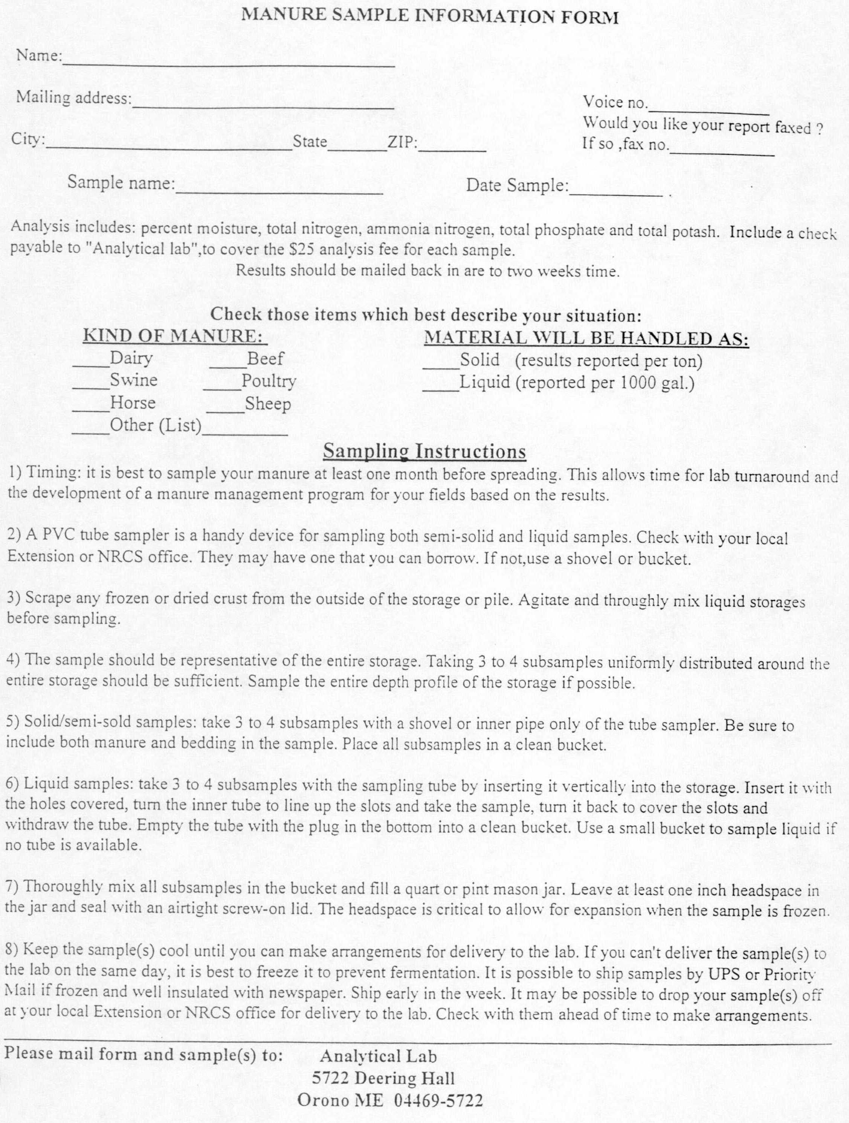

Attachment 3

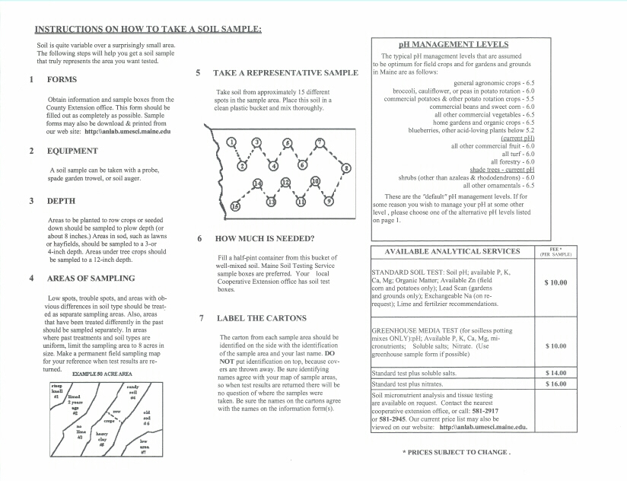

Attachment 4

RESIDUAL NITROGEN CONTRIBUTIONS FROM LEGUMES

Alfalfa:

First Year after Alfalfa

50% - 75% stand 110 lb./ ac.
25% - 49% stand 80 lb./ ac.
< 25% stand 40 lb./ ac.

Second Year after Alfalfa

50% - 75% stand 50 lb./ ac.

Red Clover and Trefoil:

First Year after Clover or Trefoil

> 50% stand 100 lb./ ac.
25% - 49% stand 70 lb./ ac.
< 25% stand 40 lb./ ac.

RESIDUAL NITROGEN FROM MANURE ORGANIC MATTER

When Applied Percent of Total Organic N Available
Poultry Dairy or Other
Current Year 60% *25% - 35%
1 Year Ago 10% 12%
2 Years Ago 5% 5%
3 Years Ago 5% 2%
*Use lower number for solid, higher number for liquid or slurry

AMMONIA-N LOSS TO VOLATILIZATION IF NOT INCORPORATED
Spring or summer applied
Days until Incorporation Percent of Total Ammonia-N available
Poultry Liquid Dairy Solid Dairy
0 - 2 80 55 60
2 - 4 60 50 45
4 - 7 40 45 25
> 7 20 40 10

Attachment 5
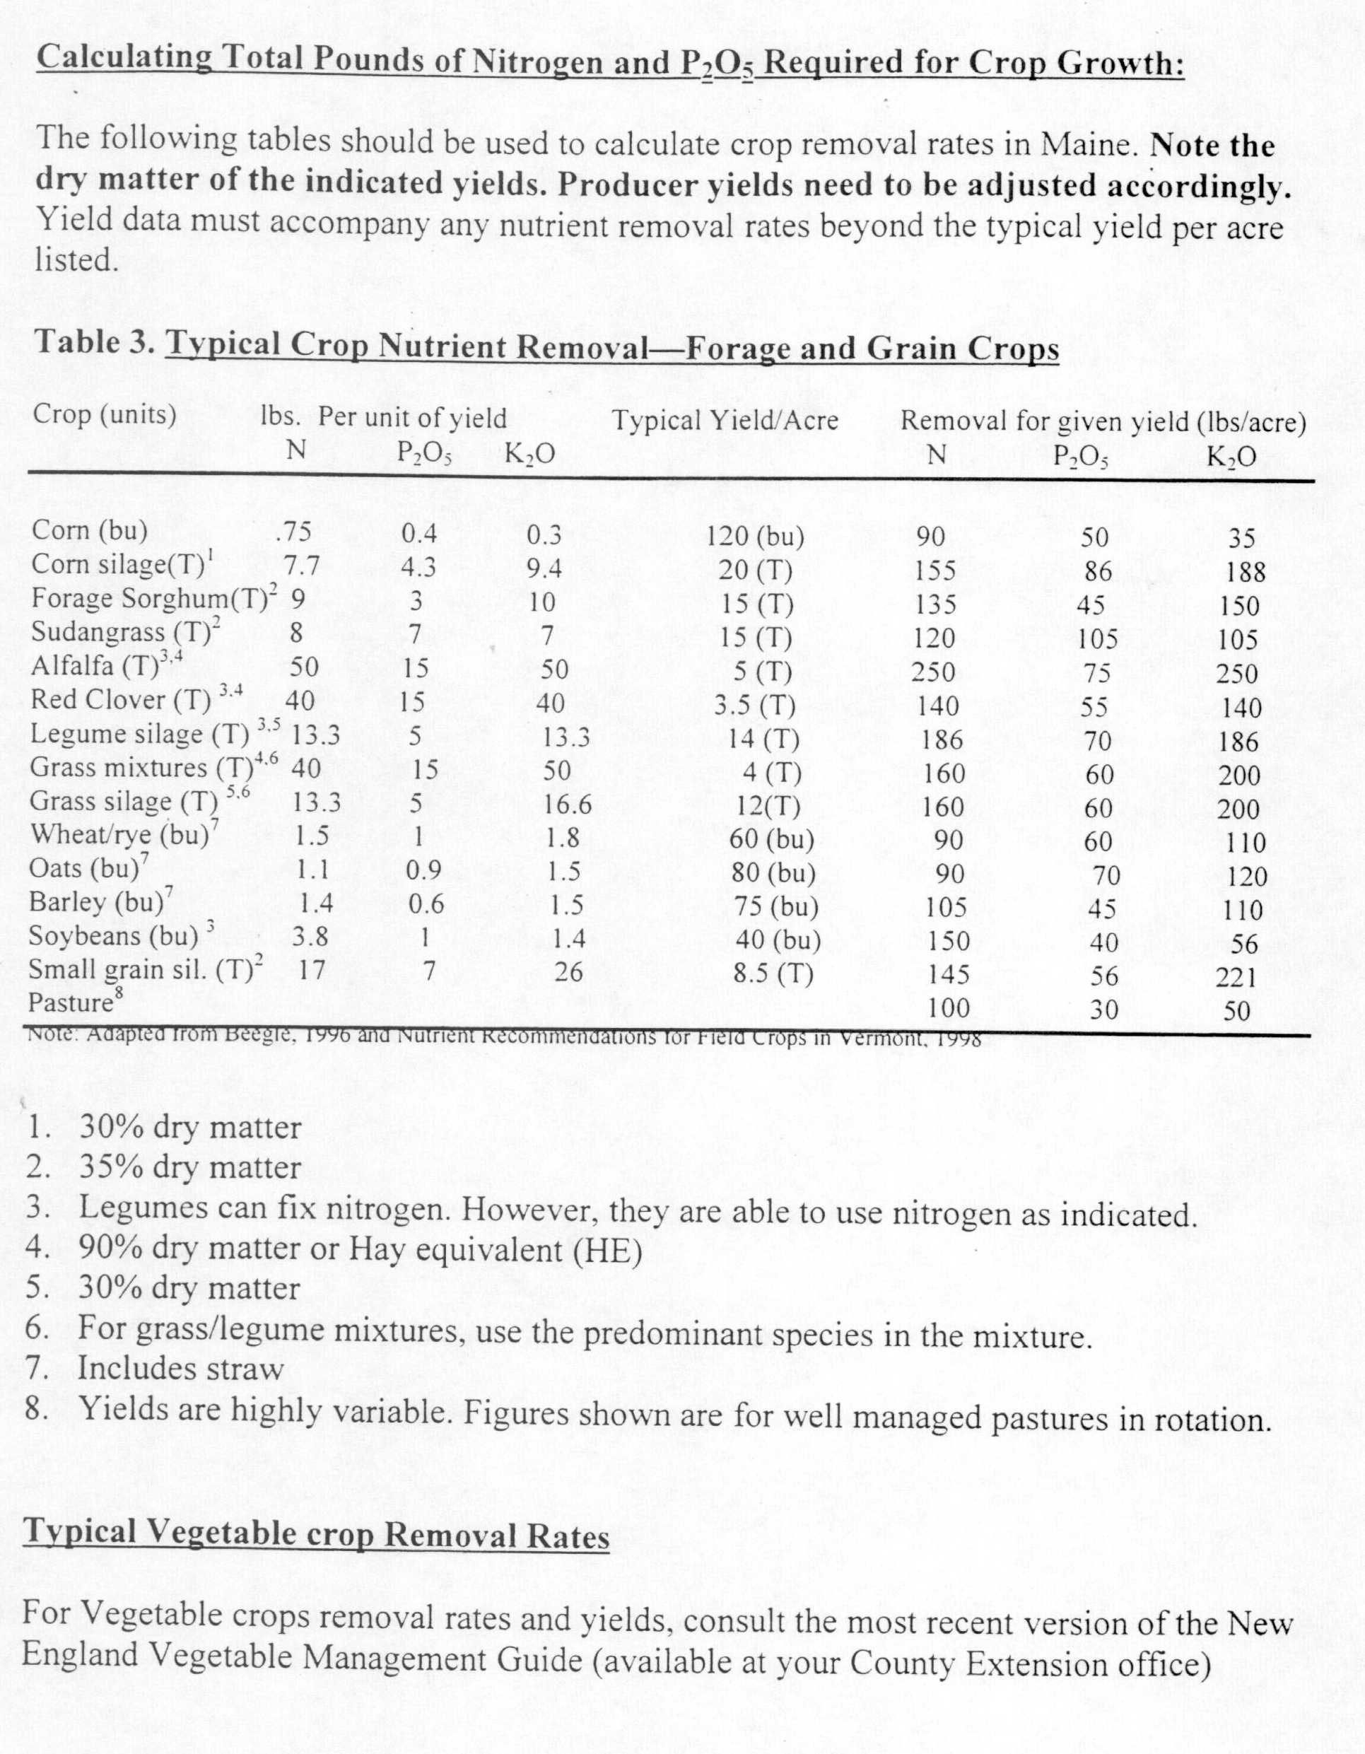

Attachment 6

Attachment 7

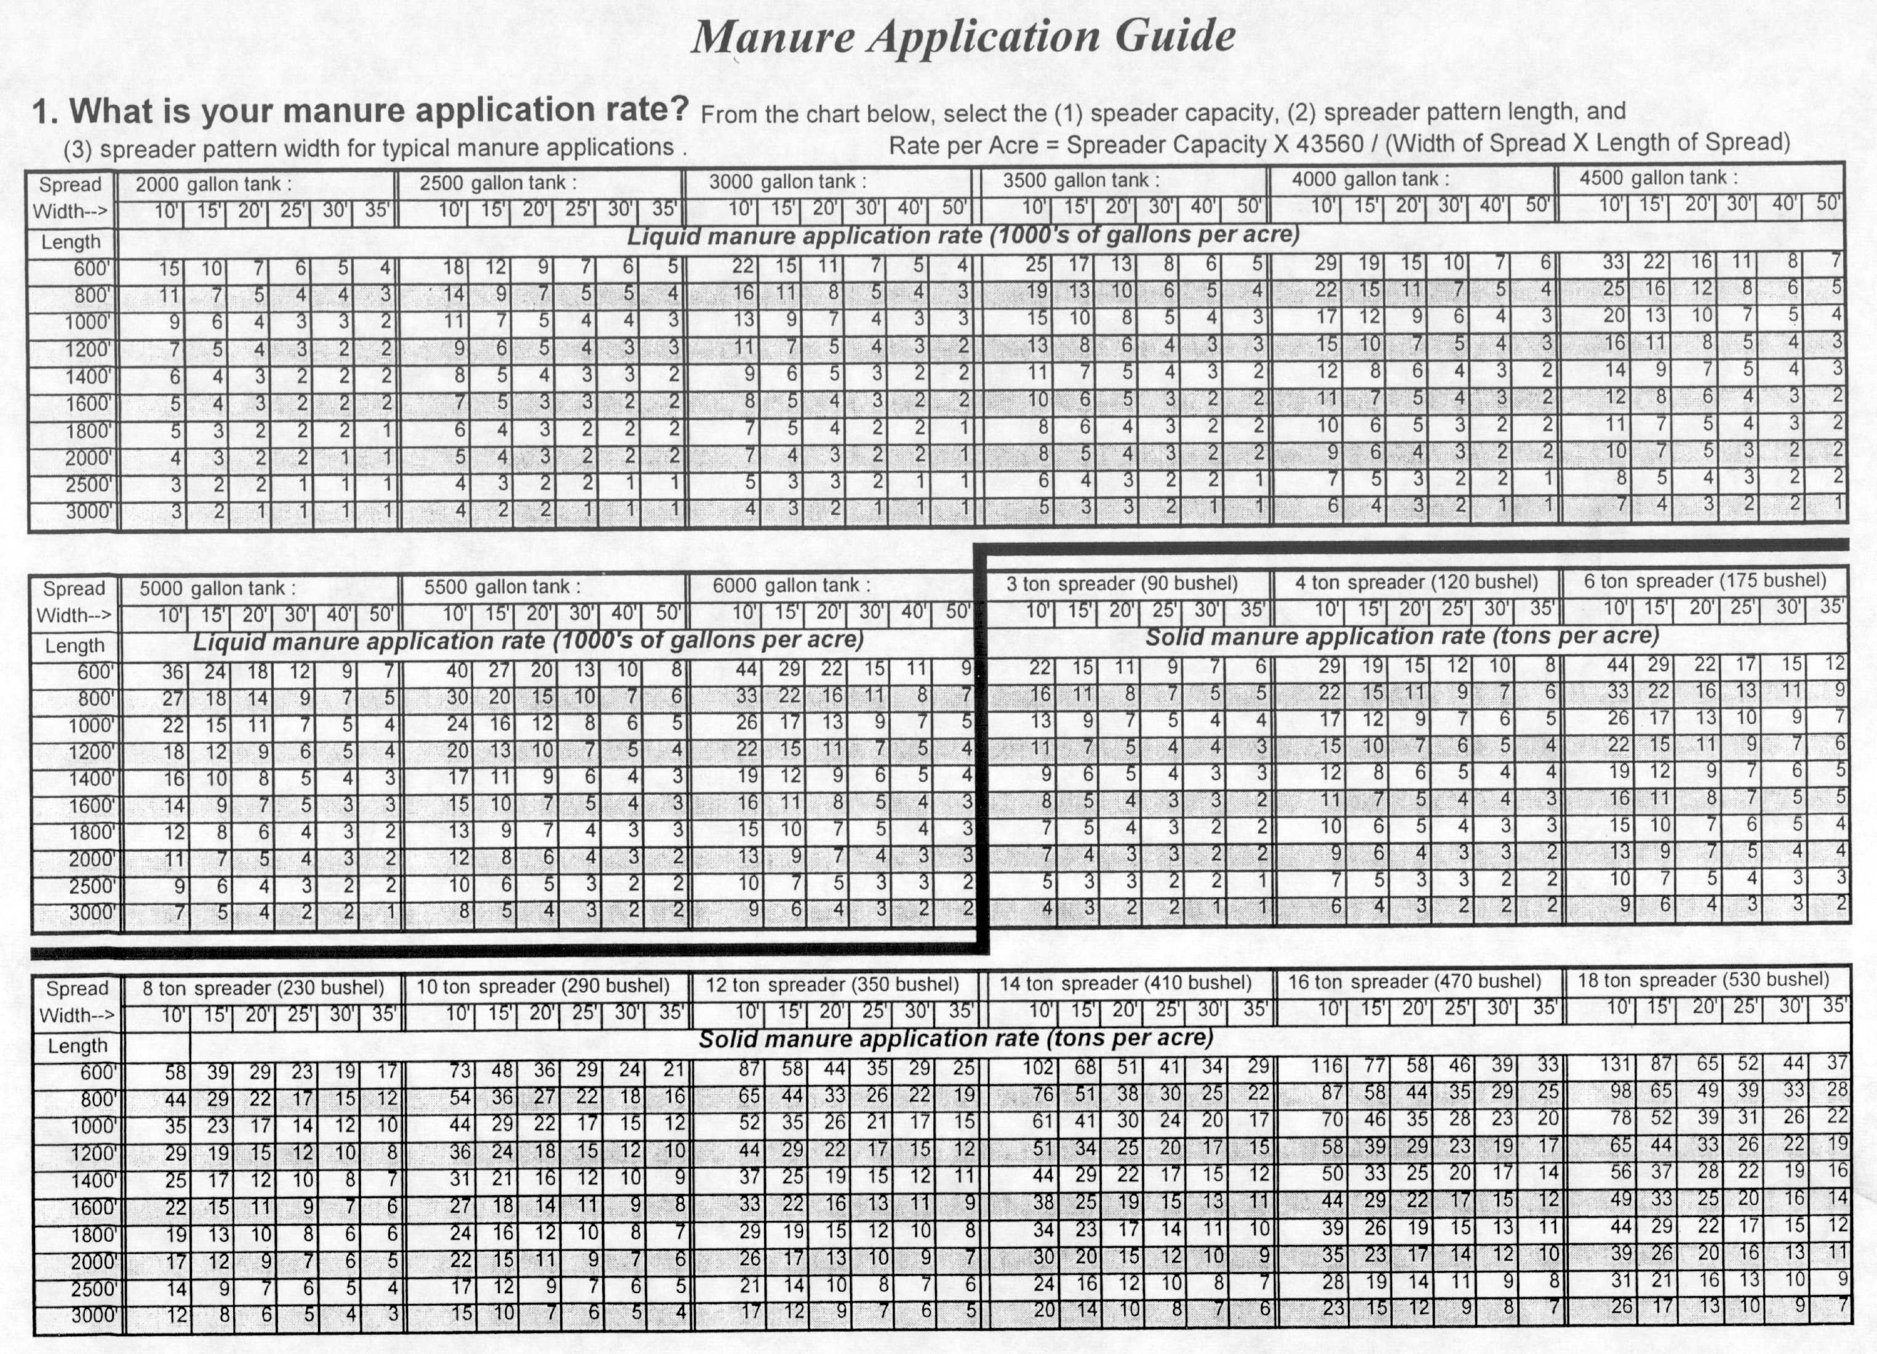

Printed under 010 01A 7600 012

Mandatory (except for farmer's own well) for people required to develop a Nutrient Management Plan.
Mandatory for people required to develop a Nutrient Management Plan.
Note: This means that the farm confines and feeds any combination of animals totaling 50,000 lb. live animal weight. Without limitation, some examples are : 24 dairy cows (plus an equivalent number of young cattle) (1400 lb./mature animal) 35 dairy cows with no young cattle(1400 lb./animal) 50 beef cows (1000 lb./animal) 125 sows or finishing pigs (400 lb./animal) 1000 feeder pigs (50 lb./animal) 50 horses (1000 lb./animal) 500 sheep (100 lb./animal) 2800 turkeys (18 lb./animal) 10,000 laying hens/broilers (5 lb./animal).
Note: Complaints are usually handled under the ‘Right to Farm Law’, 17 MRSA § 2805.

