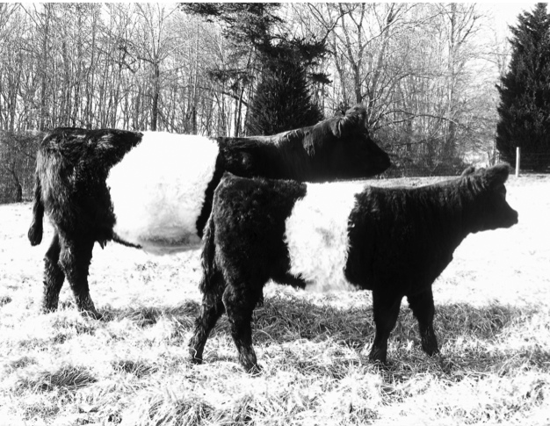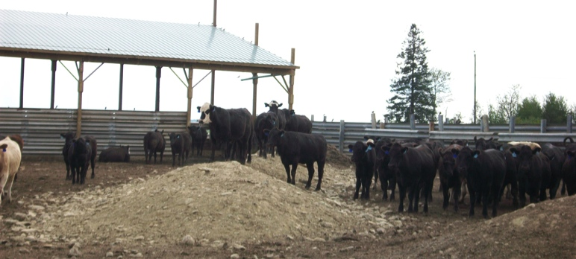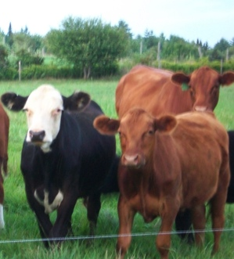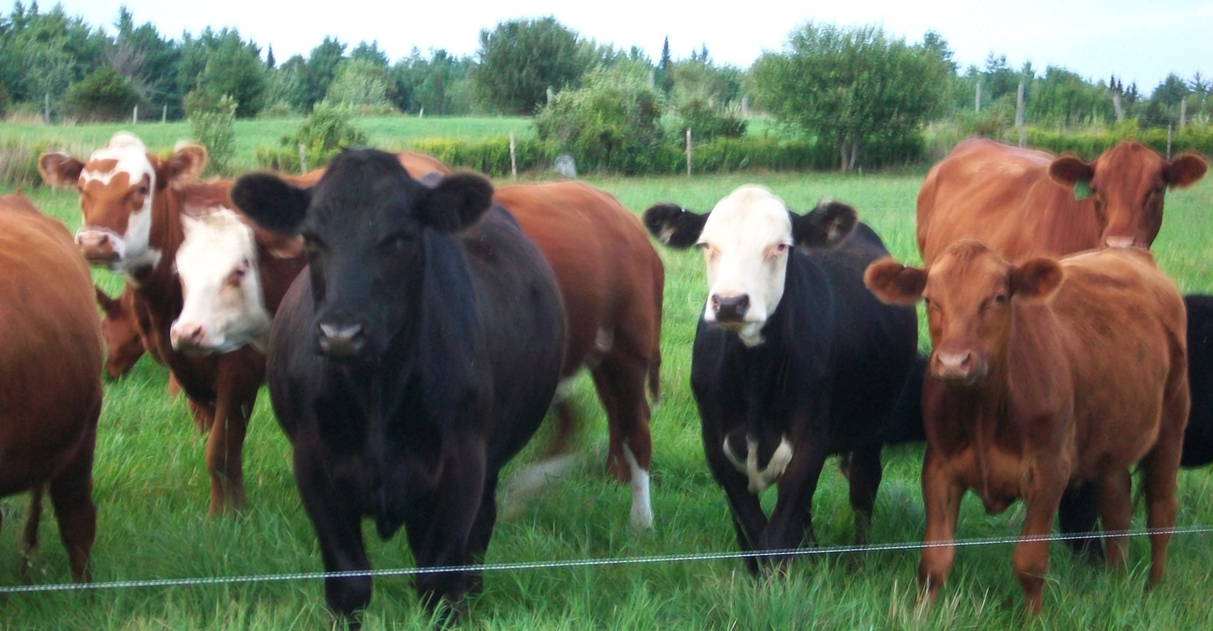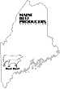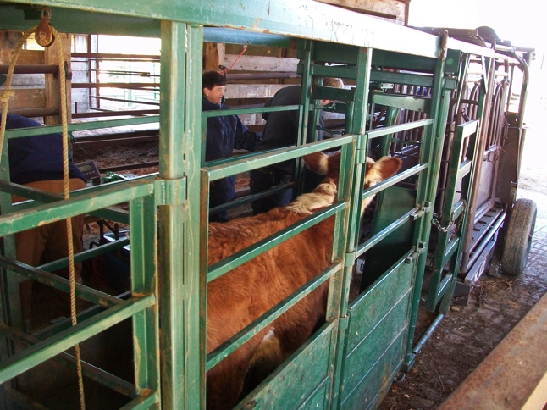

Sally Caverly, Treasurer

1457 River Road, Clinton, ME   
[www.MaineBeefProducersAssociation.com](http://www.MaineBeefProducersAssociation.com)

Maine Beef Producers Association

2015 Membership Application

Monthly Directors Meetings

(2nd Wednesday of the month)

Membership $35/yr. includes the Maine Beef Producers Association Newsletter

An optional subscription to the Country Folks Magazine is available for an extra $25.

Send to: Maine Beef Producers Association

c/o Sally Caverly, Treasurer

1457 River Rd.

Clinton, ME 04927

Please make checks payable to: **Maine Beef Producers Association. (MBPA)**

Please indicate your areas of interest:

* Beef Quality Assurance
* Club Calf Marketing
* Group Purchasing
* Northeast Livestock Exposition
* Youth
* Youth
* Feeder Cattle Marketing
* Feedlot Development
* Legislation
* Membership Promotion
* Other _____

**Member Benefits**Belonging to the Maine Beef Producers is a good thing for anyone raising beef.  Joining the Maine Beef Producers Association will allow you to participate in Association activities and help develop a stronger voice for Maine's beef industry.

Member benefits include:

* 10% off any in-stock part or those that can be ordered with a regular stock order at R S Osgoods in East Dixfield.
* 10% off the purchase of any new electric motor or 10% discount on repairs at Skowhegan Electric Motor Inc.

***Annual Production***

1,447 Farms with Beef

88,191 Cattle & Calves

$16 Million in Sales

**Annual Consumption of Beef**

77 Million Pounds

58 Pounds per Person

## Beef Industry in Maine

## 2007 Census of Agriculture & 2011 Economic Research Service

## *Membership Application*

|  |  |  |  |  |  |  |
| --- | --- | --- | --- | --- | --- | --- |
| Do you want your farm name listed in the MBPA Directory?  ______ Yes, _______ No | Purebred Breed | Number of Head | City/ Town | Mailing Address | Farm Name | Owner Email |
| Do you want your farm name listed in the MBPA website?  ______ Yes, ______ No | Commercial Breed | Number of Head Sold Annually | State |
| Zip |

Education, production assessment, legislation, marketing & recognition

Maine Beef Producers Association

The MBPA is a producer group with members throughout the state.

Our goal is to maintain a viable beef cattle industry through producer education, cooperative marketing, and development and support of youth programs.

* FEEDER CALF SALES - The cooperative marketing and organization of feeder calf sales that was started in 1988 has improved the bottom line of all producers in Maine. Preconditioning requirements were established by MBPA to further enhance the quality of animals offered for sale. These sales have also improved the genetic makeup of beef herds in the state by helping Maine producers learn what buyers want. Producers have found that market prices are affected by the quality of calves presented for sale.
* CLUB CALF SHOW & SALE – This event provides an opportunity for youth to evaluate and purchase a 4-H project animal from a variety of calves at on convenient location. This is good for the buyer and seller (youth who are the future of our industry) and the seller of quality calves. The sale helps establish the price received back at the farm.
* CALVES 4 KIDS PROGRAM – Place heifer calves with youth who will return their first female calf to the program. This is an educational program for youth to learn how to raise a heifer through calving.
* BEEF DIRECTORY – Provide online to link potential buyers and sellers.
* EDUCATIONAL EVENTS – The MBPA sponsors and co-sponsors a number of educational events including the Beef Conference, North East Livestock Expo, workshops at the Agricultural Trades Show, Grazing Conference, Beef Basics, and pasture walks to help the beef industry grow. Work with University of Maine Cooperative Extension to extend the educational network.
* WEIGHING – In conjunction with Department of Agriculture personnel they work with beef farmers to weigh, vaccinate, tag, body condition score animals on farm premises.
* BEEF QUALITY ASSURANCE PROGRAM – The MBPA cooperates with the national BQA to help farmers produce high quality animals.

***Why you should be a member of the***

***Maine Beef Producers Association?***

# **What is the**

# **Maine Beef Producers Association?**