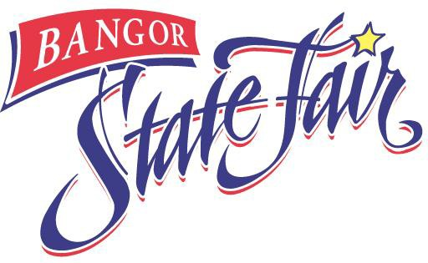

RELEASE AND COVENANT NOT TO SUE
**must be completed by each exhibitor**
515 Main Street
Bangor, ME 04401
Phone: 207-561-8300
Fax: 207-561-8301
fair@bangormaine.gov www.bangorstatefair.com

I, (print name), of (place of residence), being at least eighteen years of age or legally emancipated, in consideration of participation in the 2023 Bangor State Fair as a livestock exhibitor and access to certain premises owned by the City of Bangor, a municipal corporation organized and existing under and by virtue of the Laws of the State of Maine, for that purpose do hereby for myself, my successors, heirs and assigns, fully and completely RELEASE and HOLD HARMLESS said Bangor State Fair, Global Spectrum, LP , City of Bangor, H.C. Bangor, LLC and their officers, servants, agents and employees from any and all claims, demands and actions that I may have, or that my successors, heirs or assigns may have, on account of loss, damage or injury, including personal injury, that I may sustain upon the premises of the City of Bangor, Bass Park and Bangor State Fair grounds. I hereby acknowledge that I have been warned and cautioned that said premises may be in an unsafe condition, and may contain latent and hidden defects, which make entry thereon hazardous. I understand and acknowledge that my entry onto the described premises shall be at my sole risk and exposure, and I hereby voluntarily assume any and all risks of loss, damage or injury, including personal injury, known or unknown, potentially arising out of my entry thereon. I hereby further voluntarily assume the obligation to ascertain the presence and location of any and all hazards upon the described premises, and I hereby acknowledge and agree that no representation by the City of Bangor or by any of its officers, agents, servants or employees at any time shall relieve me or such partnership or corporation from the obligation to fully and independently investigate and ascertain the presence or absence of all such hazards. Further, I acknowledge and agree that no inaccuracy or error in any representation by the City of Bangor or by any of its officers, agents, servants or employees with respect to the presence, absence, location, kind or nature or any hazards upon the described premises shall be deemed by any person to give rise to a claim by myself or by any such partnership or corporation for any injury sustained as a result of such inaccuracy or error. WITNESS my hand and seal this day of , 20 .

Signature

Signature of parent/guardian if Participant is a minor

