Automatic EIN Revocation — How to Respond

Is club or group disbanded or disbanding this tax year?
     ⬇ ⬇
YES NO
⬇ ⬇
No action needed; report Follow instructions
disband status as usual in below
annual update ⬇
⬇

Steps to take if an active club or affiliate EIN is automatically revoked by the IRS due to failure to file for three consecutive years AND club or affiliate (Clubs, Leaders Association, Animal Science Committee) is remaining active. The IRS notice confirming revocation will be sent to the address on file in the IRS database. If this address is for the leader or treasurer instead of the county office, the county office must receive a copy of the notice on receipt.

The status of any EIN can be checked with the IRS EO Select Check tool.
[www.irs.gov/charities-non-profits/exempt-organizations-select-check]

If notice comes directly to club, or group treasurer for the Leaders Association or Animal Science Committee, that person notifies the county Extension 4-H staff, or staff Liaison in the case of an Animal Science Committee, as soon as possible and provides a copy of the letter.

If notice comes to county office, staff person contacts leader or group treasurer. In either case, staff arranges time to work with leader or treasurer to apply for a new EIN.
Process for 4-H Clubs
Club leader and county staff person work together to apply for the new EIN.
This process includes the following steps:
🗹 Step 1. Create new identity for club for banking purposes
- Clubs will select a brand new club name, not a revision of the one associated with the revoked EIN;
- complete new state-level paperwork including
  - new charter,
  - new authorization letter and certification, and
  - new articles of organization.

🗹 Step 2. Apply for new EIN with the new identifying information. We recommend applying
online. Instructions are online in the Extension 4-H Toolkit and on the IRS website.

🗹 Step 3. If the club has a bank account under the revoked EIN, that account will need to
be closed, and a new account opened with the new EIN and new club name.

Process complete. File the 990N using the new EIN during the following tax year filing period
July 1—Nov, 15.

Process for Affiliates (Leaders Association, Animal Science Committee, Horse Camp)
Group treasurer and county staff liaison work together to apply for the new EIN.
This process includes the following steps:
🗹 Step 1. Create new identity for affiliate for banking purposes
- Affiliate will select a brand new group name, not a revision of the one associated with the revoked EIN; and
- complete new affiliate paperwork, including
    - new authorization letter,
    - articles of amendment for Leaders Associations, or
    - articles of organization for Animal Science Committees.
🗹 Step 2. Apply for new EIN with the new identifying information. We recommend applying
online using these instructions [Will be linked when final version is active]

🗹 Step 3. If the group has a bank account under the revoked EIN, that account will need to
be closed, and a new account opened with the new EIN and new affiliate name.

Process complete. File the 990N using the new EIN during the following tax year filing period
July 1—Nov, 15.

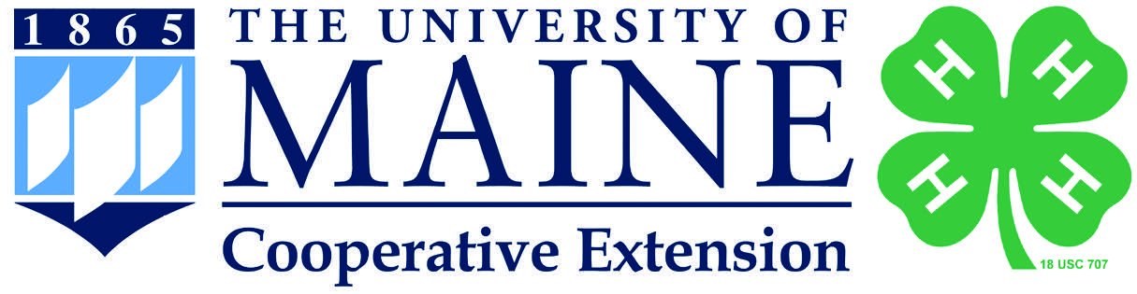

The University of Maine is an equal opportunity/affirmative action institution.

