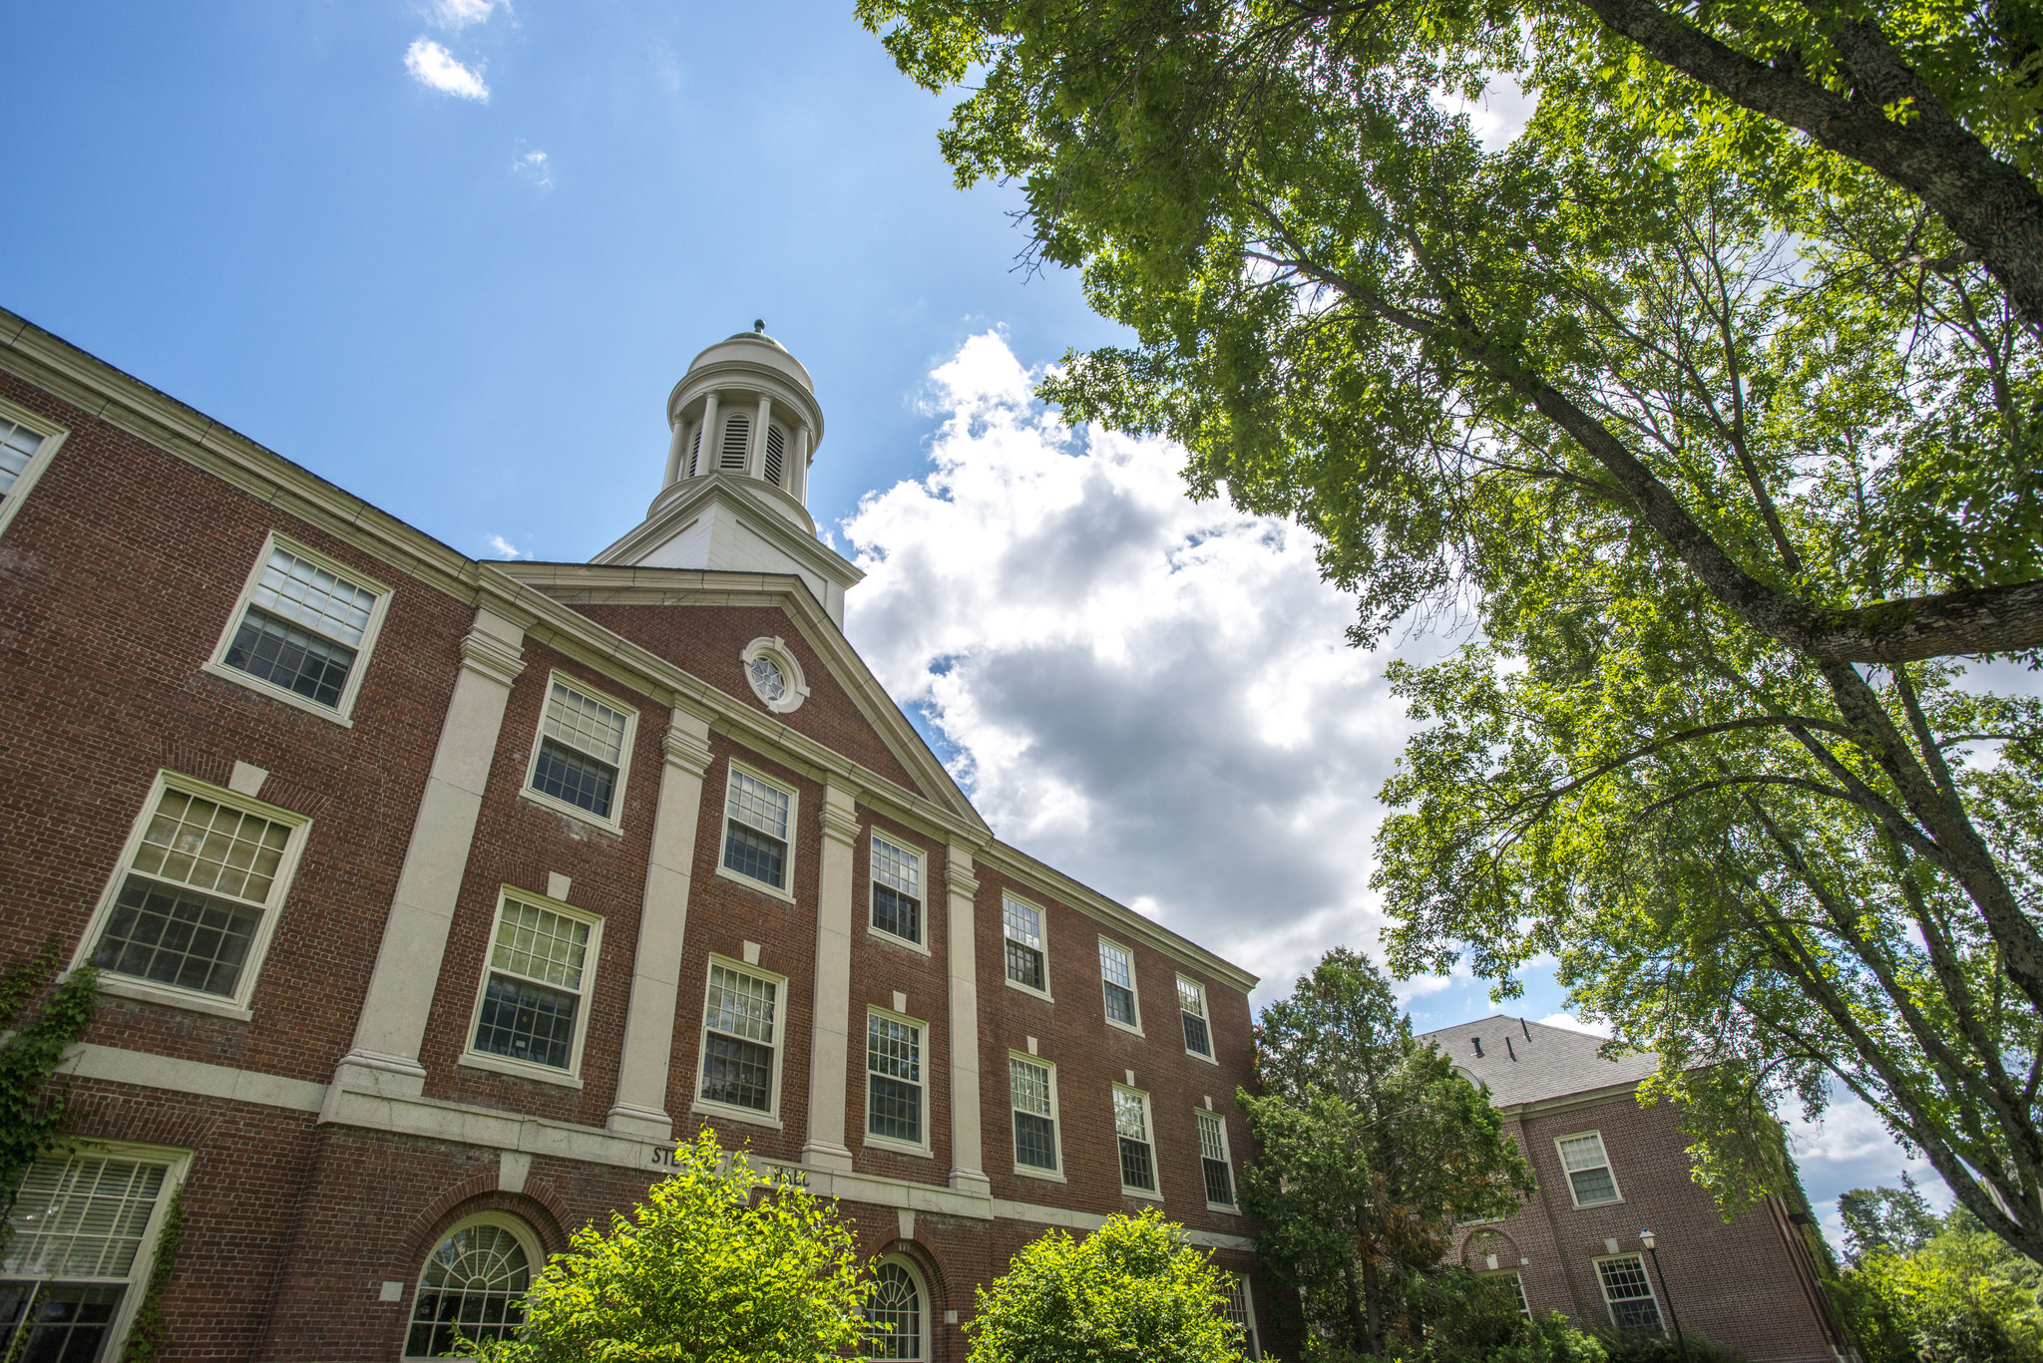

**This line is to be added to this template when inviting the public to an event:**  
For more information or to request a reasonable accommodation, call XXX-XXXX.

In complying with the letter and spirit of applicable laws and pursuing its own goals of diversity, the University of Maine System does not discriminate on the grounds of race, color, religion, sex, sexual orientation, transgender status, gender, gender identity or expression, ethnicity, national origin, citizenship status, familial status, ancestry, age, disability physical or mental, genetic information, or veterans or military status in employment, education, and all other programs and activities. The University provides reasonable accommodations to qualified individuals with disabilities upon request. The following person has been designated to handle inquiries regarding non-discrimination policies: Director of Equal Opportunity, *5713 Chadbourne Hall, Room 412, University of Maine, Orono, ME 04469-5713, 207.581.1226, TTY 711 (Maine Relay System).*

**For more information contact:**  
University of Maine Cooperative Extension XXX County  
Address  
City, State Zipcode  
Phone: 207.xxx.xxx or 800.287.xxx (in Maine)

**Name Here** is rum reiciae optam estion re porrorp oreremo debitae dolor si beriberibus doluptaquunt que earisque vit ra voluptatusam sapidit lam, ut reperum, sima dit moluptatet latem rem quibusa ndigeni mporios es voleceprepta solecere, ut dolupta ipiscianis conem ius, sequati aspicatus volorem porion net doluptatem. Nam aspedisit re nem harum quaspides si quiandi gnatiberum fugiae nis pratem hiciunt la vollendus nis exceati isquis eosae pro exceror epuditas que nus, ut eos ipsam num aliqui dolor sequatur alique porro tenihitios aut pores eosamus as dolorep repeles exero blaborum et, nim cor rerum fugias quam que verum commolo offici dolorer spidel invelesti doluptas sitius, optatur?

Sae cusam fuga. Udit quisi culparit ut essimusamus santur ma qui aut eaquae volorendunti ullat pro offictiur mod moluptame nonsedi onsendel int, eum lam que nis dolupis aliti voles sit peris et dolorep restia cullautem et adit por alis alibusda debisquos que odit etur?

Sae cusam fuga. Udit quisi culparit ut essimusamus santur ma qui aut eaquae volorendunti ullat pro offictiur mod moluptame nonsedi onsendel int, eum lam .

**Day, Month, 20xx**

**xx p.m. • Location**

Event Title Here

Image here

extension.umaine.edu