How to Calculate the
Take-Home Weight:

Market Lamb:
- Normal live (market) weight range is 90–130 lbs.; the average is 120 lbs.
- Average dressing percent (carcass weight) is 54% of the live weight but can range from 45–55%.
- The actual weight of the take-home product is usually 45–55% of the carcass weight
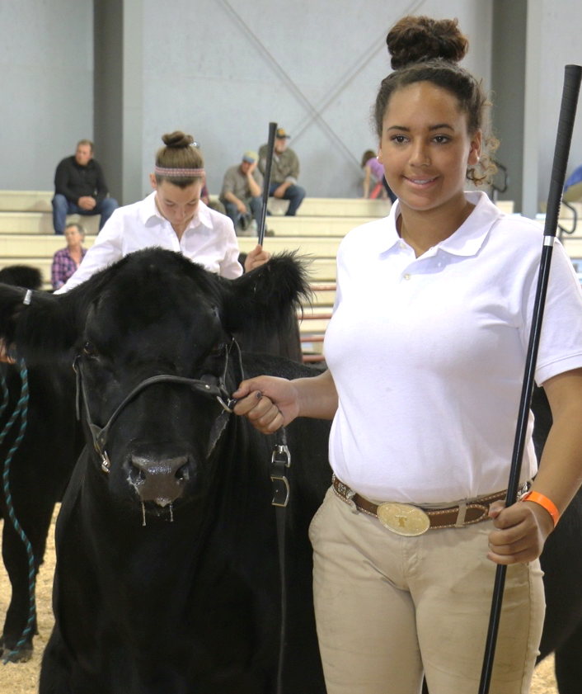
How to Calculate the
Take-Home Weight:

Market Hog:
- Normal live (market) weight range is 190–270 lbs.; the average is 245 lbs.
- Average dressing percent (carcass weight) is 72% of the live weight but can range from 68–72%
- The actual weight of the take-home product is usually 68–72% of the carcass weight

For more information about how and where to purchase a 4-H market animal, contact your local University of Maine Cooperative Extension office.
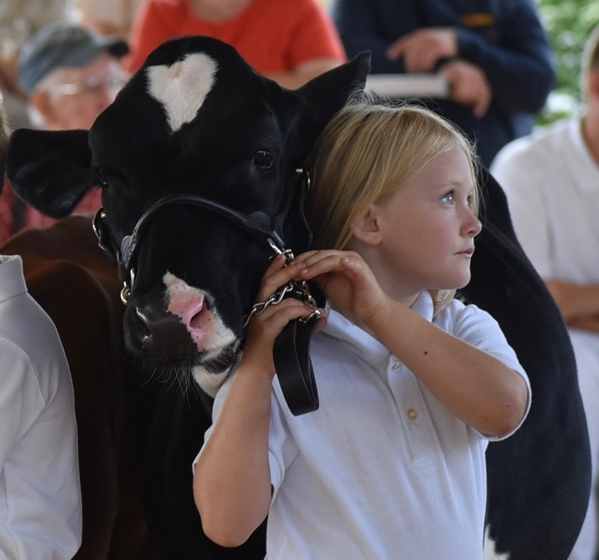
207.XXX.XXXX
include email/url
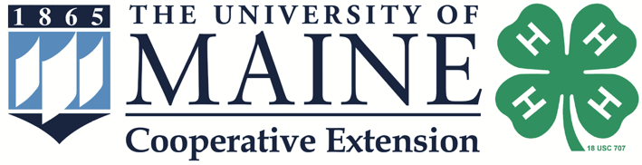
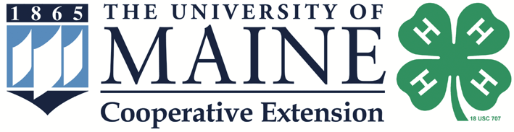
UMaine Extension Photos
The University of Maine [name of campus] is an EEO/AA employer, and does not discriminate on the grounds of race, color, religion, sex, sexual orientation, transgender status, gender expression, national origin, citizenship status, age, disability, genetic information or veteran’s status in employment, education, and all other programs and activities. The following person has been designated to handle inquiries regarding non-discrimination policies: Director of Equal Opportunity, 101 North Stevens Hall, University of Maine, Orono, ME 04469-5754, 207.581.1226, TTY 711 (Maine Relay System).

4-H youth invite you
to become a buyer

Agricultural fairs hold
4-H livestock auctions across Maine

Young people raise, market and sell their livestock as an agricultural learning opportunity.

Why Buy a 4-H Market Animal?
Support positive youth development
Youth who raise a market animal learn more than how to care for the animal. They also learn financial management, record-keeping, time management, marketing, responsibility, decision- making and other important life skills.
Support the future goals of youth
100% of the money goes directly to the 4-H member who raised the animal. Many youth
put their “profit” toward their college fund
while others buy additional animals to raise.
Support local agriculture
Isn’t it great to know that the food you feed your family is from local farms and was produced by your own neighbors?

Receive high quality food
All 4-H market animals are 100% grain-fed and
raised with the greatest care under the supervision of watchful adults.
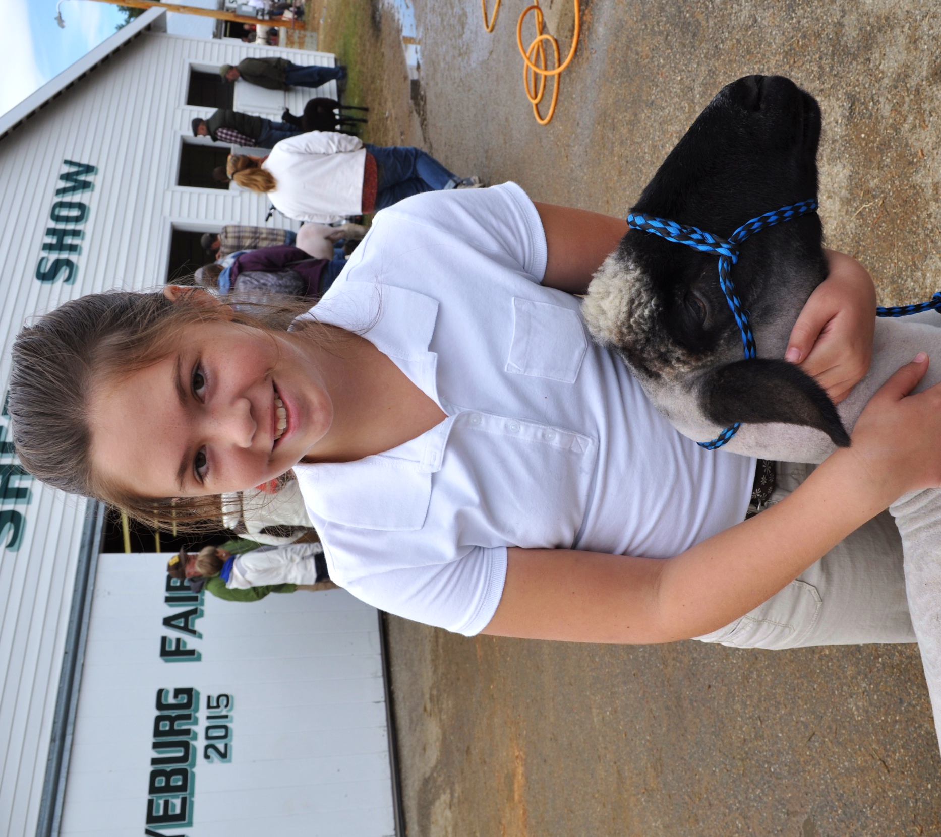

How do I Buy an Animal?
- Buyers should arrive before the auction to view the animals and talk to 4-H members.
- You may bid from anywhere in the arena; some auctions have bid cards.
- To bid, raise your hand to be recognized by the ring people.
- Please have a business card or a paper with your name and address ready so we can recognize you to the audience.
- Immediately after the sale, go to the cashier’s table, located next to the auctioneer’s table, to pay and complete the paperwork. Payment is by cash or check only.
- Representatives from local butcher shops are available with processing and trucking information. Other processing options are also available.

What do I do with the Animal?
- Meat for your freezer
- Turn the animal back for resale as a donation
- Donate the animal to a good cause
(community food pantry, fund-raiser, etc.)
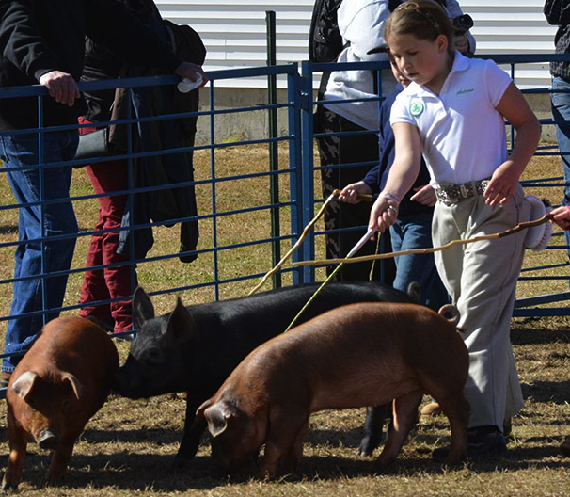
- Gifts to employees or family members
How to Calculate the
Take-Home Weight:

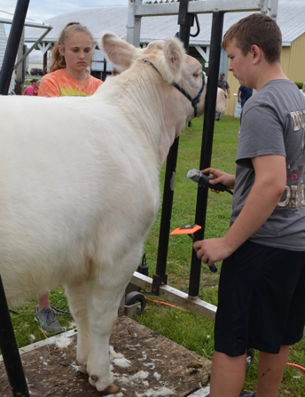
Baby Beef:
- Live (market) weight range is 950–1500 lbs; average is 1150
to 1200 lbs.
- Average dressing percent (carcass weight) is 62.3% of the live weight, but can range from 55-67%
- Actual weight of the take home product is usually 70–80% of the carcass weight (after waste products are removed)
Take-home weights for Market Lamb
and Market Hog on reverse side.
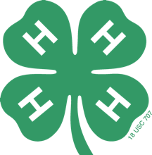

What is 4-H?

4-H is the youth development program of University of Maine Cooperative Extension. The mission of 4-H is to help youth acquire knowledge, develop life skills and form attitudes to enable them to become self-directing, productive and contributing members of society. 4-H emphasizes the importance of involving youth in the learning process. It is offered free of charge to youth ages 5-18. Youth from all cultural and economic backgrounds get involved in 4-H fun and learning. Members and volunteers live in towns, cities, farms, and suburbs across the state of Maine.

