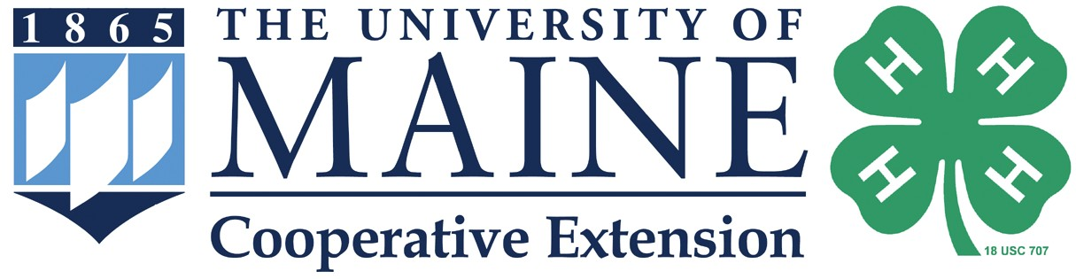

Maine 4-H Science

Where are 4-H Science programs happening in Maine?
Right here!


Maine 4-H makes hands-on STEM (Science, Technology, Engineering, and Math) education available for schools, after-school and community programs.

Insert image here
We offer:
4-H Science Project Kits for Teachers STEM Ambassadors
Follow a Researcher
Citizen Science Opportunities
4-H Science and Enrichment Programs

Want to learn more about 4-H STEM programs in the area?

Insert image here
Contact us:
extension.umaine.edu/county office University of Maine Cooperative Extension XXXXXXXX County Address
Town, ME XXXXX
207.XXX.XXXX 800.XXX.XXXX (in Maine)
TDD 800.XXX.XXXX
email address




extension.umaine.edu/4h

The University of Maine does not discriminate on the grounds of race, color, religion, sex, sexual orientation, including transgender status and gender expression, national origin, citizenship status, age, disability, genetic information or veteran status in employment, education, and all other programs and activities. The following person has been designated to handle inquiries regarding non-discrimination policies: Director, Office of Equal Opportunity, 101 North Stevens Hall, Orono ME, 04469, 207.581.1226.

