How to Apply for an EIN Online - For all Maine 4-H Clubs and Affiliated Groups

According to IRS regulations, all 4-H clubs and affiliated groups must have an EIN regardless of whether or not fundraising is planned. The EIN is needed to file the 990-N between July 1﹣Nov. 15 for each tax year.

These instructions are a revision effective April 25, 2018. Please read carefully and contact your county Extension 4-H staff if you have any questions.

Work with your county Extension 4-H staff to apply for your 4-H club or affiliated group EIN online: https://sa2.www4.irs.gov/modiein/individual/index.jsp

Landing page - click ‘Begin Application’
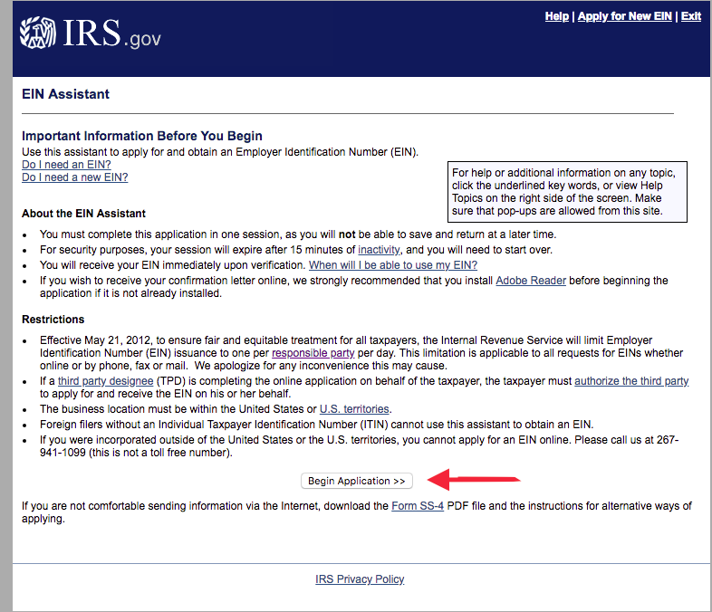
On each subsequent screen click ‘Continue>>’ to proceed to the next screen.

1st screen - What type of legal structure? - select ‘View Additional Types’
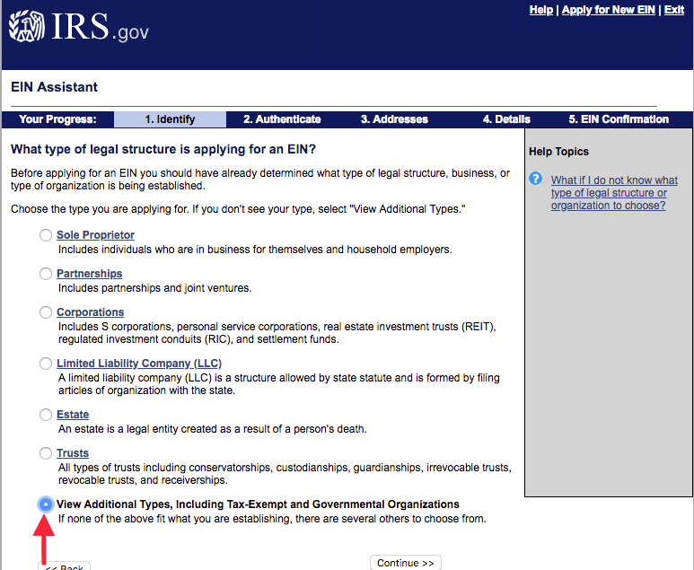

2nd screen - Select “Other, non-profit”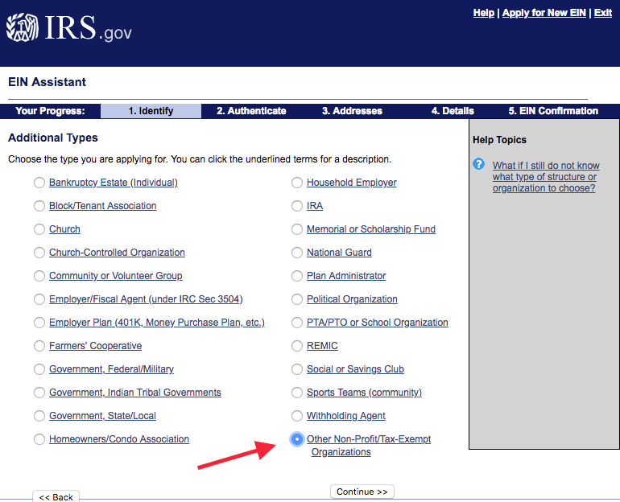

Confirm selection and continue to 4th screen - Reason for Application ‘Banking purposes’
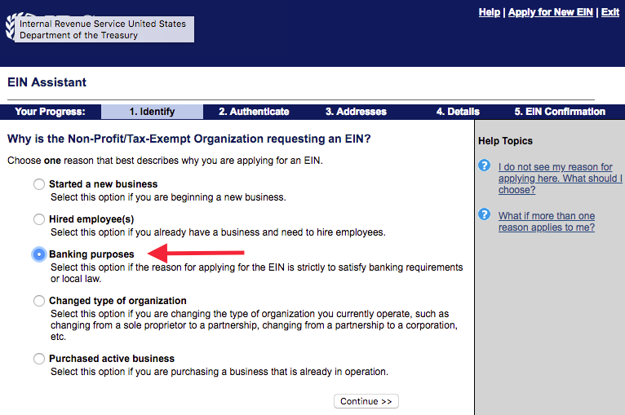

5th screen ‘Responsible Party’ - select ‘Individual’
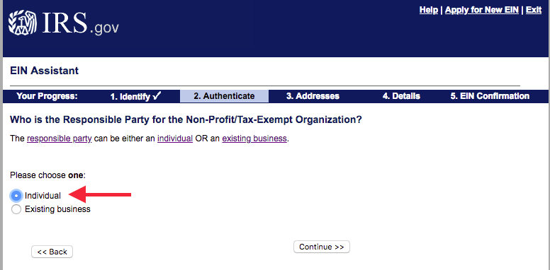

6th screen - Responsible party information - Leader’s first and last names, SSN, then select ‘I am a responsible and duly authorized member’
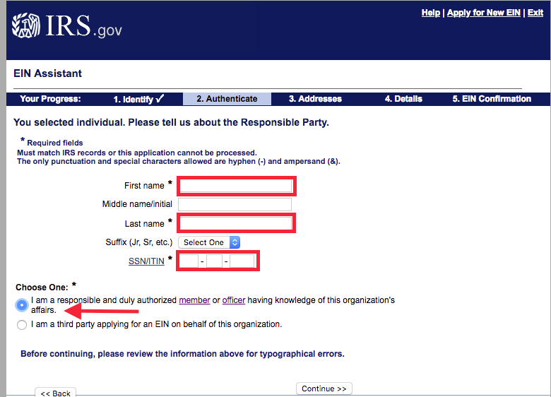

7th screen - Physical location - Use county office mailing address, select ‘No’ for other address
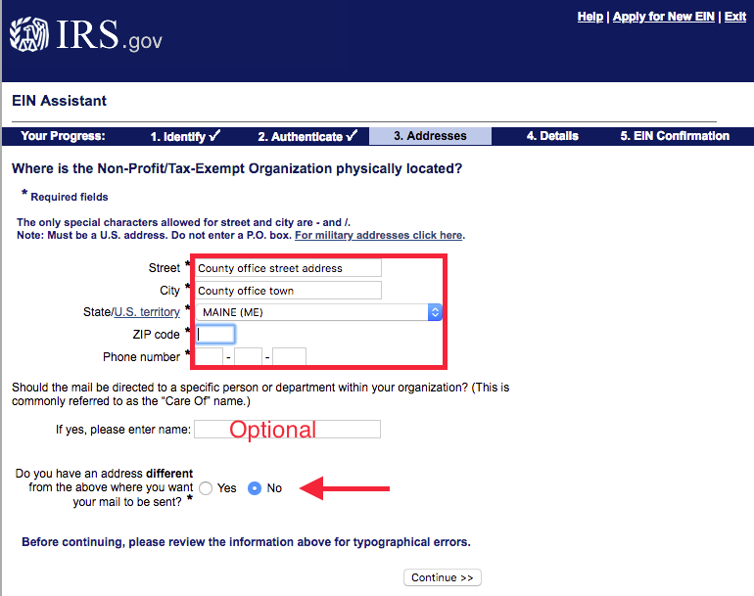
8th screen - Legal name of the organization is the club name - include ‘4-H Club’ in the name
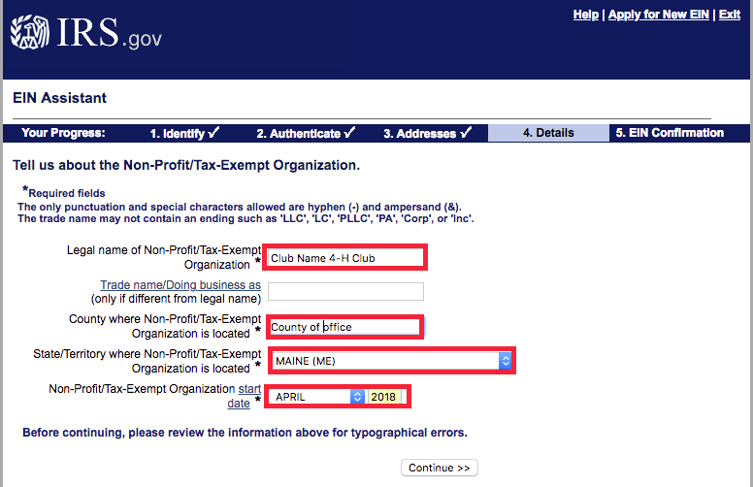
Use the current month and year for the organization/club ‘start date’

9th screen - List of five ‘Yes or No’ questions - Answer ‘No’ to all five
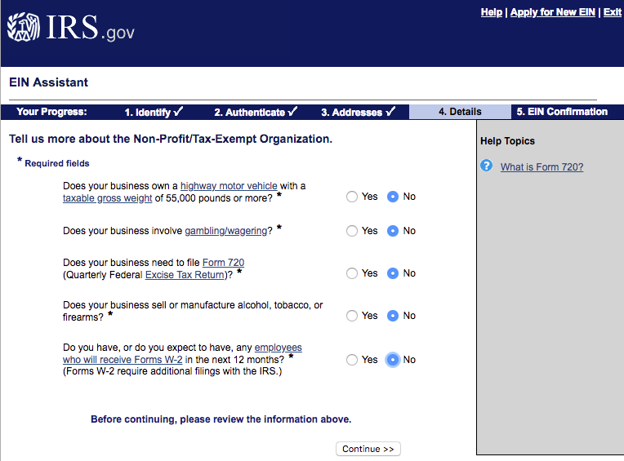

10th screen - What does your business do - Select last option ‘Other’
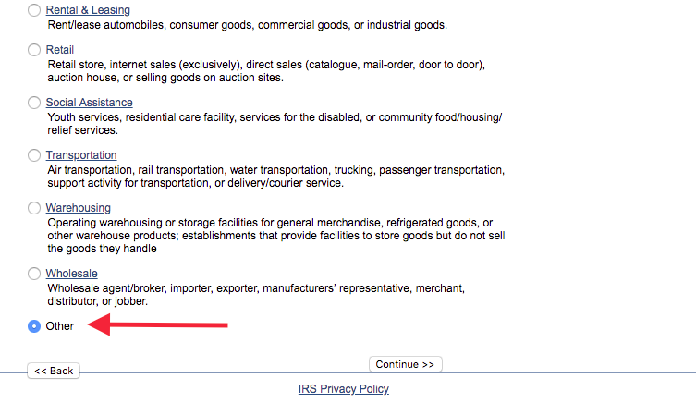

11th screen - Select ‘Other’ and enter text ‘Youth education and development’
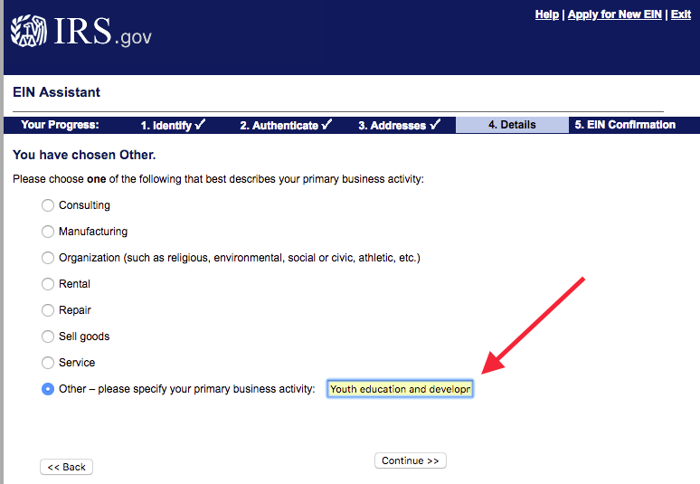

12th screen - Select how you want to receive your EIN confirmation letter.

Choose either ‘Online’ - requires Adobe Reader - EIN number available immediately; OR
Choose ‘by Mail’ - allow up to four weeks for letter to be received by the county office.
No matter which choice you make the county Extension office needs a copy of your EIN letter.
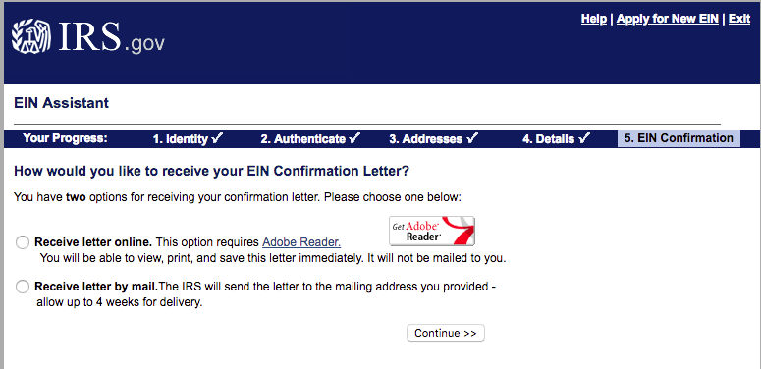

13th screen is a summary of the information you have entered. Click ‘Submit’ at the bottom of the page to generate and receive your club or group EIN.
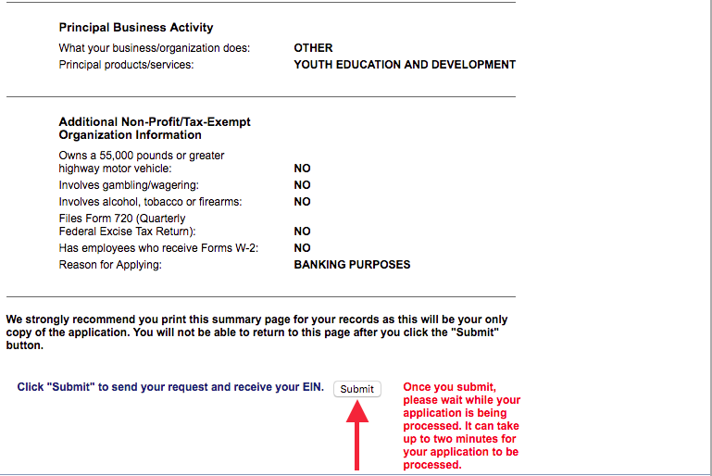

For more information or if you have any questions, contact your county Extension 4-H staff.

The University of Maine is an equal opportunity/affirmative action institution.

