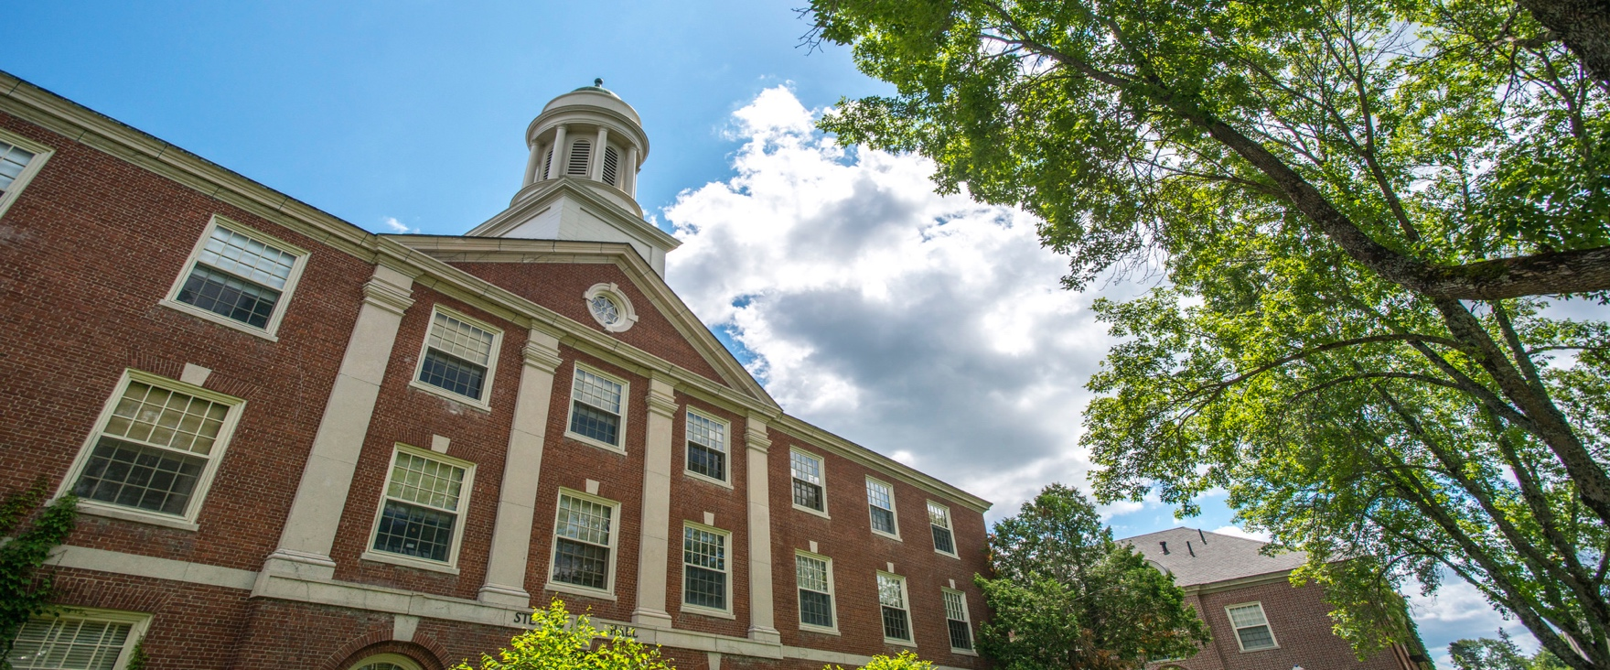

**Day, Month, 20xx**

**xx p.m. • Location**

**For more information contact:**  
University of Maine Cooperative Extension XXX County  
Address  
City, State Zipcode  
Phone: 207.xxx.xxx or 800.287.xxx (in Maine)

The University of Maine is an EEO/AA employer and does not discriminate on the grounds of race, color, religion, sex, sexual orientation, transgender status, gender expression, national origin, citizenship status, age, disability, genetic information or veteran’s status in employment, education, and all other programs and activities. The following person has been designated to handle inquiries regarding nondiscrimination policies:  Director of Equal Opportunity, 101 North Stevens Hall, University of Maine, Orono, ME  04469-5754, 207.581.1226, TTY 711 (Maine Relay System).

**Name Here** is rum reiciae optam estion re porrorp oreremo debitae dolor si beriberibus doluptaquunt que earisque vit ra voluptatusam sapidit lam, ut reperum, sima dit moluptatet latem rem quibusa ndigeni mporios es voleceprepta solecere, ut dolupta ipiscianis conem ius, sequati aspicatus volorem porion net doluptatem. Nam aspedisit re nem harum quaspides si quiandi gnatiberum fugiae nis pratem hiciunt la vollendus nis exceati isquis eosae pro exceror epuditas que nus, ut eos ipsam num aliqui dolor sequatur alique porro tenihitios aut pores eosamus as dolorep repeles exero blaborum et, nim cor rerum fugias quam que verum commolo offici dolorer spidel invelesti doluptas sitius, optatur?

Sae cusam fuga. Udit quisi culparit ut essimusamus santur ma qui aut eaquae volorendunti ullat pro offictiur mod moluptame nonsedi onsendel int, eum lam que nis dolupis aliti voles sit peris et dolorep restia cullautem et adit por alis alibusda debisquos que odit etur?

Sae cusam fuga. Udit quisi culparit ut essimusamus santur ma qui aut eaquae volorendunti ullat pro offictiur mod moluptame nonsedi onsendel int, eum lam .

Event Title Here

Image here

extension.umaine.edu/4h