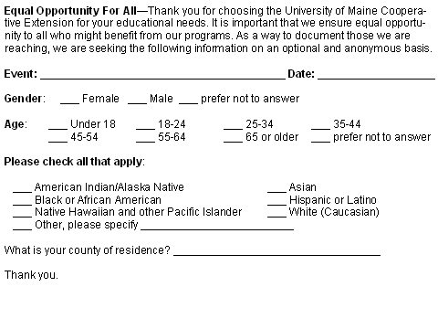­­­

Thank you.

**Equal Opportunity For All-** Thank you for choosing the University of Maine Cooperative Extension for your educational needs. It is important that we ensure equal opportunity to all who might benefit from our programs. As a way to document those we are reaching, we are seeking the following information on an optional and anonymous basis.

**Event: ____________________________________________ Date: ____/____/____**

**Gender**: ___ Female ___ Male ___ I do not identify as either ___ I prefer not to answer

**Please check all that apply**:

___ American Indian/Alaska Native ___ Asian

___ Black or African American ___ Hispanic or Latino

___ Native Hawaiian and other Pacific Islander ___ White (Caucasian)

___ Other, please specify _________________________________________

What is your county of residence?

___________________________

Thank you.

**Equal Opportunity For All-** Thank you for choosing the University of Maine Cooperative Extension for your educational needs. It is important that we ensure equal opportunity to all who might benefit from our programs. As a way to document those we are reaching, we are seeking the following information on an optional and anonymous basis.

**Event: ____________________________________________ Date: ____/____/____**

**Gender**: ___ Female ___ Male ___ I do not identify as either ___ I prefer not to answer

**Please check all that apply**:

___ American Indian/Alaska Native ___ Asian

___ Black or African American ___ Hispanic or Latino

___ Native Hawaiian and other Pacific Islander ___ White (Caucasian)

___ Other, please specify _________________________________________

What is your county of residence?

___________________________

Thank you.

**Equal Opportunity For All-** Thank you for choosing the University of Maine Cooperative Extension for your educational needs. It is important that we ensure equal opportunity to all who might benefit from our programs. As a way to document those we are reaching, we are seeking the following information on an optional and anonymous basis.

**Event: ____________________________________________ Date: ____/____/____**

**Gender**: ___ Female ___ Male ___ I do not identify as either ___ I prefer not to answer

**Please check all that apply**:

___ American Indian/Alaska Native ___ Asian

___ Black or African American ___ Hispanic or Latino

___ Native Hawaiian and other Pacific Islander ___ White (Caucasian)

___ Other, please specify _________________________________________

What is your county of residence?

___________________________

Thank you.

*University of Maine Cooperative Extension logotype*

*University of Maine Cooperative Extension logotype*

*University of Maine Cooperative Extension logotype*

**Equal Opportunity For All-** Thank you for choosing the University of Maine Cooperative Extension for your educational needs. It is important that we ensure equal opportunity to all who might benefit from our programs. As a way to document those we are reaching, we are seeking the following information on an optional and anonymous basis.

**Event: ____________________________________________ Date: ____/____/____**

**Gender**: ___ Female ___ Male ___ I do not identify as either ___ I prefer not to answer

**Please check all that apply**:

___ American Indian/Alaska Native ___ Asian

___ Black or African American ___ Hispanic or Latino

___ Native Hawaiian and other Pacific Islander ___ White (Caucasian)

___ Other, please specify _________________________________________

What is your county of residence?

___________________________

Thank you.

*University of Maine Cooperative Extension logotype*