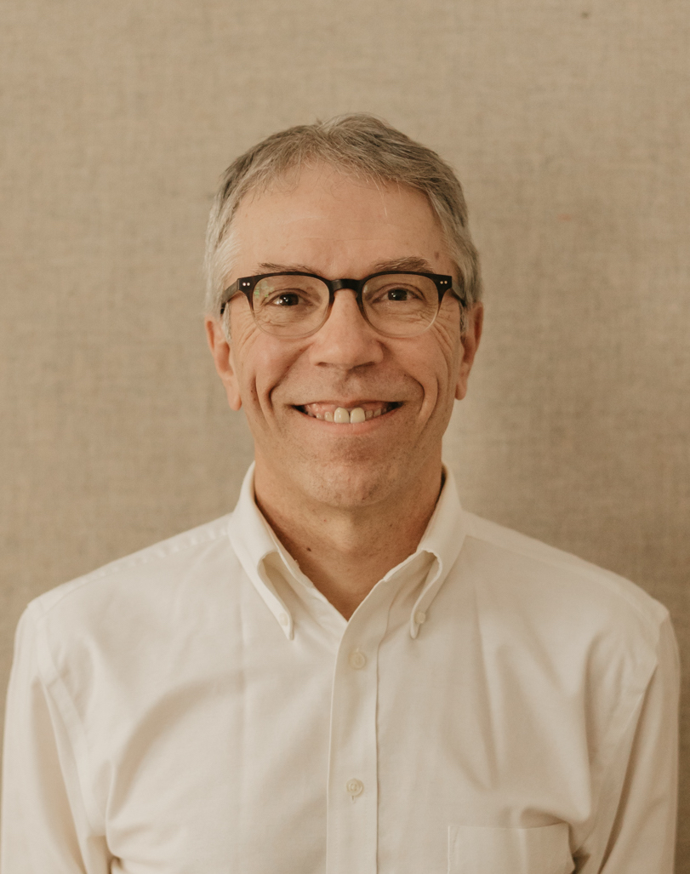
Preparing the Soil for Magical Growth
and the Vital Ingredient: Inclusivity

Highlights from Craig Freshley’s Talk
UMaine Cooperative Extension
November 2, 2022
_________________________________________________________________________________________________________

Links

Link to these Notes
https://tinyurl.com/8upzmeps

Link to the Conference Agenda
https://extension.umaine.edu/plugged-in/2022-conference/agenda/

Description

In this Keynote Address, veteran facilitator and author Craig Freshley will share with us how to make fertile soil for creativity. When groups gather to collaborate, to innovate, and to create new things, it usually happens with deliberate effort. What gathers a group together? What holds a group together? What attitudes and behaviors support innovation and collaboration? With inspirational stories and practical tips, Craig’s keynote plans to unlock answers to these and other fun questions.

Craig’s Bio

Craig is a professional meeting facilitator, speaker, trainer, and an author. Craig is a UMaine graduate. So is his wife. And so are his two daughters. When Craig was a student here, he was the Student Government President. He lived off campus – in his words – “in a house I can’t believe is still standing.”

Craig went on to get a Master’s Degree from the Muskie School at USM in Public Policy and then worked at the Maine State Planning Office and Maine Development Foundation. About 20 years ago Craig left those jobs in Augusta and started his company Good Group Decisions. He has served hundreds of clients – including Cooperative Extension -- with meeting facilitation, keynotes, training seminars, mediation, and strategic planning.

When President Trump was elected, Craig created and facilitated Make Shift Coffee Houses: places for Republicans and Democrats to meet to understand each other’s political views. He facilitated 40 of those gatherings in person all over Maine. For these efforts, Craig was nationally recognized with the American Award for Civic Collaboration.

Just six weeks ago Craig’s third book was published: Together We Decide, An Essential Guide for Making Good Group Decisions. It was the #1 new release in several categories on Amazon and an Amazon bestseller. Foreward Reviews called it “an insightful social science book that balances practical and ideological advice.” Reader’s Favorite called it “invaluable, well-written, insightful, and, above all, practical. It’s extremely thorough and seems to address every potential problem situation. Anyone who is a member of any group should read Freshley’s book.”

Key Concepts

For good stuff to grow, the soil matters

- Soil preparation is a science
  - Purpose
  - People
  - Process

- Inclusivity supports innovation

- How I see things is up to me

Common Purpose Holds People Together

People join causes, not committees

Even when it seems we don’t HAVE things in common, we can WANT things in common

Visions are statements of a better future

The story of the four bricklayers - Video Here

Solid Process Attracts Participants

Structure sets you free - One-Page Tip Here

Someone neutral in charge of the process - Video Here

All People Have Gifts to Contribute

The key is to attract right-fit people and then nurture their gifts

Include Stakeholders for Max Creativity

Stakholders are people who are one or more of the following:

Passionate about the mission

Needed to implement

Affected by the outcomes

Inclusivity Supports Innovation

Biodiverse communities are more likely to adapt and thrive

How to Enourage Good Ideas from Anywhere

- Compelling Cause
  - Envision a better future for us
    - Not us making things better for you
- Develop Relationships
  - With leaders and champions
- Shows of Respect
  - Learn stuff ahead of time
  - Listening
  - Get the name and pronoun right
  - One conversation at a time
    - David Brooks: "The quality of attention you bring to another person is the central moral act of your life." Video here.
  - Wear what they wear – do what they do
  - Shows of Respect - Article here.
- Build Trust
  - Align your words and deeds
  - Same person in all places
- Deliberate Structures
  - John and Patty were deliberate about their process
    - Growing To Give Farm
  - Here’s a website of resources
    - Liberating Structures
- Humility
  - I don’t know the answer
  - I don’t know what’s best for you
  - You might be smarter than me on this or that
  - Curiosity is a form of caring
  - Your problem is our problem

Even When We Disagree

Disagreements are not necessarily bad.
- In fact, you might say that disagreements - and working through them - is what powers innovation.

Heat can be good
- It depends if you are cooking something or burning something.

Stay at the table
- Just because we don’t agree is no excuse to not talk with each other and work together

How I See Things is Up To Me

I can’t change the world but I can be a role model for the world right around me
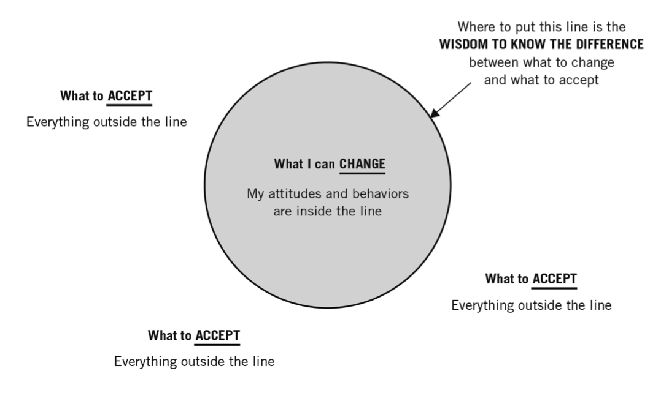
I can change my behaviors and I can change my attitudes

Whenever I’m pointing a finger at someone, three fingers are pointing back at me

I can change the lens through which I see things

I took a conflict management class. I thought I was going to learn how to manage people that I’m in conflict with. Turns out I learned about how to manage me.

What I bring to my group, including my attitude and my willingness to change behavior, really matters.

The story of Gary in the airport. How can I help you?
- Instead of an adversary trying to get her to solve his problem, he became a participant in solving their problem.

It’s Up To Me. Bob Dylan song here.

Best Wishes

My hope for you is that you help groups by being a doorway to University of Maine expertise. That you provide expertise in group process. That you model inclusive values such as wanting to help us rather than help me. That you help people solve problems and resolve tensions.

My hope for you is that by modeling cooperation, you help tensions go away.

You are Cooperative Ex-Tension

On behalf of the people of Maine, thank you for your service. I love you guys.

----------------------

If you have questions or comments about the speech, drop me a line. Craig@Freshley.com

If there’s a particular story you liked, let me know. Or a thing that I said or did. The one-chart, one-slide format was new for me. I was innovating! So I’m hungry for feedback. Thank you!

